Name: Jal Bafana | Roll no: K005
Class: Btech. Cyber Security (Sem-4) | Batch: K1
Date of Experiment: 18.02.2025 | Date of Submission: 18.02.2025

Lab 6
Aim: To implement multiple regression for a problem statement
Step 1: import a data set
Step 2: Find IV, DV
Step 3: Cleaning
Step 4: list the data model
Step 5: Evaluation MSE, R²
Step 6: Interpretation for dataset

from google.colab import drive
drive.mount('/content/drive')
file_path = '/content/drive/MyDrive/Student_Performance.csv'
import numpy as np
import pandas as pd
import matplotlib.pyplot as plt
from sklearn.linear_model import LinearRegression
from sklearn.model_selection import train_test_split
from sklearn.metrics import mean_squared_error, r2_score
df = pd.read_csv(file_path)
df
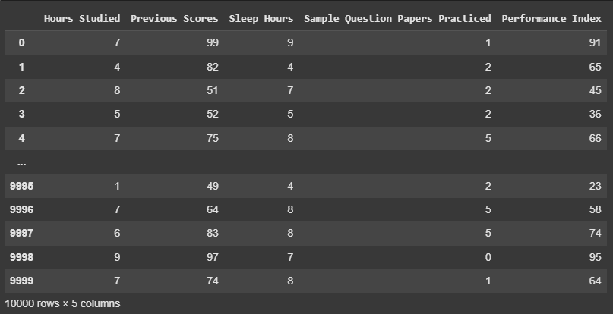

print(df.head())
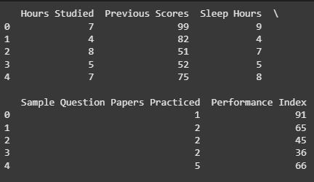

# Check the column names in your dataset
print(df.columns)

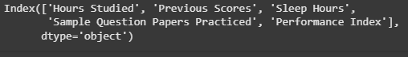

print(df.isnull().sum())
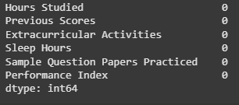

X = df[['Hours Studied', 'Previous Scores', 'Sleep Hours', 'Sample Question Papers Practiced']]
y = df['Performance Index']

X_train, X_test, y_train, y_test = train_test_split(X, y, test_size=0.2, random_state=42)

# Train the model
model.fit(X_train, y_train)

# Predict the target values for the test set
y_pred = model.predict(X_test)

# Evaluate the model's performance
mse = mean_squared_error(y_test, y_pred)
r2 = r2_score(y_test, y_pred)

# Print the metrics
print(f"Mean Squared Error: {mse}")
print(f"R^2 Score: {r2}")

# Plot Actual vs Predicted Performance Index
plt.scatter(y_test, y_pred)
plt.xlabel('Actual Performance Index')
plt.ylabel('Predicted Performance Index')
plt.title('Actual vs Predicted Performance Index')
plt.show()

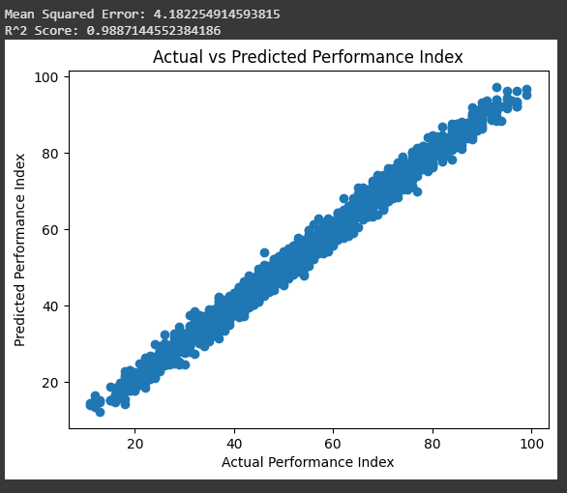

X = df[['Hours Studied', 'Sample Question Papers Practiced']]
y = df['Performance Index']

X_train, X_test, y_train, y_test = train_test_split(X, y, test_size=0.2, random_state=42)

from sklearn.linear_model import LinearRegression

# Create a linear regression model
model = LinearRegression()

model.fit(X_train, y_train)

y_pred = model.predict(X_test)

mse = mean_squared_error(y_test, y_pred)
r2 = r2_score(y_test, y_pred)

print(f"Mean Squared Error: {mse}")
print(f"R^2 Score: {r2}")

plt.scatter(y_test, y_pred)
plt.xlabel('Actual Performance Index')
plt.ylabel('Predicted Performance Index')
plt.title('Actual vs Predicted Performance Index')
plt.show()

