PRACTICAL 1

**Part A**

**AIM:** Android Layouts (Linear & Relative Layout) and Signal Handler.

**Scenario:** Create a Calculator using relative layout and Linear Layout for the buttons, which would accept two numbers and onClick of any of the four Buttons (+,-,*,/) would display the answer in a TextField. The onClick Listener has to be registered to the ActivityMain class.

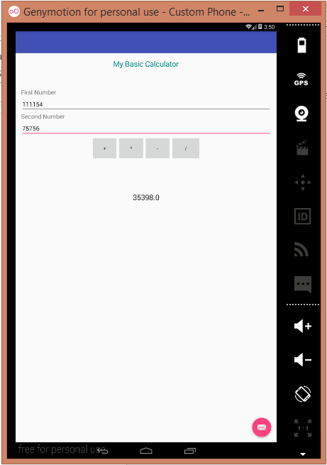

**Part B (to be completed by students)**

**(Students must submit the soft copy as per the following segments. The soft copy must be uploaded on the Blackboard. The filename should be Batch_RollNo_Exp_No)**

|  |  |
| --- | --- |
| **Roll No.: K005** | **Name: Jal Bafana** |
| **Prog/Yr/Sem: Cyber Security/2nd/4th** | **Batch: K1** |
| **Date of Experiment:** | **Date of Submission:** |

1. **Program Scenario and Program code:** (Write Scenario and Paste your program code (Java, xml resource and layout)).

<?xml version="1.0" encoding="utf-8"?>  
<LinearLayout  
 xmlns:android="http://schemas.android.com/apk/res/android"  
 android:layout_width="match_parent"  
 android:layout_height="match_parent"  
 android:orientation="vertical"  
 android:padding="16dp"  
 android:background="@android:color/white">  
  
 <TextView  
 android:id="@+id/header_lab"  
 android:layout_width="match_parent"  
 android:layout_height="wrap_content"  
 android:text="K005 Calculator"  
 android:textSize="24sp"  
 android:textStyle="bold"  
 android:gravity="center"  
 android:layout_marginBottom="8dp" />  
  
 <!-- Header for Simple Calculator -->  
 <TextView  
 android:id="@+id/header_calculator"  
 android:layout_width="match_parent"  
 android:layout_height="wrap_content"  
 android:text="Simple Calculator"  
 android:textSize="20sp"  
 android:textStyle="bold"  
 android:gravity="center"  
 android:layout_marginBottom="16dp" />  
  
 <!-- Input for First Number -->  
 <EditText  
 android:id="@+id/ed_num1"  
 android:layout_width="match_parent"  
 android:layout_height="wrap_content"  
 android:hint="Enter first number"  
 android:inputType="numberDecimal"  
 android:layout_marginBottom="16dp" />  
 <!-- Input for Second Number -->  
 <EditText  
 android:id="@+id/ed_num2"  
 android:layout_width="match_parent"  
 android:layout_height="wrap_content"  
 android:hint="Enter second number"  
 android:inputType="numberDecimal"  
 android:layout_marginBottom="16dp" />  
 <!-- Buttons for Operations -->  
 <LinearLayout  
 android:layout_width="match_parent"  
 android:layout_height="wrap_content"  
 android:orientation="horizontal"  
 android:gravity="center"  
 android:layout_marginBottom="16dp">  
 <Button  
 android:id="@+id/btn_add"  
 android:layout_width="0dp"  
 android:layout_height="wrap_content"  
 android:layout_weight="1"  
 android:text="+" />  
 <Button  
 android:id="@+id/btn_subtract"  
 android:layout_width="0dp"  
 android:layout_height="wrap_content"  
 android:layout_weight="1"  
 android:text="-" />  
 <Button  
 android:id="@+id/btn_multiply"  
 android:layout_width="0dp"  
 android:layout_height="wrap_content"  
 android:layout_weight="1"  
 android:text="*" />  
 <Button  
 android:id="@+id/btn_divide"  
 android:layout_width="0dp"  
 android:layout_height="wrap_content"  
 android:layout_weight="1"  
 android:text="/" />  
 </LinearLayout>  
 <!-- Output Label -->  
 <TextView  
 android:id="@+id/lbout"  
 android:layout_width="match_parent"  
 android:layout_height="wrap_content"  
 android:text="Result"  
 android:textSize="18sp"  
 android:gravity="center"  
 android:layout_marginTop="16dp" />  
</LinearLayout>

package com.example.k005_calculator;  
  
import androidx.appcompat.app.AppCompatActivity;  
import android.os.Bundle;  
import android.view.View;  
import android.widget.Button;  
import android.widget.EditText;  
import android.widget.TextView;  
import android.widget.Toast;  
public class MainActivity extends AppCompatActivity implements View.OnClickListener {  
 // Declare the views  
 EditText ed_num1, ed_num2;  
 TextView lbout;  
 Button btnadd, btnsubtract, btnmultiply, btndivide;  
 @Override  
 protected void onCreate(Bundle savedInstanceState) {  
 super.onCreate(savedInstanceState);  
 setContentView(R.layout.*activity_main*);  
// Initialize the views  
 ed_num1 = findViewById(R.id.*ed_num1*);  
 ed_num2 = findViewById(R.id.*ed_num2*);  
 lbout = findViewById(R.id.*lbout*);  
 btnadd = findViewById(R.id.*btn_add*);  
 btnsubtract = findViewById(R.id.*btn_subtract*);  
 btnmultiply = findViewById(R.id.*btn_multiply*);  
 btndivide = findViewById(R.id.*btn_divide*);  
// Set onClickListeners for buttons  
 btnadd.setOnClickListener(this);  
 btnsubtract.setOnClickListener(this);  
 btnmultiply.setOnClickListener(this);  
 btndivide.setOnClickListener(this);  
 }  
 @Override  
 public void onClick(View view) {  
 String num1Str = ed_num1.getText().toString();  
 String num2Str = ed_num2.getText().toString();  
// Validate inputs  
 if (num1Str.isEmpty() || num2Str.isEmpty()) {  
 Toast.*makeText*(this, "Input boxes are empty", Toast.*LENGTH_SHORT*).show();  
 return;  
 }  
 double num1, num2;  
 try {  
 num1 = Double.*parseDouble*(num1Str);  
 num2 = Double.*parseDouble*(num2Str);  
 } catch (NumberFormatException e) {  
 Toast.*makeText*(this, "Please enter valid numbers", Toast.*LENGTH_SHORT*).show();  
 return;  
 }  
 double result = 0;  
// Use if-else instead of switch-case  
 if (view.getId() == R.id.*btn_add*) {  
 result = num1 + num2;  
 } else if (view.getId() == R.id.*btn_subtract*) {  
 result = num1 - num2;  
 } else if (view.getId() == R.id.*btn_multiply*) {  
 result = num1 * num2;  
 } else if (view.getId() == R.id.*btn_divide*) {  
 if (num2 == 0) {  
 Toast.*makeText*(this, "Cannot divide by zero", Toast.*LENGTH_SHORT*).show();  
 return;  
 }  
 result = num1 / num2;  
 }  
// Display the result  
 lbout.setText(String.*valueOf*(result));  
 }  
}

1. **Output:** (Paste your program input and output screen shots).

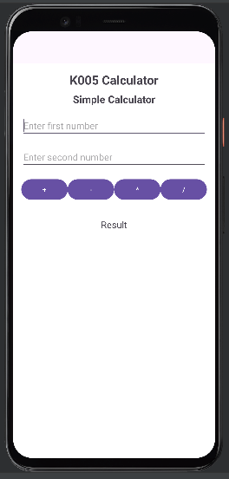

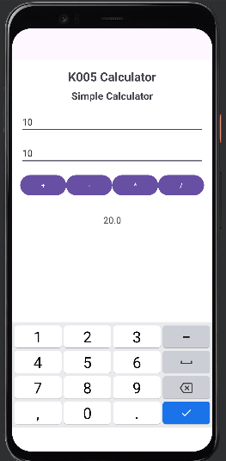

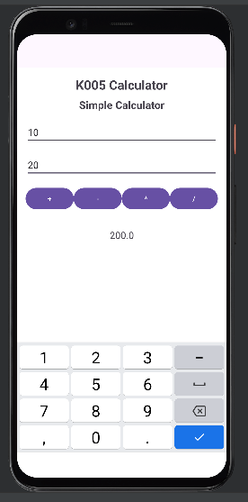

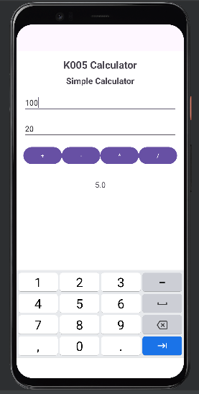

1. **Observations:** A brief description of the design aspects and working of the code in your own words.

The program utilizes a combination of LinearLayout and RelativeLayout to arrange UI elements effectively. It captures user input for two numbers, processes the mathematical operation based on button clicks, and displays the result. The code handles input validation (checks if inputs are empty or non-numeric) and provides feedback with Toast messages in case of errors like empty inputs or division by zero.

1. **Questions:** Draw & Explain with respect to layouts the Scene Graph of the experiment.

**Root (LinearLayout)**

* **TextView (header_lab)**: Displays the title.
* **TextView (header_calculator)**: Displays the "Simple Calculator" header.
* **EditText (ed_num1)**: For input of the first number.
* **EditText (ed_num2)**: For input of the second number.
* **LinearLayout (for buttons)**: Contains horizontal buttons for operations (+, -, *, /).
  + **Button (btn_add)**: For addition.
  + **Button (btn_subtract)**: For subtraction.
  + **Button (btn_multiply)**: For multiplication.
  + **Button (btn_divide)**: For division.
* **TextView (lbout)**: Displays the result.

1. **Conclusion (Learning Outcomes):** How were the outcomes defined for the experiment in Part A fulfilled through the scenarios?

This experiment helped me understand how to create a simple calculator app using Android layouts and handle user input dynamically. It also improved my skills in using event listeners to perform operations and display results.