PRACTICAL 3

Part A

**AIM:** Android Multiple Activities, ArrayAdapter and <string-array>, ListView and call Linkify.

**Scenario:** Create an app which has two activities. The first activity is a WelcomeScreen onClick on the screen anywhere would open the second activity which displays a Menu using ListView. The contents of the menu are the Name of the person, Phone Number, Email Address, Google Website, Android Tutorial Website. In the second activity when the user clicks on Name it displays the photo of the person in a third activity. When Email Address is clicked it called the inbuilt email portal. When phone number clicked it calls the in-built phone dialer app. When Google or Android Tutorial clicked it opens the website.

|  |  |
| --- | --- |
|  |  |

|  |  |
| --- | --- |
|  |  |

**Part B (to be completed by students)**

**(Students must submit the soft copy as per the following segments. The soft copy must be uploaded on the Blackboard. The filename should be Batch_RollNo_Exp_No)**

|  |  |
| --- | --- |
| **Roll No.: K005** | **Name: Jal Bafana** |
| **Prog/Yr/Sem: btech. Cyber Sec (sem-4)** | **Batch: k1** |
| **Date of Experiment: 29.01.2025** | **Date of Submission: 29.01.2025** |

1. **Program Scenario and Program code:** (Write Scenario and Paste your program code (Java, xml resource and layout)).

**activity_main.xml**

<?xml version="1.0" encoding="utf-8"?>  
<LinearLayout xmlns:android="http://schemas.android.com/apk/res/android"  
 xmlns:app="http://schemas.android.com/apk/res-auto"  
 android:id="@+id/lay_ll"  
 xmlns:tools="http://schemas.android.com/tools"  
 android:layout_width="match_parent"  
 android:layout_height="match_parent"  
 android:background="#CEEDCA"  
 android:gravity="center_horizontal"  
 android:orientation="vertical"  
 android:padding="10dp"  
 android:weightSum="10"  
 tools:context=".MainActivity">  
  
 <ImageView  
 android:layout_width="match_parent"  
 android:layout_height="wrap_content"  
 android:src="@drawable/nmlogo"  
 android:layout_weight="2" />  
  
 <TextView  
 android:layout_width="wrap_content"  
 android:layout_height="wrap_content"  
 android:layout_weight="1"  
 android:text="Mobile App Dev"  
 android:textColor="#075128"  
 android:textSize="30dp"  
 android:textStyle="bold" />  
  
 <TextView  
 android:layout_width="wrap_content"  
 android:layout_height="wrap_content"  
 android:textSize="15dp"  
 android:layout_weight="1"  
 android:text="Btech Cyber" />  
  
 <TextView  
 android:layout_width="wrap_content"  
 android:layout_height="wrap_content"  
 android:textSize="15dp"  
 android:layout_weight="1"  
 android:text="Sem 4" />  
  
  
 <ImageView  
 android:layout_width="match_parent"  
 android:layout_height="wrap_content"  
 android:src="@drawable/androidlogo"  
 android:layout_weight="2" />  
  
 <TextView  
 android:layout_width="match_parent"  
 android:layout_height="wrap_content"  
 android:layout_weight="1"  
 android:background="#8BC34A"  
 android:textColor="#1A3C1C"  
 android:textSize="30dp"  
 android:textStyle="bold|italic"  
 android:text="Click to Continue..." />  
  
  
  
</LinearLayout>

**activity_second.xml**

<?xml version="1.0" encoding="utf-8"?>  
<LinearLayout xmlns:android="http://schemas.android.com/apk/res/android"  
 xmlns:app="http://schemas.android.com/apk/res-auto"  
 xmlns:tools="http://schemas.android.com/tools"  
 android:layout_width="match_parent"  
 android:layout_height="match_parent"  
 android:gravity="center_horizontal"  
 android:orientation="vertical"  
 android:weightSum="10"  
 tools:context=".Second">  
  
 <ImageView  
 android:layout_width="match_parent"  
 android:layout_height="wrap_content"  
 android:src="@drawable/nmlogo"  
 android:layout_weight="2" />  
  
 <ListView  
 android:layout_width="match_parent"  
 android:layout_height="wrap_content"  
 android:id="@+id/lv_menu"  
 android:layout_weight="6" />  
  
 <ImageView  
 android:layout_width="match_parent"  
 android:layout_height="wrap_content"  
 android:src="@drawable/androidlogo"  
 android:layout_weight="2" />  
  
</LinearLayout>

**MainActivity.java**

package com.example.k005_lab3;  
  
import androidx.appcompat.app.AppCompatActivity;  
  
import android.content.Intent;  
import android.os.Bundle;  
import android.view.View;  
import android.widget.LinearLayout;  
  
  
public class MainActivity extends AppCompatActivity {  
  
LinearLayout layll;  
  
 @Override  
 protected void onCreate(Bundle savedInstanceState) {  
 super.onCreate(savedInstanceState);  
 setContentView(R.layout.*activity_main*);  
 layll=findViewById(R.id.*lay_ll*);  
 layll.setOnClickListener(new View.OnClickListener() {  
 @Override  
 public void onClick(View v){  
 startActivity(new Intent(MainActivity.this,Second.class));  
 }  
 });  
 }  
}

**strings.xml**

<resources>  
 <string name="app_name">K005_Lab3</string>  
 <string-array name="options">  
 <item>Abc Xyz</item>  
 <item>8169752724</item>  
 <item>jal.bafana54@nmims.in</item>  
 <item>Google Search</item>  
 <item>Android Tutorial</item>  
 </string-array>  
</resources>

**Second.java**

package com.example.k005_lab3;  
  
import androidx.appcompat.app.AppCompatActivity;  
  
import android.content.Intent;  
import android.net.Uri;  
import android.os.Bundle;  
import android.text.util.Linkify;  
import android.view.View;  
import android.widget.AdapterView;  
import android.widget.ArrayAdapter;  
import android.widget.ListView;  
import android.widget.TextView;  
public class Second extends AppCompatActivity{  
  
 ListView lvmenu;  
 @Override  
 protected void onCreate(Bundle savedInstanceState) {  
 super.onCreate(savedInstanceState);  
 setContentView(R.layout.*activity_second*);  
 lvmenu=findViewById(R.id.*lv_menu*);  
 String[] items=getResources().getStringArray(R.array.*options*);  
 ArrayAdapter<String> adapt=  
 new ArrayAdapter<>  
 (this,R.layout.*listitem*,items);  
 lvmenu.setAdapter(adapt);  
 lvmenu.setOnItemClickListener(new AdapterView.OnItemClickListener() {  
 @Override  
 public void onItemClick(AdapterView<?> parent, View view, int position, long id) {  
 TextView tv = (TextView) view;  
 switch (position)  
 {  
 case 0:  
 startActivity(new Intent(Second.this,Third.class));  
 break;  
 case 1://phone dialer  
 String str=tv.getText().toString();  
 str="tel:"+str;  
 startActivity(new Intent(Intent.*ACTION_DIAL*, Uri.*parse*(str)));  
 break;  
 case 2://Email  
 Linkify.*addLinks*(tv,Linkify.*EMAIL_ADDRESSES*);  
 break;  
 case 3: //google_search  
 startActivity(new Intent(Intent.*ACTION_VIEW*,  
 Uri.*parse*("http:www.google.co.in")));  
 break;  
 case 4: //android tutorial  
 startActivity(new Intent(Intent.*ACTION_VIEW*,  
 Uri.*parse*("https://www.tutorialspoint.com/android")));  
 break;  
  
 }  
 }  
 });  
 }  
}

**Third.java**

package com.example.k005_lab3;  
  
import androidx.appcompat.app.AppCompatActivity;  
  
import android.os.Bundle;  
public class Third extends AppCompatActivity {  
 @Override  
 protected void onCreate(Bundle savedInstanceState) {  
 super.onCreate(savedInstanceState);  
 setContentView(R.layout.*activity_third*);  
 }  
}

**AndroidManifest.xml**

<?xml version="1.0" encoding="utf-8"?>  
<manifest xmlns:android="http://schemas.android.com/apk/res/android"  
 xmlns:tools="http://schemas.android.com/tools">  
  
 <application  
 android:allowBackup="true"  
 android:dataExtractionRules="@xml/data_extraction_rules"  
 android:fullBackupContent="@xml/backup_rules"  
 android:icon="@mipmap/ic_launcher"  
 android:label="@string/app_name"  
 android:roundIcon="@mipmap/ic_launcher_round"  
 android:supportsRtl="true"  
 android:theme="@style/Theme.K005_Lab3"  
 tools:targetApi="31">  
 <activity  
 android:name=".Third"  
 android:exported="false" />  
 <activity  
 android:name=".Second"  
 android:exported="false" />  
 <activity  
 android:name=".MainActivity"  
 android:exported="true">  
 <intent-filter>  
 <action android:name="android.intent.action.MAIN" />  
  
 <category android:name="android.intent.category.LAUNCHER" />  
 </intent-filter>  
 </activity>  
 </application>  
</manifest>

**Listitem.xml**

<?xml version="1.0" encoding="utf-8"?>  
<TextView xmlns:android="http://schemas.android.com/apk/res/android"  
 android:layout_width="match_parent"  
 android:layout_height="wrap_content"  
 android:textSize="15dp"  
 android:background="@color/black"  
 android:textColor="@color/white"  
 android:textStyle="bold"  
 android:gravity="center_horizontal"  
 android:text="My Option">  
</TextView>

**Activity_third.xml**

<?xml version="1.0" encoding="utf-8"?>  
<androidx.constraintlayout.widget.ConstraintLayout  
 xmlns:android="http://schemas.android.com/apk/res/android"  
 xmlns:app="http://schemas.android.com/apk/res-auto"  
 xmlns:tools="http://schemas.android.com/tools"  
 android:layout_width="match_parent"  
 android:layout_height="match_parent"  
 tools:context=".Third">  
  
</androidx.constraintlayout.widget.ConstraintLayout>

1. **Output:** (Paste your program input and output screen shots).

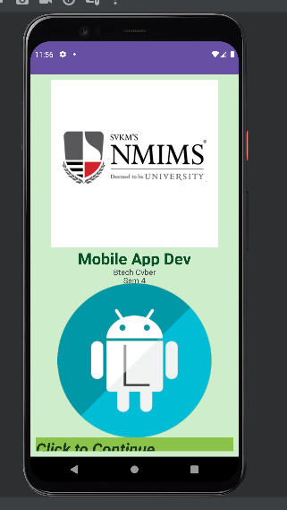

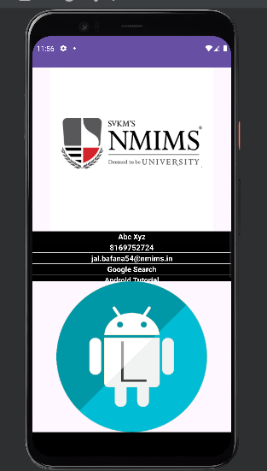

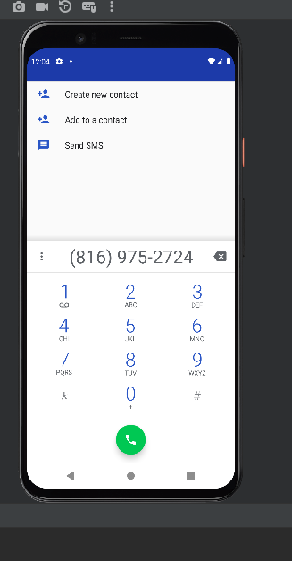

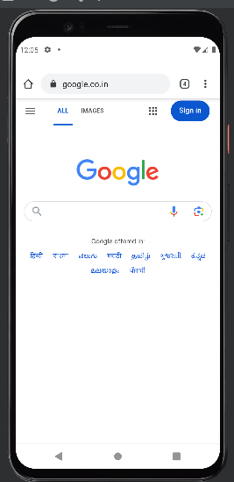

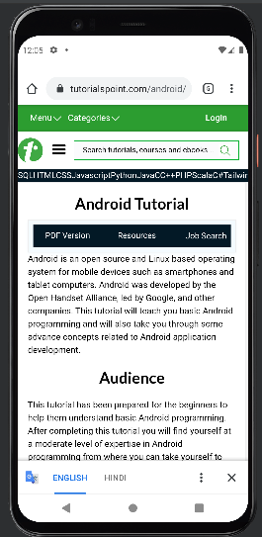

**Observations:** A brief description of the design aspects and working of the code in your own words.

The design of the app uses a simple vertical layout (LinearLayout) where UI elements like TextViews and ImageViews are stacked one below the other. The MainActivity displays text and images, and when clicked, it navigates to SecondPage.

On SecondPage, a list of items (ListView) is displayed, and clicking on each item triggers different actions (like dialing a phone number or opening a webpage). The app uses basic layout and event handling to switch between activities and perform actions based on user input.

**Questions:**Draw & Explain with respect to layouts the Scene Graph of the experiment

**MainActivity Scene Graph:**

**Root** → LinearLayout (main container)

* 1. **ImageView** (nmims logo)
  2. **TextView** (Mobile Application Development)
  3. **TextView** (BTech CSE Cybersecurity)
  4. **TextView** (Semester 4)
  5. **ImageView** (android2 image)
  6. **TextView** (Continue)
  7. **ImageView** (android logo)

**SecondPage Scene Graph:**

**Root** → LinearLayout (main container)

* 1. **ImageView** (nmims logo)
  2. **ListView** (menu items)
  3. **ImageView** (android2 image)

**Conclusion (Learning Outcomes):** How were the outcomes defined for the experiment in Part A fulfilled through the scenarios?

Have successfully learnt and implemented the labs aims in todays lab experiment in the IDE Android Studio and ran on my own personal mobile phone.