|  |  |
| --- | --- |
| **Name: Jal Bafana** | **Roll no: K005** |
| **Class: Btech. Cyber Security (Sem-4)** | **Batch: K1** |
| **Date of experiment: 03.01.2025** | **ADte of submission:** |

What is meant by 64-bit operating system and how it is different by 32-bit operating system in various aspects like performance and timing?

A 64-bit OS and a 32-bit OS refer to the architecture of the processor and how it handles data. The numbers "64-bit" and "32-bit" specifically refer to the width of the processor's registers and the amount of data the CPU can process at once.

**1. Memory Addressing and RAM Usage**

* 32-bit OS: Can address a maximum of 2³² (4,294,967,296) memory locations. This means a 32-bit OS can access a maximum of 4 GB of RAM, although in practice, it might be less due to system resource reservations and hardware limitations.
* 64-bit OS: Can theoretically address 2⁶⁴ (18,446,744,073,709,551,616) memory locations, which equates to 18.4 million TB of RAM. In practice, modern 64-bit systems typically support a few terabytes of RAM, far exceeding the practical needs of most users.

Impact on performance: A 64-bit OS can handle more RAM, which is essential for memory-intensive applications like large databases, scientific simulations, video editing, or running virtual machines. This leads to better performance in these scenarios, as more memory is available for caching, processing, and other tasks.

**2. Performance (Processing Power)**

* 32-bit OS: A 32-bit processor can handle 32 bits of data at a time. This means that the processor can manipulate data in 32-bit chunks, which limits the overall data throughput and processing speed for certain operations.
* 64-bit OS: A 64-bit processor can handle 64 bits of data at a time, meaning it can perform operations more quickly and efficiently, particularly for certain types of calculations like floating-point arithmetic, encryption, and complex scientific computations.

Impact on performance: In general, 64-bit CPUs are faster than 32-bit CPUs due to the increased data width, especially for software optimized for 64-bit processing. However, the real-world difference depends on the type of tasks:

* For most everyday applications (web browsing, office productivity), the performance gain might not be noticeable.
* For specialized software (e.g., rendering, gaming, simulations), the performance increase can be significant.

**3. Software Compatibility**

* 32-bit OS: Can only run 32-bit applications. These applications are limited by the 4 GB memory limit and may not take full advantage of modern hardware.
* 64-bit OS: Can run both 64-bit and 32-bit applications, though 64-bit applications are preferred for optimal performance. 64-bit OSes come with special compatibility layers (like Windows' WOW64) to support 32-bit applications, though they will not be as efficient as native 64-bit applications.

Impact on compatibility: A 64-bit OS is more flexible because it can support both older 32-bit applications and newer 64-bit applications. However, a 32-bit OS cannot run 64-bit applications at all.

**4. Instruction Set and Architecture**

* 32-bit OS: Uses a 32-bit instruction set, meaning the CPU can execute instructions that are up to 32 bits in length. This affects how data is transferred between registers and memory.
* 64-bit OS: Uses a 64-bit instruction set, which allows for more efficient use of the CPU's capabilities, especially for operations that involve large datasets.

Impact on timing: 64-bit processors can perform certain types of calculations more efficiently because they can handle larger chunks of data in a single instruction cycle. This reduces the number of instructions required to complete a task, leading to faster execution times for certain types of workloads.

**5. Security Features**

* 32-bit OS: Generally, 32-bit OSes have fewer advanced security features compared to 64-bit OSes. For example, 32-bit systems may lack features like hardware-backed data execution prevention (DEP) and Address Space Layout Randomization (ASLR).
* 64-bit OS: Modern 64-bit OSes often include additional security features, such as better memory protection, which make them less vulnerable to exploits like buffer overflows.

Impact on security: A 64-bit OS is generally more secure because it can take advantage of more advanced hardware-based security features.

**6. Timing (Clock Cycles and Execution Speed)**

* The execution speed of tasks in a 64-bit OS is generally faster, but it depends on the nature of the task.
* For certain computationally intensive tasks (like video encoding, scientific simulations, or 3D rendering), 64-bit processors can execute the same operation in fewer cycles due to their ability to process more data per clock cycle.
* For simpler tasks, the difference in timing between 32-bit and 64-bit processing may not be very significant. In fact, for tasks that are not optimized for 64-bit architecture, the overhead of managing larger memory addresses could sometimes cause minor inefficiencies.

Impact on timing: While the difference in timing may be negligible for light tasks, for more demanding workloads, the increased number of registers and faster processing of 64-bit systems result in reduced execution time.

**7. Disk and File System Considerations**

* 32-bit OS: Typically uses file systems and disk partitioning schemes that are limited to 32-bit addressing, which could limit disk access and file sizes.
* 64-bit OS: Can use modern file systems like NTFS on Windows, ext4 on Linux, or APFS on macOS, which support larger file sizes and more efficient disk management. Some file systems on 64-bit OSes can handle individual files up to 18.4 million TB in size.

**8. Power Consumption and Efficiency**

* 32-bit OS: Typically, 32-bit systems are more power-efficient, as they have fewer components and can be simpler in design.
* 64-bit OS: While 64-bit CPUs may consume more power due to their complexity and higher clock speeds, the increased performance means that a 64-bit OS can often perform more tasks in less time, which can offset the increased power consumption.

Impact on efficiency: In general, 64-bit systems are better suited for high-performance tasks but may consume more power, whereas 32-bit systems can be more energy-efficient for lighter workloads.

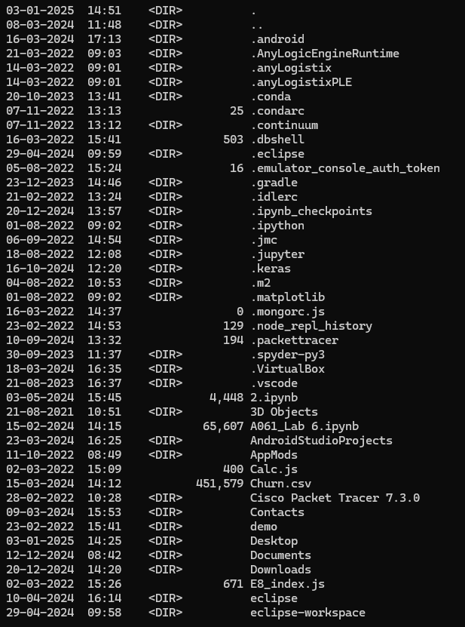

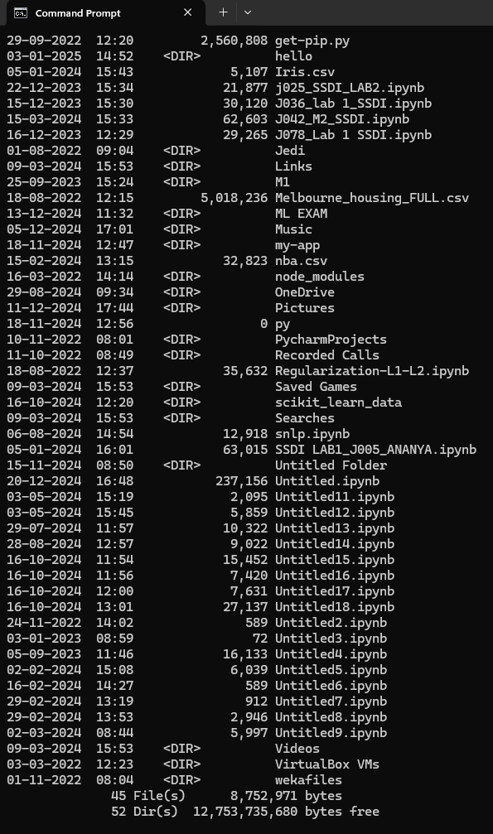

Note:- Execute following commands using cmd prompt

1. Create a directory or folder, change directory







1. Create a file in the above folder



1. Type some data in the file created,



1. Read the data,

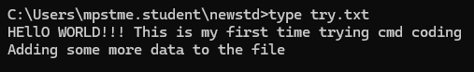

1. Rename the file and folder,



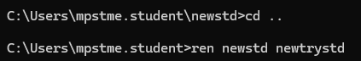

1. Create second folder and copy file from first folder to the second folder newly created





1. Delete folder,





1. Open an application,



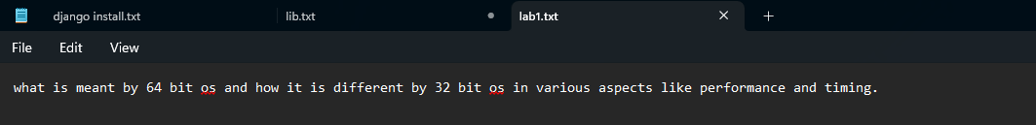

1. close an application,



1. Access different drives

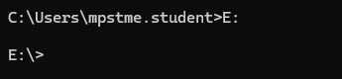

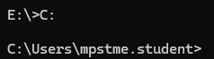

1. create 2 files and compare them FC: File Compare,

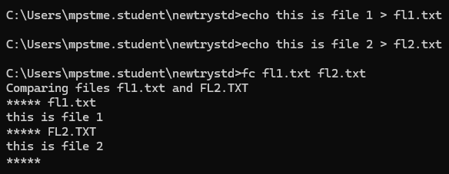

1. Network troubleshooting is never simple, but one command that makes it much easier is IPCONFIG.

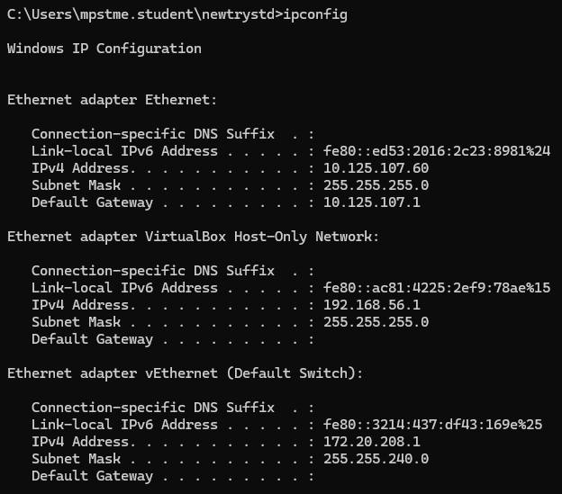

1. NETSTAT command in the command prompt,

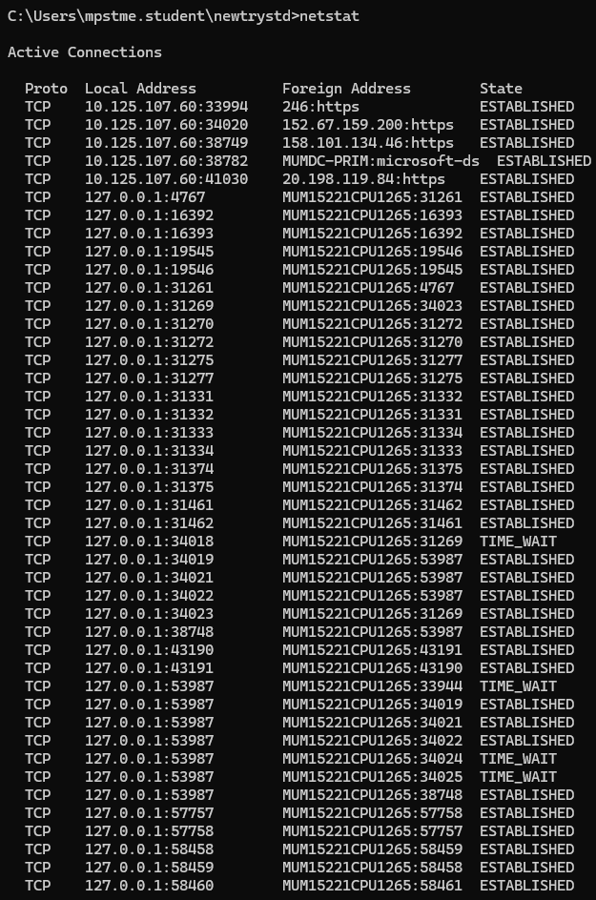

1. PING command,

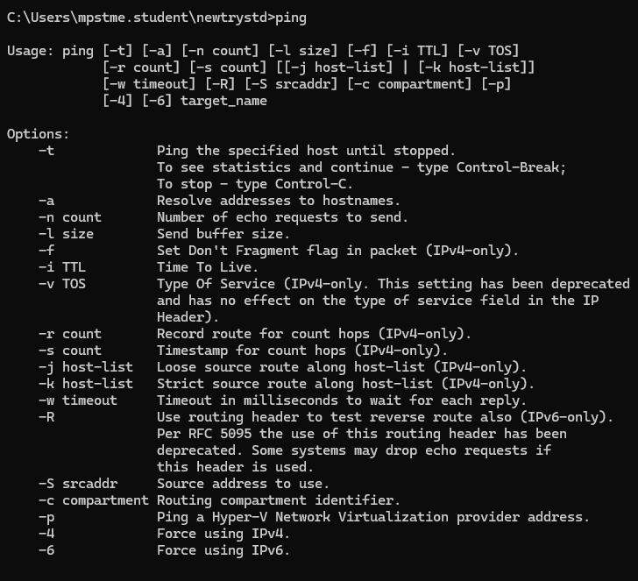

1. TRACERT nmims.edu

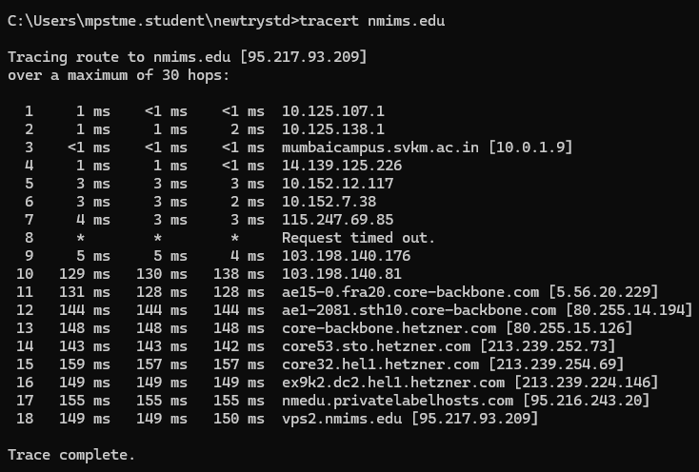

1. SYSTEMINFO,

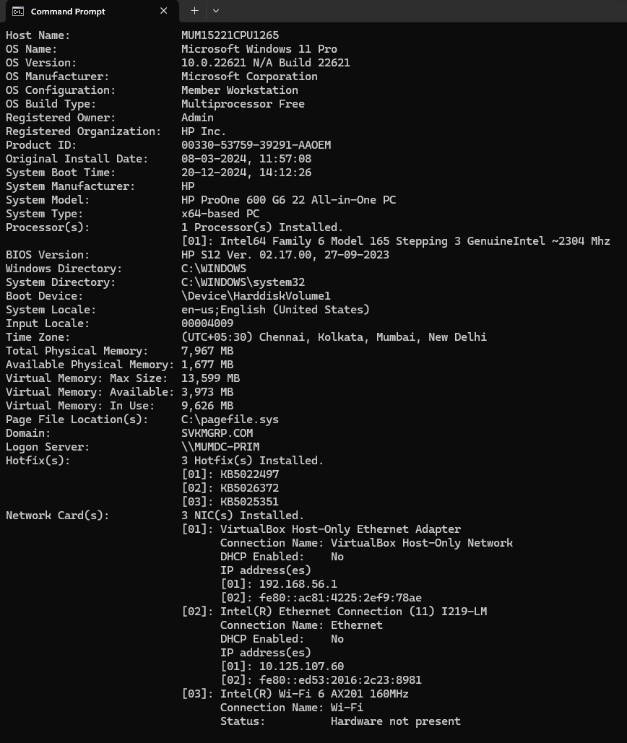

1. SFC: System File Checker,

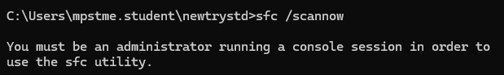

1. tasklist command to provide a current list of all tasks running on your PC,

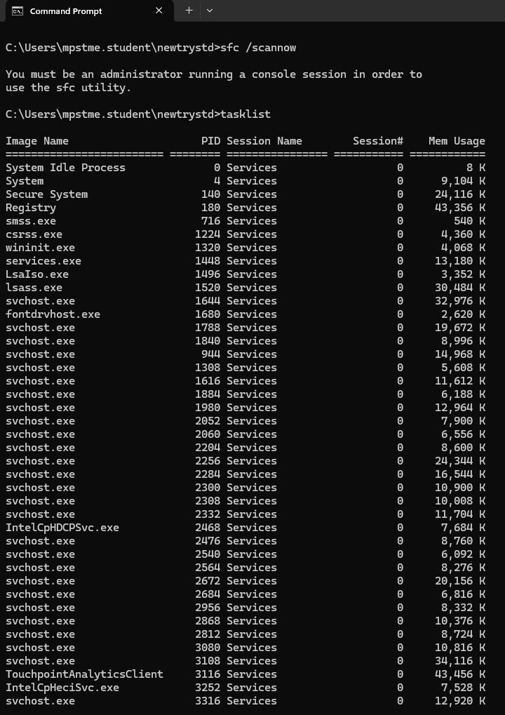

1. if possible do a simple c language or python program, after the file submitted in msteams,

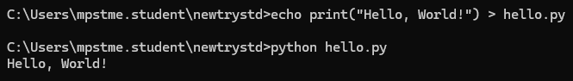

1. just shutdown using cmd prompt

