|  |  |
| --- | --- |
| **Name: Jal Bafana** | **Roll no: K005** |
| **Btech. Cyber Security (Sem-4)** | **Batch: K1** |
| **Date of Experiment: 11.01.2025** | **Date of Submission: 11.01.2025** |

#write a vector of length 10 of 3 colours

color_vector <- c('Blue','Green','Red')

cafac = factor(color_vector)

nlevels(cafac)

summary(cafac)

shifts = c('morning','afternoon','evening','night','morning','afternoon','evening','night','morning','afternoon')

length(shifts)

shiftsfac = factor(shifts,order=TRUE,levels=c('morning','afternoon','evening','night'))

nlevels(shiftsfac)

summary((shiftsfac))

shiftsfac

data1=read.csv("C:\\Users\\mpstme.student\\Downloads\\cancer.csv")

data2$treatment

f1=factor(data1$treatment)

nlevels(f1)

summary(f1)

f2=factor(data1$cancerlevel,order=TRUE,levels = c(1,2,3))

summary(f2)

f2

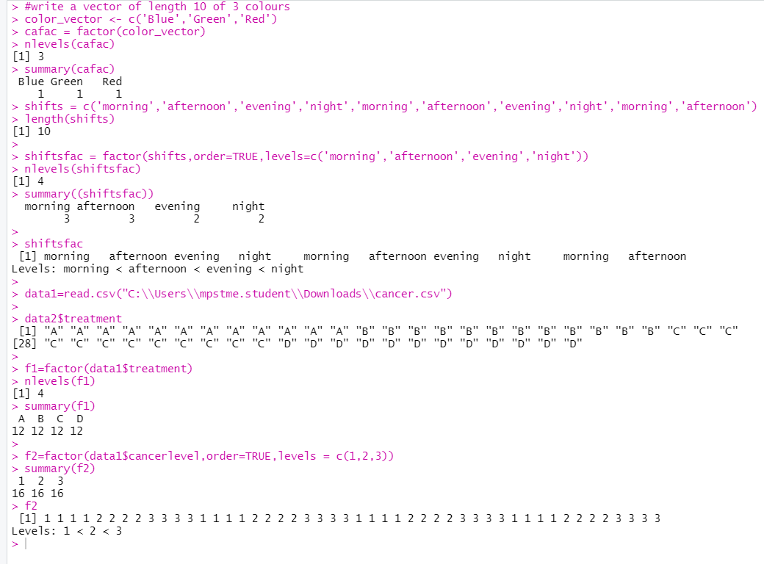

Exercise:

#Q1 jal bafana

read.csv(("C:\\Users\\mpstme.student\\Desktop\\Book1.csv"))

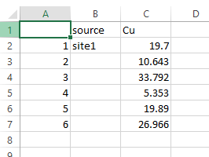

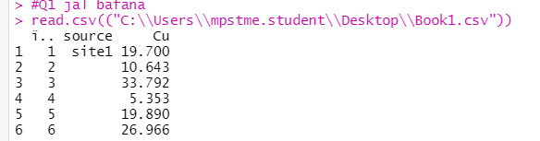

#Q2 jal bafana

read.csv(("C:\\Users\\mpstme.student\\Desktop\\Book4.csv"))

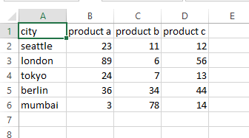

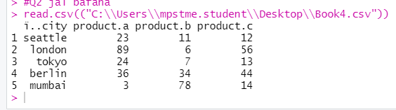

#Q3 jal bafana

data.frame(swiss)

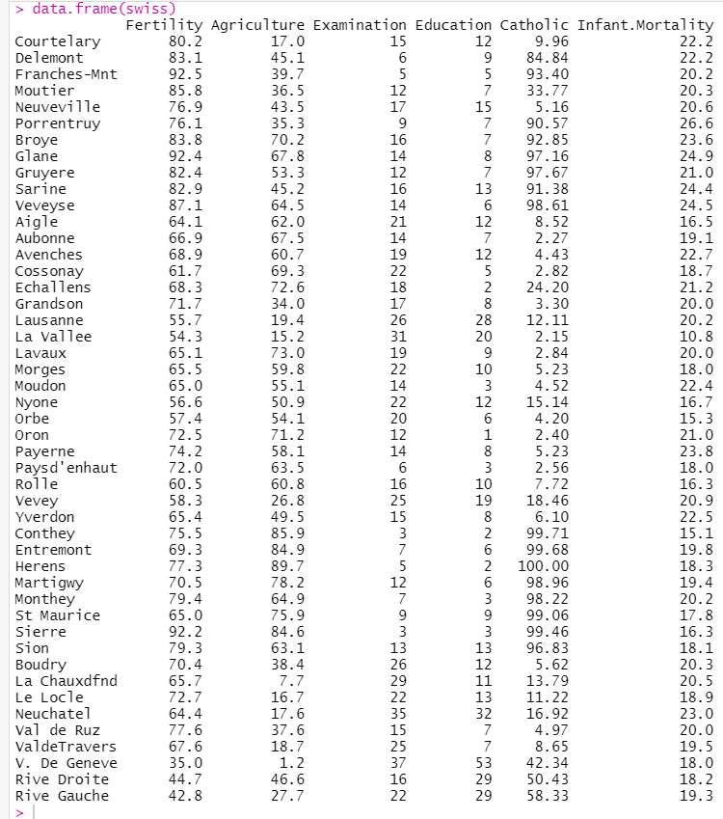

#Q4 jal bafana

months <- c("January", "February", "March", "April", "May", "June", "July", "August", "September", "October", "November", "December",

"January", "February", "March", "April", "May", "June", "July", "August")

ordered_months <- factor(months, levels = c("January", "February", "March", "April", "May", "June", "July", "August", "September", "October", "November", "December"), ordered = TRUE)

ordered_months

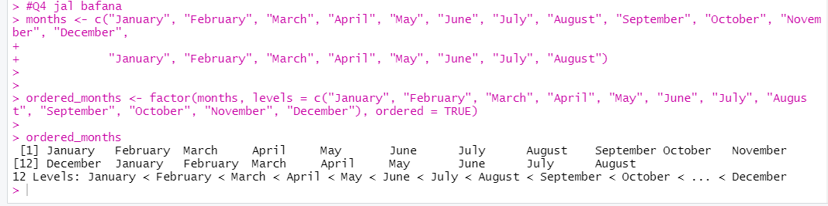

#Q5 jal bafana

Product <- c("Product A", "Product B", "Product C", "Product D")

Price <- c(10.99, 15.49, 7.89, 12.35)

Quantity <- c(100, 150, 200, 50)

df1 <- data.frame(Product, Price, Quantity)

print(df1)

A <- c("Math", "English", "Science")

B <- c(85, 90, 78)

C <- c("A", "A", "B")

df2 <- data.frame(A, B, C)

colnames(df2) <- c("Subject", "Marks", "Grade")

print(df2)

df1$Name <- c("Jal", "Arjun", "Prakhar", "Jay")

df2$Name <- c("Jal", "Arjun", "Prakhar")

combined_df <- merge(df1, df2, by = "Name")

print(combined_df)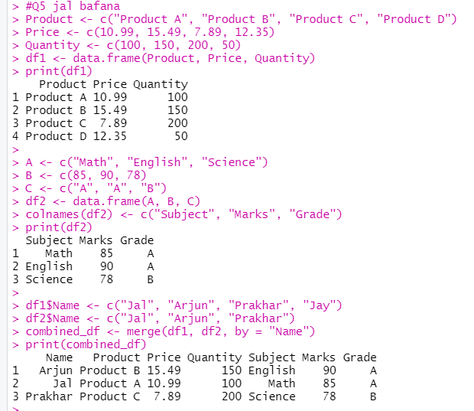

#Q6 jal bafana

A <- c("Math", "English", "History")

B <- c(75, 90, 68)

C <- c("B", "A", "C")

df2 <- data.frame(A, B, C)

colnames(df2) <- c("Subject", "Marks", "Grade")

df2

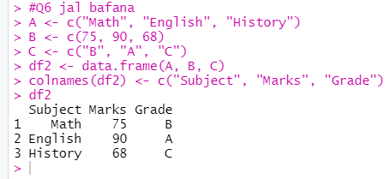

#Q7 jal bafana

name1 <- c("Jal", "Arjun", "Prakhar")

department <- c("HR", "Finance", "IT")

df1 <- data.frame(Name = name1, Department = department)

marks <- c(85, 92, 88)

df2 <- data.frame(Name = name1, Marks = marks)

merged_df <- merge(df1, df2, by = "Name")

merged_df

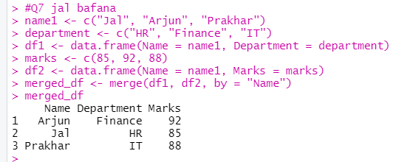

#Q8

names <- c("Jal", "Arjun", "Prakhar", "Jay")

ages <- c(20, 21, 22, 23)

df3 <- data.frame(Names = names, Ages = ages)

cat("Number of rows:", nrow(df3), "\n")

cat("Number of columns:", ncol(df3), "\n")

str(df3)

