|  |  |
| --- | --- |
| **Name: Jal Bafana** | **Roll no: K005** |
| **Class: Btech. Cyber Security (sem-4)** | **Batch: K1** |
| **Date of Experiment: 18-01-2025** | **Date of Submission: 18-01-2025** |

**Lab-3**

**Practice:**

head(airquality)

plot(airquality$Ozone, airquality$Month, main="Relation Between Ozone",

xlab="Ozone Concentration", ylab="Month of Observation", col="blue", pch=21)

plot(airquality$Month, type="p", main="Line Plot",

xlab="X-axis Label", ylab="Yaxis Label", col="red" ,pch=15)

a <- c(17,32,8,53,1)

b <- c("mumbai","pune","delhi","banglore","hydrabad")

barplot(a,names.arg=b, main="Bar-Chart", col="green")

d=table(airquality$Month)

d

barplot(d,names.arg=c(5:9), main="Bar-Chart", col="grey" )

hist(airquality$Temp, main="LA Guardia Airport's Maximum Temp.(Daily)",

xlab="Temp. (Fah)",xlim = c(50,125), col="yellow" , freq = TRUE)

boxplot(mtcars$disp~mtcars$gear)

summary(mtcars)

geeks <- c(23,56,20,63)

labels <- c("mumbai","pune","delhi","banglore")

pie(geeks,labels)

**Questions:**

# Q1 Scatter Plot jal bafana k005

plot(cars$speed, cars$dist, main="Speed vs Distance",

xlab="Speed (mph)", ylab="Distance (ft)", pch=19, col="blue")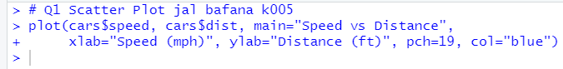

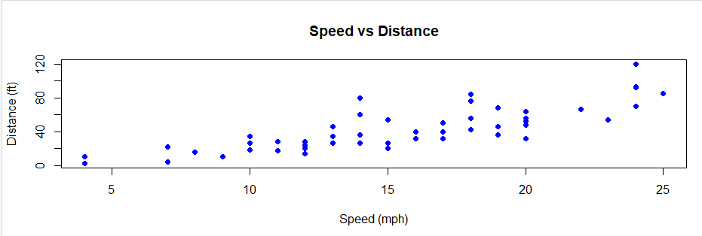

# Q2 Line Plot jal bafana k005

months <- seq(from=1, to=12, by=1)

temperature <- c(30, 32, 35, 40, 45, 50, 55, 60, 58, 53, 45, 35)

plot(months, temperature, type="o",

main="Monthly Average Temperature",

xlab="Month",

ylab="Temperature (°C)",

col="red",

lwd=2,

pch=16)

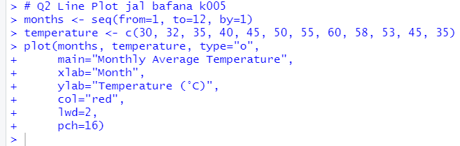

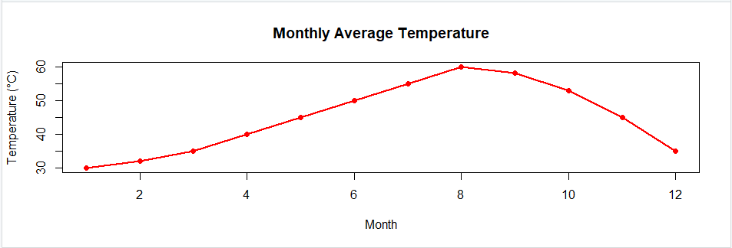

# Q3 Bar Plot jal bafana k005

cylinder_count <- table(mtcars$cyl)

barplot(cylinder_count, main="Number of Cars by Cylinder Type",

xlab="Number of Cylinders", ylab="Count of Cars",

col="lightblue")

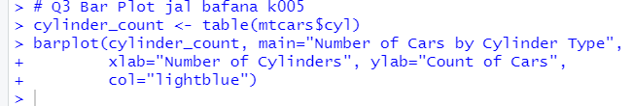

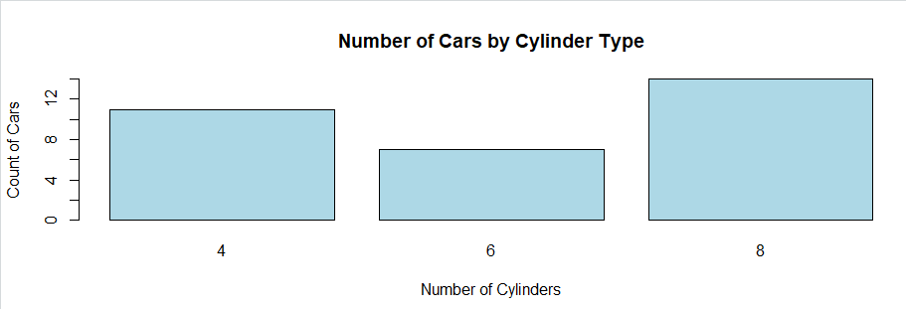

# Q4 Histogram jal bafana k005 hist(iris$Sepal.Length, main="Distribution of Sepal Lengths", xlab="Sepal Length", col="green", border="black", breaks=10)

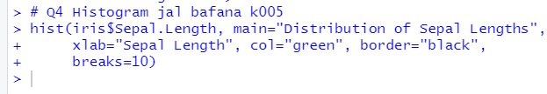

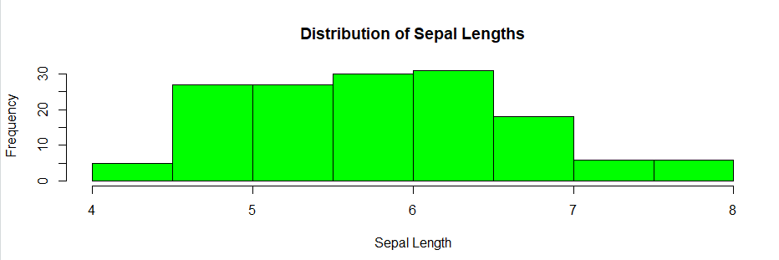

# Q5 Box Plot jal bafana k005

boxplot(mtcars$wt ~ mtcars$cyl, main="Box Plot of Car Weights by Cylinder Type",

xlab="Number of Cylinders", ylab="Weight", col=c("lightgreen", "lightblue", "lightpink"))



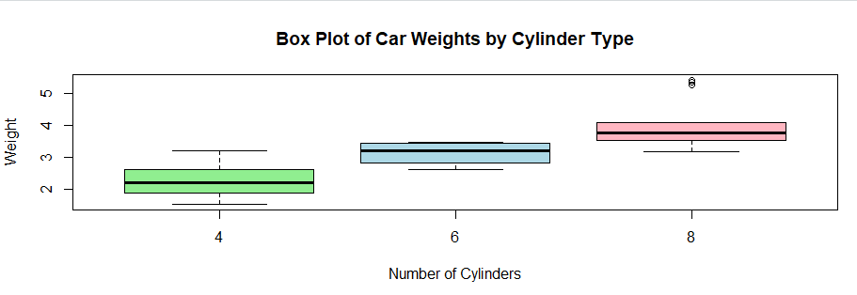

# Q6 Pie Chart jal bafana k005

species_count <- table(iris$Species)

pie(species_count, main="Proportion of Different Species",

col=c("red", "green", "blue"), labels=names(species_count))

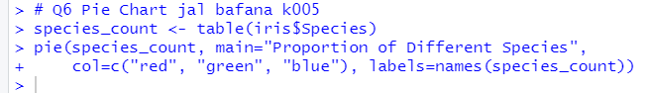

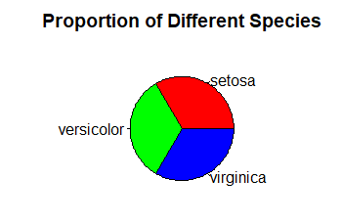

# Q7 Heatmap jal bafana k005

matrix_data <- matrix(rnorm(25), nrow=5)

heatmap(matrix_data, main="Heatmap of Random Data", col=heat.colors(256),

scale="column", labRow=letters[1:5], labCol=LETTERS[1:5])

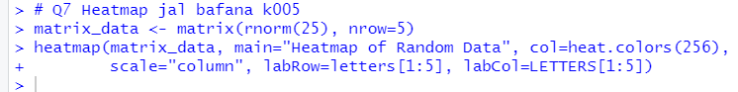

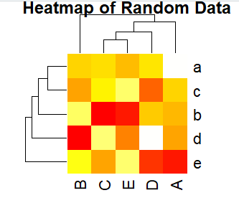

# Q8 Scatter Plot Matrix jal bafana k005

pairs(iris[, 1:4], main="Scatter Plot Matrix of Iris Dataset")



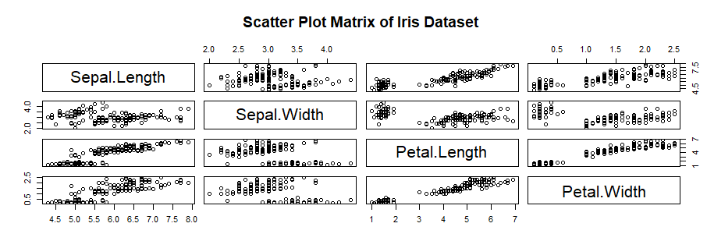

# Q9 Customizing Plots jal bafana k005

plot(mtcars$disp, mtcars$hp, main="Engine Displacement vs Horsepower",

xlab="Engine Displacement", ylab="Horsepower", pch=19,

col="purple", cex=1.5)

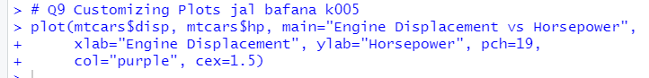

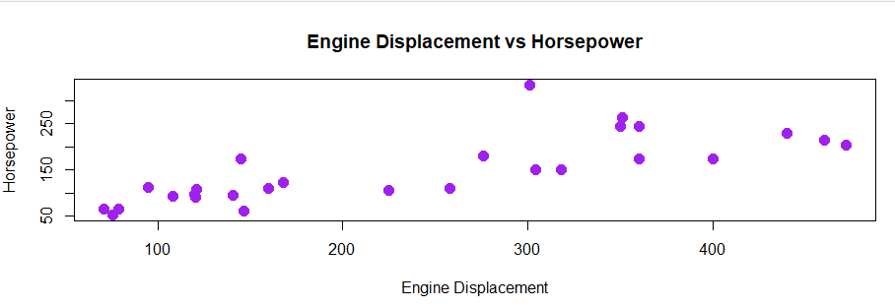

# Q10 Multiple Plots jal bafana k005

par(mfrow=c(2,2))

hist(iris$Sepal.Length, main="Histogram of Sepal Length", xlab="Sepal Length", col="orange", border="black")

boxplot(mtcars$wt ~ mtcars$cyl, main="Box Plot of Weights by Cylinders", xlab="Cylinders", ylab="Weight")

plot(mtcars$disp, mtcars$hp, main="Disp vs Horsepower", xlab="Displacement", ylab="Horsepower", pch=19, col="red")

barplot(cylinder_count, main="Car Cylinders", xlab="Cylinders", ylab="Count", col="skyblue")

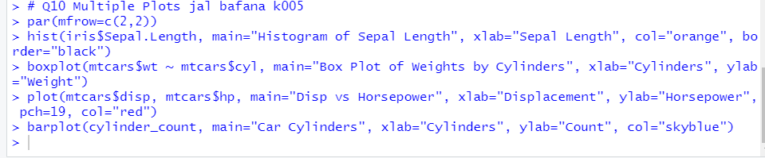

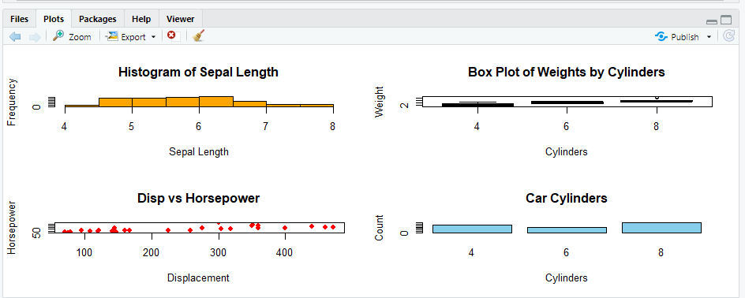

**Conclusion:** This practical helps students gain hands-on experience in visualizing data using R. Visualization techniques learned here will assist in analyzing engineering data and presenting results effectively.