|  |  |
| --- | --- |
| **Name: Jal Bafana** | **Roll no: K005** |
| **Class: Btech. Cyber Security Sem-4** | **Batch: K1** |
| **Date of experiment: 25.01.2025** | **Date of submission: 22.01.2025** |

**Lab 4**

# K005-Jal Bafana

x=c(0,1,2)

p=c(1/4,1/4,1/2)

data.frame(x,p)

#find P(X=0)

ddiscrete(0,p,x)

#find P(X<1)

pdiscrete(1,p,x)

#find P(X<=a)=0.5

qdiscrete(0.5,p,x)

rdiscrete(30,p,x)

#find mean

e=sum(x*p)

v=sum(x^2*p)-e^2

f=function(x)(x^2+2*x-0.9)

k=uniroot(f,lower=0,upper=1)$root

p=c(k^2,0.1,2*k)

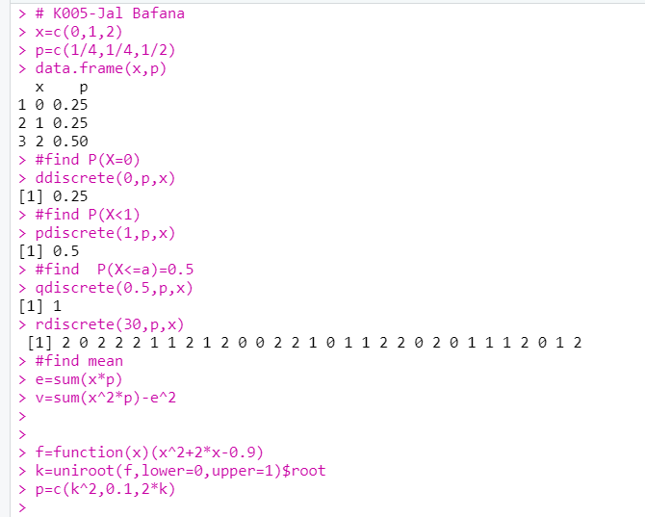

#Q1 K005-Jal Bafana

# Define the random variable X and the probability function P(X)

x1 = c(1, 2, 3, 4, 5, 6, 7)

# Define the probabilities as a function of k

k = 0.1 # An initial guess for k, will refine it later

p1 = c(k, 2*k, 3*k, k^2, k^2+k, 2*k^2, 4*k^2)

# Define the function to sum probabilities

f = function(k) sum(c(k, 2*k, 3*k, k^2, k^2+k, 2*k^2, 4*k^2)) - 1

# Find the correct value of k using uniroot

k_value = uniroot(f, lower=0, upper=1)$root

# Recalculate the probabilities with the correct k value

p1 = c(k_value, 2*k_value, 3*k_value, k_value, 2, k_value+2, 2*k_value^2)

# Calculate P(X < 5)

P_X_less_than_5 = sum(p1[x1 < 5])

# Calculate P(1 <= X <= 5)

P_X_between_1_and_5 = sum(p1[x1 >= 1 & x1 <= 5])

# Output the results

cat("Value of k:", k_value, "\n")

cat("P(X < 5):", P_X_less_than_5, "\n")

cat("P(1 <= X <= 5):", P_X_between_1_and_5, "\n")

# Calculate the mean and variance

mean_X = sum(x1 * p1)

variance_X = sum((x1^2) * p1) - mean_X^2

cat("Mean of X:", mean_X, "\n")

cat("Variance of X:", variance_X, "\n")

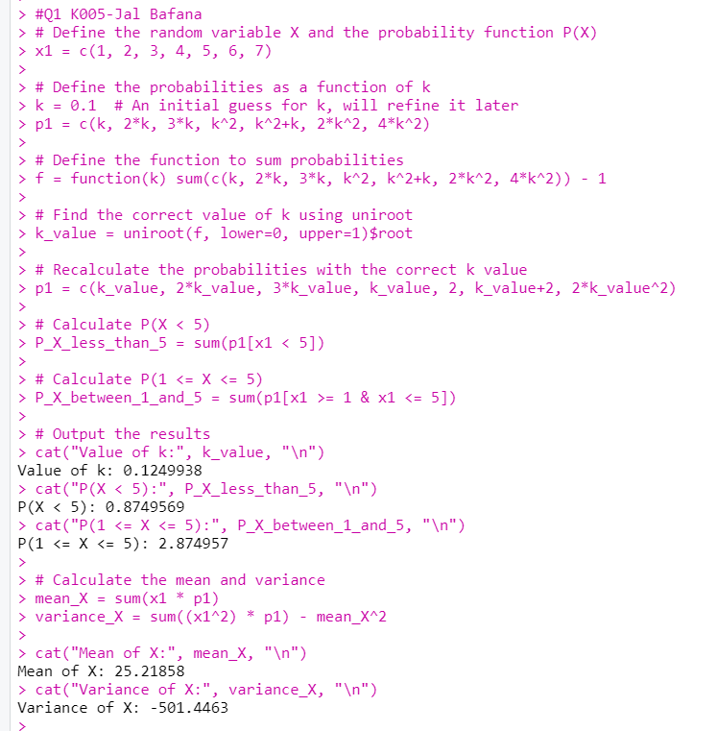

#Q2 K005-Jal Bafana

# Define the random variable X and the probability function P(X)

x2 = c(-2, -1, 0, 1, 2, 3)

# Define the probabilities as a function of k

k = 0.1 # An initial guess for k, will refine it later

p2 = c(0.1, k, 0.2, 2*k, 0.3, 3*k)

# Define the function to sum probabilities

f = function(k) sum(c(0.1, k, 0.2, 2*k, 0.3, 3*k)) - 1

# Find the correct value of k using uniroot

k_value2 = uniroot(f, lower=0, upper=1)$root

# Recalculate the probabilities with the correct k value

p2 = c(0.1, k_value2, 0.2, 2*k_value2, 0.3, 3*k_value2)

# Calculate P(X < 2)

P_X_less_than_2 = sum(p2[x2 < 2])

# Output the results

cat("Value of k:", k_value2, "\n")

cat("P(X < 2):", P_X_less_than_2, "\n")

# Calculate the mean and variance

mean_X2 = sum(x2 * p2)

variance_X2 = sum((x2^2) * p2) - mean_X2^2

cat("Mean of X:", mean_X2, "\n")

cat("Variance of X:", variance_X2, "\n")

# Plot the Probability Distribution (PDF)

plot(x2, p2, type="h", lwd=2, col="blue", main="Probability Distribution of X", xlab="X", ylab="P(X)")

# Plot the Cumulative Distribution Function (CDF)

CDF2 = cumsum(p2)

plot(x2, CDF2, type="s", lwd=2, col="red", main="Cumulative Distribution Function", xlab="X", ylab="CDF")

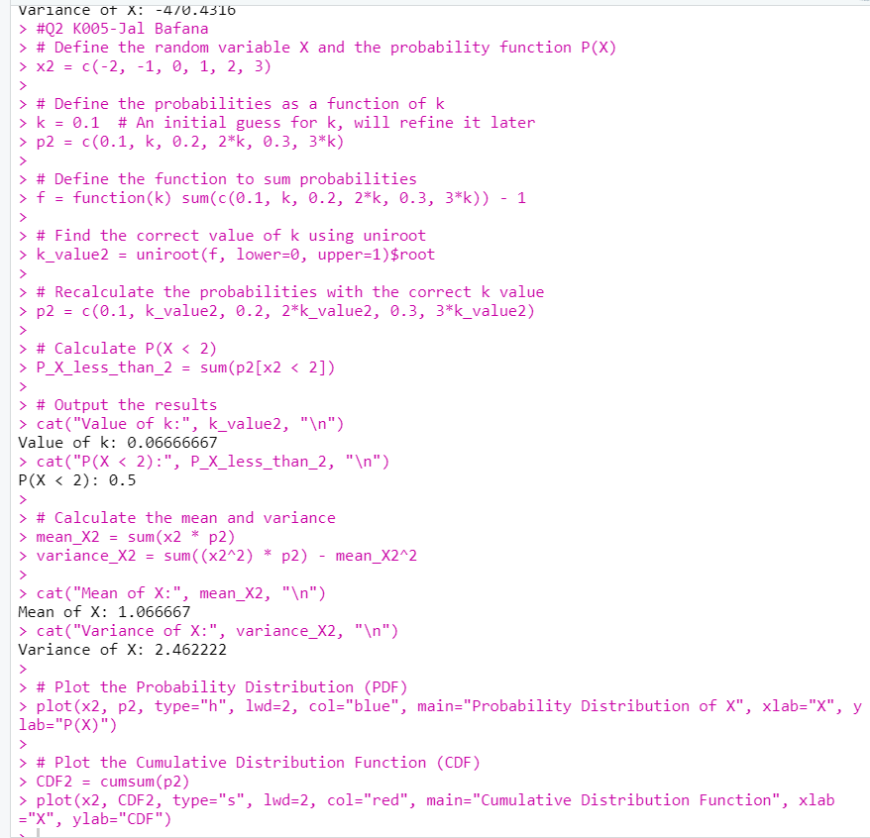

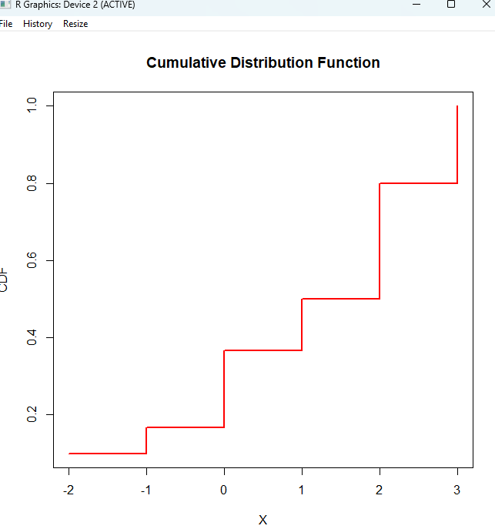

#Q3 K005-Jal Bafana

# Define the random variable X and the corresponding probabilities

x3 = c(-2, -1, 0, 1, 2)

p3 = c(1/5, 1/5, 2/5, 2/15, 1/15)

# Compute V = X^2 + 1 for each X

V3 = x3^2 + 1

# Calculate the probability distribution of V

p_V = p3

# Plot the Probability Distribution (PDF) for V

plot(V3, p_V, type="h", lwd=2, col="blue", main="Probability Distribution of V = X^2 + 1", xlab="V", ylab="P(V)")

# Plot the Cumulative Distribution Function (CDF) for V

CDF3 = cumsum(p_V)

plot(V3, CDF3, type="s", lwd=2, col="red", main="Cumulative Distribution Function of V", xlab="V", ylab="CDF")

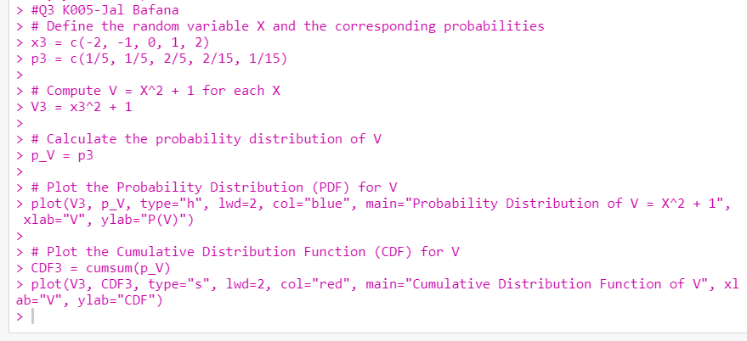

#Q4 K005-Jal Bafana

# Define the random variable X and the probabilities

x4 = c(-3, -2, -1, 0, 1, 2)

p4 = c(0.05, 0.1, 0.2, 0.3, 0.2, 0.15)

# Calculate the mean (expected value)

mean_X4 = sum(x4 * p4)

# Calculate the variance

variance_X4 = sum((x4^2) * p4) - mean_X4^2

# Output the results

cat("Mean of X:", mean_X4, "\n")

cat("Variance of X:", variance_X4, "\n")

# Plot the Probability Distribution (PDF)

plot(x4, p4, type="h", lwd=2, col="blue", main="Probability Distribution of X", xlab="X", ylab="P(X)")

# Plot the Cumulative Distribution Function (CDF)

CDF4 = cumsum(p4)

plot(x4, CDF4, type="s", lwd=2, col="red", main="Cumulative Distribution Function", xlab="X", ylab="CDF")

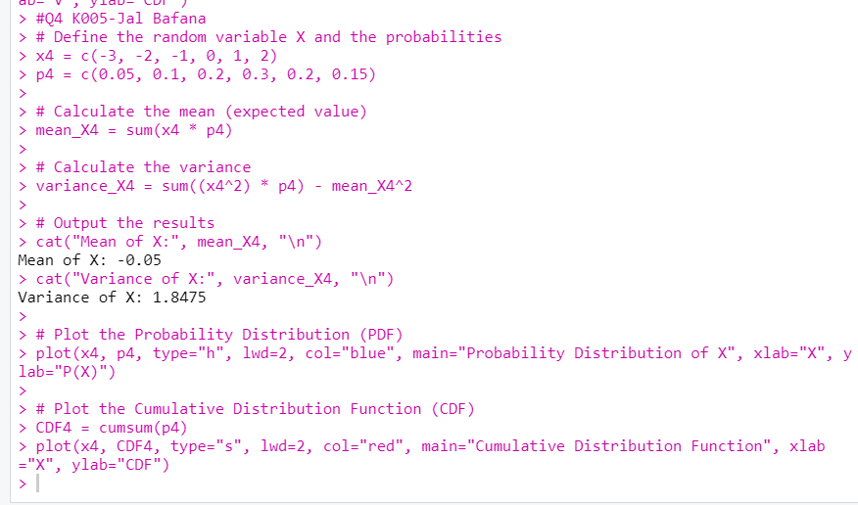

#Q5 K005-Jal Bafana

# Define the function for the sum of probabilities

f <- function(c) {

P0 <- 3 * c^2

P1 <- 4 * c - 10 * c^2

P2 <- 5 * c - 1

sum_prob <- P0 + P1 + P2

return(sum_prob - 1) # The result should be 0 when the probabilities sum to 1

}

# Solve for c using uniroot to find the root of the equation f(c) = 0

c_value <- uniroot(f, lower = 0, upper = 1)$root

cat("The value of c is:", c_value, "\n")

# Define the PMF using the calculated value of c

P0 <- 3 * c_value^2

P1 <- 4 * c_value - 10 * c_value^2

P2 <- 5 * c_value - 1

cat("P(X = 0) =", P0, "\n")

cat("P(X = 1) =", P1, "\n")

cat("P(X = 2) =", P2, "\n")

# Calculate the requested probabilities

# 1. P(X < 1) --> This is just P(X = 0)

P_X_less_than_1 <- P0

# 2. P(1 < X <= 2) --> This is P(X = 2)

P_1_less_than_X_less_equal_2 <- P2

# 3. P(0 < X <= 2) --> This is P(X = 1) + P(X = 2)

P_0_less_than_X_less_equal_2 <- P1 + P2

cat("P(X < 1) =", P_X_less_than_1, "\n")

cat("P(1 < X <= 2) =", P_1_less_than_X_less_equal_2, "\n")

cat("P(0 < X <= 2) =", P_0_less_than_X_less_equal_2, "\n")

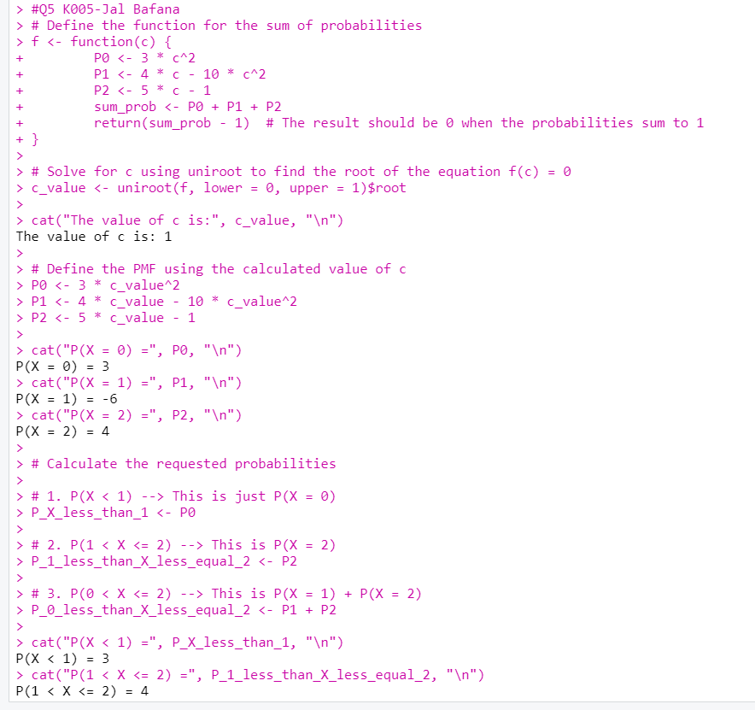

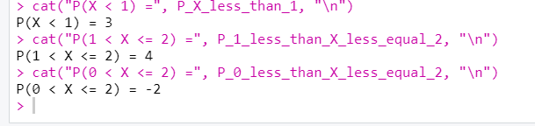

Values and Function:

