|  |  |
| --- | --- |
| **Name: Jal Bafana** | **Roll no: K005** |
| **Class: Btech. Cyber Security (sem-4)** | **Batch: K1** |
| **Date of Experiment: 08.02.2025** | **Date of Submission: 08.02.2025** |

data=read.csv("C:\\Users\\mpstme.student\\Downloads\\CardioGoodFitness.csv")

mean=mean(data$Age)

print(mean)

mode=mfv(data$Age)

print(mode)

median = median(data$Age)

print(median)

# Calculate the maximum

max = max(data$Age)

# Calculate the minimum

min = min(data$Age)

#range

range = max - min

cat("Range is:\n")

print(range)

var = var(data$Age)

print(var)

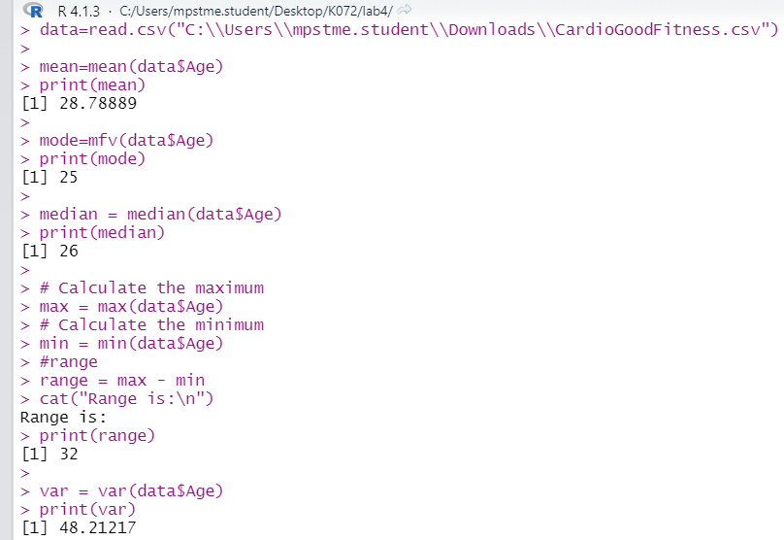

#momnets jal- bafana

#q1

x=c(0:3)

p=c(0.1,0.2,0.3,0.4)

rm0=1

rm1=sum(x*p)

rm2=sum(x*x*p)

rm3=sum(x*x*x*p)

rm4=sum(x*x*x*x*p)

rm=c(rm0,rm1,rm2,rm3,rm4)

raw2central(rm)

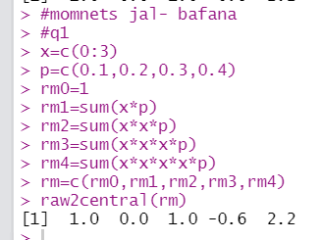

# Jal Bafana - K005

# Q1

X1 <- c(0, 1, 2)

P1 <- rep(1/3, 3)

mgf1 <- function(t) {

sum(P1 * exp(t * X1))

}

raw_moments1 <- sapply(1:4, function(n) sum(P1 * X1^n))

cat("Raw Moments: ", raw_moments1, "\n")

mean_X1 <- sum(P1 * X1)

central_moments1 <- sapply(1:4, function(n) sum(P1 * (X1 - mean_X1)^n))

cat("Central Moments: ", central_moments1, "\n")

cat("MGF at t=1: ", mgf1(1), "\n")

# Q2 Jal Bafana - K005

M1 <- 2

M2 <- 10

M3 <- -30

mean_X2 <- M1 + 3

variance_X2 <- M2 + (M1 + 3)^2 - 9

skewness_X2 <- M3 / (variance_X2^(3/2))

cat("Mean: ", mean_X2, "\n")

cat("Variance: ", variance_X2, "\n")

cat("Skewness: ", skewness_X2, "\n")

# Q3 Jal Bafana - K005

X3 <- 0:3

P3 <- (1/8) * X3

mgf3 <- function(t) {

sum(P3 * exp(t * X3))

}

mean_X3 <- sum(P3 * X3)

variance_X3 <- sum(P3 * (X3 - mean_X3)^2)

cat("MGF at t=1: ", mgf3(1), "\n")

cat("Mean: ", mean_X3, "\n")

cat("Variance: ", variance_X3, "\n")

# Q4 Jal Bafana - K005

X4 <- c(-2, 3, 1)

P4 <- c(1/3, 1/2, 1/6)

mean_X4 <- sum(P4 * X4)

moments_about_mean4 <- sapply(1:4, function(n) sum(P4 * (X4 - mean_X4)^n))

cat("First Four Moments about Mean: ", moments_about_mean4, "\n")

