|  |  |
| --- | --- |
| **Name: Jal Bafana** | **Roll No: K005** |
| **Class: Btech. Cyber Security (Sem-4)** | **Batch: K1** |
| **Date of Experiment: 08.03.2025** | **Date of Submission: 08.03.2025** |

**Lab 8 – Regression**

# Q1 Jal - K005

mean_X<- 65

mean_Y<- 67

sd_X<- 2.5

sd_Y<- 3.5

correlation <- 0.75

X <- 70

Y_pred<- mean_Y + (correlation * sd_Y / sd_X) * (X - mean_X)

Y_pred

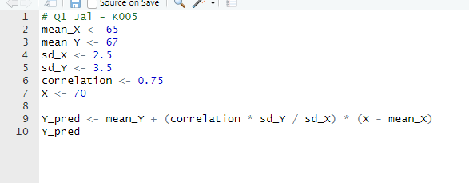

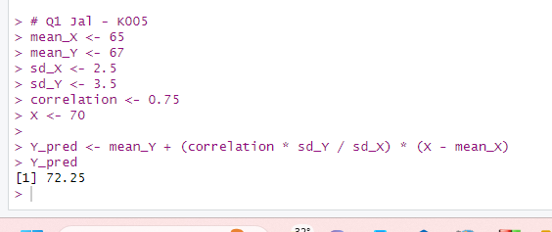

# Q2 Jal - K005

X <- c(25, 27.5, 32.5, 35, 45) # Curb weight in hundreds of pounds

Y <- c(105, 125, 140, 140, 150) # Braking distance in feet

correlation <- cor(X, Y)

cat("The Pearson correlation coefficient is:", correlation, "\n")

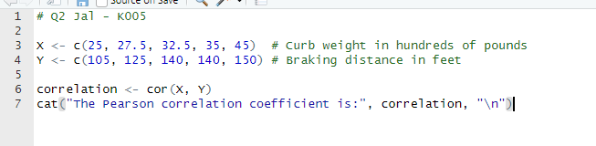

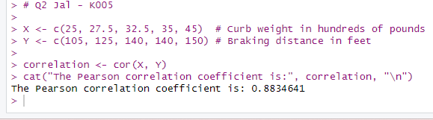

# Q4 Jal - K005

library(ISLR)

data(Auto)

model <- lm(mpg ~ . -name, data = Auto)

summary(model)

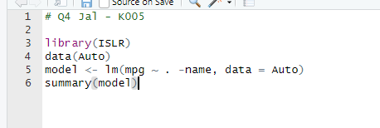

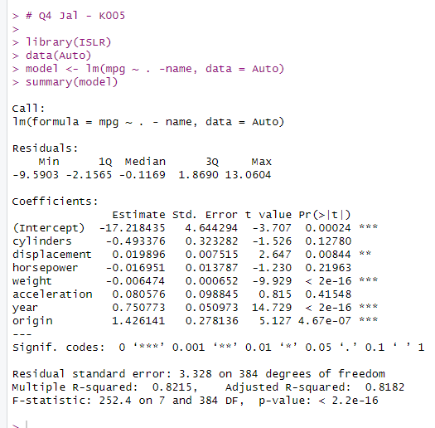

# Q5 Jal - K005

library(ISLR)

data(Carseats)

model = lm(Sales ~ Price + Urban + US, data = Carseats)

summary(model)

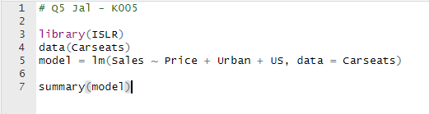

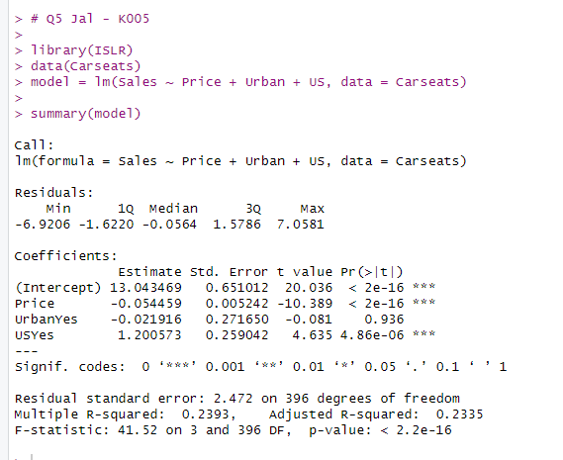

# Q6 Jal - K005

# x + 6y = 6

# 3x + 2y = 10

x_mean = 6 / (1 + 6)

y_mean = 10 / (3 + 2)

bxy = -1 / 6

byx = -3 / 2

r = sqrt(bxy * byx)

cat("Mean of x:", x_mean, "\n")

cat("Mean of y:", y_mean, "\n")

cat("Correlation coefficient (r):", r, "\n")

