|  |  |
| --- | --- |
| **Name: Jal Bafana** | **Roll no: K005** |
| **Class: Btech. Cyber Security (sem-4)** | **Batch: K1** |
| **Date of Experiment: 15.03.2025** | **Date of Submission: 15.03.2025** |

**Lab – 9**

Question 1 from classwork

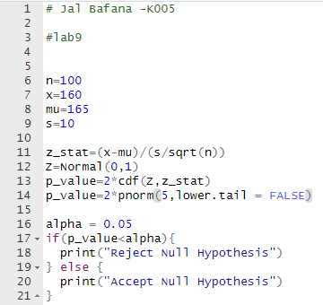

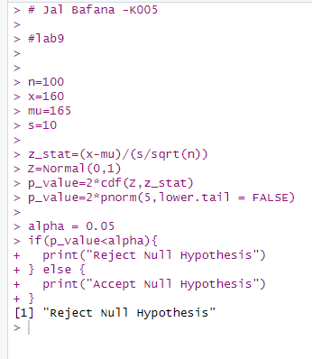

Question 2 from classwork

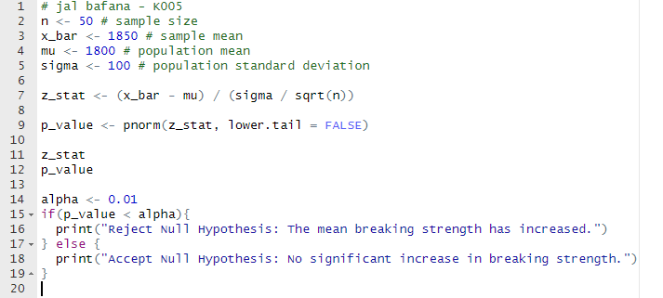

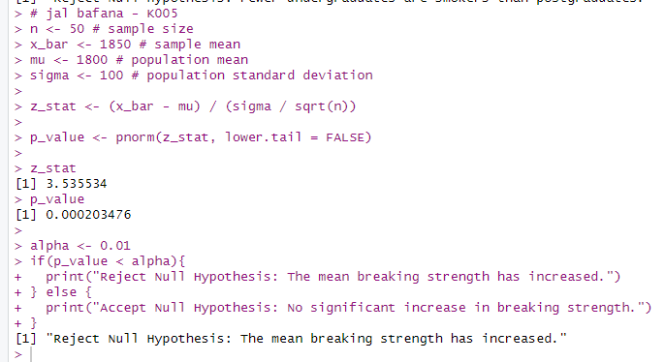

Question 3 from classwork

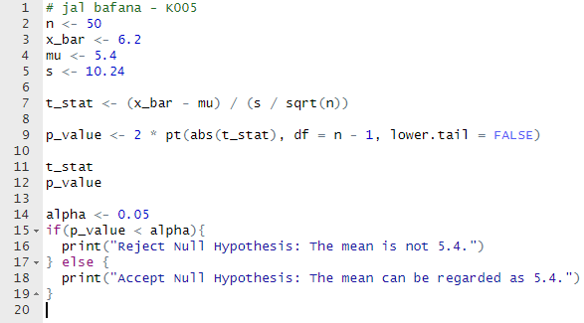

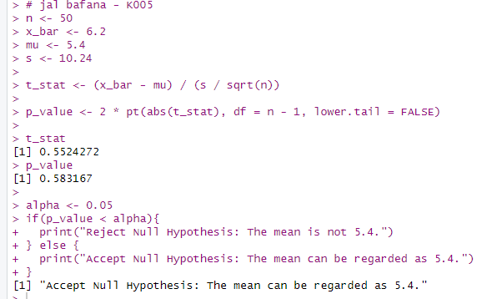

Question 3 from practical document

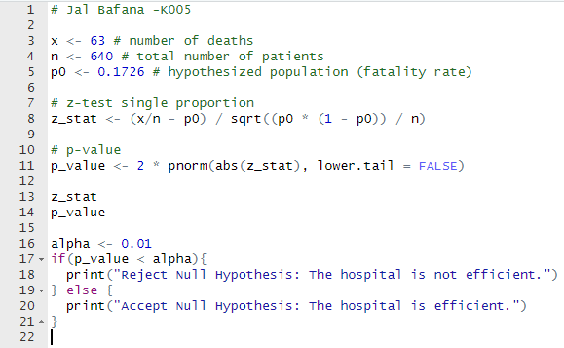

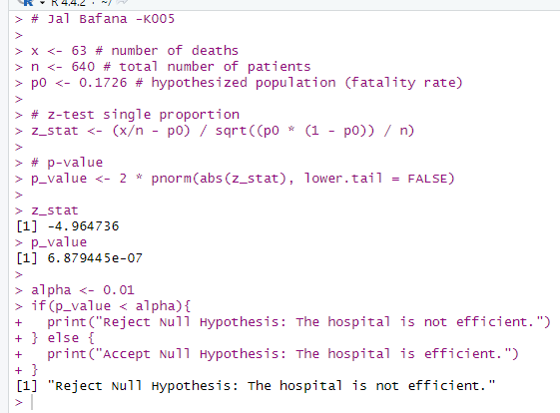

Question 4 from practical document

