|  |  |
| --- | --- |
| **Name: Jal Bafana** | **Roll no: K005** |
| **Btech. Cyber Security (Sem-4)** | **Batch: K1** |
| **Date of Experiment: 04/01/2025** | **Date of Submission: 04/01/2025** |

#by Jal, K005

2+3

x=2

y=5

plot(x,y)

name = "Jal"

a = TRUE

coml = 1 + 2i

#Q1 write a vector of names of 5 of your classmates

x1 = c("jal","arjun","rhea", "disha","aryan")

marks = c(5,4,10,4,10)

hello = c("hello",2)

vect2 = c(TRUE , 25)

vet3 = c(30 , 12.659302)

b = seq(1,12,by=0.5)

b

lst = list("jal","arjun","rhea", "disha","aryan",5,4,10,4,10)

mat = matrix(c(1:16),4)

mat

mat2 = matrix(c(1:20),byrow = TRUE,4,5)

mat2

mat3 <- matrix(1:20, nrow =4)

dimnames(mat3) <- list(month.abb[1:4],month.abb[5,9])

print(mat3)

#array syntax

a = array(c(1:9),dim = c(2,2,4,2))

print(a)

#if condition

v1= 12

v2= 15

if(v1+v2 > 20){

print(v1+v2)

}

w=data.frame(x1,marks)

w

data.frame(airquality)

**Console:**

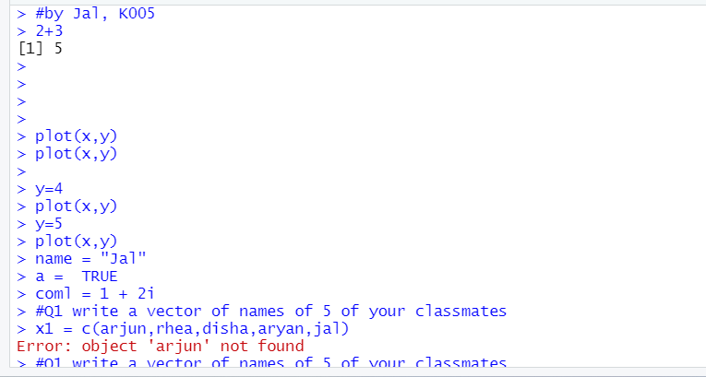

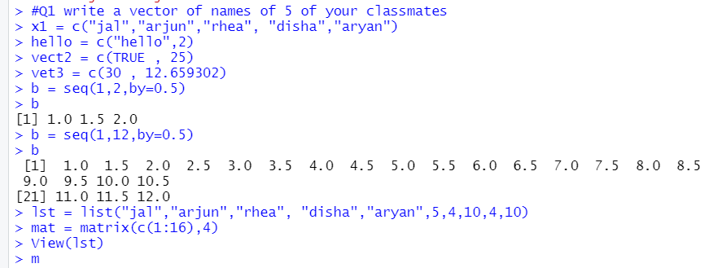

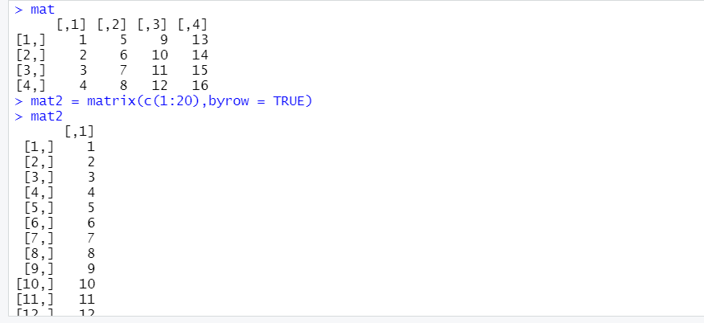

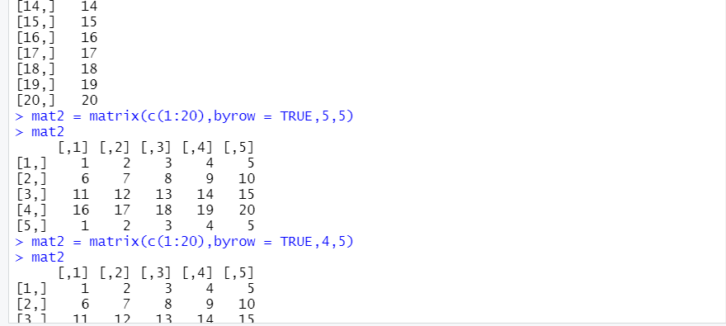

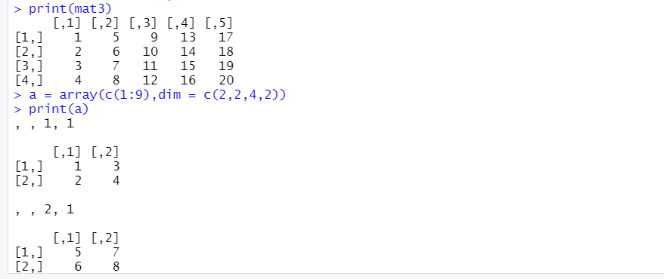

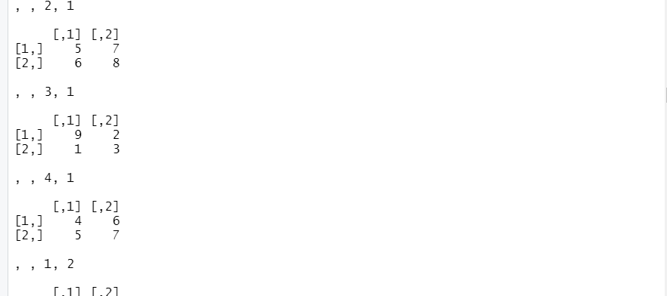

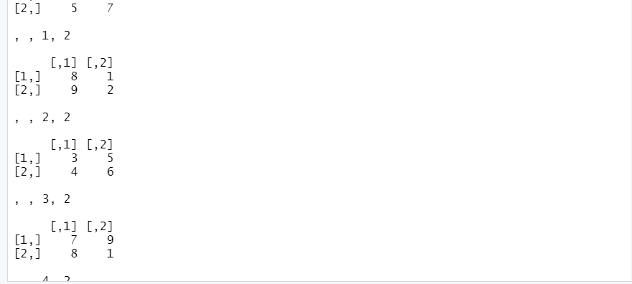

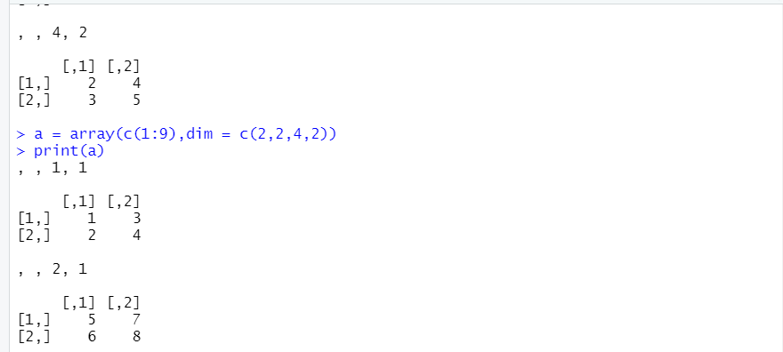

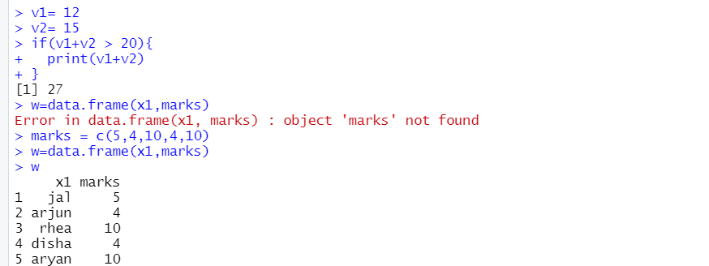

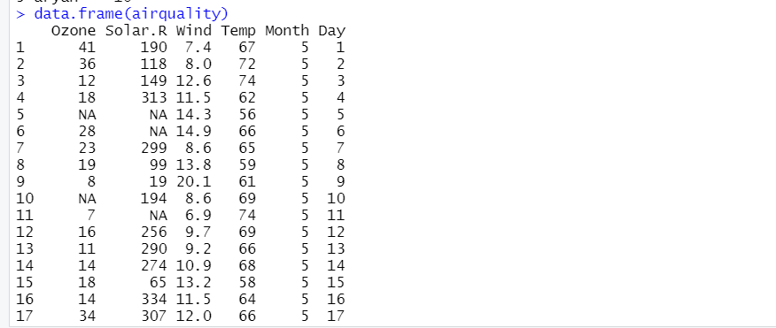

**Environment:**

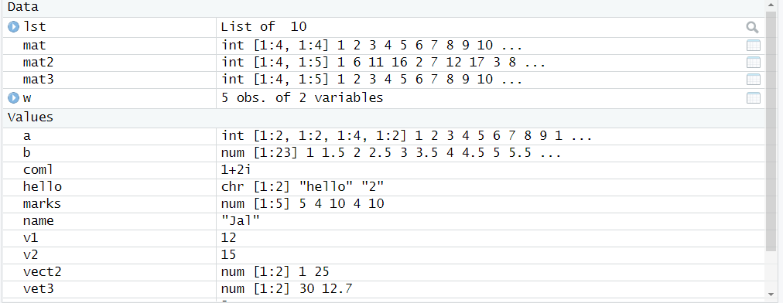

**Questions:**

1. Create a vector with some of your friend’s names

i. Get the length of above vector

ii. Get the first two friends from above vector

iii. Get the 2nd and 3rd friends

iv. Sort your friends by names using 2 methods

2. Compute the difference between 2014 and the year you started at this

university and divide this by the difference between 2014 and the year you

were born. Multiply this with 100 to get the percentage of your life you have

spent at this university.

3. Compute the sum of 4, 5, 8 and 11 by first combining them into a vector and

then using the function sum.

4. Create three vectors x,y,z with integers and each vector has 3

elements. Combine the three vectors to become a 3×3 matrix A where each

column represents a vector. Change the row names to a,b,c.

5. What is a vector? How to create it? Create a vector A of elements 5, 2, -2,

6,7,10,12,14,15 and from it create a vector Y containing elements of A>6

6. Create a vector containing following mixed elements {1, ‘a’, 2, ‘b’} and find

out its class.

7. Write a R program to create three vectors numeric data, character data and

logical data. Display the content of the vectors and their type.

8. Write a R program to create a 4 x 5 matrix, 3 x 2 matrix with labels and fill

the matrix by rows and 2 × 2 matrix with labels and fill the matrix by

columns.

9. Write a R program to compute sum, mean and product of a given vector

elements.

10.List all the observations of “airmiles” dataset.

11.Write a R program to compute addition, subtraction and multiplication of two

matrices of dimension 4x4.

12.Write a R program to create a list containing a vector, a matrix and a list; and

13.Give names to the elements in the list. Access the second element of the list.

**Complete Code:**

#Q1 write a vector of names of 5 of your classmates

# Jal , K005

name = c("jal","arjun","rhea", "disha","aryan")

len = length(name)

len

name[1:2]

name[2:3]

sort.default(name)

sort(name, decreasing = TRUE)

#Q2

per = ((2025 - 2023)/(2025 - 2005))*100

per

#Q3

numbers = c(4, 5, 8, 11)

total_sum = sum(numbers)

total_sum

#Q4

x = c(1, 2, 3)

y = c(4, 5, 6)

z = c(7, 8, 9)

A = cbind(x, y, z)

rownames(A) = c("a", "b", "c")

print(A)

#Q5

B = c(5, 2, -2, 6, 7, 10, 12, 14, 15)

Y = B[B > 6]

B

Y

#Q6

X1 = c(1, 'a', 2, 'b')

class(x1)

#Q7

nvec = c(1, 2, 3, 4, 5)

cvec = c("apple", "banana", "cherry")

lvec = c(TRUE, FALSE, TRUE)

nvec

cvec

lvec

class(nvec)

class(cvec)

class(lvec)

#Q8

mat45 = matrix(1:20, nrow = 4, ncol = 5, byrow = TRUE)

print(mat45)

mat32 = matrix(1:6, nrow = 3, ncol = 2, byrow = TRUE)

rownames(mat32) = c("Row1", "Row2", "Row3")

colnames(mat32) = c("Col1", "Col2")

print(mat32)

mat22 = matrix(1:4, nrow = 2, ncol = 2, byrow = FALSE)

rownames(mat22) = c("Row1", "Row2")

colnames(mat22) = c("Col1", "Col2")

print(mat22)

#Q9

vector = c(4, 5, 8, 10, 12)

sval = sum(vector)

mval = mean(vector)

pval = prod(vector)

sval

mval

pval

#Q10

am = data.frame(airmiles)

#Q11

mata = matrix(1:16, nrow = 4, ncol = 4, byrow = TRUE)

matb = matrix(17:32, nrow = 4, ncol = 4, byrow = TRUE)

print(mata)

print(matb)

add = mata + matb

sub = mata - matb

mul = mata %*% matb

print(add)

print(sub)

print(mul)

#Q12

vect = c(1, 2, 3, 4, 5)

matr = matrix(6:11, nrow = 2, ncol = 3)

lst = list(a = 1, b = 2)

mlst = list(vect, matr, lst)

#Q13

names(mlst) = c("Vector", "Matrix", "Nested List")

print(mlst)

cat("\nSecond element of the list (Matrix):\n")

print(mlst[[2]])

**Output:**

