**Lab1.v**

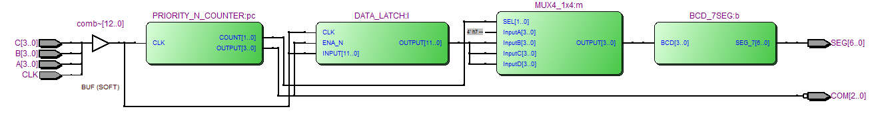

**PRIORITY_N_COUNTER.v**

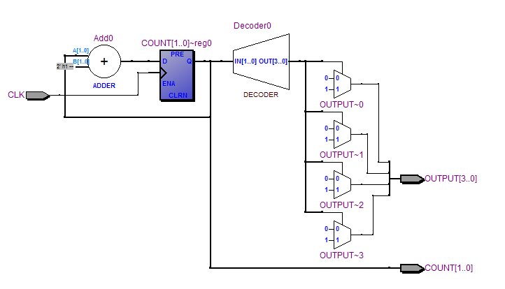

**DATA_LATCH.v**

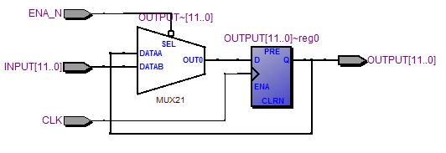

**MUX4_1x4.v**

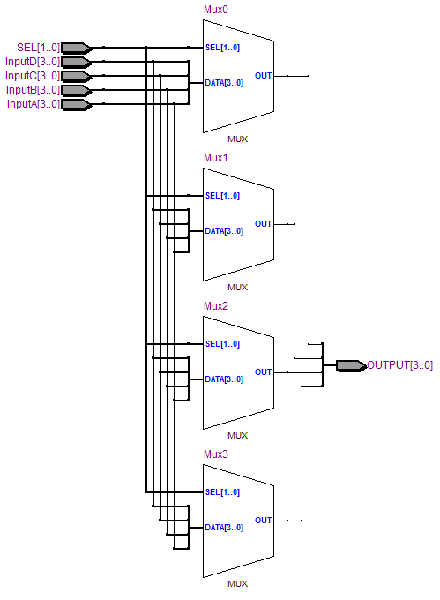

**BCD_7SEG.v**

