Team Formation Guidelines

# Purpose

This document is intended to guide the organisation in selecting the team for projects and support functions. The Skill matrix, which is maintained by the Design Head, must be consulted in order to arrive at the names of the suitable team members.

# Definition

A team consists of people who share a common goal, perform specific roles, and depend on each other to achieve the common goal; team success depends on the cooperation of all members. Teams are typically needed for tasks that involve more work, a variety of skills, or some other capability than one person could supply alone.

# Process Engineering Group

This group is responsible for the organization's process activities.

1. Where possible, this group is staffed by a core of technical professionals who are assigned full time to the group, possibly supported by others, on a part-time basis.
2. This group is staffed to represent all the relevant disciplines.

Examples of development related disciplines include:

* Requirements Analysis
* Design & Implementation
* Integration & Testing
* Validation
* Configuration Management
* Quality Assurance

The PEG will typically have a PEG Head and two or more members.

## PEG Head

The PEG Head must be an acknowledged technical leader, with these characteristics:

* Extensive experience in or knowledge of the Product development process.
* Experience advocating improved Product development processes, methods, and tools—that is, improved quality and productivity.
* Experience in management or project leadership.
* Knowledge of the Product development environment.
* Candidates for process group leadership may be found among senior technical staff members who have lobbied for improvements within their projects.

## PEG Members

Each PEG member should meet this fundamental set of qualifications:

* Be a regular employee of the organization, with experience within the projects that will be served by the PEG Members.
* Have application domain expertise.
* Have a basic understanding of the Product development process.
* Have knowledge of development methods, tools, and practices.

# Project Teams

1. Identify the skill set required for the project execution.
2. Refer the skill matrix for identification of personnel with the required skill.
3. Verify availability.
4. Select based on closest skill set, and plan for team members trainings in areas where there is no exact skill match.
5. Form the team. The project manager is the de-facto team leader.
6. The team leader is responsible for the management of team operations, which include, communication within the team, assigning tasks and responsibilities and resolving issues.

A typical project team must consist of capable and trained personnel for the following roles in the project:

|  |  |
| --- | --- |
| Sr. No. | ROLES |
|  | Project Manager |
|  | Design Teams |
|  | Verification & Review Team Members |
|  | Testing Team Members |
|  | Validation Team Members |
|  | Audit Team Members |
|  | Customer Representative |
|  | Senior Management |
|  | Estimation Team/ Estimator |
|  | Configuration Administrator |

# Process Quality Assurance

The personnel responsible for Quality assurance

* Be a regular employee of the organization, with experience within the development projects that will be served by the PEG Members.
* Have application domain expertise.
* Have a basic understanding of the development process.
* Have knowledge of development methods, tools, and practices.
* Should have a process focus.
* Additional audit certifications or ISO audit experience are recommended.

# Design Team

It will consist of members from Each functional area i.e. Hardware, Firmware and Mechanical. The personnel would be:

* Be a regular employee of the organization, with experience within the development projects corresponding their concerned functional area.
* Have a basic understanding of the development process.
* Have knowledge of development methods, tools, and practices related to Design and Implementation.

# Team dynamics

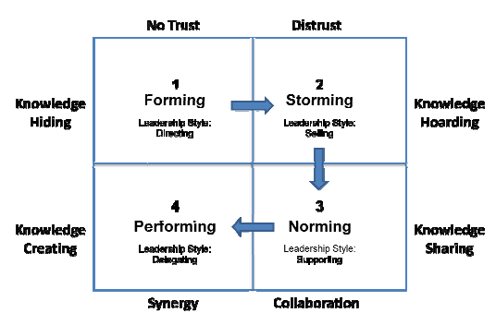

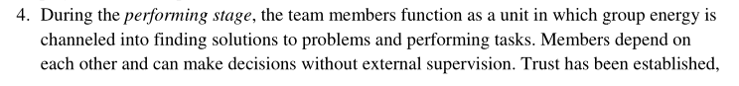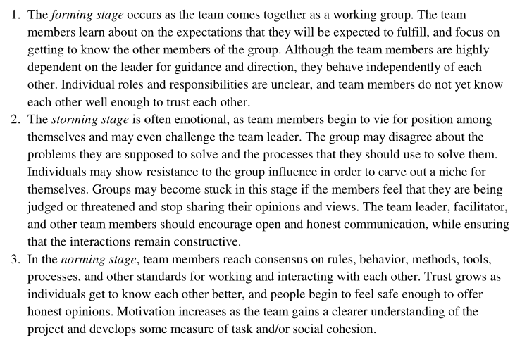

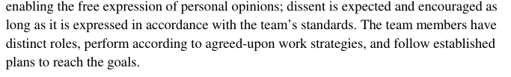

Roles and Responsibilities

# Roles and Responsibilities

| Sr. No. | Roles | Responsibilities |
| --- | --- | --- |
|  | Senior Management | Organisation Level   * Planning and setting business objectives and business needs. * Oversight over performance towards business objectives and needs. * Facilitation with regards to budget/ resources/ prioritization and guidance in actions towards business objectives and needs. * Ensures that the measurements are collected, analysed and used. * Ensure that the organisation processes and competencies are aligned with the business objectives and needs.   Project Level   * Project selection, initiation and assignment * Participate in Project Status Reviews/ Milestone Reviews * Review and Approval of Project Plan * Budget allocation for the project * Handling and Resolving escalated issues * Guiding Projects and taking corrective/preventive measures   PPQA Group   * Participate in PPQA function Reviews * Approval of Organisation Audit Plan * Handling and Resolving escalated issues   Training Group   * Budget Allocation for Trainings * Participate in Trainings function Reviews * Review and approval of training strategic and tactical plans * Define Business objectives and approve Organization Goals * Review and Approval of Organisation Training Plan   Organisation Processes   * Sponsors the organization’s activities for process development and improvement. * Demonstrates to the organization’s staff and managers its commitment to these process activities. * Establishes long-term plans and commitments for funding, staffing, and other resources. * Establishes strategies for managing and implementing the activities for process development and improvement. * Ensures that the Organization’s Set of Standard Processes supports its business goals and strategies. * Advises on setting priorities for process development and improvement. * Participates in establishing plans for process development and improvement. * Senior management coordinates process requirements and issues with higher level staff and managers. * Senior management coordinates with the organization’s managers to secure the managers’ and staff’s support and participation.   Refer guidelines in PRCD_ORGFCS for details. |
|  | Project Manager | * Project Planning and Updation * Monitoring and Controlling the Project * Risk Management * Senior Management Reviews * Milestone Reviews * Corrective Actions * Identify Metrics * Review and Approval of Functional Specifications * Change Request Management * Project Status Reviews * Release Planning |
|  | Functional Heads | * Project Status Reviews * Corrective Actions * Maintenance and Revisions of Baselines * Work Product Packaging * Design and its finalization * Requirements and Design Traceability * Requirement Elicitation and Analysis * Update the Requirement Traceability Table with the analyzed Requirements * Risk Management * Defect analysis and Resolution |
|  | Design Teams | * Project Status Reviews * Maintain the Project’s Artifacts’ Configuration * Functional Decomposition of Modules * Design & implement the modules * Study of Design * Module Testing * Perform Integration |
|  | Testing Team | * Perform Module testing * Perform Integration testing * Verify and confirm defect closure |
|  | Validation Team | * Project Status Reviews * Preparation and Approval of Test Plan and Test Cases * Perform Validation |
|  | Training Coordinator | * Preparation of Strategic and Tactical Training Plan * Identification of Training Needs and Suitable Trainers * Scheduling and Conducting Training * Maintenance of Training Records * Analysis of Training Feedbacks |
|  | Configuration Administrator | * Project Status Reviews * Preparation of Configuration Management Planning * Tools identification for Configuration Management * Creation and Maintenance of Configuration Library * Backup and Restoration |
|  | Process Engineering Group | * Review and Approve Measurement Plan * Define and Review Organization Goal * Business Objective to Process Objective Mapping * Establish and Maintain Organization Set of Standard Processes(OSSP) * Process Improvement Planning * Process Deployment * Pilot Run of Process Changes * Capture Project Learnings and update the Organisation'Database * Process Tailoring Approvals |
|  | Process Quality Assurance | Project Level   * Project Status Reviews * Provide facilitation and support QA activities of the project * Review and assist the PM in preparing the project plan (Audit Plan Section) * Review and collect the metrics and provide them to PEG * Support and advice on processes and systems. * Configuration Audit * Audit Planning and Schedule * Conduct the Project’s Audit   Organisation Level   * Prepare Organisation’s audit plan * Conduct audits |
|  | Design Head | * Participate in Project Status Reviews/ Milestone Reviews * Review and Approval of Project Plan * Budget allocation for the project * Handling and Resolving escalated issues * Guiding Projects and taking corrective/preventive measures * Custodian of the organisation’s processes and systems. * Maintaining the list of skills available and required by the practitioners. * Custodian of the Technical Library and Project Learnings |