Android Build System

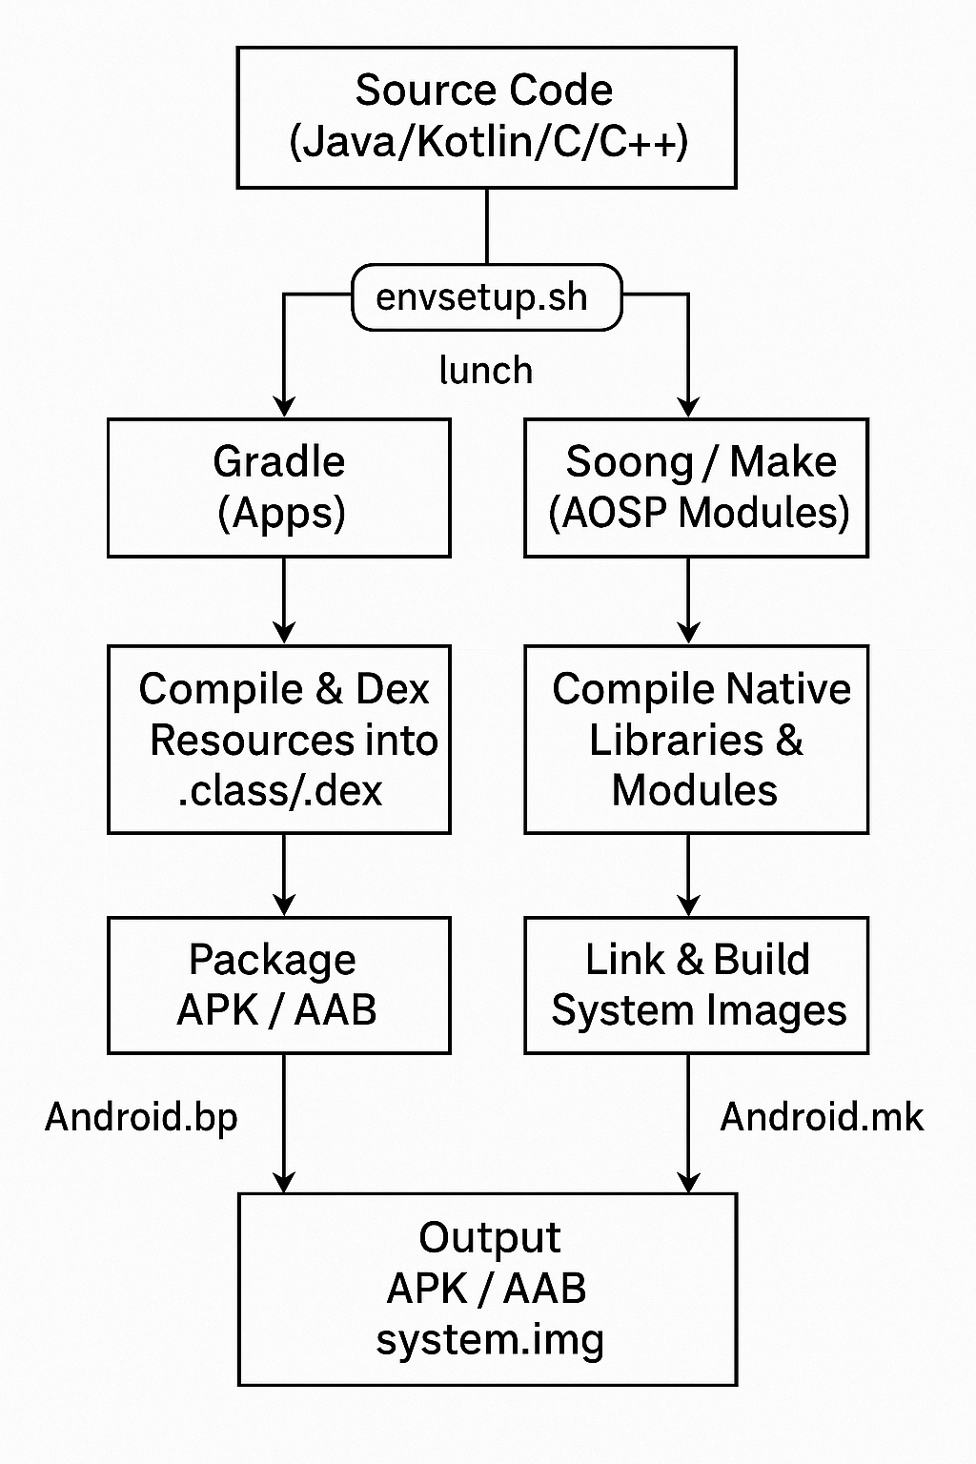

Overview of Android Build System:
- Framework to compile the Android Open Source Project (AOSP) into flashable OS images.
- Handles device diversity, vendor customizations, and maintainability of thousands of projects across hundreds of repositories.
- Compiles code in Java, C, and C++ into binaries.
- Packages APKs and manages resource files.
- Links libraries and produces bootable system images.
- Supports device-specific customizations and integration of vendor blobs.
- Handles kernel compilation.
- For a Build & Release Engineer, mastering this system is crucial.

1. Repo Tool
The Repo tool is a Python-based wrapper on top of Git, created to manage multiple Git repositories in AOSP efficiently using a single manifest.

- Google maintains AOSP across multiple Git repositories.
- Cloning repositories one by one is impractical.so repo tool was created
- repo tool manages multiple Git repositories in a single workspace.
- Uses a manifest XML to define all required repositories and branches to use
- Lets you download and sync all repositories easily
- Supports branch management, local changes, and submitting patches across repos.

2. Build Descriptions (Makefiles & Blueprints)
- The build system needs metadata to understand how to compile modules.
- This is provided by files like;
    - Android.mk → Makefile format (used in legacy system)
    - Android.bp → Blueprint format, used in Soong system (faster, more maintainable, written in Go).
- Key supporting files:
    - BoardConfig.mk → Hardware-specific settings (partition sizes, kernel path)
    - AndroidProducts.mk → Lists products and their configurations
    - device.mk → Defines device-specific components and dependencies
- Purpose: These files tell the build system what to build, how to build it, and for which device.

1. Make
- Definition: A traditional build automation tool that reads Makefiles (Android.mk) to determine how to compile and link code.
- Usage in Android:
  - Legacy AOSP system uses Kati (or ckati) to process Android.mk files.
  - Converts these instructions into a build plan that can be executed.
- Output: System binaries, libraries, APKs, and images.

2. Soong
- Definition: Modern Android build system written in Go, replacing Make for most modules.
- Input: Reads Blueprint files (Android.bp) that describe modules and dependencies.
- Function: Generates Ninja build files that describe the actual build steps.
- Advantages: Faster, more maintainable, and better dependency management than Make.

3. Ninja
- Definition: A small, fast build system that executes the build graph generated by Soong or Kati.
- Function: Reads Ninja files and builds the required artifacts in parallel, maximizing CPU usage.
- Output: Compiled binaries, libraries, APKs, system images, etc.

Summary Flow:
Android.mk → Kati → Ninja → Artifacts
Android.bp → Soong → Ninja → Artifacts

3. Build Tools
- The Android build system uses multiple layers of tools to convert metadata files into compiled artifacts( o/p files produced by build process=APKs, libraries, system binaries)
Tools:
- Soong → Parses Android.bp files and generates Ninja build files.
- Kati (ckati) → Converts Android.mk files into Ninja build files (legacy system).
- Ninja → Executes the build graph, enabling fast parallel builds.
Build Pipeline:

Source files (Android.mk / Android.bp)
↓
Soong / Kati
↓
Ninja
↓
Compiled artifacts (APKs, libraries, system binaries)

4. Environment Setup
- Before starting a build, the environment must be configured using:
  - source build/envsetup.sh
- This sets up environment variables and functions like 'lunch'.
- Lunch selects a build configuration:
  - aosp_arm-eng → Generic ARM emulator build (engineering)
  - -userdebug → Device-specific debuggable build
  - -user → Final production build
- Build variants:
  - eng → Engineering build, root access, extra debugging
  - userdebug → Same as production but debuggable
  - user → Optimized for release, no debugging, secure

5. Build Commands
The build system provides multiple commands:
• make -j$(nproc) → Builds the entire system
This will compile all modules and produce the full system image.

• m → Builds a specific module globally
m Settings
This will build the Settings app module only.

• mm → Builds only the current directory module
cd frameworks/base/core
mm
This will build only the modules located in frameworks/base/core.

• mmm path/to/module → Builds a module at a given path
mmm packages/apps/Calculator
This will build the Calculator app module only.

• make bootimage → Builds boot.img only
This generates boot.img without building the entire system.

These allow incremental compilation, saving time for developers.

6. Build Artifacts
- After the build, outputs are stored in:
out/target/product//
- Key images:
•boot.img → Contains kernel + ramdisk
• system.img → Android framework and system apps
• vendor.img → Vendor-specific HALs, binaries, configs
• userdata.img → User partition
• recovery.img → Recovery environment
- These images are later flashed onto the device using fastboot or OTA.

7. Device Customization
- Vendors like Samsung, Motorola, etc., customize AOSP builds for their devices
- Key components:
- Device tree → device/<vendor>/<device>/
  - Contains BoardConfig.mk, init scripts, and proprietary binaries.
- Vendor blobs → vendor/<vendor>/
  - Proprietary files such as drivers, HALs, and firmware.
- Kernel sources → kernel/<vendor>/<device>/
  - Device-specific Linux kernel code and configurations.

Summary: Device-specific customizations ensure the AOSP build works correctly on different hardware while integrating vendor-specific features.

8. Typical Build Flow

1. repo init -u <manifest-url> -b <branch> → Initialize the local repo with the desired branch.
2. repo sync → Download all repositories defined in the manifest.
3. source build/envsetup.sh -> Set up environment variables and functions like lunch.
4.lunch aosp_<device>-userdebug → Select a build configuration for the target device.
5. make -j$(nproc) → Build the entire system using all CPU cores.
6. fastboot flashall → Flash the compiled images onto the device.

This process fetches sources, compiles, and flashes to device.

9. OTA & Release Engineering
Build & Release Engineers handle:
• CVE patch integration → Apply security fixes per Android security bulletins.
• Creating OTA packages → Generate incremental and full updates.
• Managing feature branches → Handle customer-specific customizations.
• Debugging build issues → Identify and fix build failures.
• Automating CI/CD → Set up automated Android build pipelines.
OTA generation:
- Use ota_from_target_files to create OTA packages.
- Deliver updates securely to devices.

10. Importance for Build & Release Engineer
- Knowledge of Git/repo workflows (branching, patching)
- Understanding Android.bp and Android.mk files
- Debugging compilation errors efficiently
- Managing multiple device builds
- CVE patch backporting and validation
- Automating builds using Jenkins or other CI tools
- Critical for ensuring timely delivery of secure and stable Android builds.

