Experiment 4

Basic DML Commands :

1. INSERT INTO

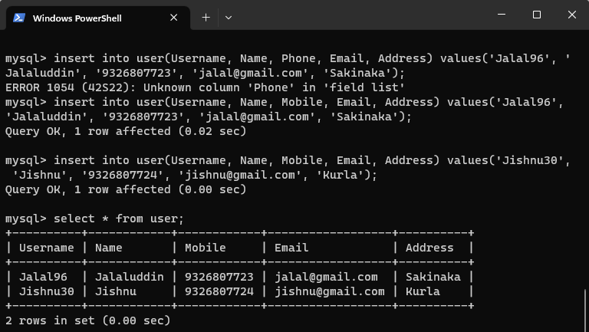

2. UPDATE-SET-WHERE

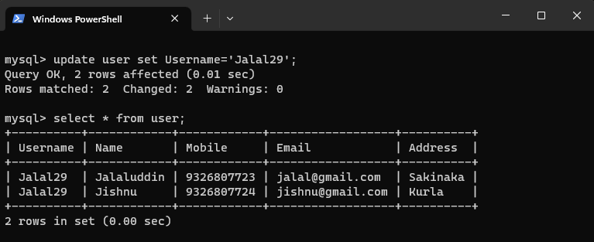

3. DELETE-FROM

