Experiment 7

1. IN

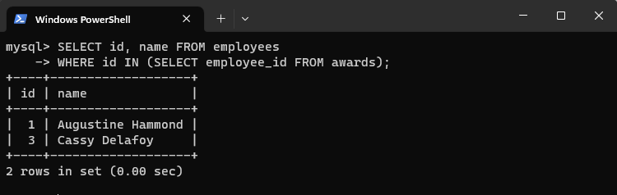

2. NOT IN

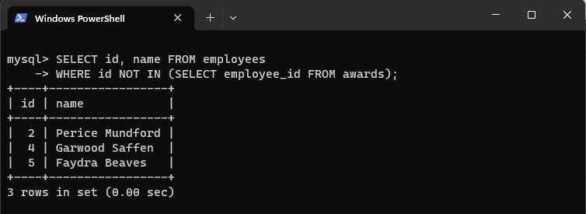

3. ALL

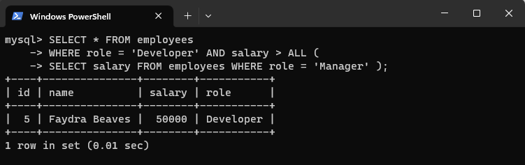

4. ANY

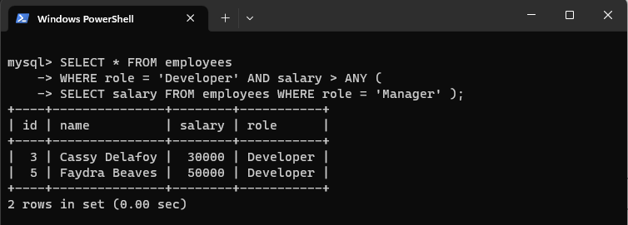

5. CO-RELATED NESTED QUERIES

