Checking if compiler is present or not :

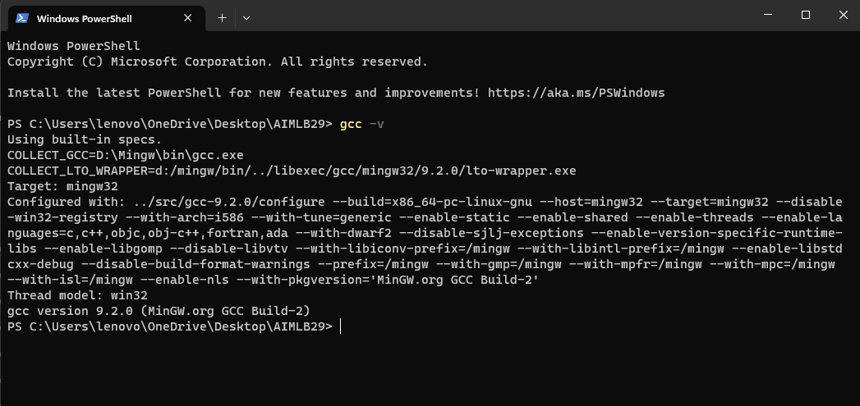

BEFORE Code Execution :

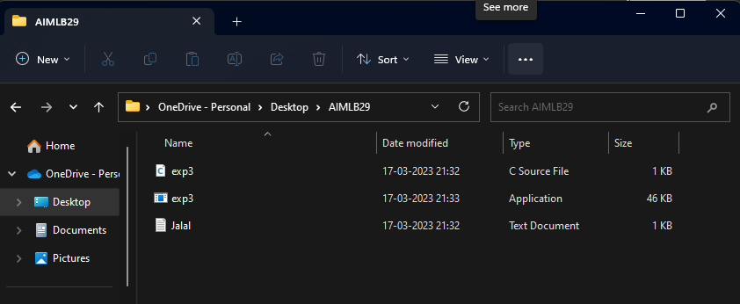

Jalal.txt File :

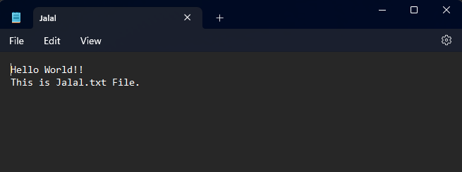

Compiling and running the Code :

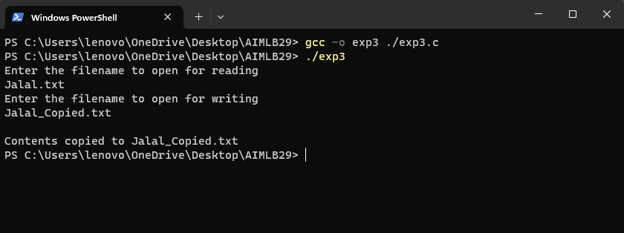

AFTER Code Execution :

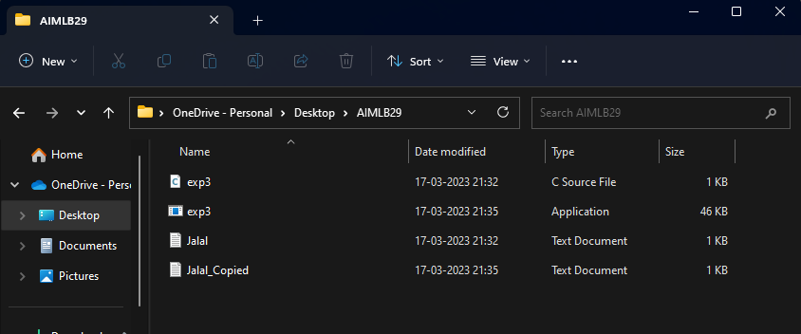

Copied from Jalal.txt to Jalal_Copied.txt :

