FCFS Scheduling Algorithm :

#include<stdio.h>

int waitingtime(int proc[],int n,int burst_time[],int wait_time[]) {

wait_time[0]=0;

for(int i=1;i<n;i++)

wait_time[i]=burst_time[i-1]+wait_time[i-1];

return 0;}

int turnaroundtime(int proc[],int n,int burst_time[],int wait_time[],int tat[]) {

int i;

for(i=0;i<n;i++)

tat[i]=burst_time[i]+wait_time[i];

return 0;}

int avgtime(int proc[],int n,int burst_time[]) {

int wait_time[n],tat[n],total_wt=0,total_tat=0;

int i;

waitingtime(proc,n,burst_time,wait_time);

turnaroundtime(proc,n,burst_time,wait_time,tat);

printf("Processes Burst Waiting Turn around\n");

for(i=0;i<n;i++) {

total_wt=total_wt+wait_time[i];

total_tat=total_tat+tat[i];

printf("%d\t%d\t\t%d\t%d\n",i+1,burst_time[i],wait_time[i],tat[i]);}

printf("Average waiting time=%f\n",(float)total_wt/(float)n);

printf("Average turn around time=%f\n",(float)total_tat/(float)n);

return 0;}

int main() {

int proc[]={1,2,3};

int n=sizeof proc /sizeof proc[0];

int burst_time[]={2,1,8};

avgtime(proc,n,burst_time);

return 0;}

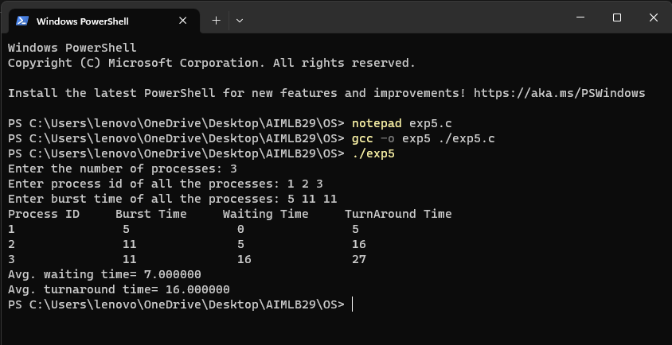

Priority Algorithm :

#include <stdio.h>

void swap(int *a,int *b){

int temp=*a;

*a=*b;

*b=temp;}

int main(){

int n;

printf("Enter Number of Processes: ");

scanf("%d",&n);

int burst[n],priority[n],index[n];

for(int i=0;i<n;i++) {

printf("Enter Burst Time and Priority Value for Process %d: ",i+1);

scanf("%d %d",&burst[i],&priority[i]);

index[i]=i+1;}

for(int i=0;i<n;i++) {

int temp=priority[i],m=i;

for(int j=i;j<n;j++) {

if(priority[j] > temp) {

temp=priority[j];

m=j; } }

swap(&priority[i], &priority[m]);

swap(&burst[i], &burst[m]);

swap(&index[i],&index[m]); }

int t=0;

printf("Order of process Execution is\n");

for(int i=0;i<n;i++){

printf("P%d is executed from %d to %d\n",index[i],t,t+burst[i]);

t+=burst[i]; }

printf("\n");

printf("Process Id\tBurst Time\tWait Time\n");

int wait_time=0;

int total_wait_time = 0;

for(int i=0;i<n;i++){

printf("P%d\t\t%d\t\t%d\n",index[i],burst[i],wait_time);

total_wait_time += wait_time;

wait_time += burst[i]; }

float avg_wait_time = (float) total_wait_time / n;

printf("Average waiting time is %f\n", avg_wait_time);

int total_Turn_Around = 0;

for(int i=0; i < n; i++){

total_Turn_Around += burst[i]; }

float avg_Turn_Around = (float) total_Turn_Around / n;

printf("Average TurnAround Time is %f",avg_Turn_Around);

return 0;}

