Picture or something up here

A-Level Computing Project
Name of said project

Candidate Name: James Alcock
Candidate Number: 9999
Centre Name: Lytchett Minster School
Centre Number: 55217

Table of Contents
Introduction 3
Existing Solutions 3
BBC Bitesize 3
Craig ‘n’ Dave 4
Geeks for Geeks 4
User Interaction 5

Introduction
My project aims to help GCSE and A-Level computer science students learn about the roles of the operating system within a modern computer in a fun and interactive yet still educational manner. I believe that making a game where the user “becomes” the operating system will allow them to more easily remember the core tasks performed by an operating system when faced with an exam question on the topic.
My approach to this will be a 2d game using python and pygame. My reason for choosing this combination is that python is by far the programming language that I have the most experience and confidence in using. I chose pygame as opposed to another GUI module like tkinter because it gives me complete control over the screen and event loop, something that I believe will be very important to make my game function as I and my users would like. I have previously used pygame to create ‘Snake’ and believe that the skills learnt during that process combined with further research during the creation of this project will allow me to competently create a polished and complete educational game.

Existing Solutions

BBC Bitesize
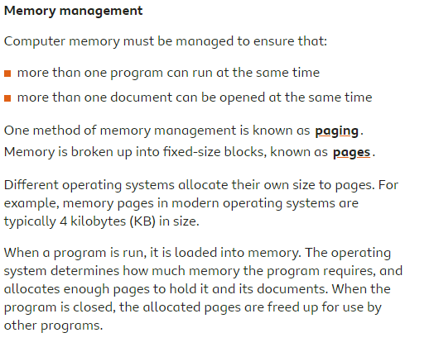
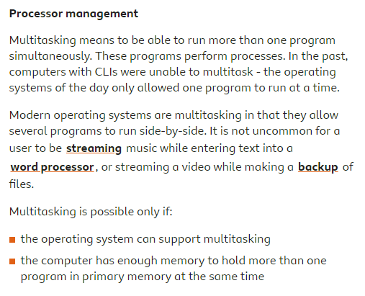
BBC Bitesize has a very comprehensive page that details all of the facts you could need to know about an operating system for GCSE exams with an impressive word count of 851. However, I feel this is overly wordy and hard to break down, especially if this is your first time learning the content. It also does not include any details on the knowledge required for A-Level. I like the fact that it includes a quick, multiple-choice quiz to test your knowledge after reading through the material.

Craig ‘n’ Dave
Craig ‘n’ Dave provides detailed videos explaining the concepts of an operating system, tailored to each exam board. I have chosen to stick to the AQA specification as this is the one my clients will be using and adding this feature would be time-consuming without adding much to my project as the various exam board specifications are largely the same.
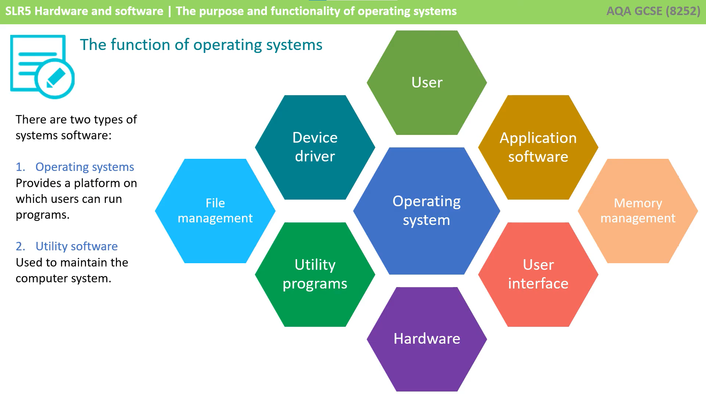
I feel that while the videos are of high quality and accuracy it is a very passive method of learning that could lead to students switching off and not fully focusing on the topic. My project will be more interactive, requiring problem-solving and critical thinking.

Geeks for Geeks
The Geeks for Geeks website provides a lot of details about the functions of an operating system but as it is not specifically tailored for GCSEs or A-Levels, there is some information that would be irrelevant and potentially confusing for my users. As mentioned previously, my project will be designed based on the AQA specification. Similarly to BBC Bitesize, there are many blocks of somewhat intimidating text. However, it is laid out better than the Bitesize website with logical and clear subheadings and bullet points.
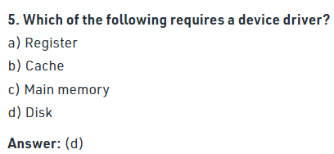
They also provide a summary quiz but is not interactive and reveals the answer directly underneath the question, making it difficult to properly test yourself.

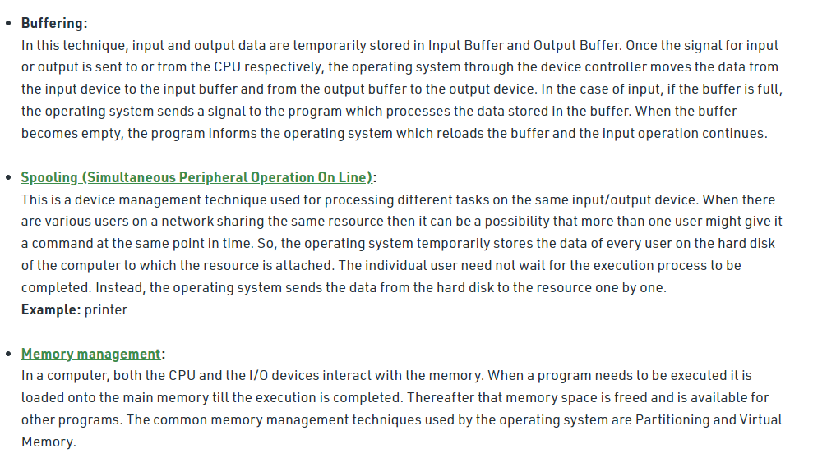
User Interaction
My target audience for this project is GCSE and A-Level computer science students. To gather some data about the features that most people would find useful, I distributed a survey to students in my class, students in a year 11 class at my school and an online forum primarily used for revision.

