Ja’Leah Beason
Sayani Sarkar
CS440
12-07-2025

Wildlife Object Detection Using YOLOv11 and a Roboflow Dataset

Abstract
This project explores wildlife object detection using the Ultralytics YOLOv11 model trained on a Roboblow dataset consisting of multiple animal species. The objective was to design and evaluate an object detection system capable of identifying animals such as dogs, horses, zebras, pandas, and birds in natural environments. Using Google Colab, I trained the YOLOv11n model for 15 epochs at a resolution of 640×640 with a batch size of 16. Evaluation results included a mean precision of 0.391, mean recall of 0.335, and a mean average precision (mAP@0.5) of 0.412. While some species were detected with high accuracy, others were missed or inconsistently labeled. I also encountered a technical issue during training in which no 'runs' folder was generated, likely preventing YOLO from saving predicted label files. This report concludes with discussion on limitations, potential improvements, and how drone imaging could enhance wildlife-monitoring applications.

Introduction
Wildlife monitoring plays an important role in conservation, environmental planning, and biodiversity protection. Traditional methods such as manual field observation or camera trap review are time-consuming and limited in scale. Computer vision tools, especially object detection models like YOLO, offer efficient alternatives.
The goal of this project was to train YOLOv11 on a wildlife dataset from Roboflow and evaluate its accuracy. During training, I encountered a technical issue: YOLO did not create the 'runs' directory, which normally stores model outputs such as prediction images with labels. As a result, the model produced no labeled output images, limiting my ability to visually inspect results.

Methodology

Dataset Description
The dataset used for this project was the publicly available 'Wildlife' dataset from Roboflow. It contains images of several species including dogs, horses, pandas, birds, and zebras. Each image includes YOLO-formatted bounding boxes.
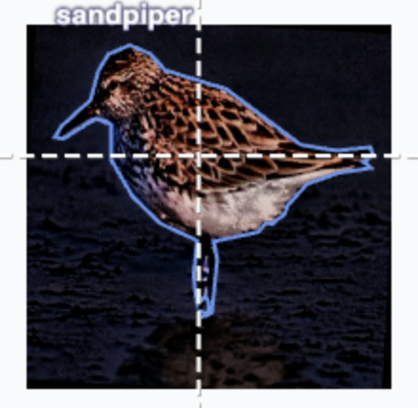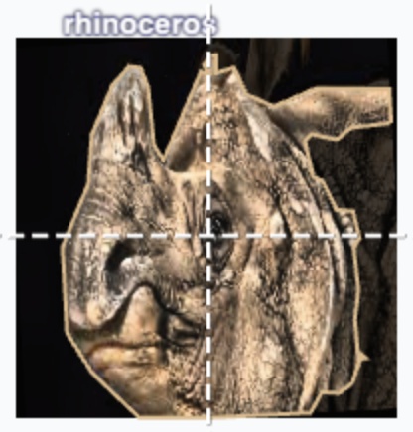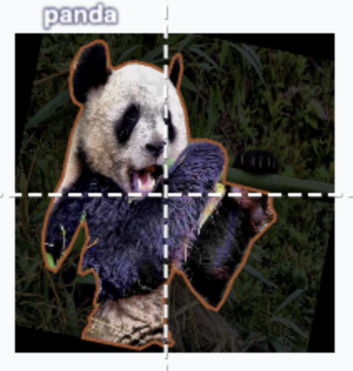
Figure 1: Sample Dataset Images

Model Setup and Training Configuration
I trained the YOLOv11n model for 15 epochs with an image size of 640 and batch size of 16. The default optimizer was used. The model was trained in Google Colab using the Roboflow-generated data.yaml file.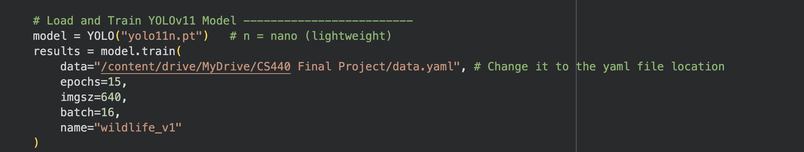Figure 2: Screenshot of Training Command

Training Issue: Missing 'runs' Directory
During training, the 'runs/detect' directory was never created. This prevented YOLO from saving outputs such as predicted images, training curves, and model weights.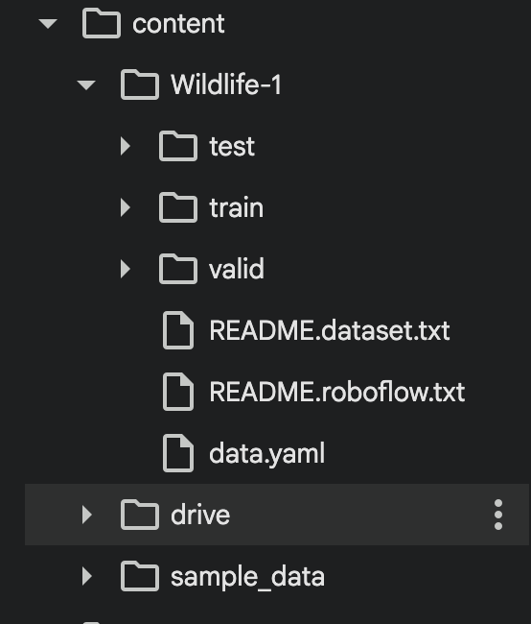
Figure 3: Missing 'runs' Folder in File Explorer

Results and Discussion
The model performed moderately well with the following metrics:
• Mean Precision: 0.391
• Mean Recall: 0.335
• mAP@0.5: 0.412
• mAP@0.5:0.95: 0.286
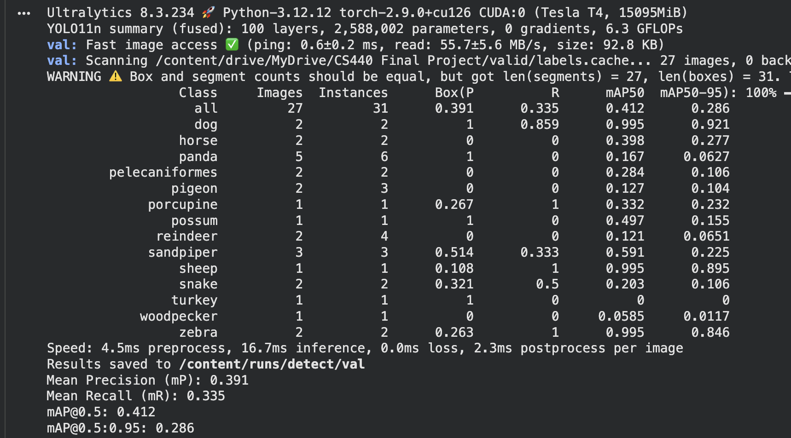
Figure 4: Validation Metrics Output
Per-class performance varied, with animals like zebras and dogs performing the best. Smaller species or those with fewer examples had much lower recall.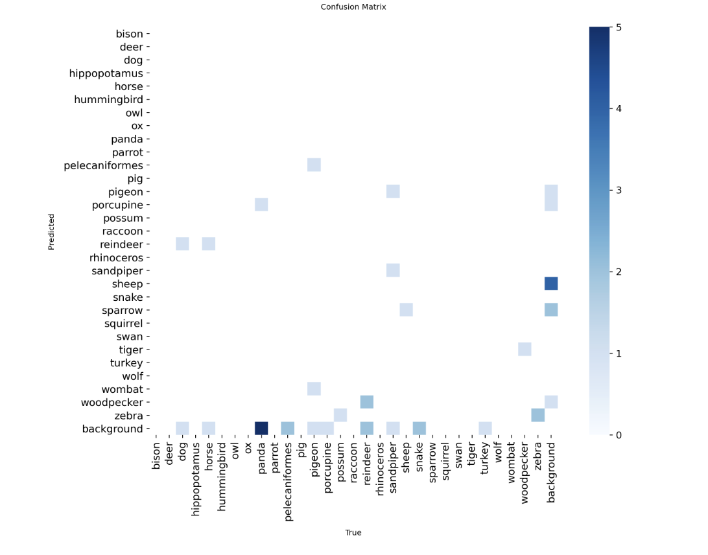
Figure 5: Class-Wise AP Table
Because the 'runs' folder never generated, I was unable to save inference images. This prevented visual evaluation.
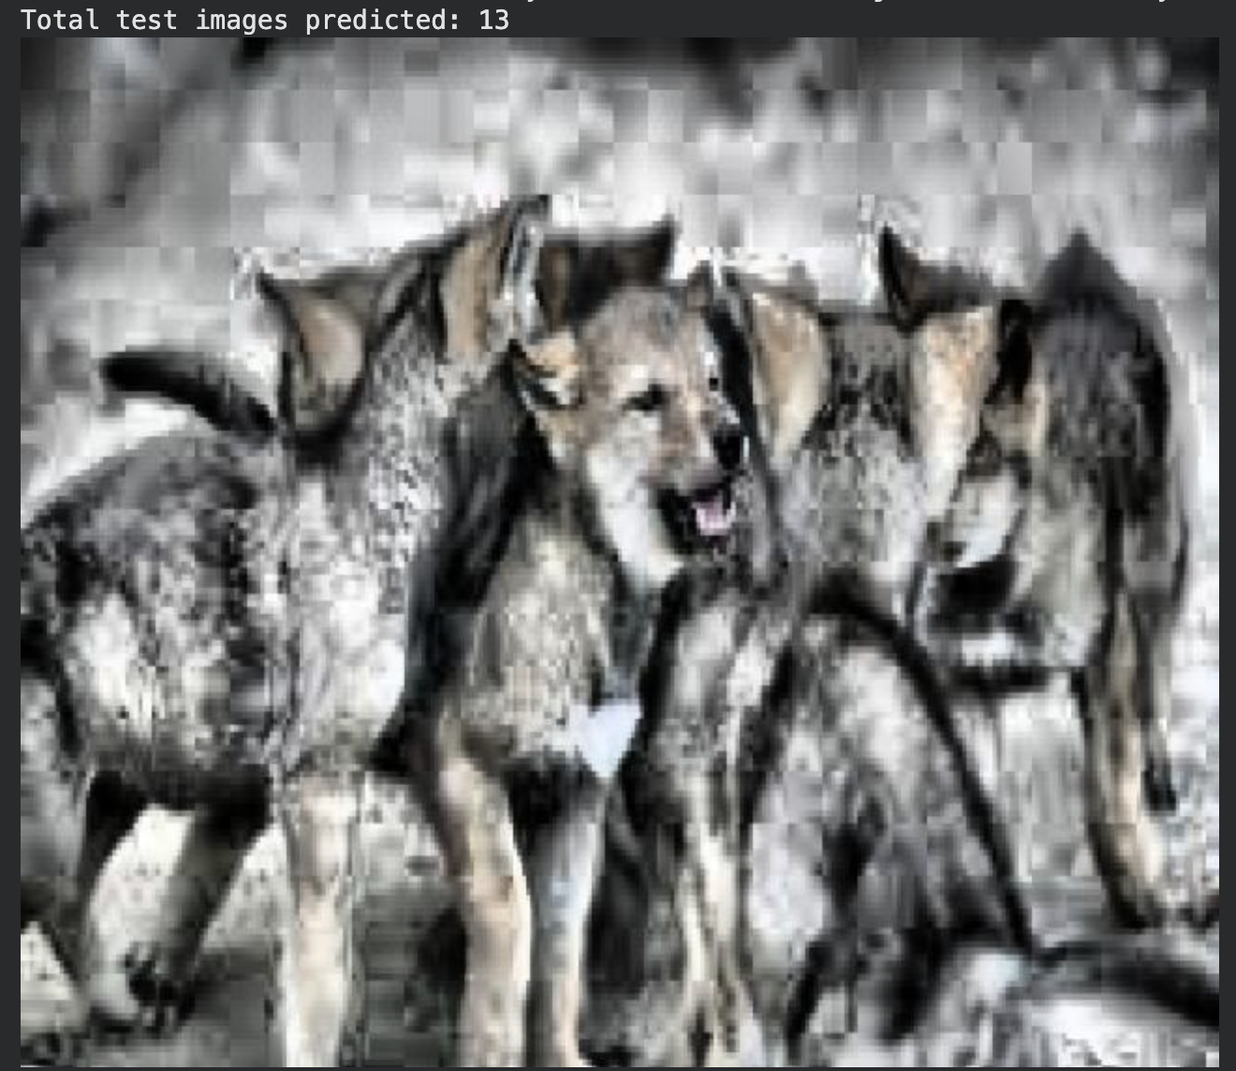 Figure 6: Example of Blank Output Image (no labels)

Drone and Mapping Reflection

Drone and mapping tools could both support and limit the wildlife detection system developed in this project. Drones would support the project by allowing fast and repeated data collection over large areas, which could provide more training images and improve YOLO’s ability to generalize to different environments. Aerial mapping also creates consistent viewpoints, making it easier for the model to detect animals without dealing with unpredictable camera angles. However, drones may also introduce limitations. Animals often appear very small from the air, which could reduce the model’s accuracy unless it is retrained specifically on aerial data. Motion blur, shadows, and tree cover can further limit visibility in drone images. Mapping tools may help organize and track detection locations, but they depend on accurate model predictions. Overall, drones and mapping tools have the potential to strengthen this project by expanding data collection and analysis, but they also require additional model adjustments to avoid reduced detection performance.

Conclusion and Future Work

This project demonstrated how YOLOv11n can be applied to wildlife object detection using a publicly available Roboflow dataset. The model reached moderate accuracy and showed strong performance for animals with clear features or many examples in the dataset while struggling with smaller or less common species. The missing “runs” directory limited the ability to analyze predictions visually, which is an important part of evaluating detection quality. Even with this limitation, the numerical results provide insight into where the model performs well and where improvements are needed. Future work could include collecting more balanced training data, running additional epochs, testing larger YOLO models or integrating aerial images to better detect animals in different environments. These steps could help create a more reliable detection system for real-world wildlife monitoring applications.

Works Cited
Roboflow. “Wildlife Object Detection Dataset.” Roboflow Universe, https://universe.roboflow.com.
Ultralytics. “YOLOv11 Documentation.” 2024.

