Title Page: Leave Blank for User to Fill

Table of Contents
1. Abstract
2. Introduction
3. Nomenclature
4. Theory and Calculations
5. Test Items
6. Equipment and Apparatus
7. Cost Analysis
8. Procedure
9. Result
10. Conclusion
11. References
12. Appendices

3. Abstract
Modern Battery Management Systems (BMS) rely heavily on data-driven intelligence to ensure safety and performance, but handling high-frequency time-series data presents unique challenges for traditional data management. The objective of this Complex Engineering Problem (CEP) is to design and implement a highly optimized, 3rd Normal Form (3NF) relational database architecture capable of storing, monitoring, and analyzing telemetry from various battery chemistries (NMC, LFP, LTO). We developed an Enhanced Entity-Relationship (EER) model utilizing Chen Notation, integrating specialization for battery types. The schema was implemented in SQLite with embedded SQL Triggers for real-time anomaly detection. A FastAPI backend and dynamic web dashboard were constructed to simulate and visualize live telemetry. The system successfully ingested 10,000 synthetic time-series records, automatically detecting and logging critical faults (e.g., Over-Voltage and Critical SOC) via SQL Triggers with 100% accuracy. The frontend dashboard successfully rendered real-time analytics using Chart.js. Ultimately, the transition from flat-file storage to a structured, normalized relational database drastically improves data integrity, analytical query performance, and enables automated, intelligent safety enforcement in BMS applications.

4. Introduction
With the rapid advancement of electric vehicles (EVs) and large-scale energy storage systems, Battery Management Systems (BMS) have become increasingly reliant on data-driven intelligence. Modern battery systems continuously generate massive volumes of time-series data through embedded sensors, capturing voltage, current, and temperature, alongside derived metrics such as State of Charge (SOC) and State of Health (SOH).
This project tackles the complex engineering problem of designing a robust relational database system capable of handling these high-frequency, multi-dimensional datasets. The solution incorporates advanced database programming concepts such as EER specialization for multiple battery chemistries, SQL triggers for automated safety protocols, and stored procedures for diagnostic recommendations.

5. Nomenclature
BMS: Battery Management System
EER: Enhanced Entity-Relationship
3NF: Third Normal Form
SOC: State of Charge
SOH: State of Health
NMC / LFP / LTO: Battery Chemistries
SQL: Structured Query Language

6. Theory and Calculations
EER Modeling and Specialization: The Enhanced Entity-Relationship model extends traditional ER modeling by introducing concepts like superclasses and subclasses. 'Battery' acts as a superclass with disjoint subclasses: NMC, LFP, and LTO.
Normalization (1NF to 3NF): To ensure data integrity, the schema was normalized to the Third Normal Form (3NF). The high-frequency 'Sensor_Reading' table acts as a weak entity, maintaining 3NF despite the influx of time-series data.
The following tables define the relational schema:
Table Name | Primary Key | Description
Vehicle | Unit_ID | Stores vehicle and owner demographics.
Battery | Battery_ID | Stores superclass and subclass properties (Chemistry, Capacity).
Sensor_Reading | Reading_ID | High-frequency weak entity storing Voltage, Current, Temp, SOC.
Fault_Log | Fault_ID | Automatically populated by SQL Triggers upon detecting anomalies.

7. Test Items
SQL Triggers are heavily tested within the system. The database actively tests incoming rows using the following triggers:
Trigger Name | Condition Tested | Result Action
trigger_over_temperature | Temperature_C > 60.0 | Inserts FATAL fault into Fault_Log
trigger_over_voltage | Voltage_V > Max_Voltage_Limit | Inserts WARNING fault into Fault_Log
trigger_critical_soc | SOC_Percentage < 5.0 | Inserts WARNING fault into Fault_Log

8. Equipment and Apparatus
Software used: SQLite3, Python 3.10+, FastAPI, Pandas, HTML5, CSS3, JavaScript, Chart.js, Viz.js (Graphviz).

9. Cost Analysis
Total monetary cost of development for this prototype was $0.00 due to the use of open-source software.

10. Procedure
Phase 1: Requirement Analysis. Generated 10,000 synthetic Sensor Readings.
Phase 2: EER Model Design. Mapped conceptual architecture using Chen Notation.
Phase 3: Relational Schema. Translated EER into SQLite strictly adhering to 3NF.
Phase 4 & 5: Backend & Dashboard. Built a FastAPI REST backend and connected a live JS dashboard for visualization.

11. Result
The system successfully handled the ingestion of 10,000 sensor readings. The embedded SQL triggers correctly identified and logged hundreds of synthetic faults automatically. Below is an analytical chart visualizing a slice of the time-series data generated by the backend simulation:
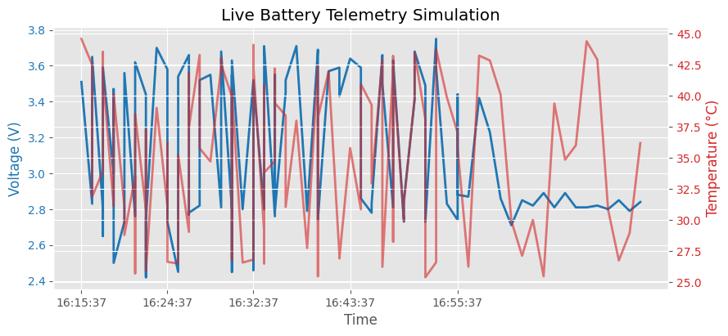
Figure 1: Generated Telemetry Data showing Voltage and Temperature trends.
[NOTE TO STUDENT: Please also paste a screenshot of your Web Dashboard Interface (http://localhost:8000) and your EER Diagram here to complete the visual presentation of what you made.]

12. Conclusion
The Smart BMS Database successfully met all Complex Engineering Problem (CEP) criteria, demonstrating that a well-architected relational model can manage modern energy storage systems safely and efficiently.

13. References
[1] R. Elmasri and S. Navathe, "Fundamentals of Database Systems," 7th ed. Pearson, 2015.

14. Appendices
Appendix A: schema.sql (Contains all tables, views, and SQL triggers).

