Aerial Robotics Kharagpur Documentation Template
Dynamic pathplanning

Dynamic Path Planning using rrt: VI RESULTS AND OBSERVATION
Rapidly-exploringRandom Tree is used to The algorithm used is slow and can
find the path from start to goal where the improvised by various methods, like
obstacles are dynamic. When drones fly, starting the algorithm from both start
there encounter a lot of obstacles, both static and end. The problem with my an algorithm is that the length of a line is small and the range of random point generation is limited and that is the reason it is taking a lot of time.Dynamic window approach
and dynamic.RRT is a fast algorithm and and RRT* can also be used.
helps in finding path in dynamic environment

I. INTRODUCTION
For Dynamic path planning i used rrt. For each VII FUTURE WORK frame of the video, the algorithm is applied. The My future work includes optimising
moving obstacles create a difference in the various my approach for the path planning
frames and the algorithm generates a random line by working on the length on path
from a certain point of a specific length checking required and reducing the time for
whether the line goes through obsctacles. If it does computation. Random points should
then ignore that line. I have tried Dynamic window be a little more scattered. I wish to
approach but that appeared slower. RRT with a small learn and work on graph theory.That
paath length was taking a lot of time and the might help in better path planning
parameters should be handled well.
CONCLUSION
Path planning is a basic requirement
for autonomous vehicles and there is a lot of scope for learning in this field and unlike theory there will be a lot of practical difficulties which should be tackled with experience Computational speed and randomising are the problems faced For ARK, path planning should be having little error since the bots will never be in our “hands”. Some
obstacles even if hit can cause a little
damage to the bot. So we can assign
penalties and make things like a game

II. PROBLEM STATEMENT REFERENCES
The given problem statement is on planning a -> OpenCV documentation by several
path in dynamic environment where the obs- authors
tacles move. In the video feed, the blue obstacles -> https://ieeexplore.ieee.org/document/
move and plan has to be made for a path from 6108732
start(red)ot end(green). -> https://www.hindawi.com/journals/
*IMAGE* ->Fig1
the black walls are to be avoided.

complexity/2018/8420294/
III. RELATED WORK ->https://github.com/AtsushiSakai/Py thonRobotics(Dynamic window)
Dynamic window approach was thought of
where the robot motion parameters are given
and an arrow moves on the image making
sure it avoids the obstacles and reaches the goal.
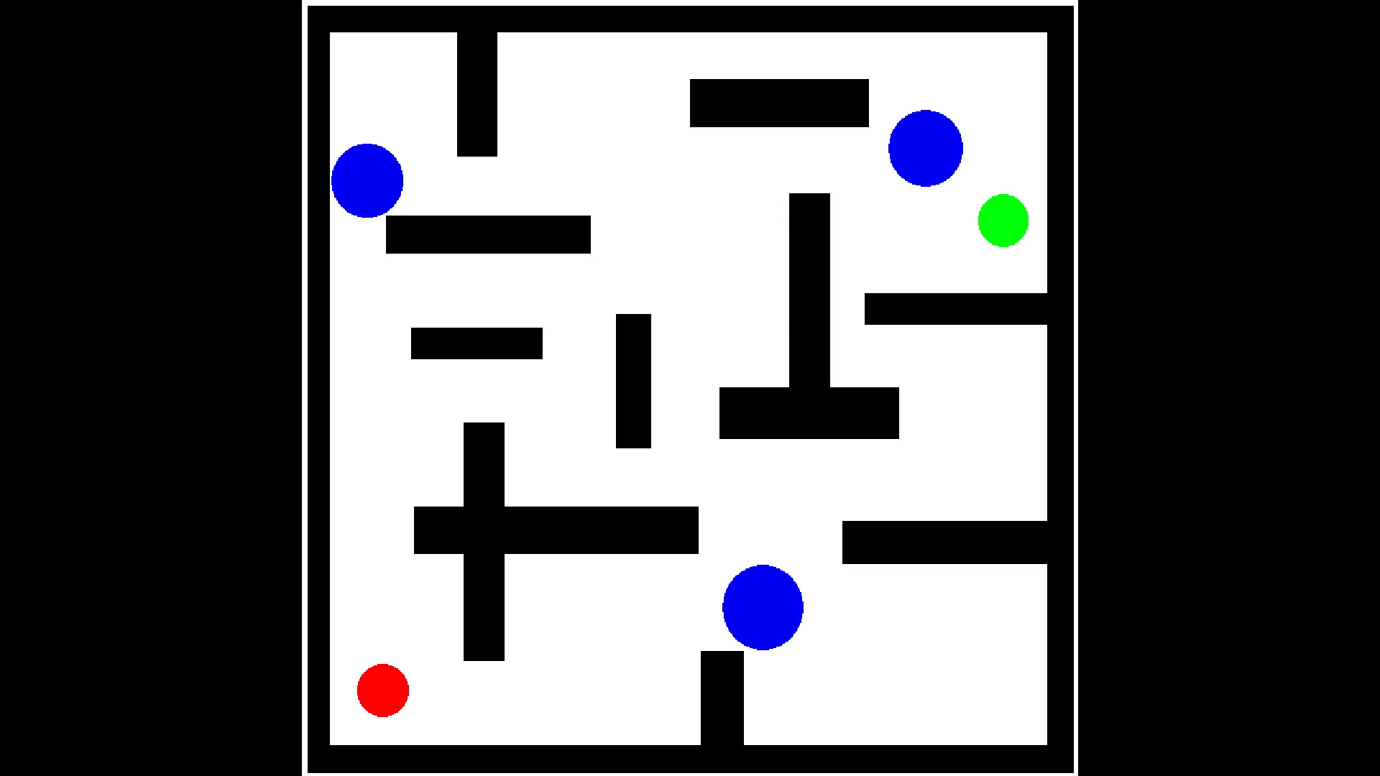
The website is mentioned in the REFERENCES
fig 2
IV. INITIAL ATTEMPTS
I wanted to scan the entire image and get the
centre and radius of the obstacles and their position
as a function of time using contour detection
.And for the walls their parameters using hough transform But in reality, all the 3D projections
on 2D need not have the same radius so the idea
was rejected. Then i learned about dynamic window
approach and that seemed a good idea with the Fig1
robot parameters given, i move an arrow on the
image to find the path. But the robot paramters
should be chosen properly and a lot of practical
difficulties occur due to inertia and stuff and it should be
optimized a lot
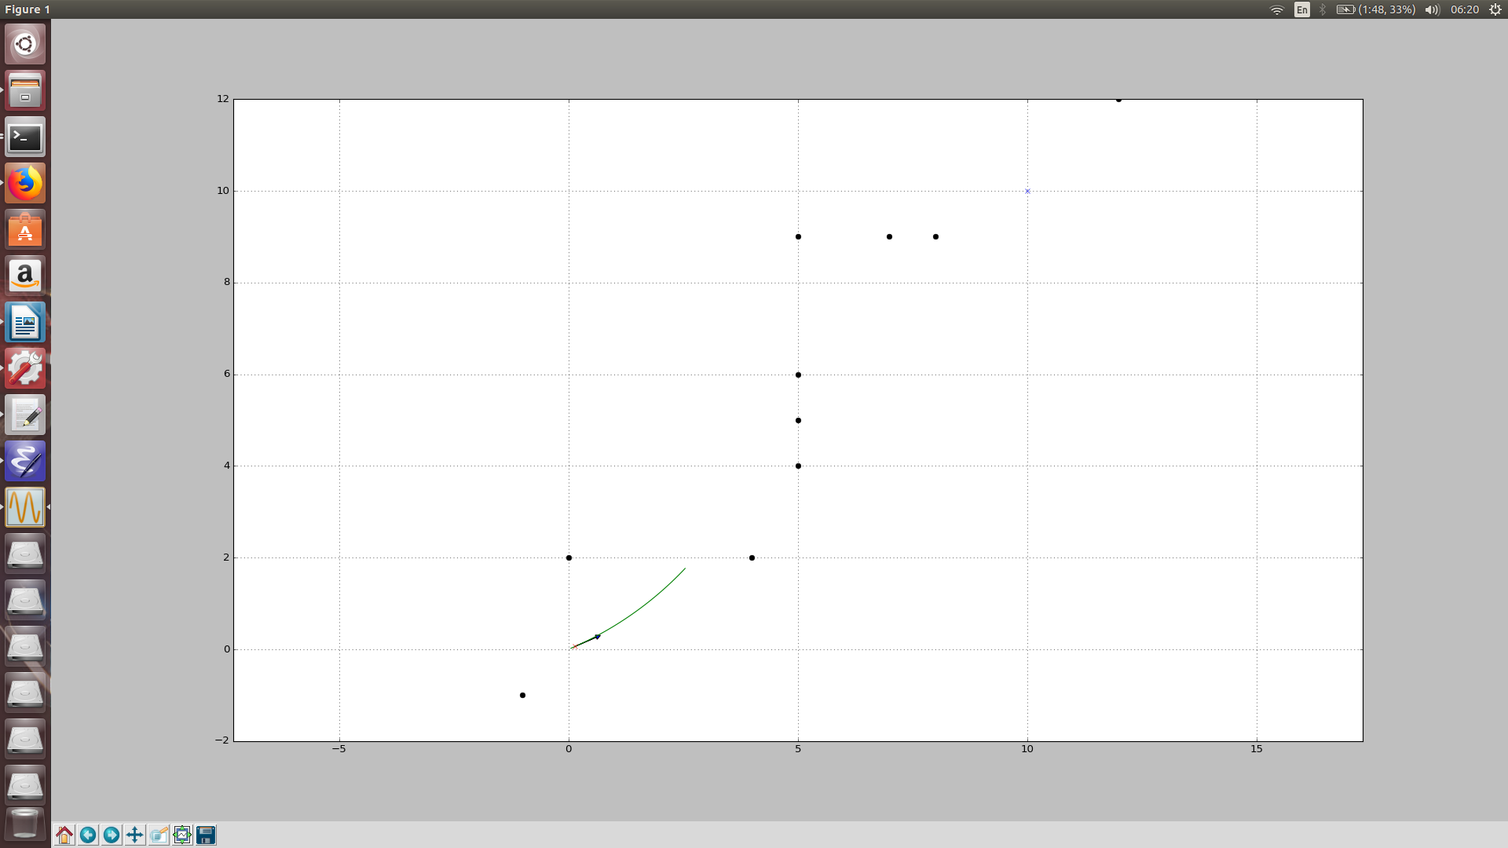
Fig 2 \ /

V FINAL APPROACH
RRT

A Rapidly-exploring Random Tree (RRT) is a data structure and algorithm that is designed for efficiently searching spaces.RRTs are constructed incrementally in a way that quickly reduces the expected distance of a randomly-chosen point to the tree. RRTs are particularly suited for path planning problems that involve obstacles.
Usually, an RRT alone is insufficient to solve a planning problem. Thus, it can be considered as a component that can be incorporated into the development of a variety of different planning algorithms.
Pseudo code: Generate a random point p
compare with the existing points(in some array a) for which is the closest
min(a[i],p)
now plot a line from a[i] to p
move by a fixed distance d
and keep generating random points till it reaches the goal

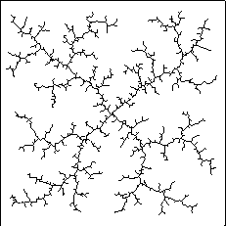
The initial errors faced were with the length of the line which
was too small compared to the size of image. It was not visible. So
I had to use a bigger length value. The line is plotted in grey
and once the frame is skipped it disappears. So i had to plot it on a black image to get a plot like Fig 3. In my code i kept storing the points in an array along with their parent so that once the goal is reached i can traverse back and plot one line from end to start
RRT appears in various optimised forms.

Usually, an RRT alone is insufficient to solve a planning problem. Thus, it can be considered as a component that can be incorporated into the development of a variety of different planning algorithms.

^Fig 3

