Credit Risk SHAP Interpretability Dashboard
This report combines SHAP plots and brief interpretations useful for recruiters and decision-makers.
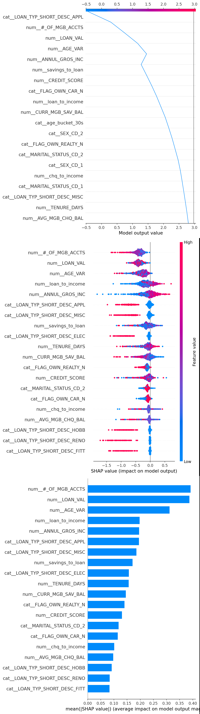
Interpretation: The dashboard shows global and local explanations of model behavior using SHAP.

