Sun4All

Application Description

- Objective:
  - Phase I: For each K1 spectroheliogram
  - Count the number of sunspots
  - Count the number of sunspots clusters
  - Record any other interesting observation

  - Phase II: For each K1 spectroheliogram
  - Measure the diameter/area of the sun
  - Measure the diameter/area of each sunspot

- Data: There are 15.000 K1 spectroheliograms for analysis. However, currently these images are presented both in the positive or the negative (Figure 1).
(A) | 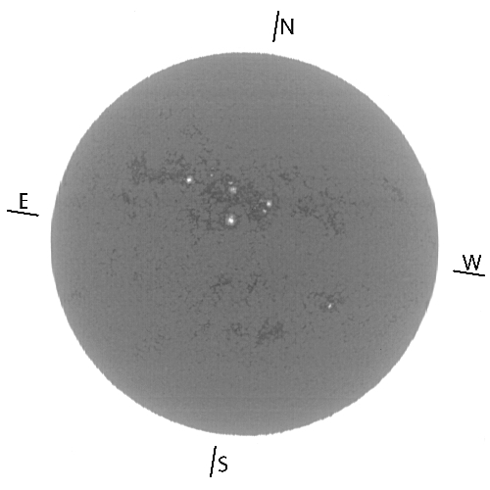 | (B) | 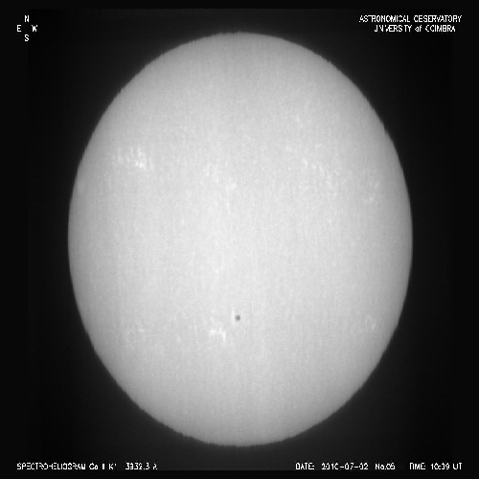
Figure 1: Example of K1 spectroheliograms in (A) positive and (B) negative.

  - When image is in positive (Figure 1., A), the sunspots appear in white.
  - When image is in negative (Figure 1. B), the sunspots appear in black.
  - The original image are stored in TIFF format with dimensions xx × yy and occupy roughly 10 Mb. For the current implementation of the application, these images were converted to JPEG with dimensions 500 × 500 px occupying about 75 Kb.

- Implementation Notes:
  - Application Setup
    - Convert all images from positive to negative or from negative to positive? What is the preferred option?
    - In my opinion, the current size of the images is too small; sometimes it is difficult to evaluate the existence of a sunspot or to distinguish if we have a big sunspot or two sunspots really close together. Also, I foresee that with an image size of 500 × 500 px it will difficult to measure the diameter/area of a sunspot, in particular for smaller sunspots. I think we should consider producing new images, and then should consider two options:
    - present the new image on a 500 × 500 px display and allow for enlarge on click, or
    - present the image on the new selected size.
    - Images are (freely??) available for download. Which is the link to download all images?

  - Users
    - Sun4All has already users registered and contributing. These data is stored in an Excel file. Is it possible to import the information on the users to the PyBossa Users' database?

  - Results Validation
    - How many times should the same image be analyzed?
    - How many concordances should be achieve to consider a valid count for an image?

