EXPERT PROJECT BLUEPRINT · WORKING DRAFT
iPIN-OpenPPI
Research and engineering blueprint for robust
sequence-based protein-protein interaction prediction
Technical white paper for an interdisciplinary expert working group
PROJECT THESIS
Develop a sequence-only predictor of intrinsic direct protein compatibility, trained through an assay-aware positive-unlabeled observation model, sparse residue-level pair attention, mutation and interface supervision, calibrated uncertainty, and an evaluation programme that controls sequence, interface, assay, publication-time, network and pretraining leakage.

PURPOSE  Consortium discussion and joint project planning | VERSION  2.0 · professional redesign | PLATFORM  NAISS Arrhenius, Sweden
STATUS  Expert working draft | REVIEW DATE  2 August 2026 | SCOPE  Direct physical PPI prediction from sequence

Document control
Item | Value
Purpose | Scientific and engineering blueprint for a joint sequence-based PPI prediction programme.
Intended audience | Computational biologists, protein scientists, machine-learning researchers, data engineers, HPC specialists and experimental collaborators.
Scope | Direct physical interaction prediction from amino-acid sequences, with explicit separation from contextual realization, co-complex association and assay detection.
Status | Working draft for expert review; hypotheses and compute budgets require empirical profiling.
Recommended project name | iPIN-OpenPPI.
Primary infrastructure | NAISS Arrhenius GPU, CPU, Disk and (where justified) Flash storage.

How to use this document
Sections 1-4 define the scientific problem and the proposed model. Sections 5-7 specify data, benchmarking and training. Section 8 maps the programme to Arrhenius. Sections 9-12 convert the concept into work packages, milestones, risks, publications and immediate decisions. The appendices contain implementation-ready schemas, equations, experiment templates and an HPC launch skeleton.

Contents
- Executive summary
- 1. Scope, definitions and scientific claim
- 2. State of the field and implications for novelty
- 3. Failure modes that the project must explicitly control
- 4. Proposed model: iPIN-OpenPPI
- 5. Data programme and evidence warehouse
- 6. Leak-resistant benchmark and evaluation framework
- 7. Training, ablation and inference strategy
- 8. Arrhenius implementation and compute strategy
- 9. Work packages, governance and 24-month roadmap
- 10. Risk register and mitigation plan
- 11. Publication, release and experimental validation strategy
- 12. Decisions required at project kickoff
- Appendices A-G

Executive summary
The project should not be framed as another binary classifier over two protein sequences. The scientifically defensible target is intrinsic sequence-encoded physical compatibility, while cellular realization and experimental detection are modeled as separate latent or conditional processes.
The 2025-2026 literature has rapidly moved from independent protein embeddings toward joint pair encoders, pair-specific language modeling, local interaction grammars and multi-chain context. PLM-interact, PPLM, MINT and SWING establish strong contemporary baselines [1-4]. At the same time, recent work demonstrates serious inflation from pretrained-language-model leakage, weak protein-disjoint evaluation, unrealistic negatives and pairwise metrics that fail to predict network behavior [5-8]. A credible programme must therefore make benchmark construction and label semantics first-class research contributions, rather than treating them as preprocessing.
The proposed iPIN-OpenPPI model has six linked innovations: (i) an assay-aware positive-unlabeled generative formulation; (ii) a shared protein encoder with learned sparse interface-region routing; (iii) symmetric intrinsic-interaction and potentially asymmetric assay-observation heads; (iv) mutation-counterfactual and residue-contact supervision; (v) distillation from structural and coevolutionary teachers while retaining sequence-only inference; and (vi) calibrated uncertainty for selective prediction and experimental prioritization.
The programme should begin with an evidence warehouse and a leakage-controlled benchmark. Only after the benchmark is frozen should large-scale model development start. This order prevents expensive optimization against a scientifically weak target and creates a publishable benchmark contribution even if the final architecture requires iteration.

Recommended outcome
- A sequence-only model that returns intrinsic direct-interaction probability, calibrated uncertainty, likely interface residues/contacts, assay-conditioned observation probabilities, affinity or mutation-effect predictions where supported, and mechanism/expert attribution.
- A reproducible evidence warehouse preserving assay, publication, construct, orientation, species, isoform, interaction type and confidence provenance rather than collapsing sources into one binary table.
- A benchmark covering protein-disjoint, sequence-cluster, interface-cluster, species, assay, publication-time and pretraining-exposure holdouts, plus realistic proteome-level class prevalence and graph reconstruction.
- A two-stage proteome-scale inference system: fast bi-encoder retrieval followed by sparse pair cross-encoder reranking.
- A prospective or strict temporal validation in which model candidates are selected after model freeze and tested experimentally or against later publications.

Non-negotiable scientific principles
Principle | Operational consequence
Separate meanings of interaction | Direct physical binding, membership in the same complex, functional association and context-specific observation must not share an undifferentiated label.
Unknown is not negative | Untested and assay-negative pairs should be handled as unlabeled or assay-specific observations unless there is strong evidence of noninteraction.
C3 and temporal evaluation are primary | Random pair splits are diagnostics, not headline evidence.
Pretraining exposure must be audited | Report both a public-PLM track and a smaller strict track with held-out families excluded from pretraining where feasible.
Precision and calibration dominate AUROC | At proteome scale, modest false-positive rates generate unusably large candidate sets.
Prospective validation is the ultimate endpoint | The most persuasive metric is validated novel PPIs per experimental test, with pre-registered selection criteria.

Immediate strategic recommendation
RECOMMENDED ORDER OF WORK
1) evidence warehouse; 2) leakage audit and frozen benchmark; 3) assay-aware PU baseline; 4) sparse local-to-global pair model; 5) structural/MSA teacher distillation and mutation consistency; 6) proteome retrieval; 7) prospective validation.

1. Scope, definitions and scientific claim

1.1 What exactly is being predicted?
The phrase protein-protein interaction is used for several biologically distinct relationships. The model and dataset must distinguish at least the following: direct binary physical contact; direct contact within a larger complex; stable co-complex membership without evidence of direct contact; transient regulatory binding; motif-domain or intrinsically disordered-region binding; and functional association inferred from pathways, co-expression, genomic context or text mining.
The core project claim should be narrow and testable: given two amino-acid sequences, predict their intrinsic capacity to form a direct physical interaction under some compatible biochemical state. This quantity is not identical to whether the proteins interact in a particular tissue, cell, compartment, condition or assay.

1.2 Three-layer causal decomposition
Let z_AB denote latent intrinsic physical compatibility of proteins A and B. Let c represent biological context, including localization, abundance, isoforms, post-translational modifications and assembly state. Let m denote the assay and experimental design, including bait/prey orientation and construct boundaries. Let y_ABm be the observed assay result.
P(y_ABm = 1 | S_A, S_B, c, m) = P(z_AB = 1 | S_A, S_B) x rho_m(S_A, S_B, c, orientation, constructs)
This decomposition separates a sequence-only intrinsic interaction head from context and observation models. It also explains why an assay-negative result cannot automatically be used as a direct negative: y = 0 may reflect non-binding, absent co-localization, insufficient expression, a missing modification, an incompatible construct or limited assay sensitivity.
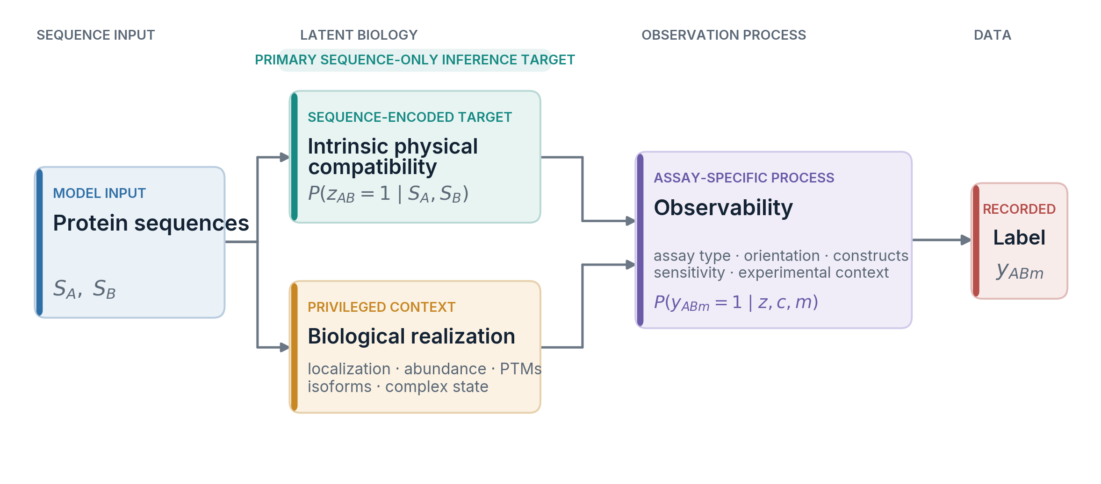
Figure 1. Causal decomposition of sequence-encoded physical compatibility, biological realization and assay observability. Only the intrinsic compatibility branch is the primary sequence-only inference target.

1.3 Symmetry and orientation
Intrinsic binary compatibility should generally be invariant to sequence order: f(S_A, S_B) = f(S_B, S_A). However, an assay-observation model may be order-sensitive because bait/prey orientation, tag location or construct design can change detectability. The architecture should therefore enforce or average symmetry in the biological head while allowing controlled asymmetry in assay-specific heads.

1.4 Intended inference outputs
Output | Interpretation
Intrinsic direct-PPI probability | Calibrated probability of direct physical compatibility based on sequence only.
Epistemic/aleatoric uncertainty | Uncertainty used for abstention, active learning and experimental triage.
Interface localization | Residue or region probabilities and sparse residue-residue contact estimates.
Assay-conditioned observability | Probability that a specified assay/design would report the interaction.
Mechanism or expert attribution | Soft routing across globular, motif-domain, IDR, coiled-coil, membrane and immune-recognition regimes.
Affinity/mutation effects | Optional outputs where suitable affinity or perturbation labels exist.

2. State of the field and implications for novelty

2.1 Evolution of sequence-based PPI modeling
Earlier sequence-based systems used handcrafted descriptors, recurrent networks or independent pretrained embeddings followed by a classifier. D-SCRIPT introduced an explicitly contact-inspired structure-aware interaction map while retaining sequence-only input [9]. RAPPPID emphasized strict protein-level splits and generalization to unseen proteins [10]. These remain important baselines because their inductive biases and compute footprints differ substantially from modern pair language models.
The field has now shifted toward joint pair encoders. PLM-interact jointly encodes protein pairs and reports cross-species, virus-host and mutation-effect applications [1]. PPLM introduces hybrid intra-chain and inter-chain attention and separate heads for binary interaction, affinity and contacts [2]. MINT modifies language modeling to learn from sets of interacting proteins and supports more than two chains [3]. SWING focuses on local sliding windows and length-agnostic interaction grammar rather than globally pooled sequence representations [4].

2.2 Current model landscape
Method | Core idea | Strength | Implication for this project
D-SCRIPT | Sequence-only, contact-inspired interaction map | Genome-scale and cross-species baseline | Predates current pair PLMs; benchmark sensitivity remains important
RAPPPID | Twin regularized AWD-LSTM | Explicit unseen-protein evaluation | Less residue-level interpretability
TUnA | ESM-2 embeddings, Transformer and spectral-normalized neural GP | Uncertainty-aware selective prediction | Dependent on frozen-PLM exposure and benchmark semantics
PLM-interact | Joint pair encoding and pair objective | Strong cross-species and mutation-effect results | Must be reevaluated under strict pretraining controls
SWING | Sliding local interaction grammar | Length robustness and local context | Window selection and global integration remain open
MINT | Multi-chain contextual PLM built from ESM-2 | Interactions among more than two proteins | Training source includes heterogeneous STRING evidence
PPLM | Hybrid intra/inter-protein attention | Interaction, affinity and contact prediction | Full pair attention can be expensive for long sequences
eSIG-Net | Mutation-aware sequence interaction grammar | Edgetic mutation prediction | Primarily perturbation-focused rather than proteome retrieval

2.3 Structure and coevolution as teachers rather than mandatory inputs
Structure-aware resources and models are valuable for interface supervision, difficult negatives and mechanistic interpretation. PINDER provides a large interaction/docking resource with sequence- and structure-aware split machinery [7]. PPIRef/PPIformer supplies nonredundant structural interfaces and mutation-effect learning [11]. AlphaFold-based interactome studies demonstrate that structural modeling can prioritize high-confidence interactions, but recent experimental assessment also shows that purely computational interactome mapping remains limited for strictly novel discovery [12-14].
Coevolution is particularly informative for paralogue pairing and interface constraints. DiffPALM shows that a protein MSA language model can identify interacting partners by exploiting inter-chain coevolution, even though it was trained on single-chain data [15]. The recommended use is privileged teacher supervision: paired MSA or structure features guide the student during training, while the deployed model remains sequence-only.

2.4 Why a larger binary classifier is not sufficient novelty
- Joint pair encoding is already established by PLM-interact and PPLM.
- Multi-chain context is already established by MINT.
- Local window grammars are already established by SWING.
- Mutation-specific interaction prediction is advanced by PLM-interact and eSIG-Net.
- Uncertainty-aware PPI prediction is already demonstrated by TUnA.
The strongest novelty therefore lies in combining a more correct statistical observation model with sparse interface routing, strict leakage-aware evaluation and prospective discovery. The project should treat architecture, labels and evaluation as a coherent system rather than isolate one network block.

3. Failure modes that the project must explicitly control

3.1 Supervised split leakage
At minimum, the benchmark must distinguish exact-pair leakage, single-protein leakage, homologous-protein leakage and interface-family leakage. A pair-disjoint split can remain trivial when the same proteins occur in many training pairs. Likewise, a sequence-cluster split can still leak structurally conserved interfaces that are weakly similar at the whole-protein level.
DataSAIL offers a general leakage-reduced splitting framework and should be evaluated for pair entities, while PINDER-style interface clustering should inform the structure-associated subset [7,16].

3.2 Pretrained protein-language-model leakage
A 2026 Nature Machine Intelligence study demonstrated that pretrained PLMs can inflate downstream PPI scores when the pretraining corpus contains held-out sequence relationships [5]. The project should therefore report two tracks: a practical public-PLM track and a strict track using a smaller model pretrained after excluding held-out sequence families and post-cutoff data. The strict model need not maximize raw performance; it estimates the contribution of pretraining exposure.

3.3 Negative-set pathology
Random pairs are often biologically implausible and allow models to learn compartment, taxonomy, family or length differences instead of binding compatibility. Conversely, assay-tested negatives can include false negatives. A robust design should separate confirmed noninteractors, assay-specific negatives, biologically matched unlabeled pairs, homology-matched decoys and easy random pairs. Only the first category warrants a strong intrinsic negative label.

3.4 Assay and source shortcuts
HuRI, BioPlex, IntAct, STRING and structural databases do not measure the same quantity. HuRI emphasizes systematic binary assays [17]. BioPlex and related AP-MS maps emphasize co-complex associations and reveal substantial cell-line specificity [18]. IntAct preserves fine-grained experiment and publication provenance [19]. STRING integrates experimental and predicted functional associations [20]. Combining them without evidence typing can make the source itself predictive of the label.

3.5 Context, isoforms and constructs
Canonical sequence identifiers are insufficient when the experiment used an isoform, fragment, domain, truncation, fusion or tagged construct. Construct boundaries should be stored and, where available, used as the sequence actually presented to the assay. Post-translational modifications and cell-state information should be represented as context or missing metadata, not silently ignored.

3.6 Network topology shortcuts
Pairwise models can exploit node degree, shared neighbors or dataset assembly rules. PRING shows that strong pairwise metrics do not guarantee topological fidelity, functional organization or cross-species graph reconstruction [6]. The sequence model should therefore be evaluated before and after any graph postprocessing, and graph priors should never be allowed to conceal weak sequence evidence.

3.7 Realistic prevalence and precision
A proteome of 20,000 proteins contains roughly 200 million unordered pairs. Even a false-positive rate of 0.1% would produce approximately 200,000 false candidates. Evaluation must therefore include precision at fixed laboratory budgets, recall at very high precision, calibration, selective prediction and enrichment over random at realistic prevalence. AUROC alone is not decision-relevant.

3.8 Non-negotiable audit checklist
Audit | Required control
Exact pair overlap | Hash canonical unordered pairs across all splits and data versions.
Protein overlap | Report C1/C2/C3 statistics and enforce C3 for the primary test.
Sequence overlap | Cluster at multiple identity/coverage thresholds; report nearest-train similarity.
Interface overlap | Cluster resolved interfaces and audit predicted structural homologues.
Publication overlap | Use first-evidence dates and freeze a historical cutoff.
PLM exposure | Record public pretraining dates/corpora; train a strict comparison model where feasible.
Assay/source balance | Stratify metrics by assay, source, orientation and construct completeness.
Topology bias | Compare against degree, interolog, similarity and graph-only baselines.

4. Proposed model: iPIN-OpenPPI

4.1 Assay-aware positive-unlabeled model
The central statistical contribution is a latent intrinsic-interaction variable z and an observation process for each assay. Direct, orthogonally validated interactions anchor z = 1. Confirmed noninteractors anchor z = 0. Assay-tested negatives supervise the observation head but do not automatically become intrinsic negatives. Untested pairs are positive-unlabeled examples.
z_AB ~ Bernoulli(p_theta(S_A, S_B))
y_ABm ~ Bernoulli(z_AB x rho_phi(S_A, S_B, m, context, orientation, constructs))
The likelihood can be optimized with a latent-variable objective, variational approximation or EM-like alternation. Identifiability is the main statistical risk: p_theta and rho_phi can compensate for each other. Constrain the model using repeated measurements across assays, orthogonal validations, confirmed negatives, explicit assay priors and regularization that prevents degenerate near-zero detectability.

4.2 Shared encoder and sparse local-to-global interaction routing
Each protein is encoded with a shared pretrained or strictly pretrained protein language model. Rather than compute full cross-attention over all residue pairs, each chain is partitioned into overlapping windows or domains. A lightweight proposer assigns interface relevance and selects a small set of candidate regions. Expensive inter-chain attention then operates only over selected region pairs, while global pooled representations remain available for overall compatibility.
Initial design ranges should be treated as hypotheses: window width 48-96 residues; 50% overlap; 8-16 selected windows per chain; multi-scale windows for short motifs and globular interfaces; differentiable top-k, sparsemax/entmax or straight-through selection. A fallback full-attention path for short pairs provides an upper-bound comparison.
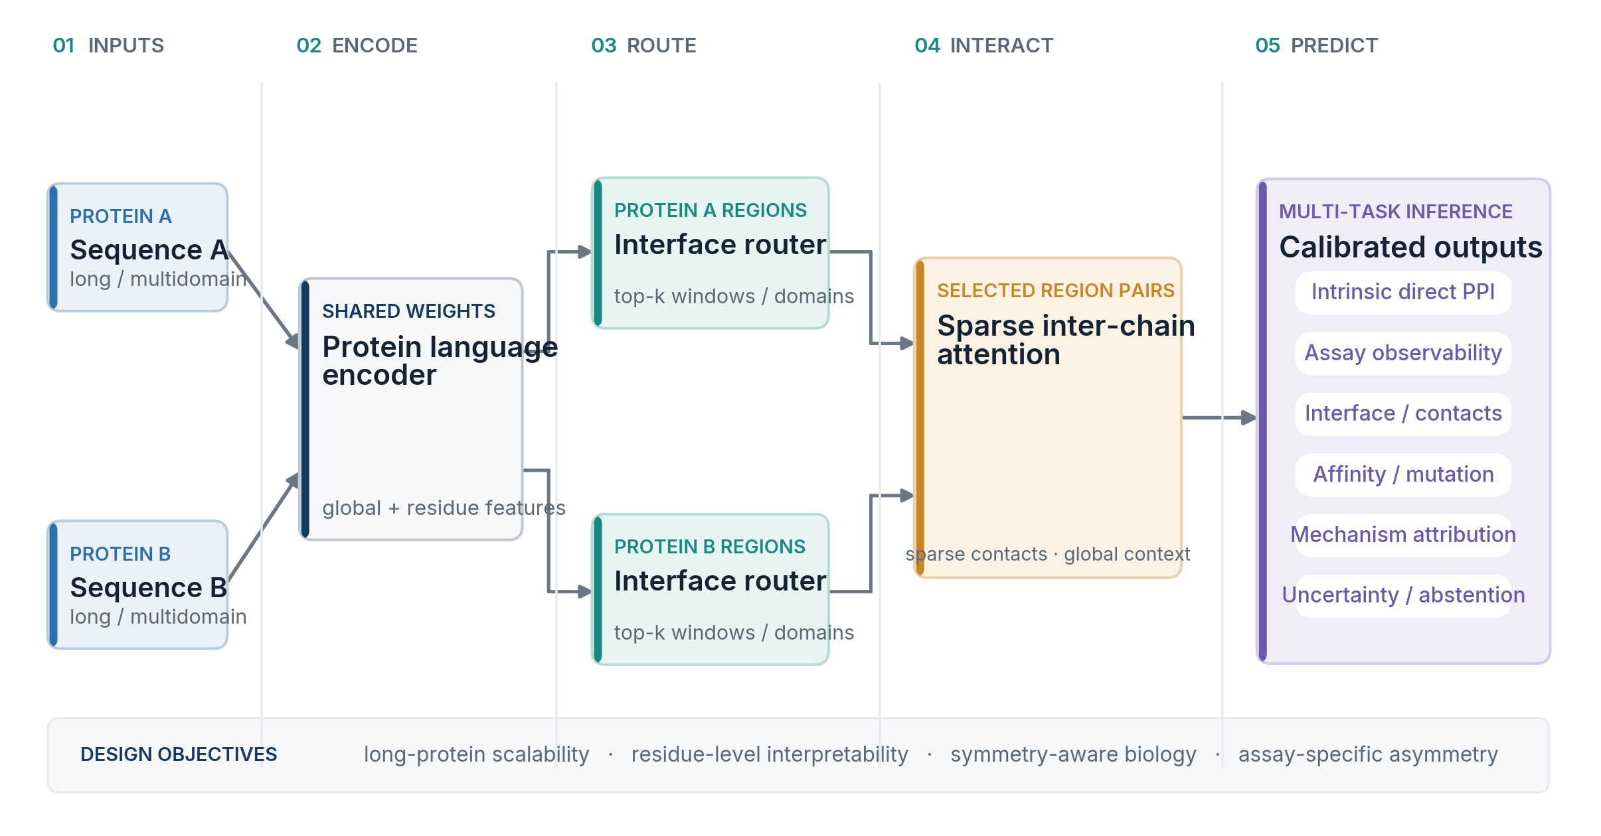
Figure 2. Sparse local-to-global pair architecture. A shared sequence encoder feeds learned interface-region routers, sparse inter-chain attention and calibrated multi-task prediction heads.

4.3 Multi-task heads
Head | Role
Intrinsic interaction | Symmetric binary probability with calibration and uncertainty.
Assay observation | Potentially asymmetric probability conditioned on assay/design.
Interaction type | Direct binary, stable co-complex, transient, motif-mediated, functional association.
Interface/contact | Residue interface masks and sparse cross-chain contact probabilities.
Affinity | Kd/pKd or Delta G when labels and conditions are sufficiently standardized.
Mutation effect | Disruption/neutral/enhancement and, where available, DeltaDeltaG.
Mechanism expert | Soft attribution to biochemical interaction regimes.

4.4 Counterfactual mutation consistency
Mutation data provide a biologically stringent regularizer because the model must predict interaction-specific changes rather than generic protein damage. For a disruptive mutation in A, the score with B should decrease. A neutral mutation should preserve the score. A compensatory double mutation should recover interaction relative to the disrupted single mutant.
f(S_A_mut, S_B) < f(S_A_wt, S_B) for disruptive mutations
|f(S_A_neutral, S_B) - f(S_A_wt, S_B)| small for neutral mutations
f(S_A_mut1, S_B_mut2) > f(S_A_mut1, S_B_wt) for rescue mutations
Use ranking and margin losses when exact thermodynamic values are inconsistent across laboratories. SKEMPI 2.0, PPIRef/PPIformer, IntAct mutation annotations and eSIG-Net-style edgetic labels are relevant sources and baselines [11,21-23].

4.5 Structural and coevolutionary teacher distillation
A privileged teacher may receive experimentally determined structures, PINDER/PPIRef interfaces, predicted complex confidence, paired-MSAs or coevolutionary scores. The deployed student receives only raw sequences. Distillation targets can include interaction logit, interface-region ranking, sparse contact map, contact uncertainty and mutation sensitivities. Teacher pseudo-labels must be generated strictly within the training partition; no structure or MSA derived from a held-out family may cross the split boundary.

4.6 Mechanism-disentangled mixture of experts
A single decision surface may poorly represent obligate globular complexes, transient regulators, short linear motifs, IDRs, coiled coils, membrane proteins and immune-recognition systems. Use a shared trunk with soft experts and an entropy/usage regularizer to avoid collapse. The principal evaluation question is whether experts improve C3 and mechanism-held-out generalization, not whether they increase random-split accuracy.
P(z_AB = 1 | A, B) = sum_k pi_k(A,B) x P_k(z_AB = 1 | A,B)

4.7 Conditional competition and cooperation as a high-risk extension
For proteins A, B and C, predict whether C increases, decreases or leaves unchanged the A-B interaction. This formulation captures competitive binding, scaffolding, cooperative assembly, allostery and mutually exclusive paralogue occupancy. It is more biologically informative than independent pair classification but label-limited; it should be a later work package after the binary model and data semantics are stable.
Delta p_AB|C = P(A interacts B | C) - P(A interacts B)

4.8 Objective function
L = L_PU + lambda_obs L_assay + lambda_contact L_contact + lambda_aff L_affinity + lambda_mut L_mutation + lambda_pairMLM L_pairMLM + lambda_cf L_counterfactual + lambda_cal L_calibration
Do not activate every term initially. Introduce losses in a curriculum and require that each added objective improves strict held-out performance or calibration. A multi-task loss that only improves an easy mixed split should be rejected.

5. Data programme and evidence warehouse

5.1 Evidence-first data model
The primary stored object should be an evidence record, not a consensus pair. Each record links exact protein constructs to an assay, publication, biological context and outcome. Consensus labels are generated downstream under a versioned policy. This preserves disagreement, enables assay modeling and supports future re-labeling without rebuilding raw ingestion.

5.2 Evidence tiers
Tier | Evidence | Training treatment
Tier 1A | Orthogonally supported direct binary interaction | Strong intrinsic positive anchor
Tier 1B | Single-assay systematic binary positive | Positive with assay-specific reliability
Tier 2 | Direct contact inferred within a structurally resolved complex | Positive for direct-contact/contact heads
Tier 3 | AP-MS or co-complex association | Co-complex head; not automatically direct binding
Tier 4 | Functional association or predicted STRING evidence | Weak supervision or pair-language pretraining only
Negative A | Experimentally supported noninteraction | Strong intrinsic negative anchor; rare
Negative B | Assay-tested negative | Observation-head negative; latent intrinsic state uncertain
Unlabeled | Untested or unknown pair | PU learning and hard-example mining

5.3 Recommended source roles
Source family | Primary information | Recommended use
HuRI | Systematic human binary interactions | Direct binary positives, systematic assay search space and negative observations
IntAct / IMEx | Fine-grained curated molecular interactions and mutation annotations | Publication, method, construct and mutation provenance
BioPlex and related AP-MS maps | Cell-line-specific co-complex associations | Co-complex and context heads; not direct-positive by default
STRING | Experimental plus predicted functional associations | Weak pair-language pretraining with evidence-channel separation
PINDER / PPIRef / PDB | Resolved and predicted structural interfaces | Contact supervision, interface clustering and teacher models
SKEMPI 2.0 and mutation datasets | Binding-energy changes upon mutation | Counterfactual and affinity heads after deduplication
Negatome / confirmed noninteractors | Curated noninteraction evidence | Strong negative anchors with provenance
Tissue/cell atlases | Context-specific abundance and association | Optional context modeling and evaluation strata

5.4 Core data entities
Entity | Required fields
ProteinSequence | Internal ID, accession, isoform, exact sequence, organism, taxonomy, canonical mapping, version dates.
Construct | Parent sequence, boundaries, mutations, tags/fusions, orientation and assay role.
Evidence | Protein/construct pair, outcome, interaction type, assay, publication, date, confidence and curator.
Context | Cell/tissue, compartment, condition, expression/abundance, PTMs and perturbations.
StructureInterface | Structure IDs, chain mapping, contact definition, interface residues, cluster ID and confidence.
MutationObservation | Wild type, mutant, partner, direction/effect, DeltaDeltaG, conditions and provenance.
SplitAssignment | Versioned cluster IDs, split policy, cutoff date and contamination audit.
PseudoLabel | Teacher/model version, score, uncertainty, generation date and allowed training partition.

5.5 Conflict resolution and consensus
Do not resolve conflicting evidence by silent majority vote. Store all records and compute task-specific consensus using an explicit hierarchy: direct orthogonal evidence; systematic binary assays; structural direct contact; single small-scale reports; co-complex association; functional association. A pair may simultaneously be a direct positive in one context and assay-negative in another. This is valid information, not necessarily noise.

5.6 Negative and unlabeled curriculum
- Begin with confirmed negatives and high-confidence positives to stabilize the intrinsic head.
- Add assay-tested negatives to the observation head, with latent intrinsic labels marginalized.
- Introduce localization-, taxonomy-, length- and family-matched unlabeled pairs.
- Add paralogue-swapped and homology-matched decoys to suppress family shortcuts.
- Run periodic retrieval mining: score unknown pairs, remove known positives/close duplicates, and add high-scoring examples as hard unlabeled data.
- Retain a small easy-random set only as a sanity check and training stabilizer.

5.7 Data versioning and governance
- Freeze raw source snapshots with checksums and source release dates.
- Version every mapping rule, construct-resolution rule and consensus-label policy.
- Produce immutable split manifests before final model selection.
- Record every sequence and structural nearest-neighbor audit result for each test example.
- Require data-card review by both a protein scientist and an ML/benchmark lead.

6. Leak-resistant benchmark and evaluation framework

6.1 Split ladder
The benchmark should provide a ladder of increasingly realistic evaluation settings rather than one train/test split. The primary paper should lead with C3, sequence-cluster, time and assay holdouts. C1 remains useful only to diagnose memorization and compare with prior literature.
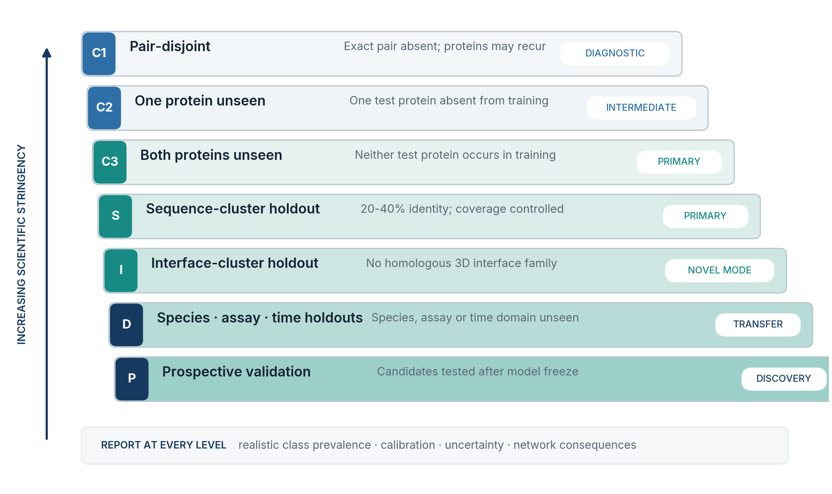
Figure 3. Evaluation ladder from diagnostic pair-disjoint testing to prospective validation after model freeze.
Split | Definition | Question answered
C1 pair-disjoint | Exact pair absent; either protein may occur in training | Diagnostic only
C2 one-protein-unseen | At least one test protein absent from training | Intermediate generalization
C3 both-proteins-unseen | Neither test protein occurs in training | Primary binary benchmark
Sequence-cluster | Complete sequence clusters assigned to one split at 40%, 30% and 20% identity with coverage control | Homology generalization
Interface-cluster | No structurally similar interface family crosses splits | Novel binding-mode generalization
Species holdout | Entire species omitted from supervised training | Evolutionary transfer
Assay holdout | One platform or assay family withheld | Assay robustness
Publication-time | Evidence first reported after a historical cutoff is test-only | Discovery simulation
Pretraining strict | Held-out families removed from PLM pretraining | Exposure audit

6.2 Pair-level metrics
- AUPRC at realistic prevalence, not only balanced test sampling.
- Precision at fixed candidate budgets such as top 100, 500, 1,000 and 10,000 per proteome.
- Recall at 90%, 95% and 99% precision.
- Matthews correlation coefficient and class-conditional error rates.
- Performance stratified by nearest-train identity, length, disorder, localization, organism, assay and interaction mechanism.

6.3 Calibration and uncertainty
Report Brier score, negative log-likelihood, expected calibration error, reliability diagrams and risk-coverage curves. TUnA demonstrates that uncertainty can reduce false positives for unseen sequences [24]. The consortium should define a selective operating mode: the model may abstain when uncertainty is high or the example lies outside the supported mechanism/sequence domain.

6.4 Interface, affinity and mutation metrics
Task | Required metrics
Interface residues | AUPRC, IoU, precision at fixed residue budget, unseen-interface stratification
Residue contacts | Precision at L/10 or fixed top-k; contact AUPRC; calibration
Affinity | RMSE/MAE, Pearson/Spearman, per-complex-family splits, condition-aware analysis
Mutation effect | Sign accuracy, disruptive/neutral/enhancing macro-F1, DeltaDeltaG correlation, within-scan ranking
Rescue mutations | Pairwise ranking and recovery of compensatory epistasis

6.5 Proteome and graph-level evaluation
After scoring candidate pairs for a complete proteome, evaluate predicted network density, degree distribution, connected components, clustering coefficients, assortativity, spectral properties, complex recovery, pathway enrichment, functional coherence and cross-species transfer. Follow PRING-style separation between pairwise classification and graph reconstruction [6].
Sequence scores must be reported before graph-constrained decoding. A graph prior can improve a network while degrading the validity of individual sequence predictions; these effects must remain distinguishable.

6.6 Prospective and temporal validation
The strongest endpoint is the number of validated novel direct PPIs per experimental test. Candidate selection should jointly optimize confidence, low uncertainty, novelty relative to train families/interfaces, biological relevance and diversity. Include matched low-score controls, high-uncertainty controls and known positive/negative assay controls. Freeze model weights and the candidate-selection rule before experiments begin.
A publication-time holdout is the minimum viable approximation when wet-lab validation is unavailable. Determine the first supporting publication for each pair, remove close sequence/interface homologues from training and assess discovery of later evidence.

7. Training, ablation and inference strategy

7.1 Baseline ladder
- Sequence similarity/interolog baseline with no learned model.
- Protein-level metadata and degree-only controls to expose shortcuts.
- Frozen PLM bi-encoder with symmetric MLP classifier.
- RAPPPID-style recurrent twin network.
- D-SCRIPT contact-inspired model.
- TUnA uncertainty-aware baseline.
- Reproducible PLM-interact/SWING/PPLM-like pair encoders where code and compute permit.
- Assay-aware PU baseline without sparse interface routing.
- Full iPIN-OpenPPI model.

7.2 Phased development programme
Phase | Focus | Exit deliverable
Phase 0 | Data and benchmark | Frozen evidence v1, contamination audit and baseline scripts
Phase 1 | Assay-aware PU baseline | Demonstrate label-model value before architectural complexity
Phase 2 | Sparse interface routing | Compare sparse vs full attention at matched compute/parameters
Phase 3 | Mutation and contact supervision | Test mechanistic and C3 gains
Phase 4 | Structure/MSA distillation | Quantify teacher value and leakage risk
Phase 5 | Mechanism experts | Measure improvement on mechanism-held-out sets
Phase 6 | Proteome retrieval | Bi-encoder index plus cross-encoder reranking
Phase 7 | Model freeze and validation | Temporal/prospective evaluation

7.3 Go/no-go gates
Gate | Minimum acceptance criterion
PU formulation gate | Must improve C3 AUPRC/calibration and reduce assay-stratified error versus BCE with random negatives.
Sparse routing gate | Must match or improve strict performance with lower memory/runtime for long pairs and provide meaningful interface localization.
Mutation gate | Must improve held-out mutation ranking without harming interaction calibration.
Teacher gate | Must improve strict test sets after pseudo-label leakage audits; otherwise remove teacher.
Expert gate | Must improve at least two mechanism-held-out strata and avoid expert collapse.
Proteome gate | Must meet predefined precision at the experimental candidate budget and yield plausible network density.

7.4 Ablation matrix
Axis | Variants
Label model | BCE random negatives / matched negatives / nnPU / latent assay model
Encoder | Frozen / LoRA-adapted / full fine-tuning / strict pretrained
Pair interaction | Pooled bi-encoder / concatenated cross-encoder / full cross-attention / sparse routing
Local selection | Fixed windows / learned top-k / entmax / oracle interface windows
Supervision | Interaction only / +contacts / +mutation / +affinity / +pair MLM
Teacher | None / structure / coevolution / combined
Experts | Single head / mechanism MoE / assay MoE
Uncertainty | Temperature scaling / deep ensemble / spectral GP / evidential alternatives

7.5 Optimization and batching
- Bucket by total pair length and, for sparse models, estimated selected-window count.
- Use token-based rather than pair-based batch accounting.
- Start with BF16, activation checkpointing, FlashAttention where validated, fused AdamW and gradient clipping.
- Use parameter-efficient tuning for benchmark iteration; reserve full fine-tuning for finalists.
- Sample evidence records rather than consensus pairs when training assay heads; avoid repeatedly oversampling highly studied pairs without weighting.
- Maintain independent validation sets for intrinsic interaction, assay prediction, interface and mutation tasks to prevent one task from dominating model selection.

7.6 Proteome-scale retrieval
A full pair cross-encoder is not feasible over hundreds of millions of pairs. Train a fast symmetric bi-encoder to retrieve a few hundred or thousand candidate partners per protein. Rerank candidates with the sparse pair cross-encoder. Calibrate the two-stage system jointly and measure retrieval recall of known interactions before evaluating reranking precision.
For large protein collections, precompute normalized embeddings and use an approximate-nearest-neighbor index. Where the intrinsic relation is not well represented by a simple dot product, use multiple learned query/key projections or late interaction over a small set of region embeddings.

8. Arrhenius implementation and compute strategy

8.1 Relevant platform characteristics
Arrhenius is an HPE Cray EX EuroHPC system. The GPU partition contains 382 nodes. Each node contains four NVIDIA GH200 Grace Hopper superchips, each with 96 GB HBM and 128 GB LPDDR memory, together with four 72-core Arm CPUs. Each GPU node has four Slingshot links and approximately 1.8 TB local NVMe. The shared Lustre system has a 25 PB Disk tier rated at 260 GiB/s aggregate and a 2 PB Flash tier rated at 15 million random 4K-read IOPS [25].
Component | Project-relevant specification
GPU node | 4 x GH200; 384 GB aggregate HBM; 512 GB aggregate Grace LPDDR; 288 Arm CPU cores
GPU partition | 382 nodes
CPU thin node | 2 x AMD EPYC 9755, 256 total cores, 768 GB RAM
CPU fat node | 2 x AMD EPYC 9745, 256 total cores, 3 TB RAM
Local storage | Approximately 1.8 TB NVMe per node
Shared Disk | 25 PB Lustre; no backup
Shared Flash | 2 PB Lustre NVMe; high random IOPS; no backup
Scheduler/launcher | Slurm; mpprun recommended for many applications; srun also documented
Containers | Apptainer supported; multi-node Slingshot-aware containers require validation/support

8.2 Mapping workloads to resources
One four-GH200 node is appropriate for ingestion-pipeline tests, adapter/full fine-tuning of medium backbones, sparse-attention profiling, contact-head experiments and long-sequence memory studies. Four to eight nodes are a sensible initial scale for pair-language pretraining, strict PLM experiments and large ablation sweeps. CPU and fat nodes should handle MMseqs2 clustering, interface processing, publication/provenance joins, paired-MSA preparation and evaluation bootstraps.
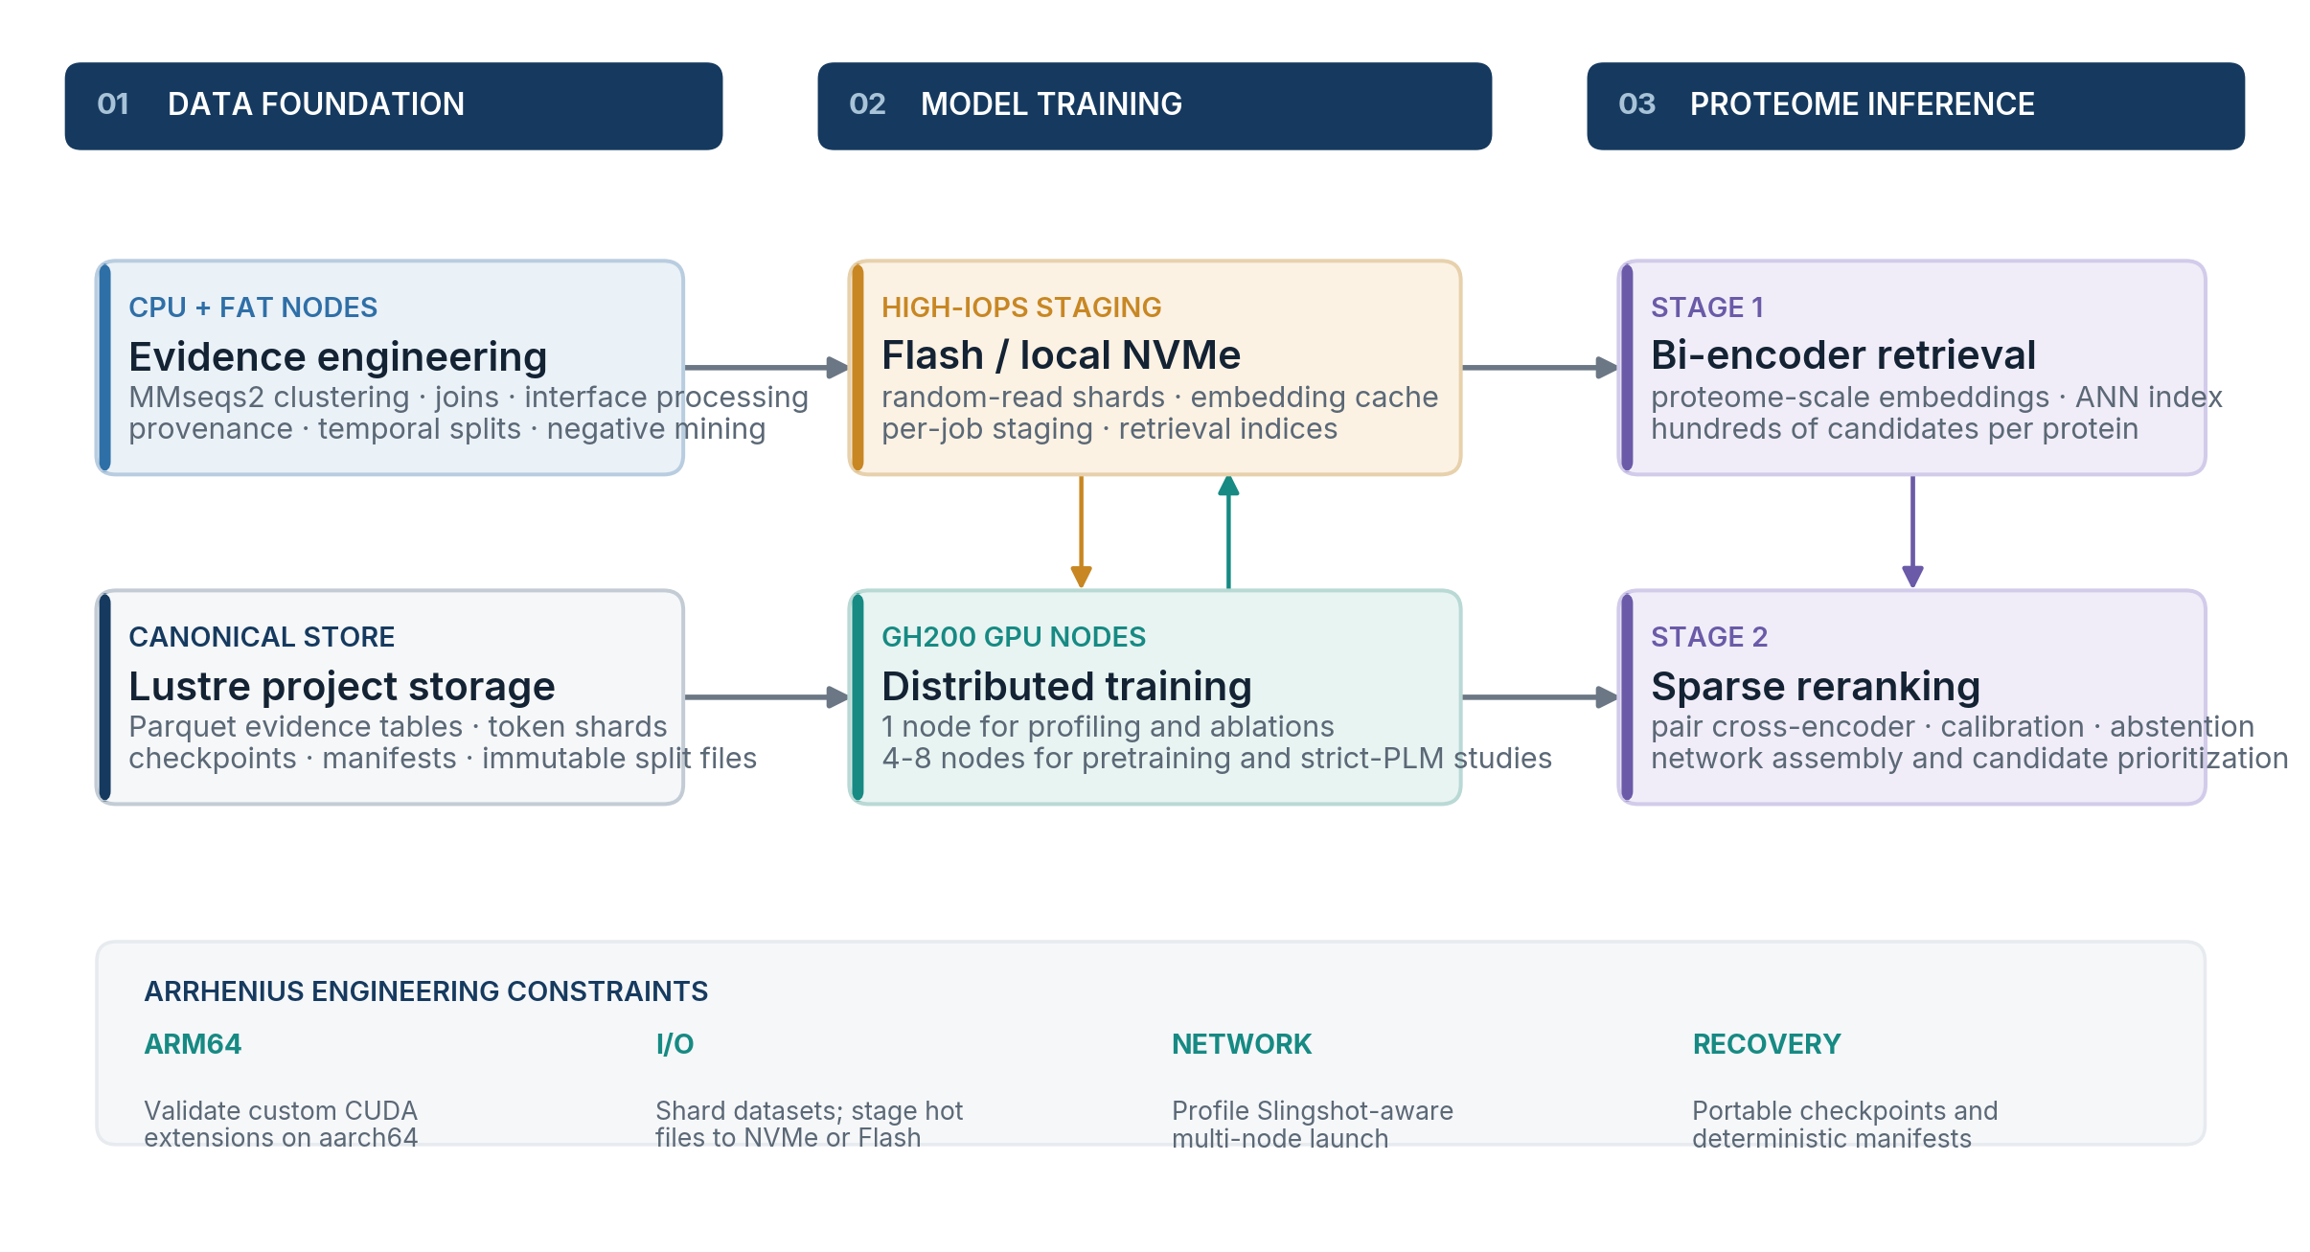
Figure 4. Arrhenius-aligned division of data engineering, distributed model training and two-stage proteome-scale inference.

8.3 Arm/aarch64 compatibility
GH200 nodes use Arm CPUs. Validate all compiled dependencies on aarch64 early: FlashAttention, xFormers, custom CUDA kernels, fused optimizers, FAISS GPU, MMseqs2, structural alignment tools and any C++/CUDA extensions. Keep a minimal native environment as a fallback even when Apptainer is used. Build and cache validated container images before requesting large allocations.

8.4 Multi-node communication
NAISS documentation states that multi-node applications require Slingshot support and advises contacting support for efficient containerized inter-node communication [26]. Before production training, benchmark all-reduce bandwidth and scaling efficiency on 1, 2 and 4 nodes using the intended PyTorch/NCCL stack. Do not assume nominal hardware scale translates directly into training throughput.

8.5 Storage and I/O layout
- Store canonical, versioned Parquet evidence and sequence tables on project Disk.
- Store frequently accessed token shards, embedding indices and many-small-file workloads on Flash when an allocation is justified.
- Stage epoch shards and temporary checkpoints to node-local NVMe; copy durable artifacts back asynchronously.
- Avoid one file per protein or pair. Use sharded memory-mapped arrays, Arrow/Parquet row groups or WebDataset-style tar shards.
- Store protein sequences once and reference them by integer ID from evidence/pair tables.
- Because Arrhenius Disk and Flash are not backed up, replicate irreplaceable metadata, source manifests and final checkpoints to institutional storage.

8.6 Distributed training recommendations
- Begin with data parallelism; introduce FSDP/ZeRO when optimizer state or activations require sharding.
- Use BF16, activation checkpointing and length-aware gradient accumulation.
- Shard checkpoints per rank but produce periodic consolidated, portable model states.
- Track tokens/s/GPU, achieved FLOPs, HBM use, communication fraction, data wait time and checkpoint overhead.
- Run deterministic smoke tests and exact-data-subset regression tests before long jobs.

8.7 Compute-budgeting formula
Compute requests should be based on measured throughput rather than model parameter count alone. After profiling, estimate GPU-hours as follows:
GPU-hours = total processed tokens / (measured tokens per second per GPU x 3600) x inefficiency factor x number of repeated runs
The inefficiency factor should include evaluation, checkpointing, failed jobs, data stalls and multi-node scaling loss. A proposal should separate mandatory benchmark/baseline compute from optional scale-up experiments. The first allocation should prioritize a complete leakage-controlled study over one oversized model run.

8.8 Reproducibility on Arrhenius
- Pin source commit, container digest, module versions, CUDA/NCCL versions and data manifest in every run.
- Log Slurm job ID, node list, GPU topology, seeds and exact split version.
- Use experiment hashes derived from model, data and optimization configuration.
- Save calibration objects, retrieval indices and threshold policies together with model weights.
- Maintain a small CPU/GPU reproducibility fixture that can be executed after software or system upgrades.

9. Work packages, governance and 24-month roadmap

9.1 Work packages
WP | Title | Primary deliverables
WP0 | Scientific framing and governance | Definitions, evidence ontology, target organisms, direct-vs-co-complex policy, review cadence
WP1 | Evidence warehouse | Source snapshots, construct resolution, provenance schema, conflict-preserving ingestion
WP2 | Benchmark and leakage audit | C1-C3, sequence/interface/species/assay/time/pretraining splits and baseline suite
WP3 | Assay-aware PU model | Latent observation model, identifiability tests, calibration and uncertainty
WP4 | Sparse pair architecture | Window proposer, sparse cross-attention, contact head and long-sequence scaling
WP5 | Mechanistic supervision | Mutation consistency, affinity, structure/MSA teacher and mechanism experts
WP6 | Proteome retrieval and validation | Bi-encoder retrieval, reranking, graph evaluation and experimental/temporal validation
WP7 | Infrastructure and release | Arrhenius stack, containers, workflow automation, model/data cards and public release

9.2 Recommended role ownership
Role | Accountability
Scientific lead | Defines biological claim, interaction taxonomy, acceptance criteria and experimental priorities.
Data/benchmark lead | Owns source ingestion, provenance, splits, contamination audits and data cards.
Model lead | Owns architecture, optimization, ablations and uncertainty.
Structural/co-evolution lead | Owns interface clustering, teacher features, paired-MSAs and leakage controls.
HPC/MLOps lead | Owns Arrhenius environments, scaling, storage, workflow and reproducibility.
Experimental lead | Owns assay selection, construct design, controls and prospective validation.
Statistics lead | Reviews PU identifiability, calibration, uncertainty and significance testing.

9.3 Indicative roadmap
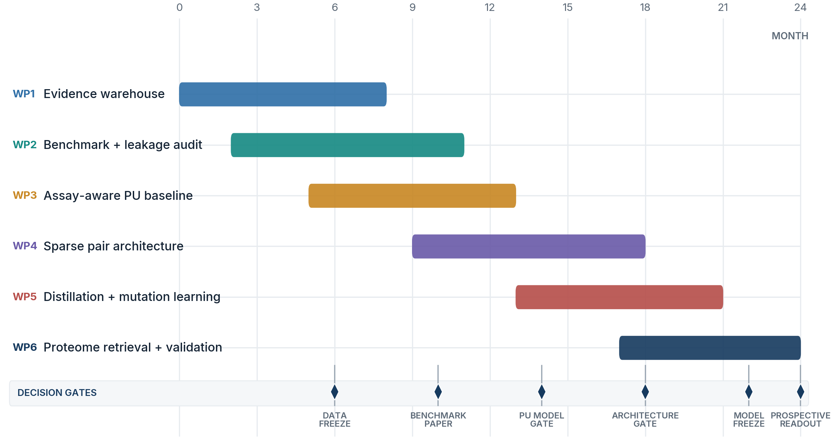
Figure 5. Indicative 24-month programme. Work packages overlap intentionally; model work begins only after a usable evidence and split pipeline exists.

9.4 Milestones
Month | Milestone
M3 | Evidence ontology and initial source ingestion complete
M6 | Evidence warehouse v1 and first immutable split manifests
M10 | Leakage audit and benchmark manuscript-ready results
M14 | Assay-aware PU model passes go/no-go gate
M18 | Sparse architecture passes long-sequence and C3 gate
M21 | Teacher/mutation/expert ablation freeze
M22 | Proteome candidate-generation model freeze
M24 | Temporal/prospective validation readout and release package

9.5 Governance cadence
- Weekly technical stand-up for WP dependencies and blockers.
- Biweekly model/data review with fixed dashboards for leakage, calibration and strict-split performance.
- Monthly scientific decision meeting with recorded decisions and model/data freeze status.
- Quarterly external expert review focused on biological validity, negative-label policy and prospective validation.
- No benchmark change after final model-selection begins without explicit version increment and full baseline rerun.

10. Risk register and mitigation plan
Risk | Likelihood | Impact | Mitigation
Latent model is non-identifiable | High | High | Use repeated assays, orthogonal anchors, assay priors, sensitivity analysis and simpler PU baselines.
Strict splits leave too little data | High | Medium | Use multiple strictness levels, pretraining/finetuning separation and report uncertainty; do not weaken the primary split silently.
Public PLM leakage dominates gains | High | High | Run strict smaller PLM track and nearest-pretraining similarity analysis.
Assay metadata incomplete | High | Medium | Represent missingness explicitly; restrict assay-aware claims to well-annotated subsets.
Construct-to-sequence mapping fails | Medium | High | Store exact constructs when available; exclude ambiguous cases from strict benchmark.
Sparse proposer selects wrong regions | Medium | High | Warm-start with structural interfaces, use oracle-window upper bound and retain global/fallback path.
Mixture-of-experts collapse | Medium | Medium | Load balancing, entropy regularization, expert dropout and mechanism-stratified validation.
Teacher introduces hidden leakage | High | High | Generate pseudo-labels only inside split, version teachers, audit template/MSA provenance.
Proteome inference false positives | High | High | Calibrated selective prediction, realistic prevalence, retrieval/rerank validation and candidate diversity constraints.
aarch64 dependency incompatibility | Medium | Medium | Early smoke builds, native fallback environment, avoid unmaintained custom kernels.
Multi-node scaling is poor | Medium | Medium | Profile 1/2/4 nodes, optimize I/O and communication, prefer more independent runs if scaling is inefficient.
Storage overload or data loss | Medium | High | Shard data, stage locally, monitor quotas and replicate irreplaceable artifacts off-system.
No experimental validation capacity | Medium | High | Secure collaboration early; maintain publication-time validation as minimum viable route.

10.1 Statistical reporting
Use bootstrap confidence intervals clustered by protein family or interaction component rather than treating pairs as independent. Pre-register the primary benchmark, metric and model-selection criterion. For multiple ablations, report effect sizes and confidence intervals, not only best-point estimates. Maintain a hidden final test whose labels are inaccessible during model development where operationally possible.

11. Publication, release and experimental validation strategy

11.1 Three-paper strategy
Paper | Working title | Core contribution
Paper 1 | Beyond Random Splits: a Time-, Homology-, Interface- and Assay-Controlled Benchmark for Sequence-Based PPI Prediction | Evidence warehouse, split protocol, leakage audit, baseline reevaluation and graph metrics.
Paper 2 | Assay-Aware Positive-Unlabeled Learning with Sparse Interface Attention for Sequence-Based PPI Prediction | Latent observation model, sparse architecture, uncertainty, mutation/contact supervision and strict ablations.
Paper 3 | Prospective Proteome-Scale Interaction Discovery with a Sequence-Only Model Distilled from Structural and Evolutionary Teachers | Retrieval system, model freeze, candidate selection and prospective/temporal validation.

11.2 Public release package
- Versioned benchmark manifests and contamination-audit reports.
- Evidence ontology and ingestion code, subject to source licenses.
- Baseline implementations and frozen evaluation harness.
- Model checkpoints for public-PLM and strict tracks where licensing permits.
- Calibration objects, thresholds, retrieval index recipes and network-evaluation scripts.
- Model card describing supported organisms/mechanisms, known blind spots and prohibited interpretations.
- Data card describing assay composition, construct coverage, missingness, conflicts and split logic.

11.3 Candidate selection for wet-lab validation
Candidate ranking should be pre-registered and should not select only the highest raw score. A balanced panel should include high-confidence low-uncertainty novel pairs, mechanism-diverse pairs, proteins of biological interest, nearest-neighbor-distant examples, high-uncertainty examples and matched negative controls. Construct design should be informed by predicted interface regions while preserving full-length context where feasible.
Report assay success/failure separately from biological positive/negative results. A failed expression or construct test is not a validated noninteraction. Use at least one orthogonal follow-up for the most important positives whenever practical.

11.4 Claims that should be avoided
- Do not claim prediction of in-vivo interaction from sequence alone without context qualification.
- Do not call randomly sampled unknown pairs true negatives.
- Do not present random-split AUROC as evidence of novel partner discovery.
- Do not describe structure/teacher-distilled outputs as sequence-independent evidence if the teacher used homologous templates or paired MSAs.
- Do not compare models across different negative distributions without prevalence correction and matched evaluation.

12. Decisions required at project kickoff
Decision | Question for the consortium
Target scope | Human only, multi-species, or staged human + model organisms?
Interaction definition | Direct binary only for primary task, or direct + co-complex multi-task?
Sequence representation | Canonical isoform only, or systematic construct/isoform support from day one?
Strict track | How much compute is reserved for decontaminated PLM pretraining?
Assay focus | Which assay families have enough metadata to support explicit observability modeling?
Structural teachers | PINDER/PPIRef only, or also AlphaFold/ColabFold pseudo-complexes?
Organism holdouts | Which species define realistic transfer and future application?
Prospective validation | Which laboratory, assay capacity and candidate budget are available?
Release policy | Open weights/data manifests, controlled evidence subsets, or staged release?
Success criterion | Primary metric and minimum precision at the intended experimental budget.

Recommended default decisions
- Primary task: direct physical heteromeric interaction; co-complex as a separate auxiliary task.
- Primary benchmark: C3 + 30% sequence-cluster + publication-time holdout; interface-cluster analysis on the structural subset.
- Initial organisms: human plus yeast and E. coli for evolutionary transfer, with species-held-out tests.
- Initial backbone: medium public ESM-2-like encoder with LoRA plus a smaller strict pretrained encoder.
- First model milestone: global pair representation with assay-aware PU learning before sparse routing.
- Prospective target: 200-500 tested pairs if laboratory capacity permits; otherwise a strict temporal benchmark with later publications.
BOTTOM LINE
Arrhenius provides sufficient GPU memory, CPU capacity, local NVMe and interconnect bandwidth for this programme. The principal bottleneck is not compute. It is constructing labels and benchmarks that measure novel biochemical compatibility rather than recognition of familiar proteins, interfaces, assays, sources or network topology.

Appendix A. Proposed evidence-record schema
Field | Type | Meaning
evidence_id | String/UUID | Immutable internal evidence identifier
protein_a_id / protein_b_id | Integer | Internal sequence IDs; canonical unordered pair stored separately
construct_a_id / construct_b_id | Integer/null | Exact tested constructs, including boundaries and tags
organism_a / organism_b | Taxonomy ID | Species and strain where relevant
interaction_type | Ontology term | Direct binary, direct in complex, co-complex, functional association
assay_type | PSI-MI term | Experimental detection method
orientation | Categorical | Bait/prey or directional assay role
outcome | Positive/negative/ambiguous/failed | Separate technical failure from biological negative
publication_id | PMID/DOI | Primary evidence source
first_evidence_date | Date | Used for temporal splits
context_id | Foreign key | Cell, tissue, compartment, condition, PTMs
confidence | Numeric + scheme | Source confidence with explicit scale
curation_source | Categorical | HuRI, IntAct, BioPlex, PDB, etc.
raw_source_release | String/date | Source snapshot and checksum
split_eligibility | Flags | Reasons for inclusion/exclusion from strict tasks

Appendix B. Loss components and implementation notes
Loss | Form | Notes
L_PU | Non-negative PU or latent likelihood | Treat unknowns as unlabeled; estimate or tune class prior by organism/assay.
L_assay | Binary/categorical observation loss | Condition on assay, orientation and construct; model missing metadata.
L_contact | Focal/BCE + structural consistency | Sparse residue pairs; mask unresolved regions.
L_affinity | Huber/Gaussian NLL | Condition-aware where possible; normalize measurement type.
L_mutation | Classification/ranking/regression | Prefer within-complex ranking and sign consistency.
L_pairMLM | Paired or multi-chain masked modeling | Use only evidence channels allowed for the training tier.
L_counterfactual | Margin/ranking consistency | Disruptive, neutral and compensatory mutations.
L_calibration | Brier/NLL/regularizer | May be post-hoc for final calibration; avoid optimizing ECE directly without care.
L_router | Entropy/load balancing | Prevent expert or window-selector collapse.

Appendix C. Baseline reproduction checklist
- Use one immutable split manifest and one negative/unlabeled sampling policy across all comparable baselines.
- Report parameters, trainable parameters, maximum length, truncation policy, tokens processed and GPU-hours.
- Retune decision thresholds on validation data for each prevalence scenario.
- Evaluate raw scores and calibrated scores separately.
- Report results for C1, C2, C3 and strict cluster/time tests, not only the easiest setting.
- Measure per-protein degree and nearest-train sequence similarity correlation with predictions.
- Run sequence-shuffle, partner-swap and label-source probes to expose shortcuts.
- Repeat key models with at least three seeds; cluster bootstrap test examples for uncertainty intervals.
- Archive all logits and metadata so that future metrics can be recomputed without retraining.

Appendix D. Suggested primary model-selection score
A single score should not replace the full dashboard, but a predeclared composite can prevent cherry-picking. One option is a weighted geometric mean of strict C3 AUPRC, temporal AUPRC, calibration quality and high-precision recall, with a hard constraint on proteome network density. Example:
Score = (AUPRC_C3 x AUPRC_time x Recall_at_95pct_precision x (1 - normalized_Brier))^(1/4)
The exact weights and normalization must be selected before final model comparison. A model failing the precision or calibration constraint should not win because of a high AUROC.

Appendix E. Illustrative Arrhenius single-node Slurm skeleton
This is a template, not a guaranteed site-specific launch recipe. Confirm current module names, account, partition, GPU flags and launcher behavior in NAISS documentation. Multi-node container jobs require Slingshot-aware validation with NAISS support.
#!/bin/bash
#SBATCH -A <project_account>
#SBATCH -p gpu
#SBATCH -N 1
#SBATCH --gpus=4
#SBATCH -t 12:00:00
#SBATCH -J ipin_openppi
#SBATCH -o logs/%x-%j.out
#SBATCH -e logs/%x-%j.err
set -euo pipefail
# Load the current NAISS GPU/software stack or activate a validated Apptainer image.
# module load <site-recommended-modules>
export OMP_NUM_THREADS=8
export TOKENIZERS_PARALLELISM=false
export NCCL_DEBUG=WARN
# Stage sharded training data to node-local NVMe when appropriate.
# rsync -a /nobackup/proj/disk/<project>/data/shards/ "$TMPDIR/shards/"
srun python -m torch.distributed.run \
--standalone --nproc_per_node=4 \
train.py --config configs/pu_sparse_pair.yaml

Appendix F. First 12 decisive experiments
ID | Experiment | Decision
E1 | Random-negative BCE vs matched-negative BCE vs nnPU | Quantify label-policy impact under C3/time splits
E2 | Intrinsic-only vs intrinsic + assay head | Test whether assay modeling improves calibration and transfer
E3 | Symmetric vs unconstrained pair head | Measure biological invariance and orientation effects
E4 | Frozen vs LoRA vs full encoder tuning | Choose cost/performance point
E5 | Bi-encoder vs concatenated pair encoder | Establish joint-encoding value on strict splits
E6 | Full attention vs sparse routing | Performance, memory, runtime and long-sequence scaling
E7 | Fixed windows vs learned proposer vs oracle windows | Isolate routing quality from cross-attention capacity
E8 | +contact supervision | Test interface localization and C3 gains
E9 | +mutation consistency | Test edgetic and mechanistic generalization
E10 | +structure teacher / +MSA teacher | Quantify privileged information and leakage
E11 | Single expert vs mechanism MoE | Evaluate mechanism-held-out transfer and collapse
E12 | Two-stage proteome retrieval | Retrieval recall, rerank precision, calibration and graph fidelity

Appendix G. Selected references
1. Liu D, et al. PLM-interact: extending protein language models to predict protein-protein interactions. Nature Communications. 2025. doi:10.1038/s41467-025-64512-w.
2. Liu J, et al. A paired sequence language model for protein-protein interaction modeling. Nature Communications. 2026. doi:10.1038/s41467-026-70457-5.
3. Ullanat V, et al. Learning the language of protein-protein interactions. Nature Communications. 2026. doi:10.1038/s41467-025-67971-3.
4. Siwek JC, et al. Sliding Window Interaction Grammar (SWING): a generalized interaction language model for peptide and protein interactions. Nature Methods. 2025;22:1707-1719. doi:10.1038/s41592-025-02723-1.
5. Szymborski J, Emad A. A flaw in using pretrained protein language models in protein-protein interaction inference models. Nature Machine Intelligence. 2026;8:197-208. doi:10.1038/s42256-025-01176-7.
6. Zheng X, et al. PRING: Rethinking Protein-Protein Interaction Prediction from Pairs to Graphs. NeurIPS Datasets and Benchmarks Track. 2025. arXiv:2507.05101.
7. Kovtun D, et al. PINDER: The protein interaction dataset and evaluation resource. bioRxiv. 2024. doi:10.1101/2024.07.17.603980.
8. Lambourne L, et al. Experimental assessment of AI-based interactome mapping. Nature Communications. 2026. doi:10.1038/s41467-026-70942-x.
9. Sledzieski S, Singh R, Cowen L, Berger B. D-SCRIPT translates genome to phenome with sequence-based, structure-aware, genome-scale predictions of protein-protein interactions. Cell Systems. 2021;12:969-982.e6.
10. Szymborski J, Emad A. RAPPPID: towards generalizable protein interaction prediction with AWD-LSTM twin networks. Bioinformatics. 2022;38:3958-3967.
11. Bushuiev A, et al. Learning to design protein-protein interactions with enhanced generalization. ICLR. 2024. OpenReview:xcMmebCT7s.
12. Zhang J, et al. Predicting protein-protein interactions in the human proteome. Science. 2025;390:eadt1630. doi:10.1126/science.adt1630.
13. Burke DF, et al. Towards a structurally resolved human protein interaction network. Nature Structural & Molecular Biology. 2023.
14. Humphreys IR, et al. Computed structures of core eukaryotic protein complexes. Science. 2021. doi:10.1126/science.abm4805.
15. Lupo U, Sgarbossa D, Bitbol AF. Pairing interacting protein sequences using masked language modeling. Proceedings of the National Academy of Sciences. 2024. doi:10.1073/pnas.2311887121.
16. Joeres R, et al. Data splitting to avoid information leakage with DataSAIL. Nature Communications. 2025. doi:10.1038/s41467-025-58606-8.
17. Luck K, et al. A reference map of the human binary protein interactome. Nature. 2020;580:402-408. doi:10.1038/s41586-020-2188-x.
18. Huttlin EL, et al. Dual proteome-scale networks reveal cell-specific remodeling of the human interactome. Cell. 2021;184:3022-3040.e28.
19. del Toro N, et al. The IntAct database: efficient access to fine-grained molecular interaction data. Nucleic Acids Research. 2022;50:D648-D653.
20. Szklarczyk D, et al. The STRING database in 2023: protein-protein association networks and functional enrichment analyses for any sequenced genome of interest. Nucleic Acids Research. 2023;51:D638-D646.
21. Jankauskaite J, et al. SKEMPI 2.0: an updated benchmark of changes in protein-protein binding energy, kinetics and thermodynamics upon mutation. Bioinformatics. 2019;35:462-469.
22. Pan X, et al. eSIG-Net: an interaction language model that decodes the protein code of single mutations. Nature Methods. 2026. doi:10.1038/s41592-026-03086-x.
23. Liu D, et al. Mutation-effect dataset and fine-tuning analyses in PLM-interact. Nature Communications. 2025. doi:10.1038/s41467-025-64512-w.
24. Ko YS, Parkinson J, Liu C, Wang W. TUnA: an uncertainty-aware transformer model for sequence-based protein-protein interaction prediction. Briefings in Bioinformatics. 2024;25:bbae359. doi:10.1093/bib/bbae359.
25. NAISS. Arrhenius technical description. Accessed 2 August 2026. https://www.naiss.se/resources/arrhenius-technical-description/.
26. NAISS. Arrhenius High Performance Computing Quick Start. Updated 24 July 2026. https://hpc.pages.naiss.se/user-documentation/support-docs/arrhenius_hpc/quickstart/.
27. Blohm P, et al. Negatome 2.0: a database of non-interacting proteins derived by literature mining, manual annotation and protein structure analysis. Nucleic Acids Research. 2014.
28. Orchard S, et al. Protein interaction data curation: the International Molecular Exchange (IMEx) consortium. Nature Methods. 2012;9:345-350.
29. Porras P, et al. Towards a unified open access dataset of molecular interactions. Nature Communications. 2020;11:6144.
30. Evans R, et al. Protein complex prediction with AlphaFold-Multimer. bioRxiv. 2021. doi:10.1101/2021.10.04.463034.
31. Laman Trip DS, et al. A tissue-specific atlas of protein-protein associations from 7,811 human biopsies. Nature Biotechnology. 2025. doi:10.1038/s41587-025-02659-z.
32. Wang XW, et al. Assessment of community efforts to advance network-based prediction of protein-protein interactions. Nature Communications. 2023. doi:10.1038/s41467-023-37079-7.
33. Qi X, et al. Atlas of predicted protein complex structures across species and interaction contexts. Nature Communications. 2026. doi:10.1038/s41467-026-70884-4.
34. Bernett J, Blumenthal DB, List M. Cracking the black box of deep sequence-based protein-protein interaction prediction. Briefings in Bioinformatics. 2024;25:bbae076.
35. Schmirler R, et al. Fine-tuning protein language models boosts predictions across diverse tasks. Nature Communications. 2024. doi:10.1038/s41467-024-51844-2.
End of document

