**UNIT TEST**

Component

**API-CARS**

(Developed for a Nexu backend test)







**Created by José Gaxiola**

For this unit test, we consume all the endpoints requested using **Postman**.

1. **GET /brands**

List all models of the brand

URL: http://localhost/api-cars/brands

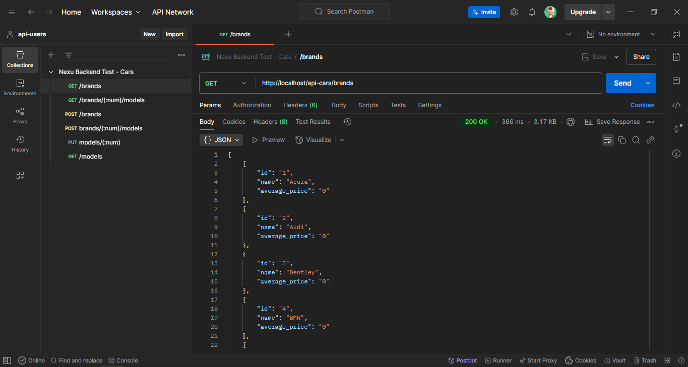

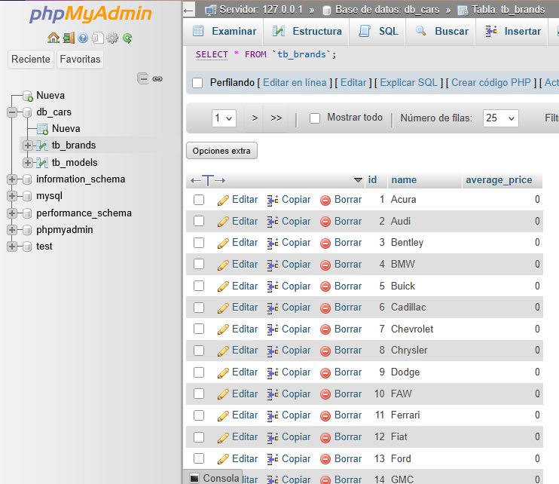

1. **GET /brands/(:id)/models**

List all models of the brand.

URL: http://localhost/api-cars/brands/1/models

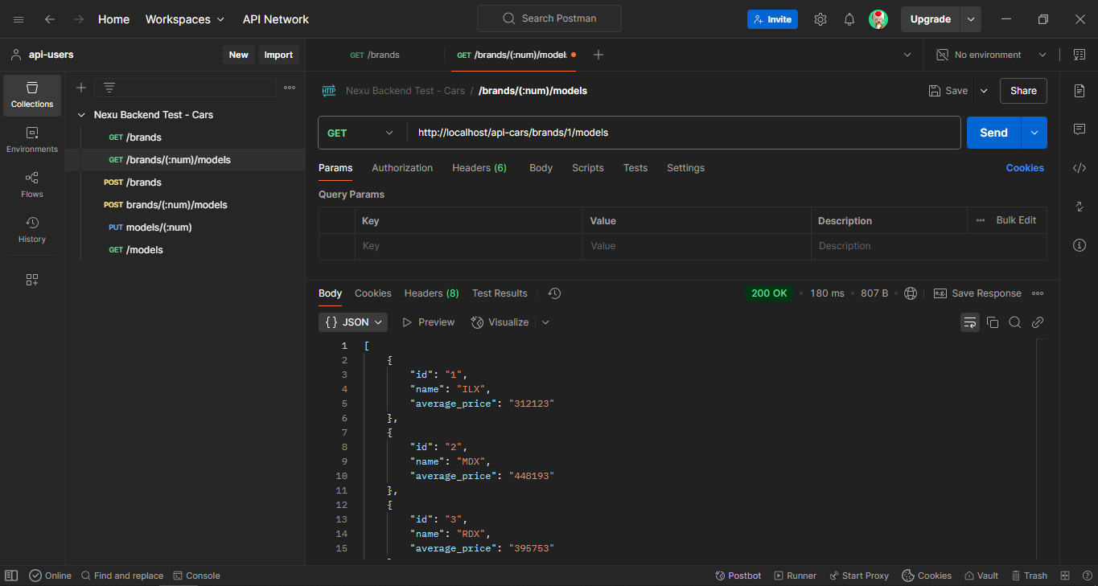

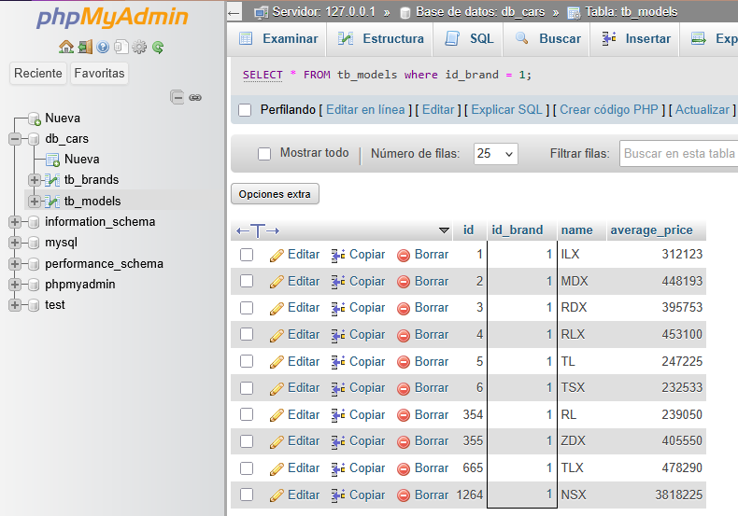

1. **POST /brands**

Add new brands.

URL: http://localhost/api-cars/brands

Parameters:

* name:Toyota
* average_price:300000

If a brand name is already in use return a response code and error message:

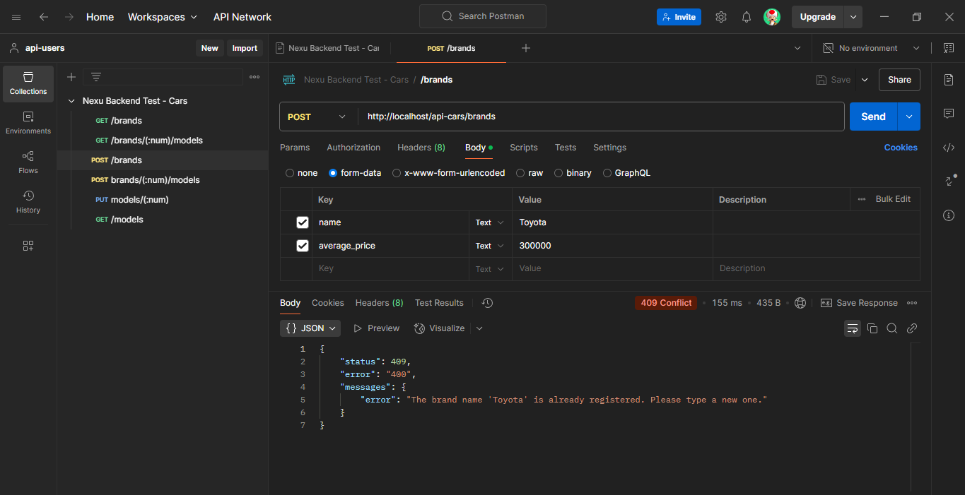

A brand name must be unique:

Parameters:

* name:Jalogax
* average_price:300521

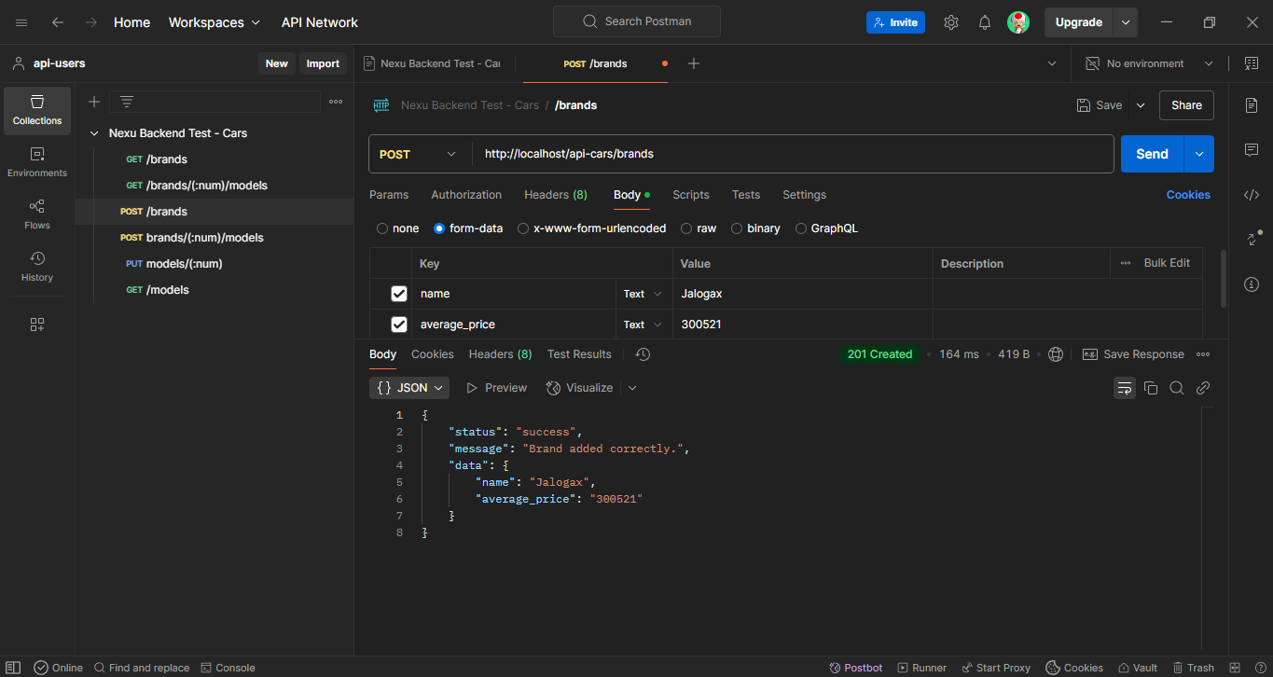

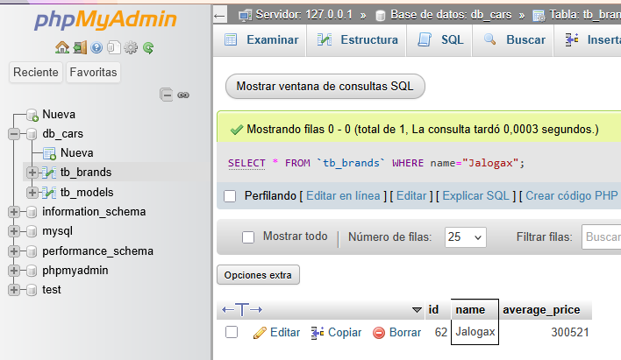

1. **POST brands/(:id)/models**

Add new model to a brand.

URL: <http://localhost/api-cars/brands/1/models>

Parameters:

* name:Prius
* average_price:406400

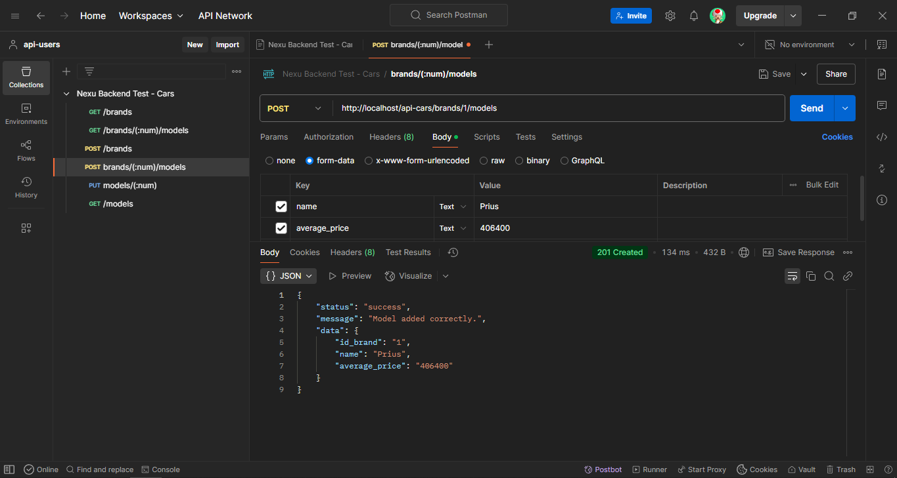

If the brand id doesn't exist return a response code and error message:

URL: <http://localhost/api-cars/brands/11154651/models>

Parameters:

* name:Prius
* average_price:406400

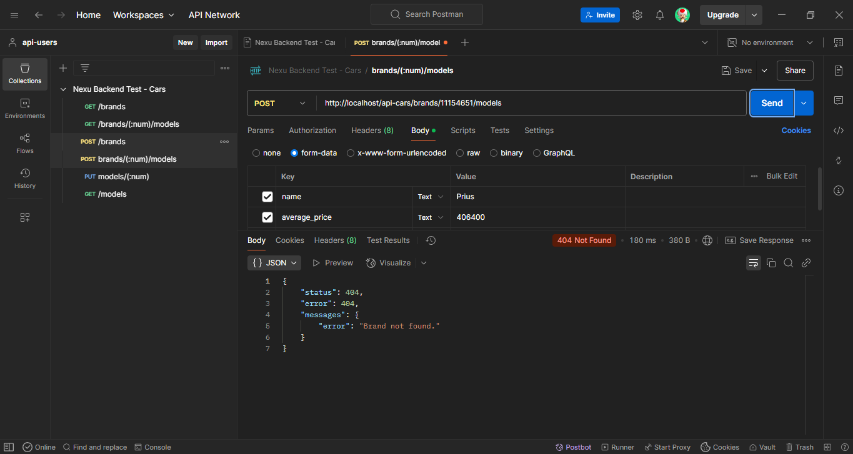

A model name must be unique inside a brand. If the model name already exists for that brand return a response code and error message reflecting it.

URL: http://localhost/api-cars/brands/1/models

Parameters:

* name:Prius
* average_price:406400

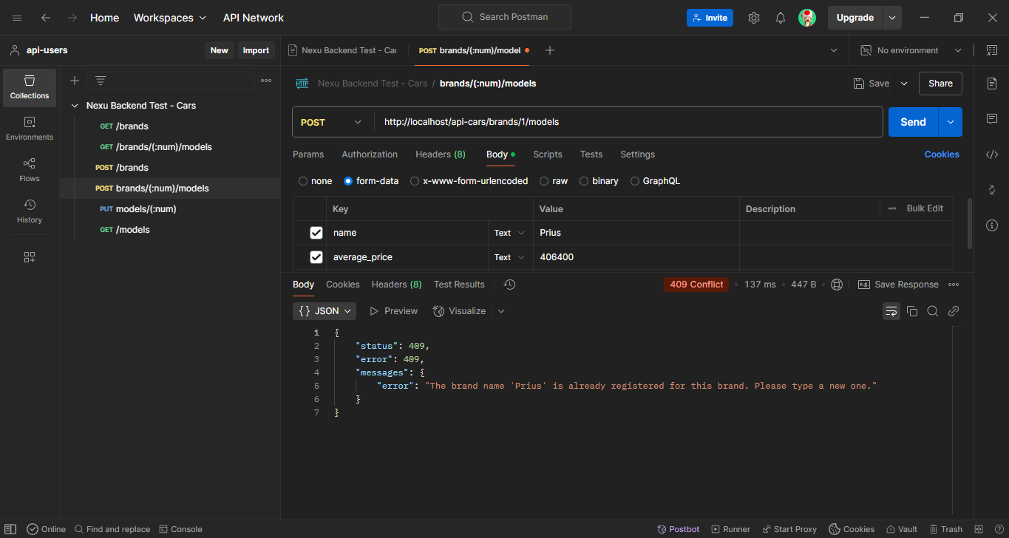

Average price is optional; if supply it must be greater than 100,000.

URL: http://localhost/api-cars/brands/1/models

Parameters:

* name:Jalogax model
* average_price:99999

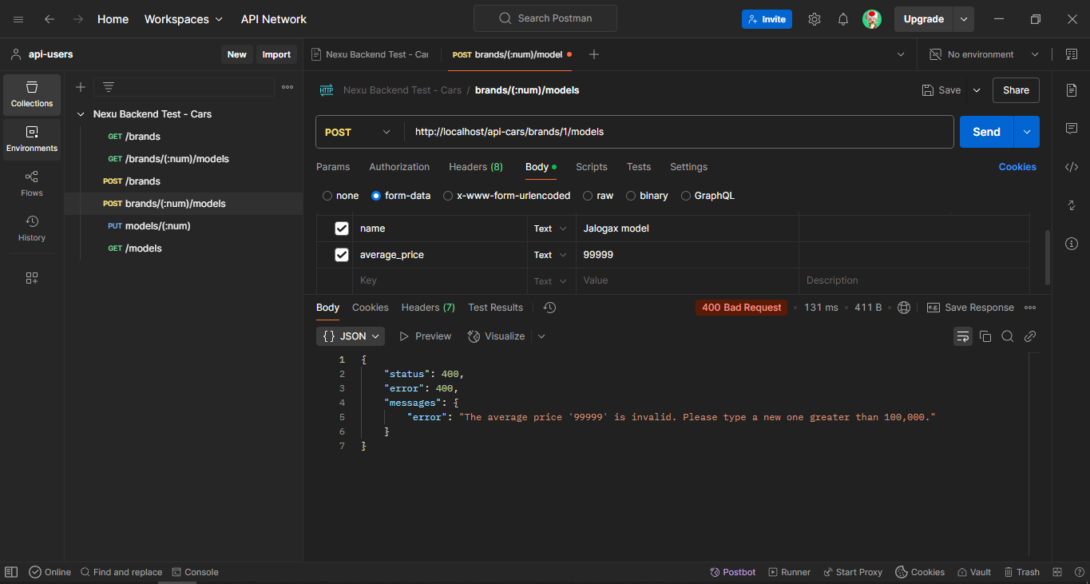

Parameters:

* name:Jalogax model
* average_price:100001

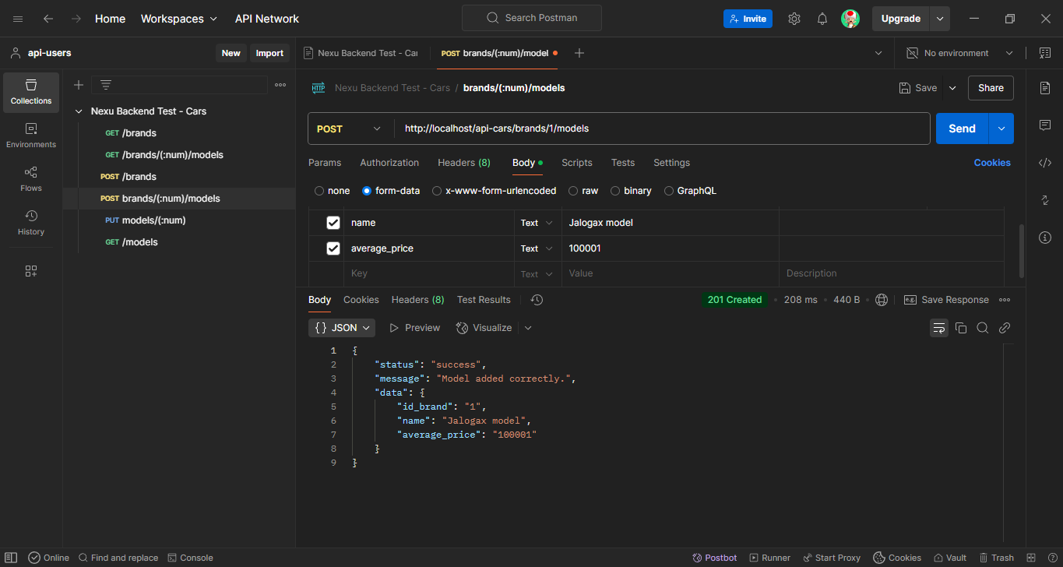

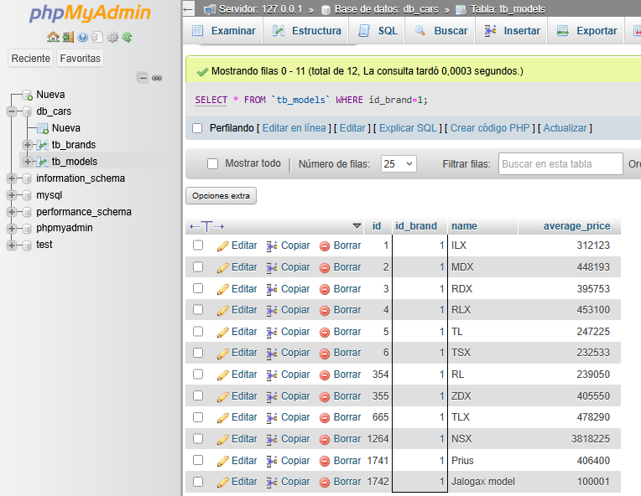

1. **PUT models/(:id)**

Update the average price of a model.

URL: http://localhost/api-cars/models/1

Parameters:

* {"average_price": 500000}

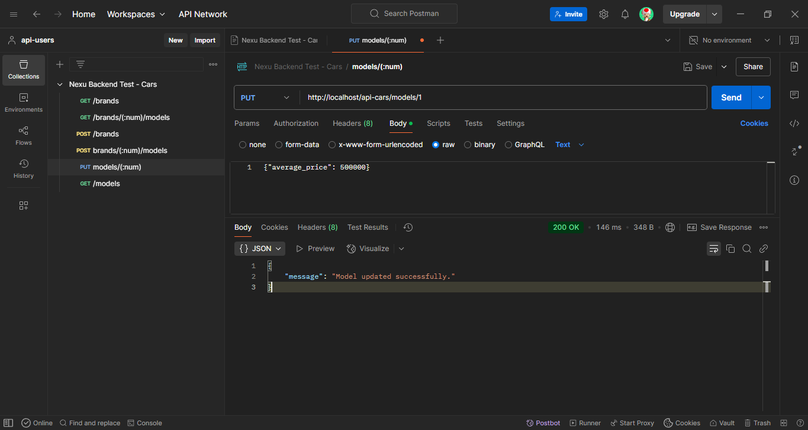

The average_price must be greater then 100,000.

URL: http://localhost/api-cars/models/1

Parameters:

* {"average_price": 500000}

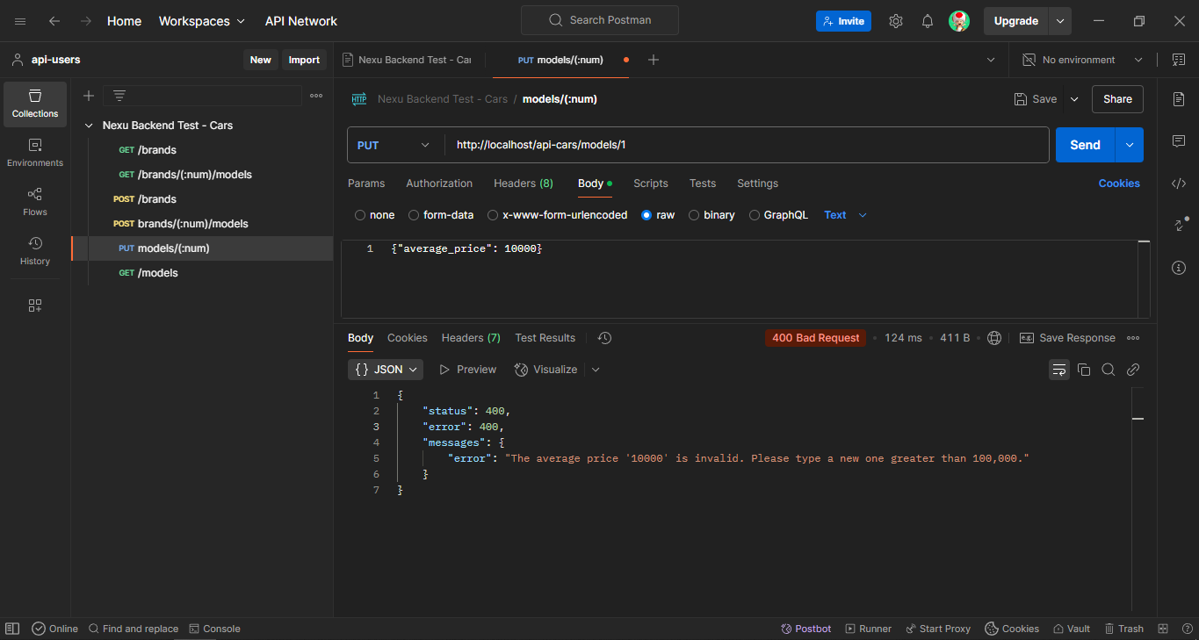

1. **GET /models**

List all models.

URL: http://localhost/api-cars/models

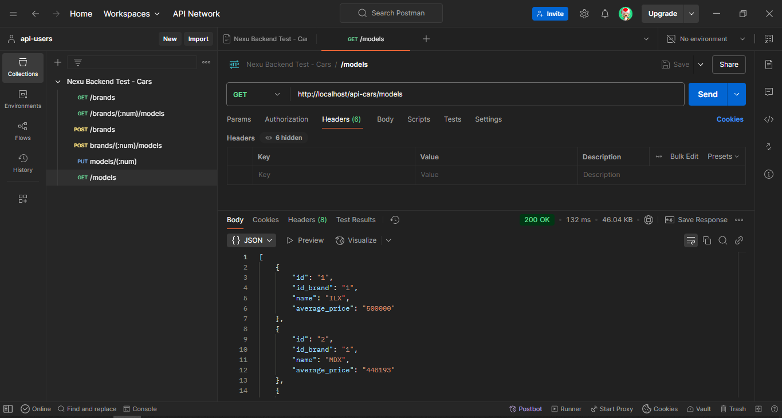

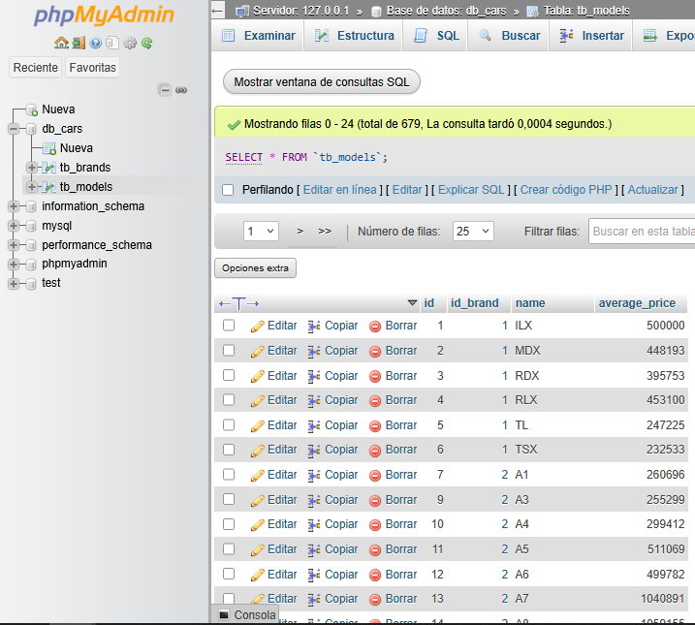

If greater param is included show all models with average_price greater than the param. If lower param is included show all models with average_price lower than the param.

URL: http://localhost/api-cars/models?greater=380000&lower=400000

