**IT629 - Introduction to Algorithm**

Assignment - 1

**Name : Patel Mahek Vishalkumar**

**Student ID : 202412068**

**1.** Use the random number generator to generate a sequence of N random integers, where N can have value 100, 1000, 2000, 5000 ... 100000 ... etc.

**Code :**

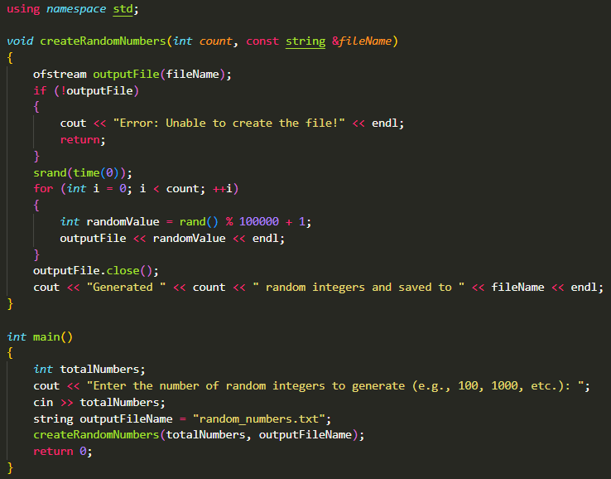

**Output :**



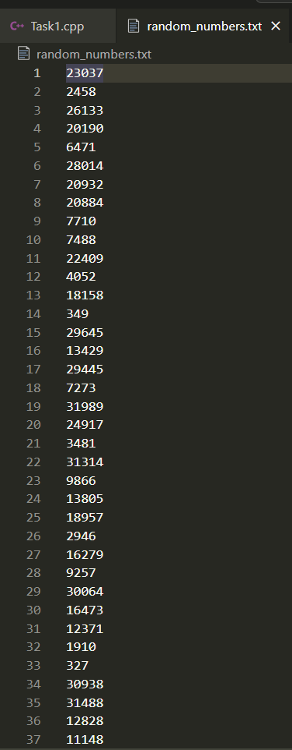

**2.** Program the insertion sort algorithm to sort N integers. Input and output are both in the form of txt files. Test the algorithm for small N.

**Code :**

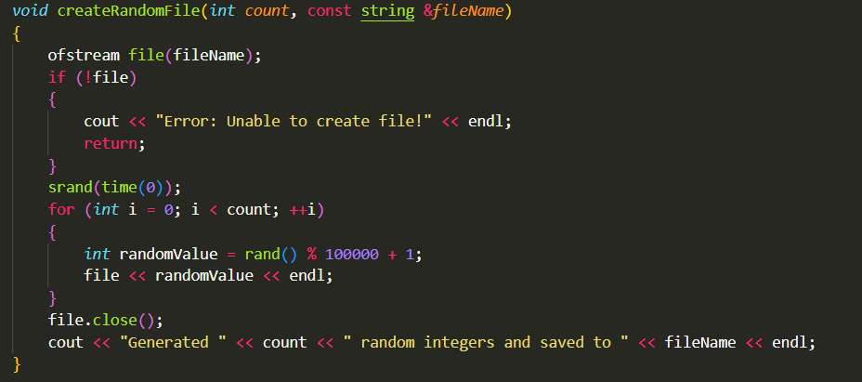

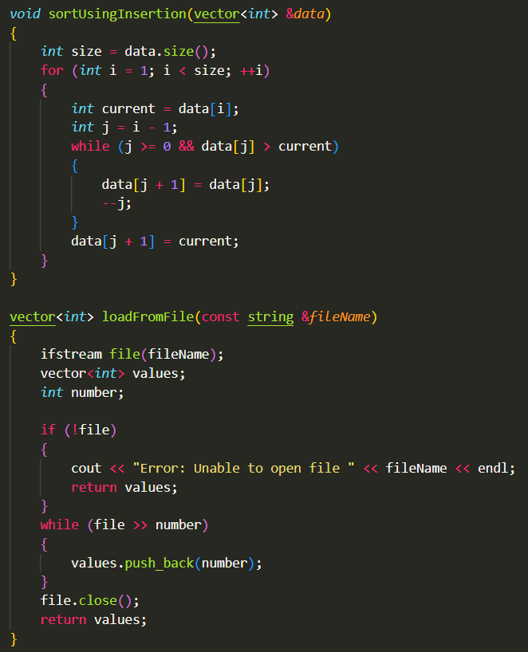

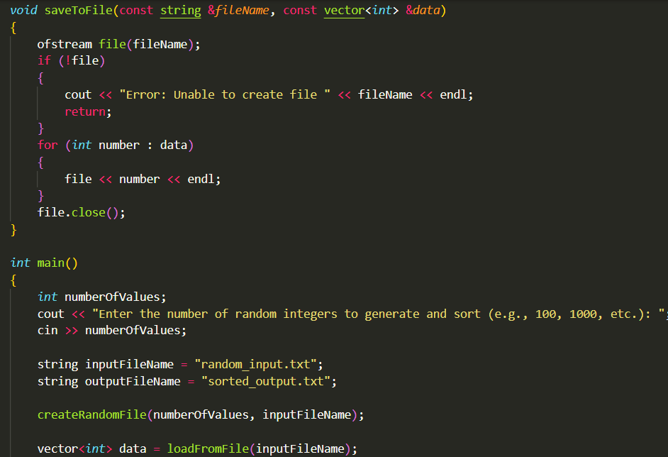

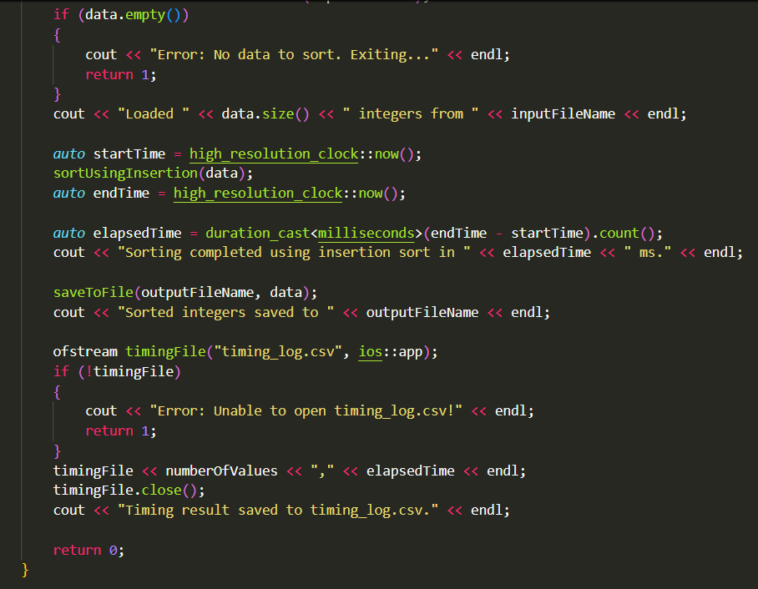

**Output:**

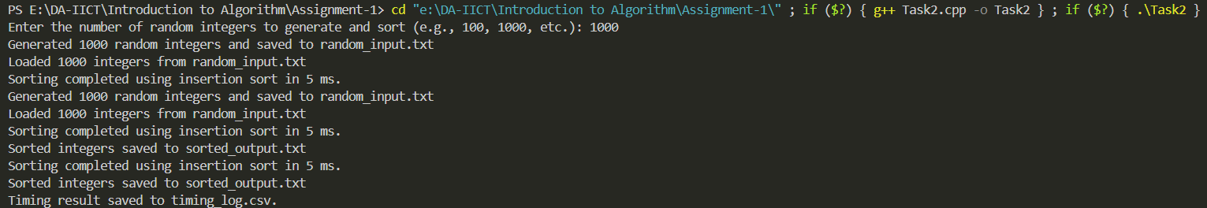

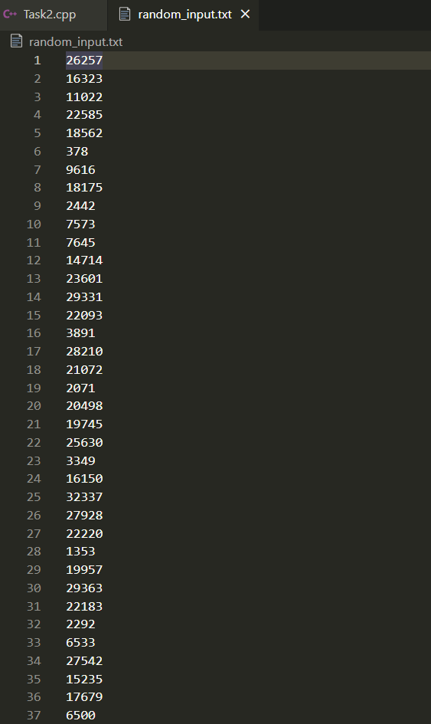

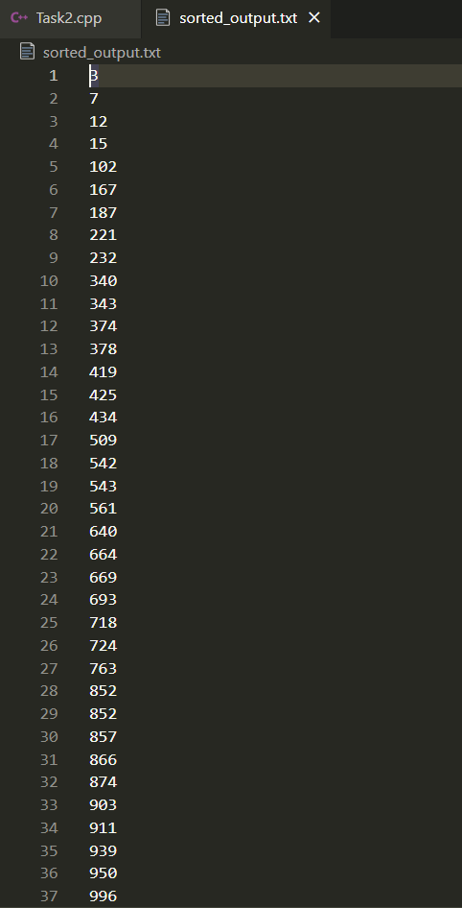

**3.** Measure the running time of the algorithm, and plot it as a function of N. Verify that the running time grows as N^2.

**Output 1:**



**Output 2:**

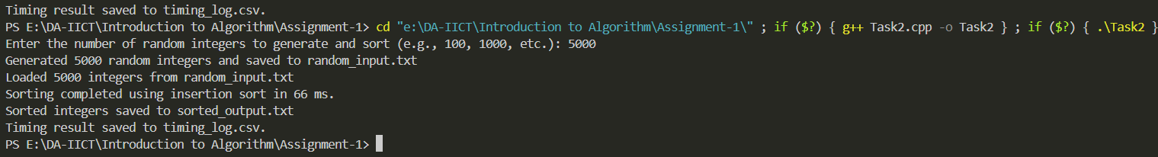

**Output 3:**

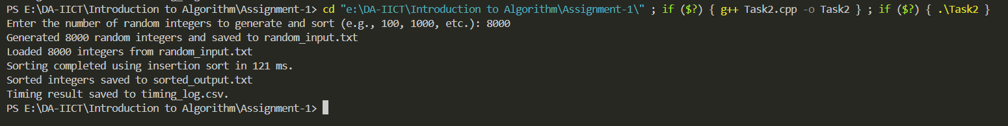

**Output 4:**

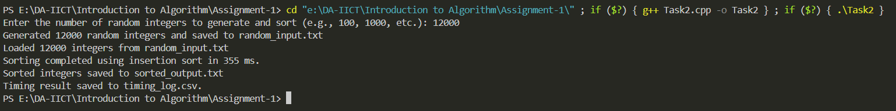

**Output 5:**

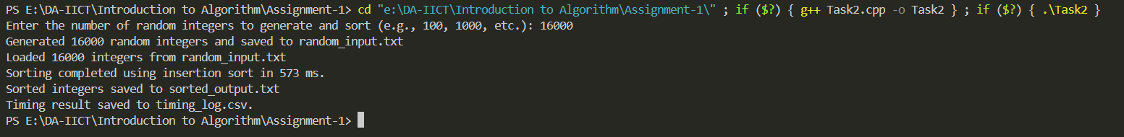

**Output 6:**

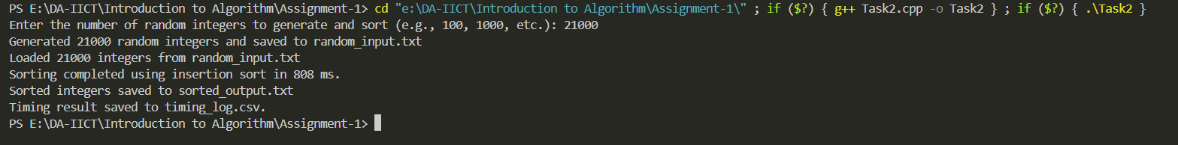

**4.** Repeat steps 2 and 3 with the merge-sort algorithm. Plot and verify that the running time grows as N*log(N).

**Code :**

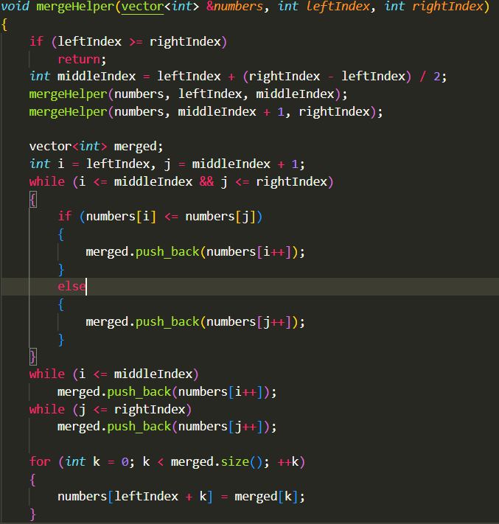

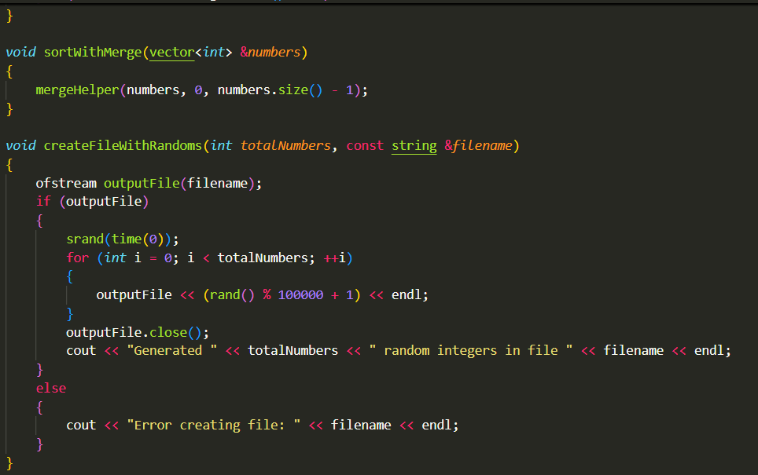

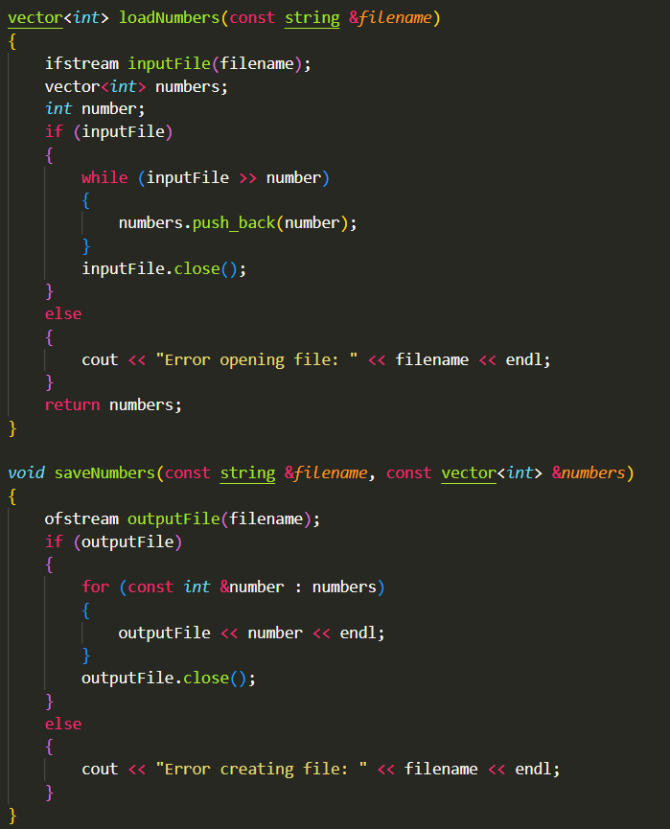

**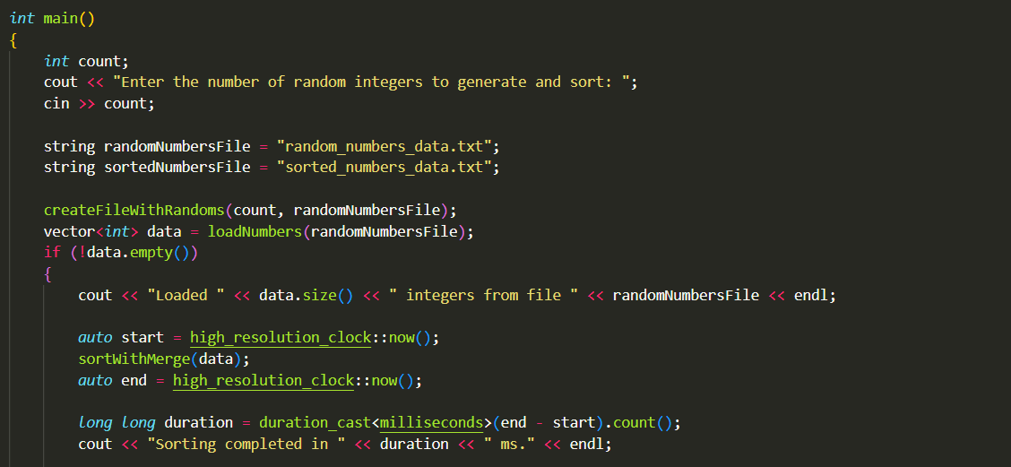  
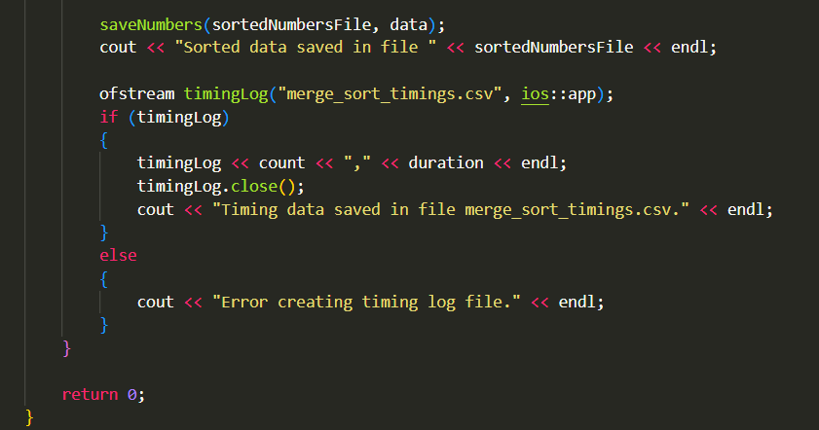**

**Outputs :**

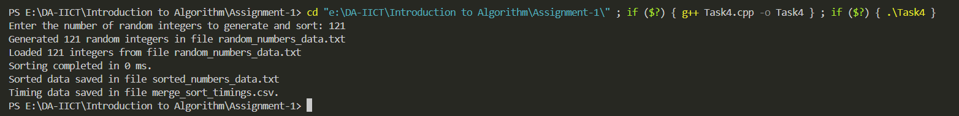

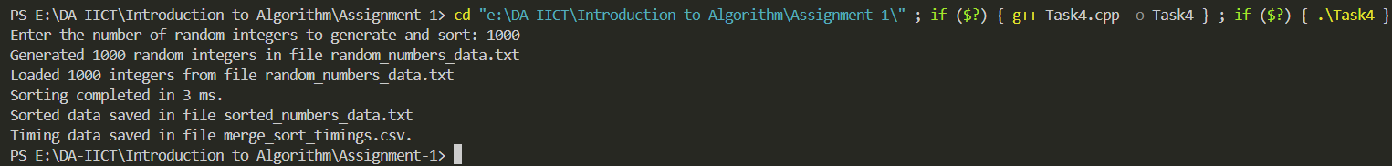

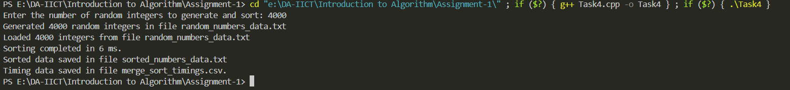

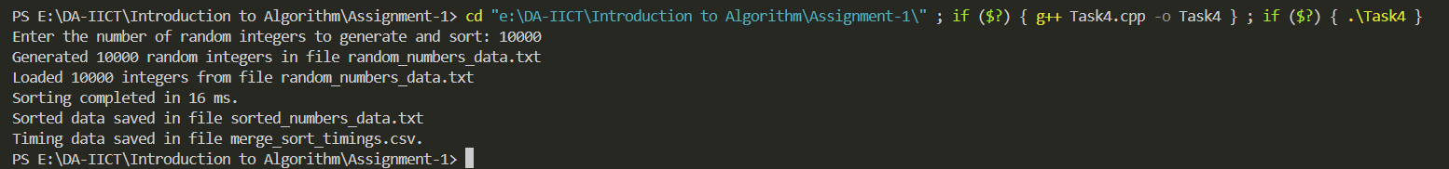

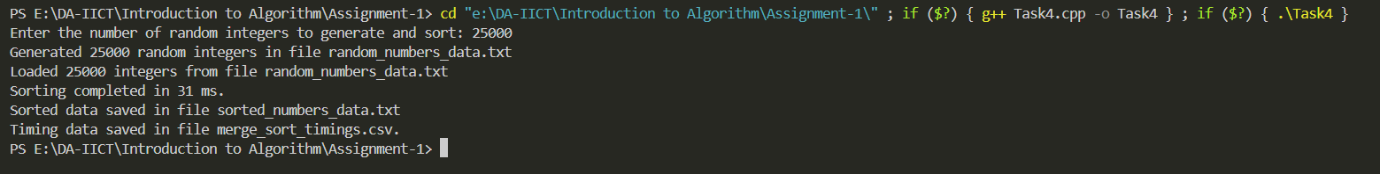

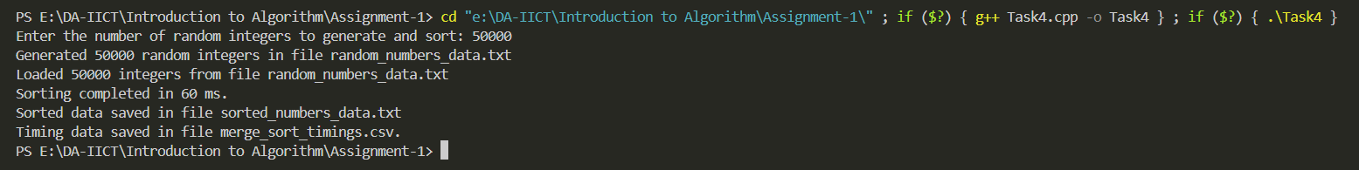

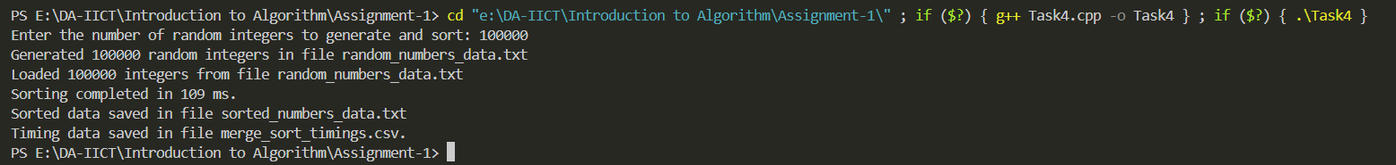

**5.** Compare the two plots. Do they cross?

Shown the comparison graph of both the algorithms with different scaling on Y axis for better visualization.

