**IT629 - Introduction to Algorithm**

Assignment – 3 & 4

**Name : Patel Mahek Vishalkumar**

**Student ID : 202412068**

1. Using the random number generator, generate N = 500 integer key values, as in the previous laboratory assignments.

**Code:**

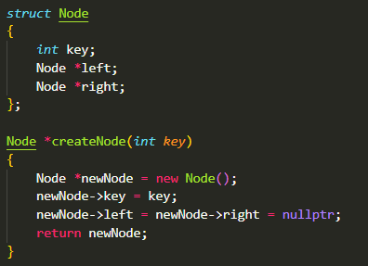

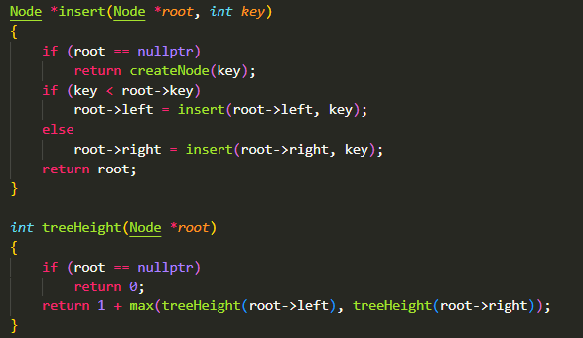

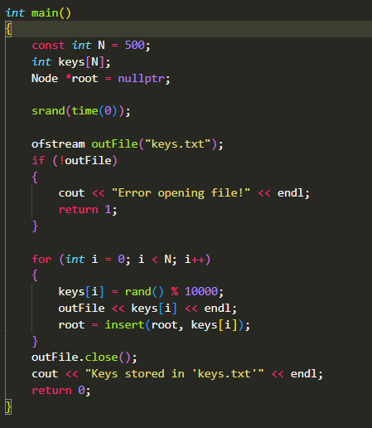

**Output:**



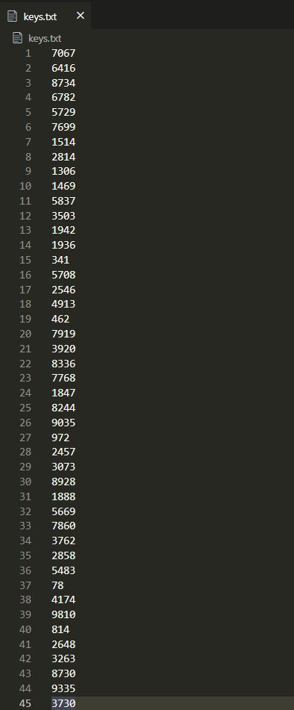

1. Generate a binary search tree from the above 500 key values, by implementing TREE-INSERT for every incoming node. Determine the height of the tree generated.

**Code:**

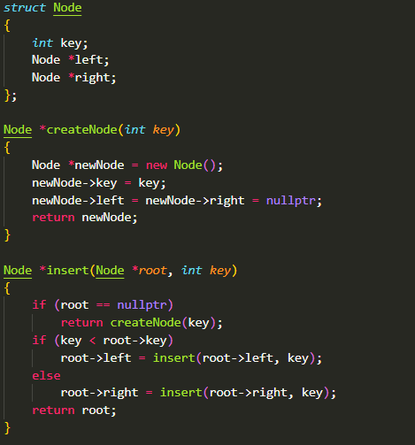

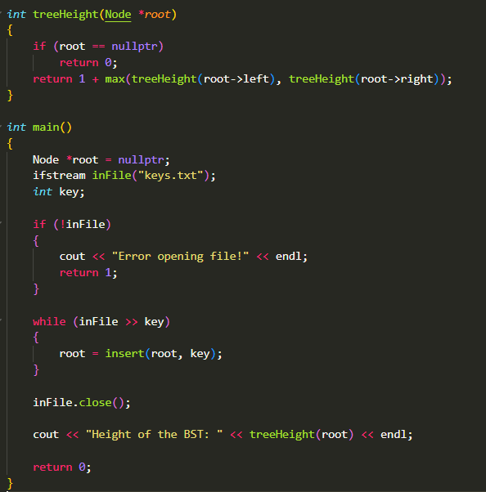

**Output:**



1. SORT the 500 key values using a sort program written by you earlier. Generate another binary search tree from these SORTED key values. Determine the height of the tree generated. How does this height compare with the height determined in Step 2?

**Code:**

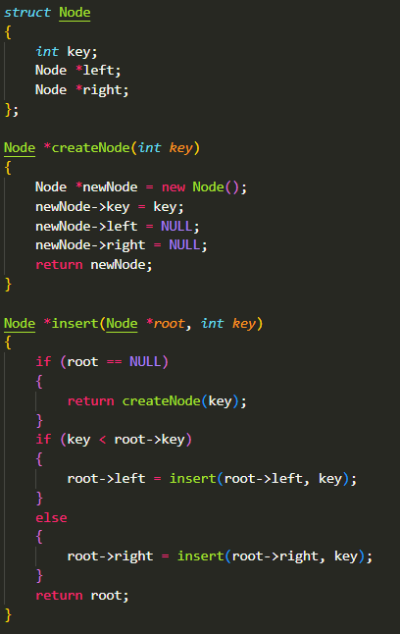

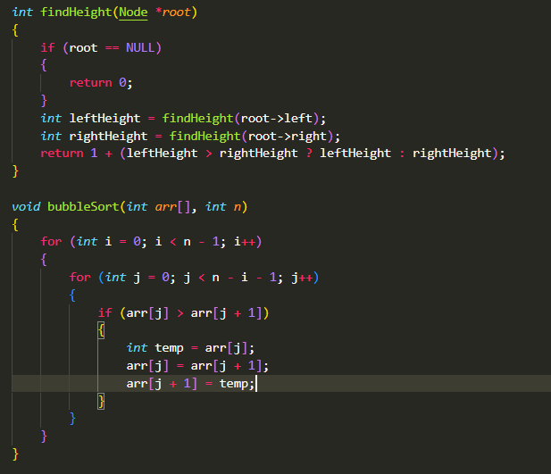

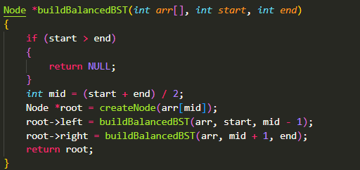

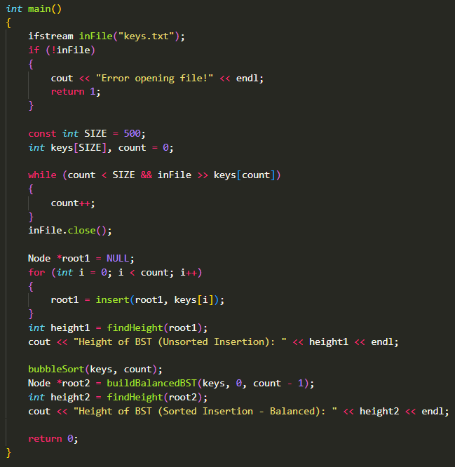

**Output:**



1. Your class has 100+ students, whose ID number & name data will be provided. Implement a simple database of students using a binary search tree. Insert the student data into the binary search tree. ID Number is key, and name is satellite data. [You may use other data.]

**Code:**

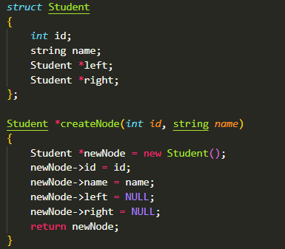

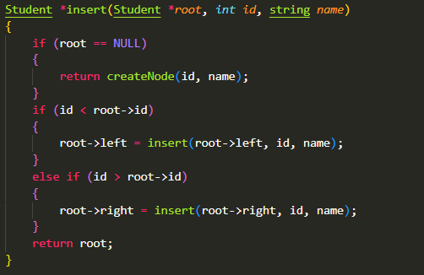

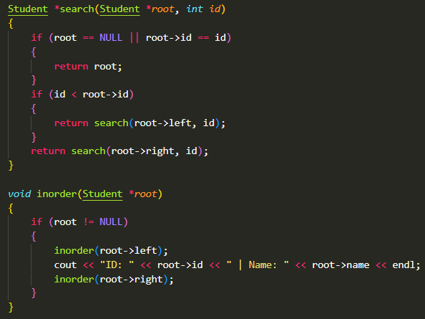

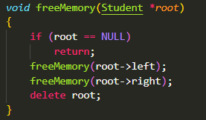

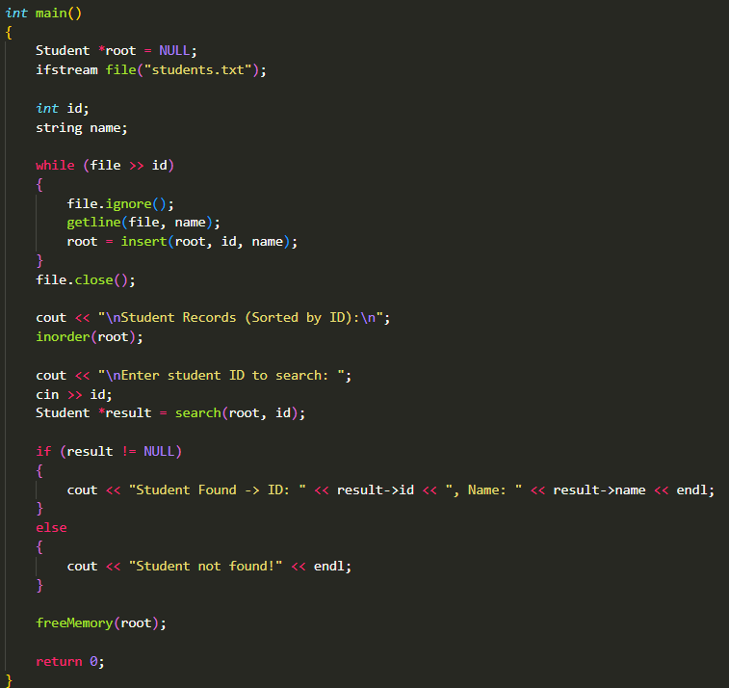

**Output:**

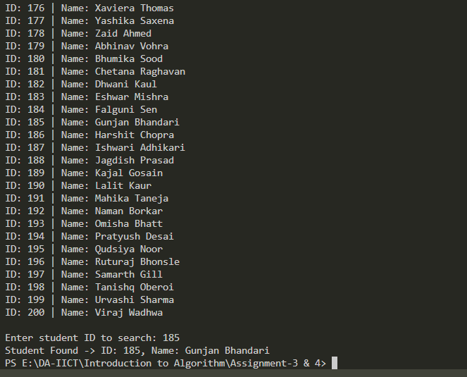

1. Write a search function to find the student name from a given ID number.

**Code:**

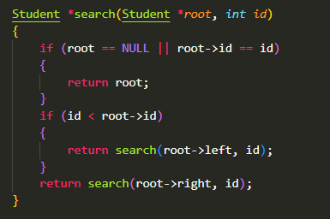

**Note:** This search function added in 4th task to search by id.