**Assignment 1 :Intro to Web Science**

**Que1 : Given below is an Ethernet frame without the Preamble and the Frame Check Sequence.**

**ANS:**

00 27 10 21 fa 48 00 13 10 e8 dd 52 08 06 00 01 08 00 06 04 00 01 00 13 10 e8 dd 52 c0 a8 02 01 00 00 00 00 00 00 c0 a8 02 67

1. Source MAC Address

00 13 10 e8 dd 52

2. Destination MAC Address

00 27 10 21 fa 48

3. What protocol is inside the data payload?

08 06 : This ether type is for Address Resolution Protocol

4. Please mention what the last 2 fields hold in the above frame.

00 01 08 00 06 04 00 01 00 13 10 e8 dd 52 c0 a8 02 01 00 00 00 00 00 00 : This field is payload of 48 bits.

c0 a8 02 67 : This is Frame check sequence

**Que2:** **Let us consider we have two cables of 20 meters each. One of them is in a 100MBps network while the other is in a 10MBps network. If you had to transfer data through each of them, how much time it would take for the first bit to arrive in each setting? (For your calculation you can assume that the speed of light takes the same value as in the videos.) Please provide formulas and calculatoins along with your results.**

**Method** :

Given the length of the cable is 20 meters

the speed of the data travelled is considered has speed of light 3*10^8

time=distance/speed

for the 100mbps

time=20/3*10^8

**ANS:**

**time=6.6*10^-7sec**

**the time for 10mbs remain same as the cabel length and speed of transfer is same.**

**Que3** : **Consider a situation in which you need to check if url{www.wikipedia.org} is reachable or not. Using the knowledge you gained above to underline{find the following information}:**

**ANS:**

1. The **{% packet loss}** if at all it happened after sending 100 packets.

**Ans**: **0%**

**Method** : ping -n 100 www.wikipedia.org

i) Screenshot performed in Home Network

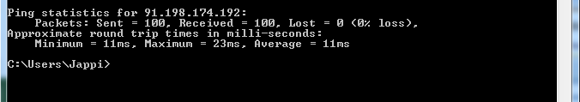

ii) Screenshot performed in University Network

2. **{Size}** of the packet sent to {Wikipedia} server.

**Ans**: **32 bytes**

**Method** : ping www.wikipedia.org

i) Screenshot performed in Home Network

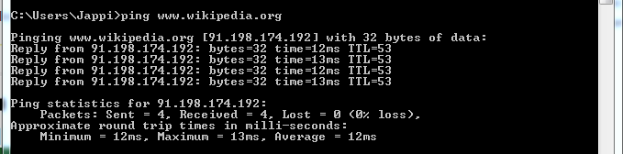

ii) Screenshot performed in University Network

3**. {IP address}** of your machine and the {**Wikipedia**} server

**Ans:** Local machine IP Add : **192.168.2.5**

**Method** : ipconfig

**Ans**: Server IP Add :**91.198.174.192**

**Method** : ping www.wikipedia.org

4. **{Query Time}** for DNS query of the above url.

**Ans** : **8msec**

**Method** : dig www.wikipedia.org

i) Screenshot performed in Home Network

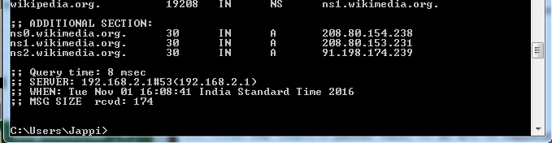

ii) Screenshot performed in University Network

5**. Number of {Hops}** in between your machine and the server

**Ans**: **13 hops**

**Method**: tracert www.wikipedia.org

i) Screenshot performed in Home Network

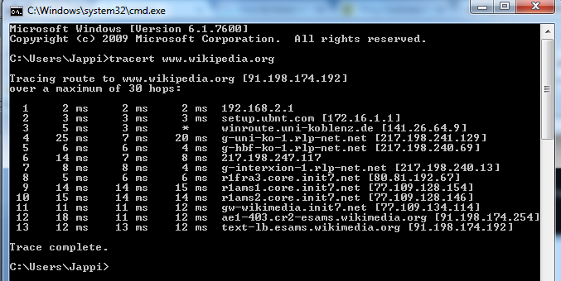

ii) Screenshot performed in University Network

6**. MAC address** of the device that is acting as your network gateway.

**Ans**: 6c-72-20-7c-a8-05

**Method** : arp -a 192.168.0.1

Here 192.168.0.1 is network gateway IP address which is the first hope found when trace route the hostname.

i) Screenshot performed in Home Network

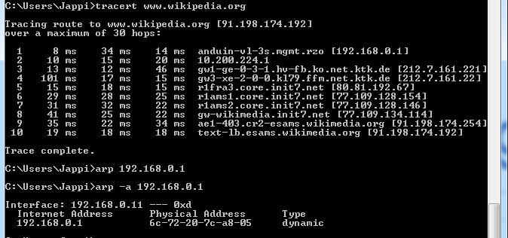

ii) Screenshot performed in University Network

**Que4. Write a simple python program that does the following:**

1. Generate a random number sequence of 10 values between 0 to 90.

2. Perform sine and cosine operation on numbers generated.

3. Store the values in two different arrays named SIN & COSIN respectively.

4. Plot the values of SIN & COSIN in two different colors.

5. The plot should have labeled axes and legend.

**ANS:**

