|  |  |
| --- | --- |
|  | **CSCI/ISAT B104**  **Computer Programming Techniques, Practices, and Tools**  **Fall 2024**  **Project Documentation**  **Team XX** |

Contents

Project Contributions by Team Member 2

Collaboration Tools 3

YRBS Questions Explored 4

YRBS Demographic Information Explored 5

YRBS Data Winnowing & Retrieval 6

Research Question and/or Hypothesis 7

Bibliography 8

Acknowledgements 8

# Project Contributions by Team Member

**Members and their Contact Information**

|  |  |  |
| --- | --- | --- |
| **Member** | **Email** | **Text** |
| Jalyn Perry | jalynmp@email.uscb.edu | 8435993055 |
| Tabias Farrison | tabiasf@email.uscb.edu | 8039284887 |

**Overall**

Relative Contribution of each member over the course of the entire project

|  |  |  |
| --- | --- | --- |
| **Member** | **Contribution** | **Total Hours** |
|  |  |  |
|  |  |  |

**YRBS Question Identification & Documentation**

|  |  |  |  |
| --- | --- | --- | --- |
| **Member** | **Contribution** | **Hours** | **Components** |
| Jalyn Perry | 50 % | 1 |  |
| Tabias Farrison | 50 % | 1 |  |

**YRBS Data Winnowing & Retrieval**

|  |  |  |  |
| --- | --- | --- | --- |
| **Member** | **Contribution** | **Hours** | **Components** |
| Jalyn Perry | 60% | 3 |  |
| Tabias Farrison | 40% | 1.5 |  |

**Data Analysis (via Python)**

|  |  |  |  |
| --- | --- | --- | --- |
| **Member** | **Contribution** | **Hours** | **Components** |
| James Doe | 80 % | 16.75 |  |
| Leroy Jenkins | 20 % | 4.25 |  |

**Data Visualization (via Python)**

|  |  |  |  |
| --- | --- | --- | --- |
| **Member** | **Contribution** | **Hours** | **Components** |
| James Doe | 50 % | 12.5 |  |
| Leroy Jenkins | 50 % | 12.5 |  |

**Python Script Creation**

|  |  |  |  |
| --- | --- | --- | --- |
| **Member** | **Contribution** | **Hours** | **Components** |
| James Doe | 50 % | 12.5 |  |
| Leroy Jenkins | 50 % | 12.5 |  |

**Poster Development**

|  |  |  |  |
| --- | --- | --- | --- |
| **Member** | **Contribution** | **Hours** | **Components** |
| James Doe | 50 % | 12.5 |  |
| Leroy Jenkins | 50 % | 12.5 |  |

**Presentation Preparation & Practice**

|  |  |  |  |
| --- | --- | --- | --- |
| **Member** | **Contribution** | **Hours** | **Components** |
| James Doe | 100 % | 2.5 |  |
| Leroy Jenkins | 0 % | 0.25 |  |

**Project Documentation & Administration**

|  |  |  |  |
| --- | --- | --- | --- |
| **Member** | **Contribution** | **Hours** | **Components** |
| James Doe | 100 % | 2.5 |  |
| Leroy Jenkins | 0 % | 0.25 |  |

# Collaboration Tools

Tools to assist with task management, version control, communication, etc.

* Github
* Trello

# YRBS Questions Explored

Questions & responses explored over the course of the project.

*Place screenshots of the two questions below. Be sure to include their “response keys”.*

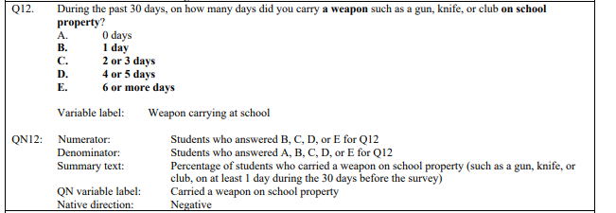

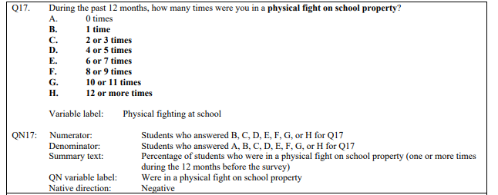

# YRBS Demographic Information Explored

Demographic questions & responses explored over the course of the project

*Place screenshots of the questions below. Be sure to include their “response keys”.*

*Demographic information includes gender, age, height, weight, ethnicity, etc.*

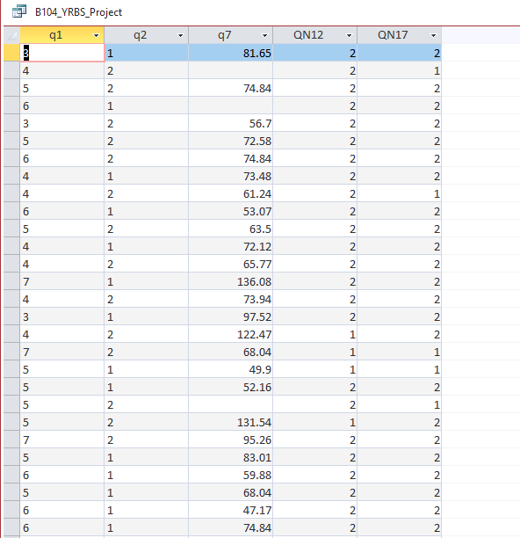

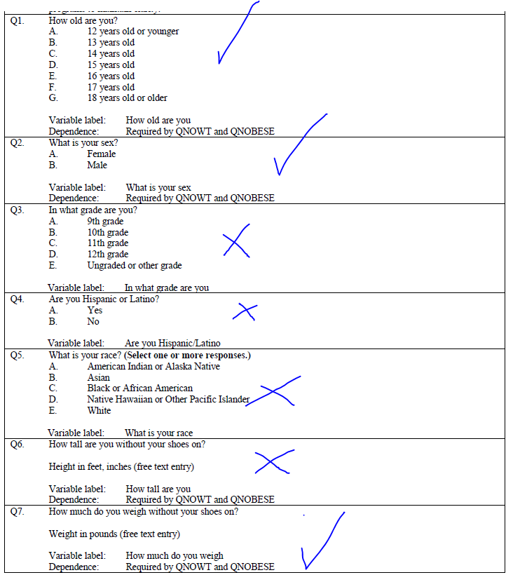

# YRBS Data Winnowing & Retrieval

How we winnowed & retrieved the data explored over the course of the project.

Write down a step-by-step guide explaining how you winnowed & retrieved the data from the YRBS site.

*Place screenshots of the SQL code and other relevant details here*

* *Download msdb file*
* *Open in msdb file in microsoft access*
* *Create new query* 
  + 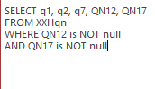
* Run query
* Resulting data
  + 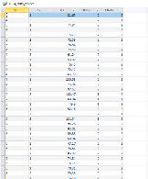
* *Save query*
* *Export as excel sheet*

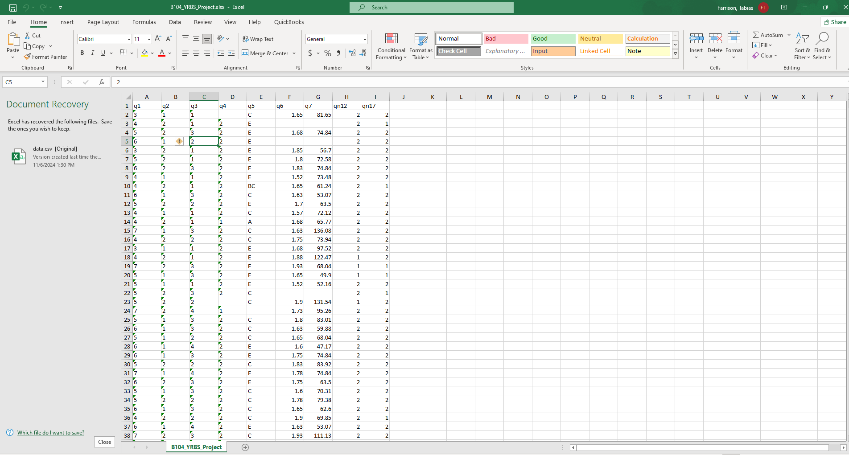

# YRBS Data Winnowing & Retrieval

How we winnowed & retrieved the data explored over the course of the project.

* Imported data and attempted to plot correlation between q12 and q17
* 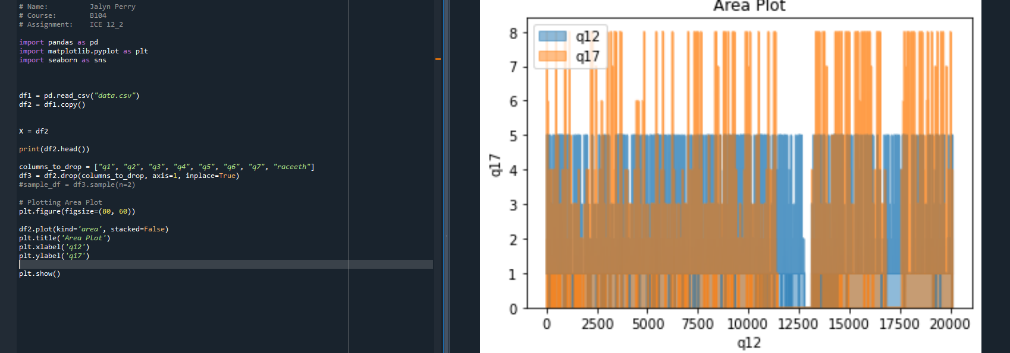

# Research Question and/or Hypothesis

The specific research questions we sought to answer.

Write down your research question here.

# Bibliography

Resources which we used over the course of the project.

Citations for:

Python Library Documentation

Python Tutorials

Best Practices

Poster Templates

Stack Overflow questions/answers

Etc.

Follow APA format

# Acknowledgements

Specific peers who helped you debug

Upper class students, parents, siblings, friends, etc. who provided feedback and guidance

Etc.