# Exercise: Inheritance

**Activity Instructions – Overview**

Package **com.accenture.tcf.exercises.inheritance**.

1. Per the UML diagram below:

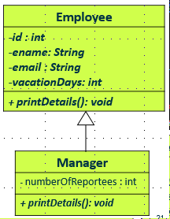

* 1. Create Employee and Manager classes based on the UML.
  2. Create a main class, CompanyDemo, class that will print the following output:

Expected output:

Id : 101234

Name : John Peter

Email : john.peter@accenture.com

Vacation Days : 20

Number of Reportees : 10

1. Per the UML diagram below

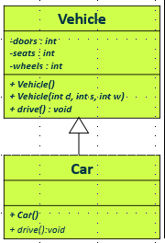

* 1. Create a Vehicle and Car classes based on the UML.

**Vehicle class:**

Create two constructors

* default (with message “Building a vehicle”)
* constructor that receives the number of doors, number of seats and the number of wheels as input.

Create method “drive” to display a message: ‘Driving a Vehicle’.

**Car class:**

Create a Car constructor with message “Building a Car”

Override the drive method and display “Driving a Car”.

* 1. Create a main class, **Parking**, that will print the following output

Building a vehicle...

number of doors = 0

number of seats = 0

number of wheels = 0

Building a vehicle...

Building a Car...

number of doors = 4

number of seats = 5

number of wheels = 4

Driving Car

1. Per the UML diagram below:

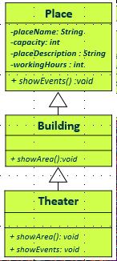

* 1. Create Place, Building and Theater classes.

**Place class:**

* showEvents is an abstract method.

**Building class:**

* showArea is an abstract method.

**Theater class:**

* Override the showArea method and display the size multiply by 12.
* Override the showEvents method to display a message ‘Events ready to be hosted !!’
  1. Create main class, CodingtonDemo, and complete the ff TODO:
* Create a theater object.
* Display the area using the showArea method
* Invoke the showEvents method

Expected result:

Theater area : 6000

Events ready to be hosted !!