# Problem 1

Create a class named **DoublesArray**. Given an array of doubles, create methods that:

1. **computeSum(double[] numbers)**: computes the sum
2. **computeAve(double[] numbers)**: computes the average
3. **getHighestValue(double[]** **numbers)**: returns the highest number

# Problem 2 | Attendance Tracker

Create an Attendance Tracker that:

1. Continuously asks user to enter EID and displays the time-in
   1. If a user already timed in, a message is displayed that the user already timed-in
   2. Otherwise, a message is displayed that the user timed-in at the current time
2. If no more EID is to be entered, then the list of attendees and their time-in displayed and the program terminates

## Sample Output

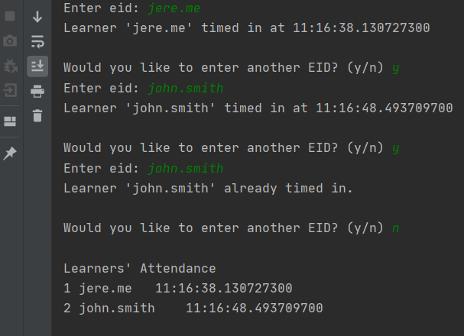

# Class Diagram

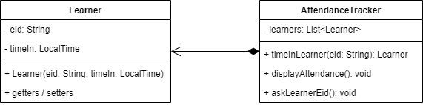

# Class Definition

|  |  |
| --- | --- |
| **AttendanceTracker** | |
| **Method** | **Description** |
| timeInLearner(eid) | Returns a Learner object with the given EID and current time  If learner’s EID already time-in, the method returns a null |
| displayAttendance() | Displays the list of attendees and their respective time-in |
| askLearnerEid() | Uses a scanner to ask for user input  Displays the appropriate message when a non-existing or existing EID is entered |

Create **AttendanceTrackerMain** class for the main method. Feel free to add helper methods.