Graceful
Open Issue Dependency Graph — Sprints 1–4
Source: GitHub — Jam3sl1u/Graceful (Issues, live as of document generation)
Generated for personal project records

Scope & Method
This document covers every currently OPEN GitHub issue labeled sprint-1 through sprint-4 in the Graceful repository — 60 issues in total (#24–#83). Sprint 0 (foundation: project init, schema migrations, auth, RLS — issues #10–#23) is fully closed and is not graphed, but is noted where an open issue's original dependency pointed to it.
Each issue in the repo carries a structured "Dependencies" section in its body (Blocked by / Blocks, referencing issue numbers). This document parses those declarations directly — it does not infer dependencies from titles or guesswork. If the repo's issue bodies are incomplete or out of date, this graph will inherit that.
"Blocked by (open)" in the tables below lists only blockers that are themselves still open. An issue with no open blockers is marked "Ready to start."

Summary
Sprint | Open issues | High | Med | Low
Sprint 1 | 10 | 6 | 4 | 0
Sprint 2 | 19 | 14 | 5 | 0
Sprint 3 | 14 | 9 | 4 | 1
Sprint 4 | 17 | 13 | 4 | 0
Total | 60 | 42 | 17 | 1

Ready to Start Now (no open blockers)
12 of 60 open issues have every blocker already closed and can be picked up immediately:
- #24 [Sprint 1] Implement church group creation
- #29 [Sprint 1] Build audit log writer utility + read endpoint (BR-13)
- #37 [Sprint 2] Implement service week CRUD
- #53 [Sprint 3] Implement song catalog CRUD + search (BR-09 key validation)
- #61 [Sprint 3] Implement Google Calendar OAuth connect/disconnect
- #67 [Sprint 4] Integrate Pingram SMS dispatch + webhook verification
- #68 [Sprint 4] Integrate Resend email dispatch + webhook verification
- #70 [Sprint 4] Implement notification preferences (BR-14 minimum-channel guard)
- #75 [Sprint 4] Implement PWA manifest & install prompt
- #76 [Sprint 4] Implement rate limiting on auth, SMS, and write endpoints
- #77 [Sprint 4] Audit input validation (Zod) across all Phase 1 routes
- #78 [Sprint 4] Run infrastructure security pass (HTTPS, CSP, secret scan)

Key Bottleneck Issues (block the most other open work)
- #37 — Implement service week CRUD (blocks 5 other open issues)
- #40 — Implement send set invitation (BR-05 double-booking check) (blocks 5 other open issues)
- #34 — Implement availability set/get (blocks 3 other open issues)
- #53 — Implement song catalog CRUD + search (BR-09 key validation) (blocks 3 other open issues)
- #59 — Implement event CRUD (BR-10 time validation) (blocks 3 other open issues)
- #24 — Implement church group creation (blocks 2 other open issues)
- #25 — Implement join church group via invite code (blocks 2 other open issues)
- #26 — Build member directory endpoint (blocks 2 other open issues)

Cross-Sprint Dependency Overview
Only dependencies that cross a sprint boundary are drawn here, to keep the chain of custody between sprints readable. Full within-sprint detail follows in the per-sprint sections.
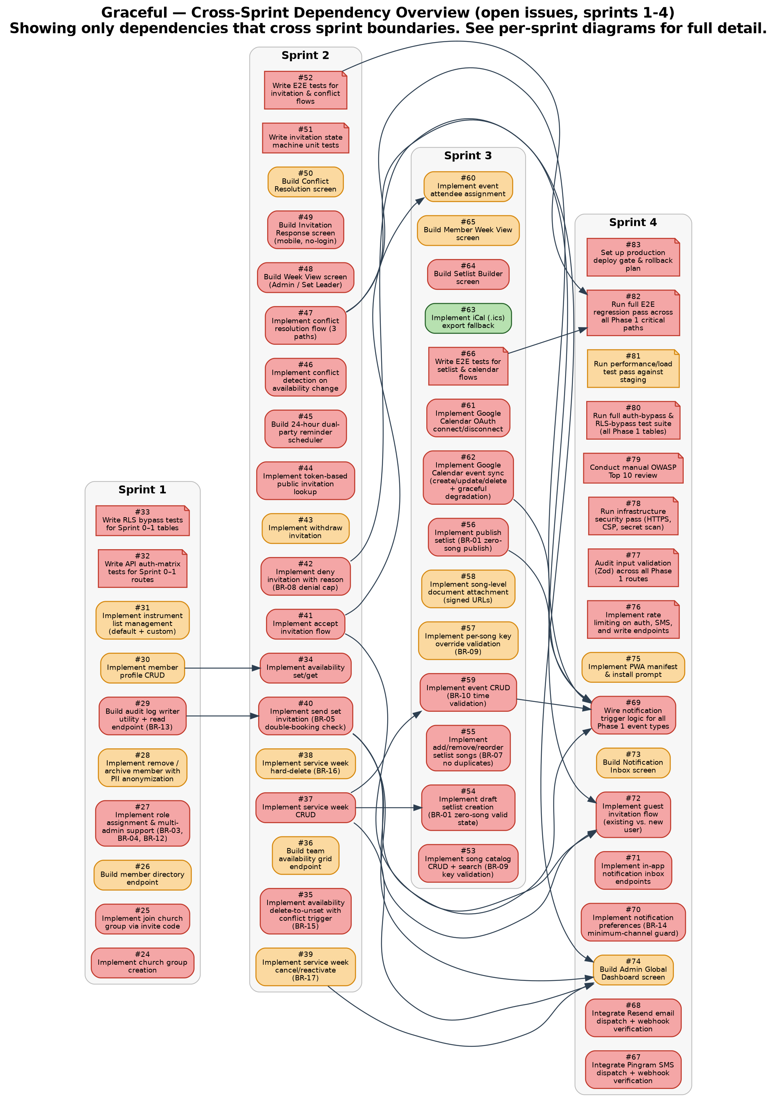

Sprint 1 — Foundation
Church group, members, roles, instruments
Legend: Box = feature issue | Note shape = chore issue (tests, infra, audits) | Red fill = priority:high Orange fill = priority:med Green fill = priority:low | Grey dashed box = closed Sprint 0 prerequisite (already satisfied)
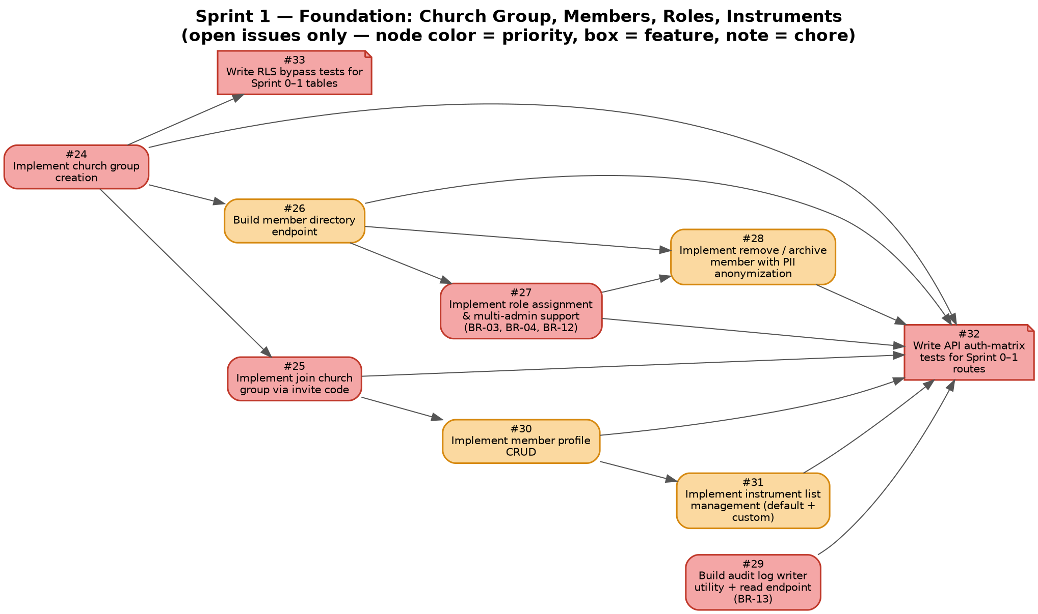

Sprint 1 — Foundation — Issue Detail
# | Title | Priority | Blocked by (open) | Blocks | Status
24 | Implement church group creation | HIGH | — | #25, #26 | Ready to start
25 | Implement join church group via invite code | HIGH | #24 | #30, #26 | Blocked
26 | Build member directory endpoint | MED | #24 | #27, #28 | Blocked
27 | Implement role assignment & multi-admin support (BR-03, BR-04, BR-12) | HIGH | #26 | #29 | Blocked
28 | Implement remove / archive member with PII anonymization | MED | #26, #27 | #79 | Blocked
29 | Build audit log writer utility + read endpoint (BR-13) | HIGH | — | — | Ready to start
30 | Implement member profile CRUD | MED | #25 | #31 | Blocked
31 | Implement instrument list management (default + custom) | MED | #30 | #40 | Blocked
32 | Write API auth-matrix tests for Sprint 0–1 routes | HIGH | #24, #25, #26, #27, #28, #29, #30, #31 | — | Blocked
33 | Write RLS bypass tests for Sprint 0–1 tables | HIGH | #24 | #79 | Blocked

Sprint 2 — Scheduling Core
Availability, service weeks, invitations, conflicts
Legend: Box = feature issue | Note shape = chore issue (tests, infra, audits) | Red fill = priority:high Orange fill = priority:med Green fill = priority:low | Grey dashed box = closed Sprint 0 prerequisite (already satisfied)
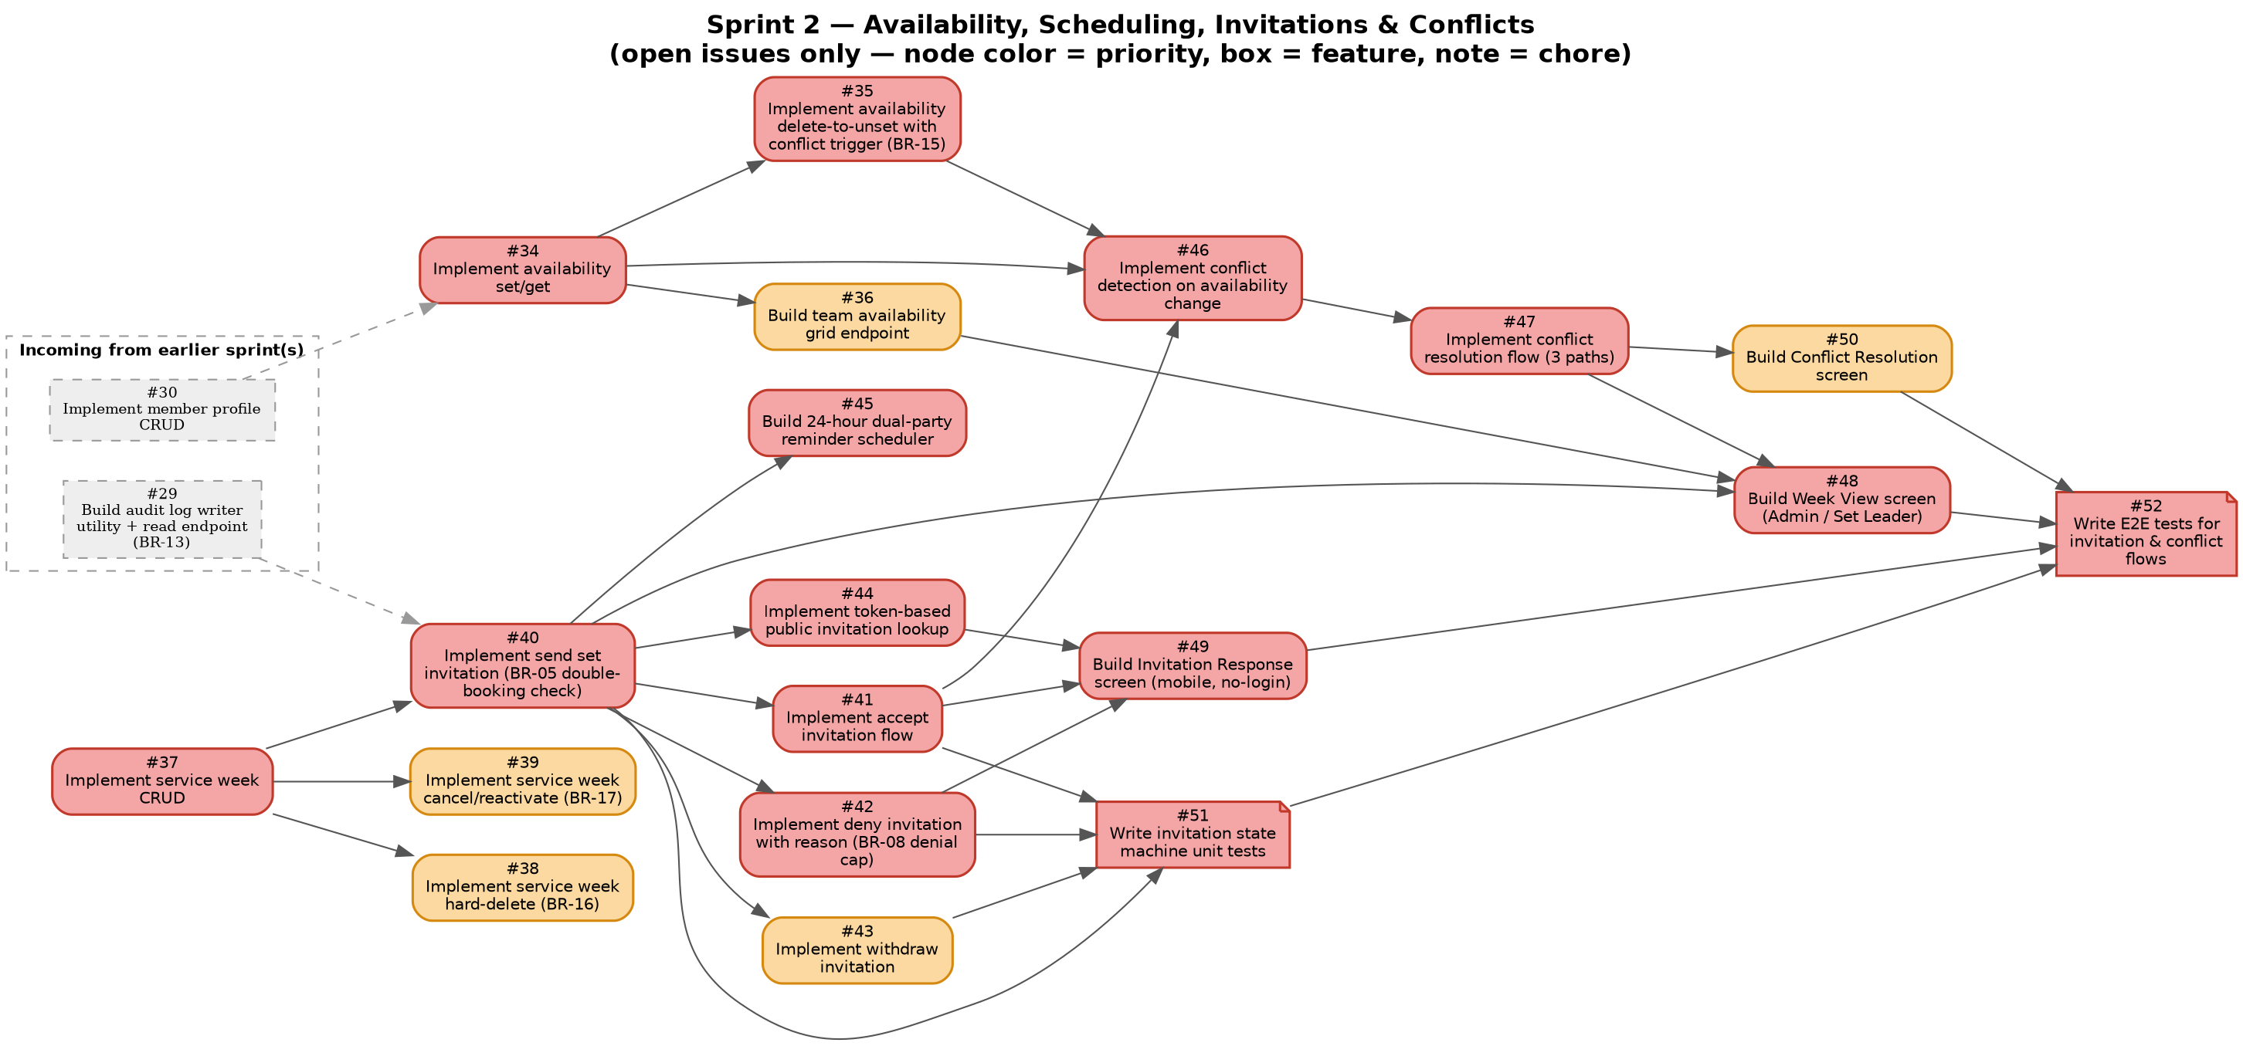

Sprint 2 — Scheduling Core — Issue Detail
# | Title | Priority | Blocked by (open) | Blocks | Status
34 | Implement availability set/get | HIGH | #30 | #35, #36, #46 | Blocked
35 | Implement availability delete-to-unset with conflict trigger (BR-15) | HIGH | #34 | #46 | Blocked
36 | Build team availability grid endpoint | MED | #34 | #48 | Blocked
37 | Implement service week CRUD | HIGH | — | #38, #39, #40, #54, #59 | Ready to start
38 | Implement service week hard-delete (BR-16) | MED | #37 | — | Blocked
39 | Implement service week cancel/reactivate (BR-17) | MED | #37 | #62 | Blocked
40 | Implement send set invitation (BR-05 double-booking check) | HIGH | #37, #29 | #41, #42, #43, #44, #45 | Blocked
41 | Implement accept invitation flow | HIGH | #40 | #49 | Blocked
42 | Implement deny invitation with reason (BR-08 denial cap) | HIGH | #40 | #49 | Blocked
43 | Implement withdraw invitation | MED | #40 | — | Blocked
44 | Implement token-based public invitation lookup | HIGH | #40 | #49 | Blocked
45 | Build 24-hour dual-party reminder scheduler | HIGH | #40 | #51 | Blocked
46 | Implement conflict detection on availability change | HIGH | #34, #35, #41 | #47, #50 | Blocked
47 | Implement conflict resolution flow (3 paths) | HIGH | #46 | #50 | Blocked
48 | Build Week View screen (Admin / Set Leader) | HIGH | #36, #40, #47 | — | Blocked
49 | Build Invitation Response screen (mobile, no-login) | HIGH | #41, #42, #44 | — | Blocked
50 | Build Conflict Resolution screen | MED | #47 | — | Blocked
51 | Write invitation state machine unit tests | HIGH | #40, #41, #42, #43 | #52 | Blocked
52 | Write E2E tests for invitation & conflict flows | HIGH | #48, #49, #50, #51 | — | Blocked

Sprint 3 — Setlists & Calendar
Songs, setlists, events, Google Calendar sync
Legend: Box = feature issue | Note shape = chore issue (tests, infra, audits) | Red fill = priority:high Orange fill = priority:med Green fill = priority:low | Grey dashed box = closed Sprint 0 prerequisite (already satisfied)
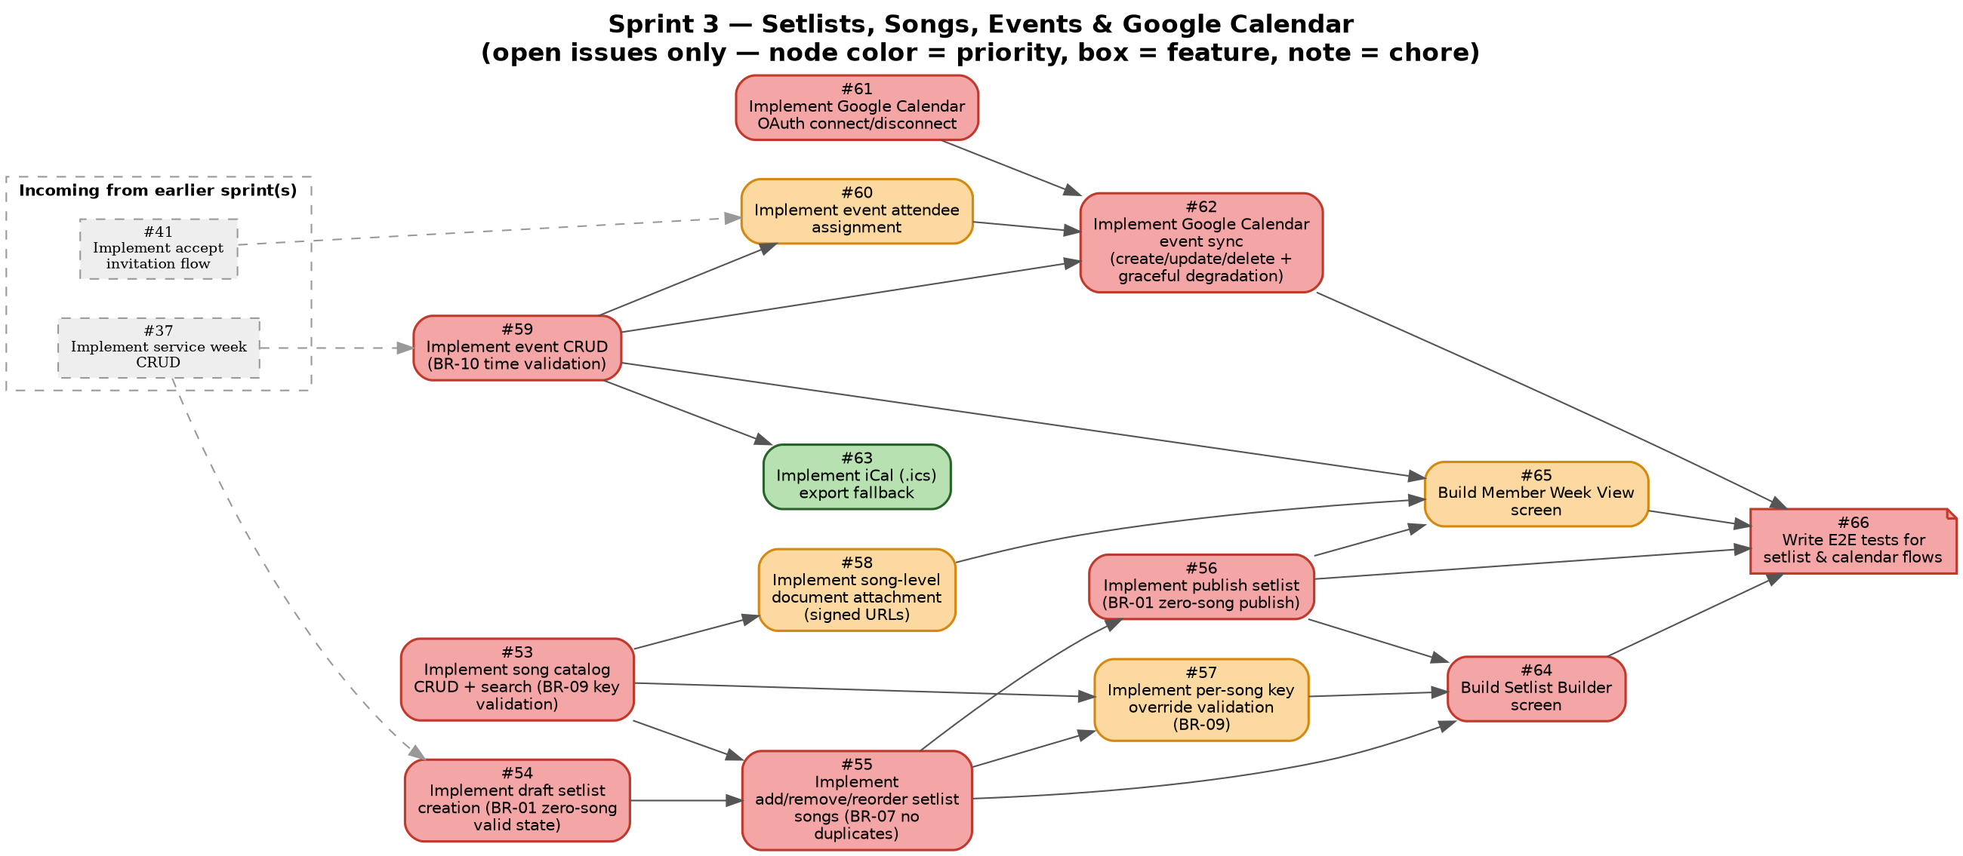

Sprint 3 — Setlists & Calendar — Issue Detail
# | Title | Priority | Blocked by (open) | Blocks | Status
53 | Implement song catalog CRUD + search (BR-09 key validation) | HIGH | — | #55, #57, #58 | Ready to start
54 | Implement draft setlist creation (BR-01 zero-song valid state) | HIGH | #37 | #55, #56 | Blocked
55 | Implement add/remove/reorder setlist songs (BR-07 no duplicates) | HIGH | #54, #53 | #56, #64 | Blocked
56 | Implement publish setlist (BR-01 zero-song publish) | HIGH | #55 | #64, #66 | Blocked
57 | Implement per-song key override validation (BR-09) | MED | #53, #55 | — | Blocked
58 | Implement song-level document attachment (signed URLs) | MED | #53 | — | Blocked
59 | Implement event CRUD (BR-10 time validation) | HIGH | #37 | #60, #62, #63 | Blocked
60 | Implement event attendee assignment | MED | #59, #41 | #62 | Blocked
61 | Implement Google Calendar OAuth connect/disconnect | HIGH | — | #62 | Ready to start
62 | Implement Google Calendar event sync (create/update/delete + graceful degradation) | HIGH | #59, #60, #61 | #66 | Blocked
63 | Implement iCal (.ics) export fallback | LOW | #59 | — | Blocked
64 | Build Setlist Builder screen | HIGH | #55, #56, #57 | #66 | Blocked
65 | Build Member Week View screen | MED | #56, #59, #58 | — | Blocked
66 | Write E2E tests for setlist & calendar flows | HIGH | #56, #62, #64, #65 | — | Blocked

Sprint 4 — Notifications, Guests & Launch
Notifications, guest flow, security hardening, deploy gate
Legend: Box = feature issue | Note shape = chore issue (tests, infra, audits) | Red fill = priority:high Orange fill = priority:med Green fill = priority:low | Grey dashed box = closed Sprint 0 prerequisite (already satisfied)
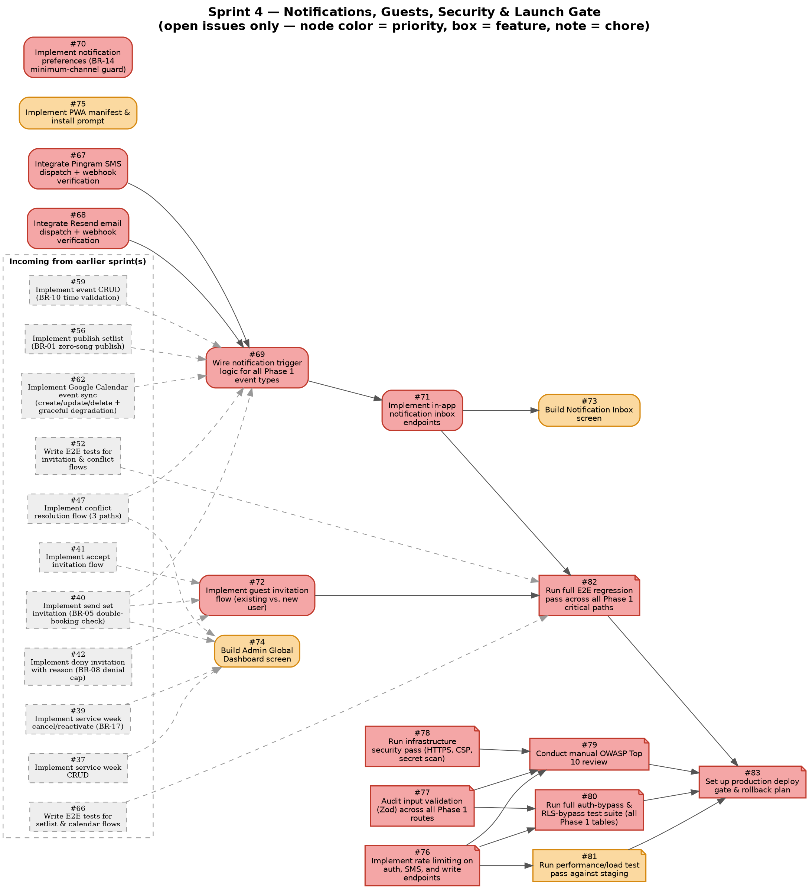

Sprint 4 — Notifications, Guests & Launch — Issue Detail
# | Title | Priority | Blocked by (open) | Blocks | Status
67 | Integrate Pingram SMS dispatch + webhook verification | HIGH | — | #69, #72 | Ready to start
68 | Integrate Resend email dispatch + webhook verification | HIGH | — | #69, #72 | Ready to start
69 | Wire notification trigger logic for all Phase 1 event types | HIGH | #67, #68, #40, #47, #56, #59, #62 | #71, #82 | Blocked
70 | Implement notification preferences (BR-14 minimum-channel guard) | HIGH | — | #69 | Ready to start
71 | Implement in-app notification inbox endpoints | HIGH | #69 | #73 | Blocked
72 | Implement guest invitation flow (existing vs. new user) | HIGH | #40, #41, #42 | — | Blocked
73 | Build Notification Inbox screen | MED | #71 | — | Blocked
74 | Build Admin Global Dashboard screen | MED | #37, #40, #47, #39 | — | Blocked
75 | Implement PWA manifest & install prompt | MED | — | — | Ready to start
76 | Implement rate limiting on auth, SMS, and write endpoints | HIGH | — | #81 | Ready to start
77 | Audit input validation (Zod) across all Phase 1 routes | HIGH | — | #80, #79 | Ready to start
78 | Run infrastructure security pass (HTTPS, CSP, secret scan) | HIGH | — | #79 | Ready to start
79 | Conduct manual OWASP Top 10 review | HIGH | #76, #77, #78 | #83 | Blocked
80 | Run full auth-bypass & RLS-bypass test suite (all Phase 1 tables) | HIGH | #76, #77 | #79, #83 | Blocked
81 | Run performance/load test pass against staging | MED | #76 | #83 | Blocked
82 | Run full E2E regression pass across all Phase 1 critical paths | HIGH | #52, #66, #71, #72 | #83 | Blocked
83 | Set up production deploy gate & rollback plan | HIGH | #79, #80, #81, #82 | — | Blocked

Appendix — Full Open Issue List (All Sprints)
All 60 open issues, #24–#83, sorted by issue number.
# | Title | Priority | Blocked by (open) | Blocks | Status
24 | Implement church group creation | HIGH | — | #25, #26 | Ready to start
25 | Implement join church group via invite code | HIGH | #24 | #30, #26 | Blocked
26 | Build member directory endpoint | MED | #24 | #27, #28 | Blocked
27 | Implement role assignment & multi-admin support (BR-03, BR-04, BR-12) | HIGH | #26 | #29 | Blocked
28 | Implement remove / archive member with PII anonymization | MED | #26, #27 | #79 | Blocked
29 | Build audit log writer utility + read endpoint (BR-13) | HIGH | — | — | Ready to start
30 | Implement member profile CRUD | MED | #25 | #31 | Blocked
31 | Implement instrument list management (default + custom) | MED | #30 | #40 | Blocked
32 | Write API auth-matrix tests for Sprint 0–1 routes | HIGH | #24, #25, #26, #27, #28, #29, #30, #31 | — | Blocked
33 | Write RLS bypass tests for Sprint 0–1 tables | HIGH | #24 | #79 | Blocked
34 | Implement availability set/get | HIGH | #30 | #35, #36, #46 | Blocked
35 | Implement availability delete-to-unset with conflict trigger (BR-15) | HIGH | #34 | #46 | Blocked
36 | Build team availability grid endpoint | MED | #34 | #48 | Blocked
37 | Implement service week CRUD | HIGH | — | #38, #39, #40, #54, #59 | Ready to start
38 | Implement service week hard-delete (BR-16) | MED | #37 | — | Blocked
39 | Implement service week cancel/reactivate (BR-17) | MED | #37 | #62 | Blocked
40 | Implement send set invitation (BR-05 double-booking check) | HIGH | #37, #29 | #41, #42, #43, #44, #45 | Blocked
41 | Implement accept invitation flow | HIGH | #40 | #49 | Blocked
42 | Implement deny invitation with reason (BR-08 denial cap) | HIGH | #40 | #49 | Blocked
43 | Implement withdraw invitation | MED | #40 | — | Blocked
44 | Implement token-based public invitation lookup | HIGH | #40 | #49 | Blocked
45 | Build 24-hour dual-party reminder scheduler | HIGH | #40 | #51 | Blocked
46 | Implement conflict detection on availability change | HIGH | #34, #35, #41 | #47, #50 | Blocked
47 | Implement conflict resolution flow (3 paths) | HIGH | #46 | #50 | Blocked
48 | Build Week View screen (Admin / Set Leader) | HIGH | #36, #40, #47 | — | Blocked
49 | Build Invitation Response screen (mobile, no-login) | HIGH | #41, #42, #44 | — | Blocked
50 | Build Conflict Resolution screen | MED | #47 | — | Blocked
51 | Write invitation state machine unit tests | HIGH | #40, #41, #42, #43 | #52 | Blocked
52 | Write E2E tests for invitation & conflict flows | HIGH | #48, #49, #50, #51 | — | Blocked
53 | Implement song catalog CRUD + search (BR-09 key validation) | HIGH | — | #55, #57, #58 | Ready to start
54 | Implement draft setlist creation (BR-01 zero-song valid state) | HIGH | #37 | #55, #56 | Blocked
55 | Implement add/remove/reorder setlist songs (BR-07 no duplicates) | HIGH | #54, #53 | #56, #64 | Blocked
56 | Implement publish setlist (BR-01 zero-song publish) | HIGH | #55 | #64, #66 | Blocked
57 | Implement per-song key override validation (BR-09) | MED | #53, #55 | — | Blocked
58 | Implement song-level document attachment (signed URLs) | MED | #53 | — | Blocked
59 | Implement event CRUD (BR-10 time validation) | HIGH | #37 | #60, #62, #63 | Blocked
60 | Implement event attendee assignment | MED | #59, #41 | #62 | Blocked
61 | Implement Google Calendar OAuth connect/disconnect | HIGH | — | #62 | Ready to start
62 | Implement Google Calendar event sync (create/update/delete + graceful degradation) | HIGH | #59, #60, #61 | #66 | Blocked
63 | Implement iCal (.ics) export fallback | LOW | #59 | — | Blocked
64 | Build Setlist Builder screen | HIGH | #55, #56, #57 | #66 | Blocked
65 | Build Member Week View screen | MED | #56, #59, #58 | — | Blocked
66 | Write E2E tests for setlist & calendar flows | HIGH | #56, #62, #64, #65 | — | Blocked
67 | Integrate Pingram SMS dispatch + webhook verification | HIGH | — | #69, #72 | Ready to start
68 | Integrate Resend email dispatch + webhook verification | HIGH | — | #69, #72 | Ready to start
69 | Wire notification trigger logic for all Phase 1 event types | HIGH | #67, #68, #40, #47, #56, #59, #62 | #71, #82 | Blocked
70 | Implement notification preferences (BR-14 minimum-channel guard) | HIGH | — | #69 | Ready to start
71 | Implement in-app notification inbox endpoints | HIGH | #69 | #73 | Blocked
72 | Implement guest invitation flow (existing vs. new user) | HIGH | #40, #41, #42 | — | Blocked
73 | Build Notification Inbox screen | MED | #71 | — | Blocked
74 | Build Admin Global Dashboard screen | MED | #37, #40, #47, #39 | — | Blocked
75 | Implement PWA manifest & install prompt | MED | — | — | Ready to start
76 | Implement rate limiting on auth, SMS, and write endpoints | HIGH | — | #81 | Ready to start
77 | Audit input validation (Zod) across all Phase 1 routes | HIGH | — | #80, #79 | Ready to start
78 | Run infrastructure security pass (HTTPS, CSP, secret scan) | HIGH | — | #79 | Ready to start
79 | Conduct manual OWASP Top 10 review | HIGH | #76, #77, #78 | #83 | Blocked
80 | Run full auth-bypass & RLS-bypass test suite (all Phase 1 tables) | HIGH | #76, #77 | #79, #83 | Blocked
81 | Run performance/load test pass against staging | MED | #76 | #83 | Blocked
82 | Run full E2E regression pass across all Phase 1 critical paths | HIGH | #52, #66, #71, #72 | #83 | Blocked
83 | Set up production deploy gate & rollback plan | HIGH | #79, #80, #81, #82 | — | Blocked

