OVERVIEW

# MORPHEUS FIT

Powered by Two JJ Game Studio



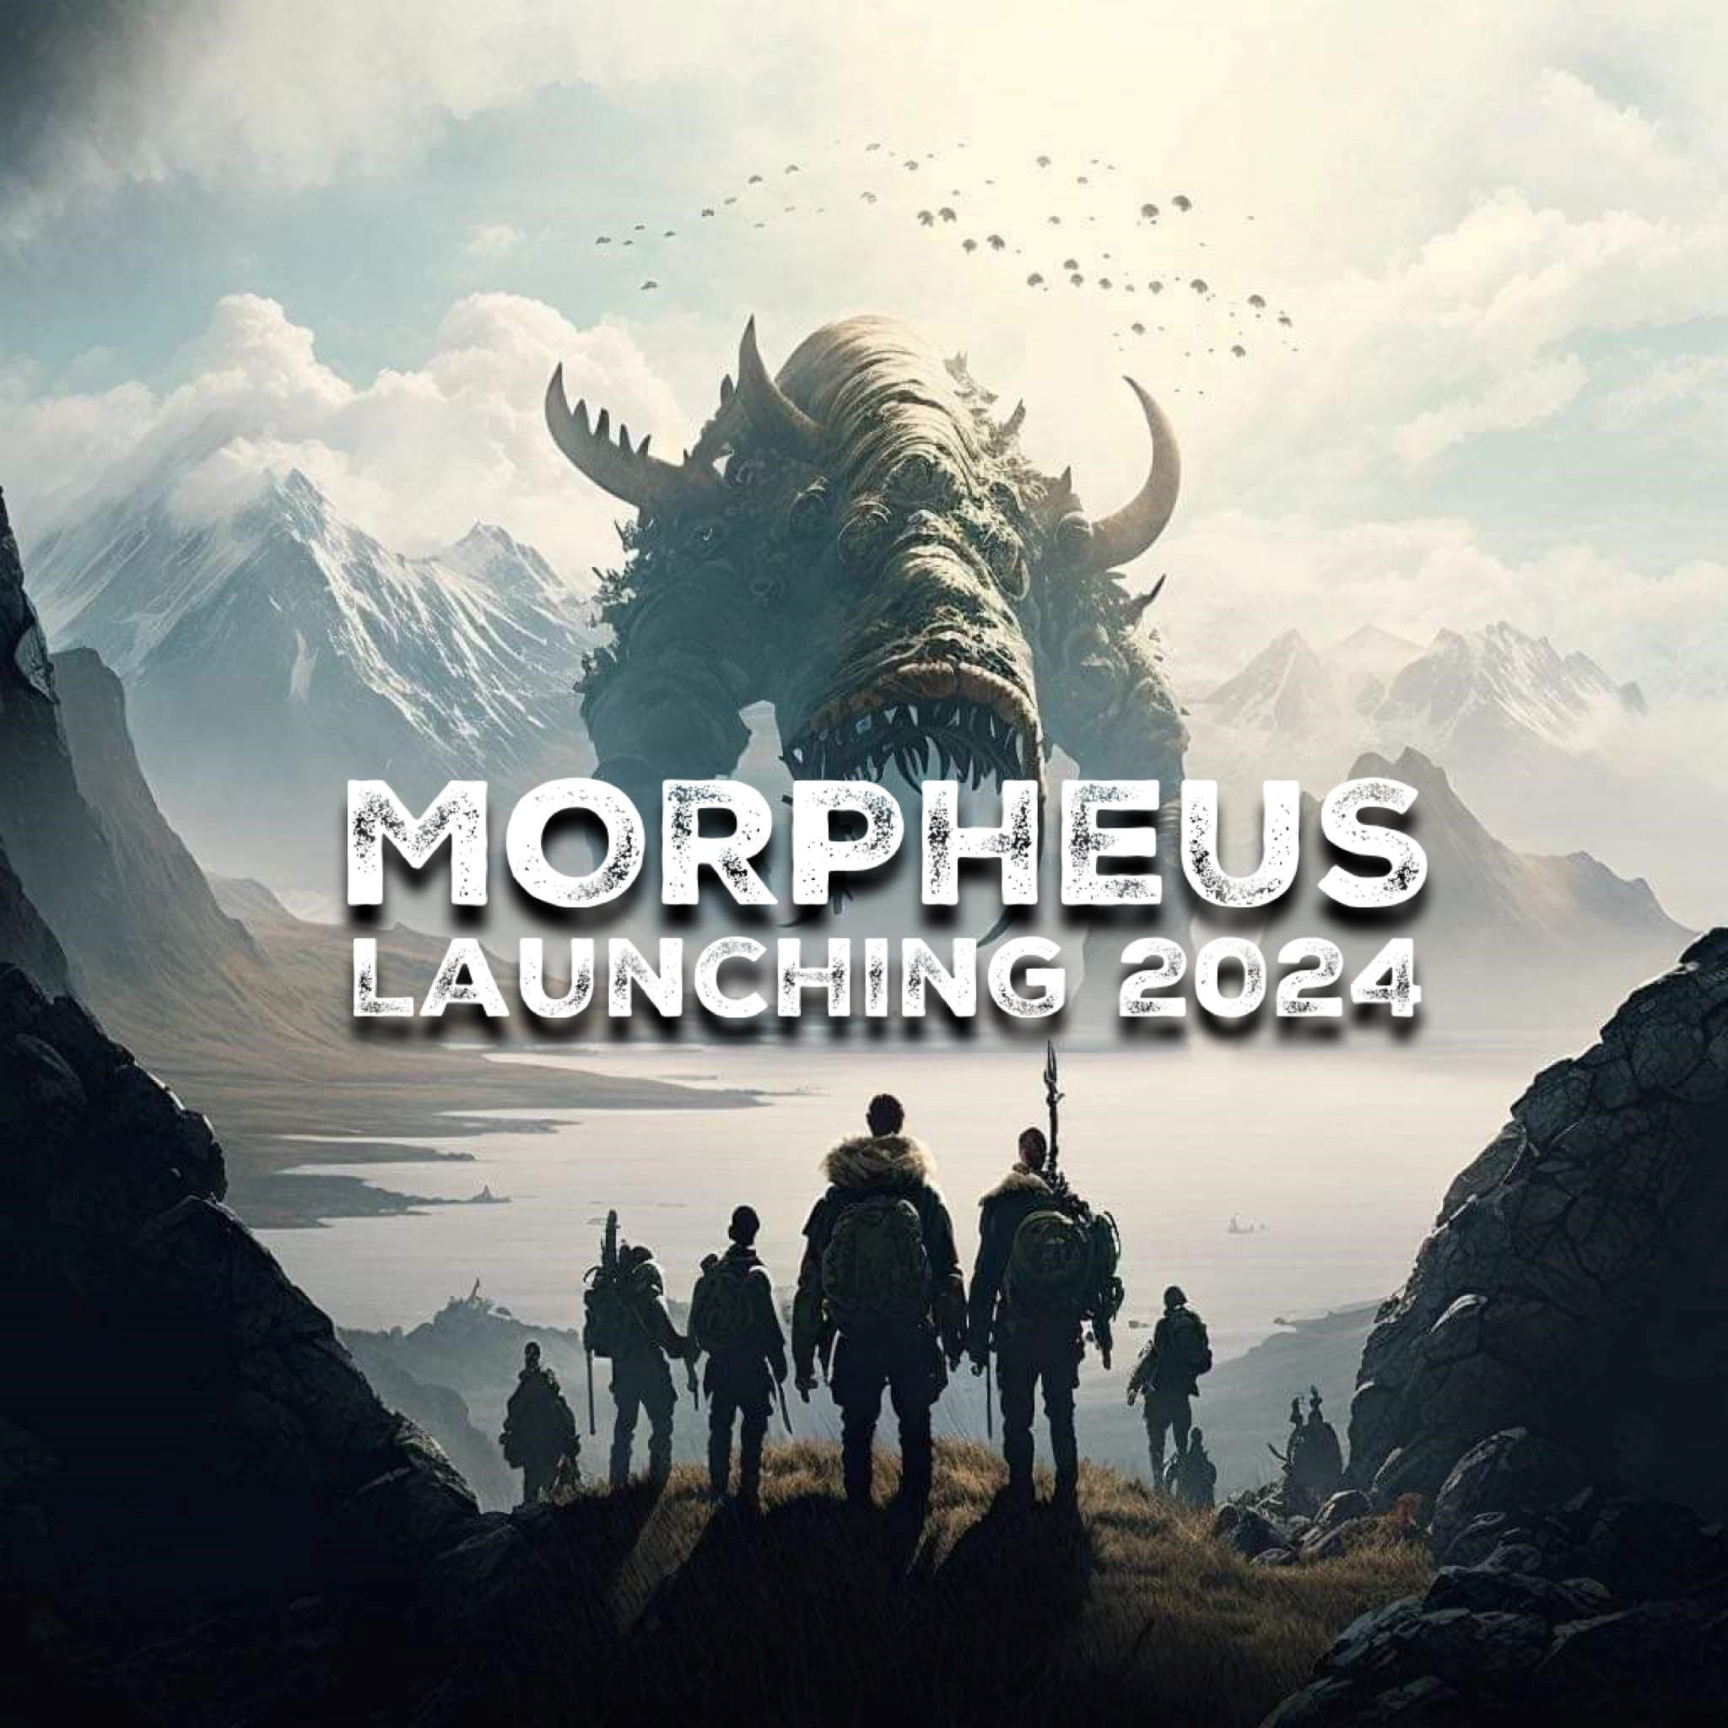Morpheus Fit, t ultimate fusion of fitness and fantasy adventure! Embark on an

exhilarating journey across multiple dimensions and timelines, where every step you take in the real world propels you further into an epic virtual realm. Team up with friends to build your empire, forge alliances, and conquer challenges beyond imagination. With

customizable storylines and maps, the power to craft your destiny is in your hands. Track your steps and heart rate in real-time, turning every workout into a thrilling quest for greatness. Earn bonus multipliers based on your intensity, forge powerful weapons and armor, and defend your territory against the relentless onslaught of pirate raids.

Morpheus Fit isn't just a fitness app—it's an adventure of a lifetime waiting to unfold.

Join the revolution and redefine your fitness journey today!

## Key Features

**Team-based Empires:** Join forces with friends to conquer challenges and build your empire across diverse dimensions and timelines. (Consider adding a feature where players can recruit allies from different dimensions or timelines for unique abilities.)

**Customizable Storylines and Maps:** Take control of your destiny by creating your own storylines and maps for your team to explore and conquer. (Provide players with tools to design their own quests and challenges within the game.)

**Real-life Fitness Tracking:** Track your steps and heart rate in real-time, using your physical activity to traverse across islands and unlock new territories within the game. (Integrate with popular fitness trackers and smartwatches for seamless data synchronization.)

**Heart Rate Multiplier:** Earn bonus multipliers based on your heart rate while walking or running, encouraging players to push themselves to new limits and achieve their fitness goals. (Offer rewards or in-game currency for maintaining optimal heart rates during workouts.)

**Forge Weapons and Armor:** Utilize resources collected during your fitness adventures to forge powerful weapons, armor, and defense items at your base. Strengthen your team and prepare for epic battles ahead. (Implement crafting mechanics that require strategic resource management and team collaboration.)

**Cooperative Quests:** Join forces with other players to embark on challenging quests and adventures. Work together to complete objectives within the allocated time, or face significant penalties as a team. (Incorporate real-time communication features to coordinate team efforts and strategize during quests.)

**Defend Against Pirate Raids:** Beware the perils of the high seas as your island faces the threat of pirate raids. Rally your teammates, defend your territory, and thwart the nefarious schemes of marauding pirates determined to plunder your hard-earned treasures.

## Factors Contributing to the Potential Success

**Innovative Concept:** Morpheus stands out in the crowded fitness app market with its innovative concept of blending fitness tracking with immersive gaming experiences. By offering users an adventure where physical activity translates into in-game progress, Morpheus taps into a unique niche that sets it apart from traditional fitness apps.

**Engagement and Immersion:** The app's emphasis on teamwork, customizable storylines, and real-life fitness integration creates a deeply engaging and immersive experience for users. By providing a platform for users to create their own adventures, forge alliances, and defend against pirate raids, Morpheus offers a level of interactivity and excitement that keeps users coming back for more.

**Social Connectivity:** Morpheus fosters a sense of community and social connectivity through its team-based gameplay mechanics. By encouraging users to team up with friends and embark on quests together, Morpheus creates opportunities for collaboration, camaraderie, and friendly competition. This social aspect of the app not only enhances user engagement but also strengthens user retention over time.

**Motivational Incentives:** The app's heart rate multiplier system and rewards for achieving fitness milestones provide users with motivational incentives to push their limits and strive for continuous improvement. By gamifying the fitness experience and offering tangible rewards for physical activity, Morpheus motivates users to stay active and committed to their fitness goals.

**Scalability and Expansion:** With its modular design and customizable features, Morpheus has the flexibility to scale and expand its offerings over time. Whether through the introduction of new dimensions, quests, or gameplay mechanics, Morpheus has the potential to evolve and adapt to the changing needs and preferences of its user base.

Overall, Morpheus' combination of innovation, engagement, social connectivity, motivational incentives, and scalability positions it for success in the competitive landscape of fitness apps. By delivering a unique and compelling fitness experience, Morpheus has the potential to capture the imaginations of users worldwide and become a leading player in the industry.

## Screenshots

