Aemon’s Nook

Design Doc

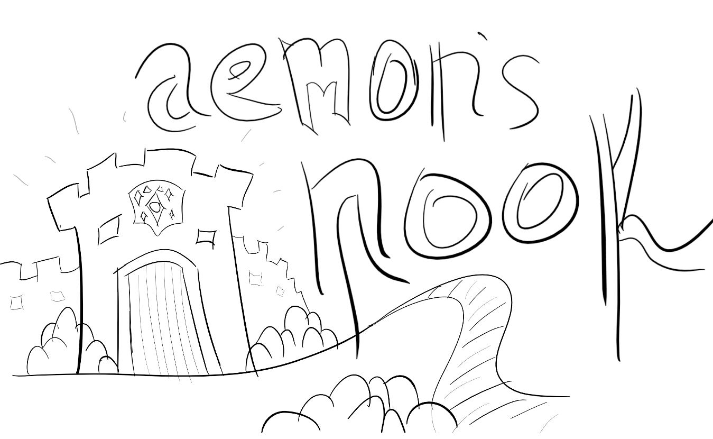

**A Cunning Adventure** awaits you as you

[game pitch here]