1. **序論**

* ESG資訊之重要性(包含對投資人、強制揭露ESG、對法人持股)：投資人對ESG資訊之重視，參考附件1 (Introduction)以及探討法人持股與ESG績效關係之文獻
* 過去文獻&本文研究/方法(分成3段寫)
  + 3過去文獻僅研究機構投資人對ESG績效與ESG自願揭露的影響
  + 1過去探討揭露語調的文獻大多著重在年報或盈餘宣告等財務資訊的揭露
  + 2過去語調分析較多使用字典法 但字典法有其缺點
* 迴歸結果
* 貢獻(有3點，分別對應前面3段)
* 本文分七章節

1. **文獻回顧**

第一節 ESG資訊揭露之相關文獻

* ESG資訊揭露之影響因素：參考附件4 (Key determinants of voluntary CSR reporting)，其中單獨一段探討法人持股(X含governments/policy makers?)與ESG資訊/揭露之關係
* ESG資訊揭露之經濟後果：參考附件1 (Section 2.1)、附件2 (Section 2.1) 、附件3 (Benefits of CSR Reporting)，其中單獨一段討論永續報告書文字揭露特性的文獻(參考附件1 Section 2.1第二段)

第二節 揭露語調之相關文獻

* 正向語調的兩個理論：informative (signal) effect; obfuscation混淆 (risk) effect，參考Davis et al. (2012)、Huang et al. (2014)、Jain et al. (2023)、Li et al. (2019)、Liu_ZenghuiPhD
* 語調的實證研究

第三節 語調之衡量方法

* 字典法: Henry (2008), Loughran and McDonald (2011)
* BERT/FinBERT模型

文獻

FinBERT網頁

<https://huggingface.co/yiyanghkust/finbert-esg-9-categories>

<https://www.allenhuang.org/coding.html>

2: 揭露語調

**informative (signal) effect**;

定義：

1. 2-3 Jain, A., Manchiraju, H., & Sunder, S. V. (2023). Institutional ownership and the informativeness of disclosure tone. *Journal of Business Finance & Accounting*, *50*(1-2), 61-90.

(2-7都在2下面)

1. 2-1 Davis, A. K., Piger, J. M., & Sedor, L. M. (2012). Beyond the numbers: Measuring the information content of earnings press release language. *Contemporary Accounting Research*, *29*(3), 845-868.
2. Davis, A. K., & Tama‐Sweet, I. (2012). Managers’ use of language across alternative disclosure outlets: earnings press releases versus MD&A. *Contemporary Accounting Research*, *29*(3), 804-837.
3. Mahoney, W., & Lewis, J. (2004). The IR book. *2004 available on-line at http://www. ir-book. com*.

Managers’ earnings press release language varies significantly across firms and ranges from straightforward to promotional (Mahoney and Lewis 2004).

1. ~~Levin, I. P., Schneider, S. L., & Gaeth, G. J. (1998). All frames are not created equal: A typology and critical analysis of framing effects.~~*~~Organizational behavior and human decision processes~~*~~,~~*~~76~~*~~(2), 149-188.~~

~~Managers generally report financial performance in comparative terms, and so we expect managers’ earnings press release language to communicate both positive (i.e., optimistic) and negative (i.e., pessimistic) sentiments. It is well-established that presenting information in positive terms results in more favorable evaluations than does presenting information in negative terms.~~

1. ~~Katz, S. B. (2002). Language And Persuasion In Biotechnology Communication.~~
2. Katz, S. B. (2001). Language and persuasion in biotechnology communication with the public: How not to say what you’re not going to say and not say it. *AgBioForum 4* (2): 93–97.
3. Morris, M. W., Sheldon, O. J., Ames, D. R., & Young, M. J. (2005). Metaphor in stock market commentary: Consequences and preconditions of agentic descriptions of price trends. *Unpublished manuscript, Columbia University*.

(5-6) Language also influences how information is both perceived and understood

(8-9一組)

1. Feldman, R., Govindaraj, S., Livnat, J., & Segal, B. (2010). Management’s tone change, post earnings announcement drift and accruals. *Review of Accounting Studies, 15*, 915-953.
2. ~~Hooks, K. L., & Moon, J. E. (1993). A classification scheme to examine management discussion and analysis compliance.~~ *~~Accounting Horizons, 7~~*~~(2), 41–59.~~

~~In 1989, the SEC issued guidelines to clarify what was expected in MD&A disclosures in an attempt to make them more informative.~~ **~~Hooks and Moon (1993)~~** ~~attempt to measure the differences between the actual and expected frequency of MD&A disclosures across a spectrum of disclosures that they classify as mandated to those that are classified as voluntary and show that these differences have decreased for certain items after the SEC MD&A guideline release in 1989, indicating firms provide more disclosure in their MD&A after 1989.~~

1. Kothari, S. P., Li, X., & Short, J. E. (2009). The effect of disclosures by management, analysts, and business press on cost of capital, return volatility, and analyst forecasts: A study using content analysis. *The Accounting Review*, *84*(5), 1639-1670.
2. ~~Mayew, W. J., Sethuraman, M., & Venkatachalam, M. (2015). MD&A disclosure and the firm's ability to continue as a going concern.~~*~~The Accounting Review~~*~~,~~*~~90~~*~~(4), 1621-1651.~~

(10-11一組)

1. Li, F. (2010a). The information content of forward‐looking statements in corporate filings—A naïve Bayesian machine learning approach. *Journal of Accounting Research, 48*(5), 1049-1102.
2. ~~Grundfest, J. A., & Perino, M. A. (1997). Ten things we know and ten things we don’t know about the Private Securities Litigation Reform Act of 1995: Testimony Before the Subcommittee on Securities of the Committee on Banking, Housing, and Urban Affairs of the United States Senate.~~

~~the safe harbor provisions of the Private Securities Litigation Reform Act of 1995 encourage more forward-looking information (Grundfest and Perino [1997]) and should make MD&A disclosures more informative~~

1. Durnev, A., & Mangen, C. (2020). The spillover effects of MD&A disclosures for real investment: The role of industry competition. *Journal of Accounting and Economics*, *70*(1), 101299.

(接2-2)

1. Li, F., Lundholm, R., & Minnis, M. (2013). A measure of competition based on 10‐K filings. *Journal of Accounting Research*, *51*(2), 399-436.
2. Demers, E. A., & Vega, C. (2011). Linguistic tone in earnings announcements: News or noise?. *SSRN Electronic Journal*.

機構投資人與tone (後面也有)

1. ~~BlackRock, (2021).~~ *~~Blackrock Investment Stewardship–Global principles~~*~~.~~ [~~https://www.blackrock.com/corporate/literature/factsheet/blk-responsible-investment-engprinciples-global.pdf~~](https://www.blackrock.com/corporate/literature/factsheet/blk-responsible-investment-engprinciples-global.pdf)

~~we argue that a more informative tone helps investors understand the nuances of managerial choices and obtain a sense of managers’outlook for future economic performance. By reducing the information gathering costs, a more informative abnormal tone enables better monitoring by institutional investors. For instance, BlackRock, a prominent institutional investor, claims that it engages with firms or uses its vote to encourage better disclosures when it believes that transparency of the firm is inadequate (BlackRock, 2021~~

(2-5裡面的)

1. Bryan, S. H. (1997). Incremental information content of required disclosures contained in management discussion and analysis. *Accounting Review*, 285-301.
2. Bochkay, K., & Levine, C. B. (2019). Using MD&A to improve earnings forecasts. *Journal of Accounting, Auditing & Finance*, *34*(3), 458-482.

-------------------------------------------------------------------------

1. 2-4 Li, M., Wu, H., Xiao, M., & You, J. (2019). Beyond cheap talk: management's informative tone in corporate disclosures. *Accounting & Finance*, *59*(5), 2905-2959.

**obfuscation混淆 (risk) effect**

定義：

(接10)

1. Verrecchia, R. E. (1983). Discretionary disclosure. *Journal of accounting and economics, 5*, 179-194.

However, the MD&A might **not be as informative** as intended for several reasons. Companies **have concerns over proprietary costs** (Verrecchia [1983])

1. ~~Grundfest, J. A., & Perino, M. A. (1997). 同10~~

~~and uncertainties about the judicial interpretation of safe harbor protection (Grundfest and Perino [1997]).~~

1. ~~Hüfner, B. (2007). The SEC’s MD&A: Does it Meet the Informational Demands of Investors? —A Conceptual Evaluation—.~~ *~~Schmalenbach Business Review, 59~~*~~, 58-84.~~

~~Also, the MD&As are~~ **~~not required to be audited~~** ~~(Hüfner [2007])~~

1. ~~Securities and Exchange Commission. (2003). Interpretation: Commission guidance regarding management’s discussion and analysis of financial condition and results of operations.~~ *~~Securities Act Release~~*~~, (33-8350), 34-48960.~~

~~and many include substantial boilerplate disclaimers and disclosures, generic language, and immaterial detail (SEC [2003]).~~

1. Pava, M. L., & Epstein, M. J. (1993). How good is MD&A as an investment tool?. *Journal of Accountancy*, 175(3), 51.

Pava and Epstein [1993] show that although most of the companies they study accurately describe historical events, very few provide useful and accurate forecasts in their MD&As.

1. 2-2 Huang, X., Teoh, S. H., & Zhang, Y. (2014). Tone management. *The Accounting Review*, *89*(3), 1083-1113.
2. Li, F. (2008). Annual report readability, current earnings, and earnings persistence. *Journal of Accounting and economics*, *45*(2-3), 221-247.
3. Larcker, D. F., & Zakolyukina, A. A. (2012). Detecting deceptive discussions in conference calls. *Journal of Accounting Research*, *50*(2), 495-540.
4. Tama-Sweet, I. (2009). *Do managers alter the tone of their earnings announcements around stock option grants and exercises?*. University of Oregon.
5. ~~Schrand, C. M., & Walther, B. R. (2000). Strategic benchmarks in earnings announcements: the selective disclosure of prior‐period earnings components.~~*~~The Accounting Review~~*~~,~~*~~75~~*~~(2), 151-177.~~
6. Arslan-Ayaydin, Ö., Boudt, K., & Thewissen, J. (2016). Managers set the tone: Equity incentives and the tone of earnings press releases. *Journal of Banking & Finance*, *72*, S132-S147.
7. Henry, E. (2008). Are investors influenced by how earnings press releases are written?. *The Journal of Business Communication (1973)*, *45*(4), 363-407.
8. Arslan‐Ayaydin, Ö., Thewissen, J., & Torsin, W. (2021). Disclosure tone management and labor unions. *Journal of Business Finance & Accounting*, *48*(1-2), 102-147.
9. Hossain, M., Raghunandan, K., & Rama, D. V. (2020). Abnormal disclosure tone and going concern modified audit reports. *Journal of Accounting and Public Policy*, *39*(4), 106764.

---------------------------------------------------------------------------

(2-5裡面)

1. ~~Jaggi, B., & Sannella, A. (1995). The association between the accuracy of management earnings forecasts and discretionary accounting changes.~~*~~Journal of Accounting, Auditing & Finance~~*~~,~~*~~10~~*~~(1), 1-21.~~
2. Rogers, J. L., Van Buskirk, A., & Zechman, S. L. (2011). Disclosure tone and shareholder litigation. *The Accounting Review*, *86*(6), 2155-2183.
3. Skinner, D. J. (1994). Why firms voluntarily disclose bad news. *Journal of Accounting Research*, *32*(1), 38-60.
4. ~~Francis, J., Philbrick, D., & Schipper, K. (1994). Shareholder litigation and corporate disclosures.~~*~~Journal of Accounting Research~~*~~,~~*~~32~~*~~(2), 137-164.~~
5. Krishnan, G. V., Pevzner, M., & Sengupta, P. (2012). How do auditors view managers’ voluntary disclosure strategy? The effect of earnings guidance on audit fees. *Journal of Accounting and Public Policy*, *31*(5), 492-515.
6. Chen, L., Krishnan, G., & Pevzner, M. (2012). Pro forma disclosures, audit fees, and auditor resignations. *Journal of Accounting and Public Policy*, *31*(3), 237-257.

-------------------------------------------------------------------------------------

1: ESG資訊揭露之相關文獻

* ESG資訊揭露之影響因素(什麼因素會影響企業要不要揭露ESG資訊)：參考附件4 (Key determinants of voluntary CSR reporting)，其中單獨一段探討法人持股(X含governments/policy makers?2-3)與ESG資訊/揭露之關係

1. 附件4綜說 Christensen, H. B., Hail, L., & Leuz, C. (2021). Mandatory CSR and sustainability reporting: Economic analysis and literature review. *Review of Accounting Studies*, *26*(3), 1176-1248.

每本篇幅不須很多

**3.1 Generic firm and manager characteristics公司與管理階層特質**

**(一)公司特性**

1. Hahn, R., & Kühnen, M. (2013). Determinants of sustainability reporting: A review of results, trends, theory, and opportunities in an expanding field of research. *Journal of Cleaner Production*, *59*, 5-21.
2. Li, J. M., Lu, S., & Nassar, S. (2021). Corporate social responsibility metrics in S&P 500 firms’ 2017 sustainability reports. *Rustandy Center for Social Sector Innovation, University of Chicago*.

One of the most common findings is a significantly positive association between firm size and the quantity or quality of CSR disclosures (e.g., Hahn and Kühnen 2013; Li et al. 2021).

1. Cormier, D., Magnan, M., & Van Velthoven, B. (2005). Environmental disclosure quality in large German companies: economic incentives, public pressures or institutional conditions?. *European Accounting Review*, *14*(1), 3-39.
2. Thorne, L., S. Mahoney, L., & Manetti, G. (2014). Motivations for issuing standalone CSR reports: A survey of Canadian firms. *Accounting, Auditing & Accountability Journal*, *27*(4), 686-714.

This positive relation could be explained by greater public scrutiny of large firms, which arguably incentivizes them to engage in CSR activities and reporting (e.g., Cormier and Magnan 2003; Thorne et al. 2014).

1. Wickert, C., Scherer, A. G., & Spence, L. J. (2016). Walking and talking corporate social responsibility: Implications of firm size and organizational cost. *Journal of Management Studies*, *53*(7), 1169-1196.

Another explanation may be that CSR communication is relatively less costly for larger firms, while the actual implementation of CSR activities is not (Wickert et al. 2016).

**(二)持股結構**

1. Höllerer, M. A. (2013). From taken‐for‐granted to explicit commitment: The rise of CSR in a corporatist country. *Journal of Management Studies*, *50*(4), 573-606.

Höllerer (2013) finds a positive association between dispersed private-sector ownership and the decision to disclose stand-alone CSR reports.

1. Cormier, D., & Magnan, M. (1999). Corporate environmental disclosure strategies: determinants, costs and benefits. *Journal of Accounting, Auditing & Finance*, *14*(4), 429-451.
2. Cormier, D., Magnan, M., & Van Velthoven, B. (2005). Environmental disclosure quality in large German companies: economic incentives, public pressures or institutional conditions?. *European Accounting Review*, *14*(1), 3-39.

Cormier and Magnan (1999) and Cormier et al. (2005) find that concentrated ownership is associated with less environmental disclosure.

**(三)公司治理結構與管理階層特性**

1. Dalla Via, N., & Perego, P. (2018). Determinants of conflict minerals disclosure under the Dodd–Frank Act. *Business Strategy and the Environment*, *27*(6), 773-788.

Dalla Via and Perego (2018) find that various measures for the strength of firms’ corporate governance systems (e.g., long-term managerial incentive schemes, number of board meetings, etc.) are positively associated with CSR disclosures.

1. Mallin, C., Michelon, G., & Raggi, D. (2013). Monitoring intensity and stakeholders’ orientation: how does governance affect social and environmental disclosure?. *Journal of Business Ethics*, *114*, 29-43.

Mallin et al. (2013) find that firms with a greater stakeholder orientation in their corporate governance policies also disclose more (and better) information on social and environmental issues.

1. Lewis, B. W., Walls, J. L., & Dowell, G. W. (2014). Difference in degrees: CEO characteristics and firm environmental disclosure. *Strategic Management Journal*, *35*(5), 712-722.
2. Parker, L. D. (2014). Corporate social accountability through action: Contemporary insights from British industrial pioneers. *Accounting, Organizations and Society*, *39*(8), 632-659.
3. Cronqvist, H., & Yu, F. (2017). Shaped by their daughters: Executives, female socialization, and corporate social responsibility. *Journal of Financial Economics*, *126*(3), 543-562.
4. Peters, G. F., & Romi, A. M. (2015). The association between sustainability governance characteristics and the assurance of corporate sustainability reports. *Auditing: A Journal of Practice & Theory*, *34*(1), 163-198.

(51-54一組)

Regarding managerial characteristics, studies find associations between CSR reporting and managers’ educational levels and training (Lewis et al. 2014), personal views (e.g., Adams and McNicholas 2007; Parker 2014), ethnicity (Haniffa and Cooke 2005), whether the CEO has a daughter (Cronqvist and Yu 2017), (over-)confidence (McCarthy et al. 2017), and prior expertise with CSR issues (Peters and Romi 2015).

-----------------------------------------------------------------------

**3.2 Firms’ business activities and external events**

**(一)營業活動 (business activities)**

1. Byrd, J., K. Hickman, C.R. Baker, and B. Cohanier. (2016). Corporate social responsibility reporting in controversial industries. *International Review of Accounting, Banking & Finance 8* (2-4): 1–14.
2. Grougiou, V., Dedoulis, E., & Leventis, S. (2016). Corporate social responsibility reporting and organizational stigma: The case of “sin” industries. *Journal of Business Research*, *69*(2), 905-914.

**(二) CSR績效**

1. Hummel, K., & Schlick, C. (2016). The relationship between sustainability performance and sustainability disclosure–Reconciling voluntary disclosure theory and legitimacy theory. *Journal of accounting and public policy*, *35*(5), 455-476.
2. Cho, C. H., & Patten, D. M. (2007). The role of environmental disclosures as tools of legitimacy: A research note. *Accounting, organizations and society*, *32*(7-8), 639-647.
3. Clarkson, P. M., Li, Y., Richardson, G. D., & Vasvari, F. P. (2008). Revisiting the relation between environmental performance and environmental disclosure: An empirical analysis. *Accounting, organizations and society*, *33*(4-5), 303-327.

(58-59一組，但兩者結果相反)

**(三) 開始出具永續報告書之時點/特殊事件**

1. ~~Belal, A., & Owen, D. L. (2015). The rise and fall of stand-alone social reporting in a multinational subsidiary in Bangladesh: A case study.~~*~~Accounting, Auditing & Accountability Journal~~*~~,~~*~~28~~*~~(7), 1160-1192.~~
2. ~~Stubbs, W., & Higgins, C. (2014). Integrated reporting and internal mechanisms of change.~~*~~Accounting, auditing & accountability journal~~*~~,~~*~~27~~*~~(7), 1068-1089.~~
3. ~~Luo, X. R., Wang, D., & Zhang, J. (2017). Whose call to answer: Institutional complexity and firms’ CSR reporting.~~*~~Academy of management journal~~*~~,~~*~~60~~*~~(1), 321-344.~~

(60-62一組->開始發布永續報告書之時點)

1. Patten, D. M. (1992). Intra-industry environmental disclosures in response to the Alaskan oil spill: A note on legitimacy theory. *Accounting, organizations and Society*, *17*(5), 471-475.
2. Heflin, F., & Wallace, D. (2017). The BP oil spill: shareholder wealth effects and environmental disclosures. *Journal of Business Finance & Accounting*, *44*(3-4), 337-374.
3. Bonetti, P., Cho, C. H., & Michelon, G. (2023). Environmental disclosure and the cost of capital: Evidence from the Fukushima nuclear disaster. *European Accounting Review*, 1-29.

(63-65受到特殊事件影響，CSR揭露程度較高)

**3.3 External stakeholder and societal pressure 外部利害關係人**

**(一)股東**

1. Huang, X. B., & Watson, L. (2015). Corporate social responsibility research in accounting. *Journal of accounting literature*, *34*(1), 1-16.
2. Gamerschlag, R., Möller, K., & Verbeeten, F. (2011). Determinants of voluntary CSR disclosure: empirical evidence from Germany. *Review of managerial science*, *5*, 233-262.
3. Reid, E. M., & Toffel, M. W. (2009). Responding to public and private politics: Corporate disclosure of climate change strategies. *Strategic management journal*, *30*(11), 1157-1178.

**(二)機構投資人(法人股東) 接續下方法人持股**

**(四)配合下面**

1. Dhaliwal, D. S., Li, O. Z., Tsang, A., & Yang, Y. G. (2011). Voluntary nonfinancial disclosure and the cost of equity capital: The initiation of corporate social responsibility reporting. *The Accounting Review*, *86*(1), 59-100.
2. Solomon, J. F., Solomon, A., Norton, S. D., & Joseph, N. L. (2011). Private climate change reporting: an emerging discourse of risk and opportunity?. *Accounting, Auditing & Accountability Journal*, *24*(8), 1119-1148.
3. Pawliczek, A., Skinner, A. N., & Wellman, L. A. (2021). A new take on voice: the influence of BlackRock’s ‘Dear CEO’letters. *Review of Accounting Studies*, *26*(3), 1088-1136.

(69-71一組 更加反映投資人的偏好)

1. Chen, T., Dong, H., & Lin, C. (2020). Institutional shareholders and corporate social responsibility. *Journal of Financial Economics*, *135*(2), 483-504.
2. Dyck, A., Lins, K. V., Roth, L., & Wagner, H. F. (2019). Do institutional investors drive corporate social responsibility? International evidence. *Journal of financial economics*, *131*(3), 693-714.

(72-73一組：CSR活動)

1. ~~Naughton, J. P., Wang, C., & Yeung, I. (2019). Investor sentiment for corporate social performance.~~*~~The Accounting Review~~*~~,~~*~~94~~*~~(4), 401-420.~~

**(三)政府/監管機關**

1. Reid, E. M., & Toffel, M. W. (2009). Responding to public and private politics: Corporate disclosure of climate change strategies. *Strategic management journal*, *30*(11), 1157-1178.
2. Marquis, C., & Qian, C. (2014). Corporate social responsibility reporting in China: Symbol or substance?. *Organization Science*, *25*(1), 127-148.

**(四)其他利害關係人**

1. Deegan, C. (2010). Organizational legitimacy as a motive for sustainability reporting. In *Sustainability accounting and accountability* (pp. 146-168). Routledge.
2. Cho, C. H., Michelon, G., Patten, D. M., & Roberts, R. W. (2015). CSR disclosure: the more things change…?. *Accounting, Auditing & Accountability Journal*, *28*(1), 14-35.
3. Aerts, W., & Cormier, D. (2009). Media legitimacy and corporate environmental communication. *Accounting, Organizations and Society*, *34*(1), 1-27.

----------------------------------------------------------------------------------------------

* 法人持股 institutional ownership與ESG資訊/揭露之關係

(在1-1裡面)

1. 1-1 Dyck, A., Lins, K. V., Roth, L., & Wagner, H. F. (2019). Do institutional investors drive corporate social responsibility? International evidence. *Journal of financial economics*, *131*(3), 693-714.

(四)機構投資人對E、S績效也有影響，不只有G

1. Gillan, S. L., & Starks, L. T. (2000). Corporate governance proposals and shareholder activism: The role of institutional investors. *Journal of financial Economics*, *57*(2), 275-305.
2. Gillan, S., & Starks, L. T. (2003). Corporate governance, corporate ownership, and the role of institutional investors: A global perspective. *Weinberg Center for Corporate Governance Working Paper*, (2003-01).
3. Ferreira, M. A., & Matos, P. (2008). The colors of investors’ money: The role of institutional investors around the world. *Journal of financial economics*, *88*(3), 499-533.
4. Aggarwal, R., Erel, I., Ferreira, M., & Matos, P. (2011). Does governance travel around the world? Evidence from institutional investors. *Journal of financial economics*, *100*(1), 154-181.

----------------------------------------------------------

(一)(在1-2裡面)

1. 1-2 Nofsinger, J. R., Sulaeman, J., & Varma, A. (2019). Institutional investors and corporate social responsibility. *Journal of Corporate Finance*, *58*, 700-725.

~~為何投資人會關心CSR資訊？-- 4個原因~~

1. ~~Bialkowski, J., & Starks, L. T. (2016). SRI funds: Investor demand, exogenous shocks and ESG profiles.~~
2. ~~Nofsinger, J., & Varma, A. (2014). Socially responsible funds and market crises.~~*~~Journal of banking & finance~~*~~,~~*~~48~~*~~, 180-193.~~
3. ~~Bollen, N. P. (2007). Mutual fund attributes and investor behavior.~~*~~Journal of financial and quantitative analysis~~*~~,~~*~~42~~*~~(3), 683-708.~~
4. ~~Renneboog, L., Ter Horst, J., & Zhang, C. (2008). Socially responsible investments: Institutional aspects, performance, and investor behavior.~~*~~Journal of banking & finance~~*~~,~~*~~32~~*~~(9), 1723-1742.~~
5. ~~Renneboog, L., Ter Horst, J., & Zhang, C. (2011). Is ethical money financially smart? Nonfinancial attributes and money flows of socially responsible investment funds.~~*~~Journal of Financial Intermediation~~*~~,~~*~~20~~*~~(4), 562-588.~~
6. ~~Benson, K. L., & Humphrey, J. E. (2008). Socially responsible investment funds: Investor reaction to current and past returns.~~*~~Journal of Banking & Finance~~*~~,~~*~~32~~*~~(9), 1850-1859.~~
7. (同87)
8. Cumming, D., & Johan, S. (2007). Socially responsible institutional investment in private equity. *Journal of Business Ethics*, *75*, 395-416.
9. Bushee, B. J., Carter, M. E., & Gerakos, J. (2014). Institutional investor preferences for corporate governance mechanisms. *Journal of Management Accounting Research*, *26*(2), 123-149.

----------------------------------------------------------------------

1. ~~1-3(同74) Chen, T., Dong, H., & Lin, C. (2020). Institutional shareholders and corporate social responsibility.~~*~~Journal of Financial Economics~~*~~,~~*~~135~~*~~(2), 483-504.~~

(五)CSR如何影響機構投資人之持股

1. ~~Hong, H., & Kacperczyk, M. (2009). The price of sin: The effects of social norms on markets.~~*~~Journal of financial economics~~*~~,~~*~~93~~*~~(1), 15-36.~~
2. Fernando, C., Sharfman, M., & Uysal, V. (2010, May). Does greenness matter? The effect of corporate environmental performance on ownership structure, analyst coverage and firm value. In *FMA European Conference, Hamburg, Germany*.
3. Chava, S. (2014). Environmental externalities and cost of capital. *Management science*, *60*(9), 2223-2247.
4. ~~Nofsiger, J. R., Sulaeman, J., & Varma, A. (2016). Institutional investors’ socially responsible investments: It Just makes (economic) sense.~~*~~Unpublished working paper. University of Alaska Anchorage, National University of Singapore, and Illinois State University~~*~~. 前面有了~~
5. Starks, L. T., Venkat, P., & Zhu, Q. (2017). Corporate ESG profiles and investor horizons. *Available at SSRN 3049943*.
6. ~~Gillan, S., Hartzell, J. C., Koch, A., & Starks, L. T. (2010). Firms’ environmental, social and governance (ESG) choices, performance and managerial motivation.~~*~~Unpublished working paper~~*~~,~~*~~10~~*~~.~~

----------------------------------------------------------------------------

2-3自己也要探討裡面

1. ~~BlackRock, (2021). 同前18~~
2. Diamond, D. W., & Verrecchia, R. E. (1991). Disclosure, liquidity, and the cost of capital. *The Journal of Finance*, *46*(4), 1325-1359.
3. ~~Keim, D. B. (1999). An analysis of mutual fund design: the case of investing in small-cap stocks.~~*~~Journal of Financial Economics~~*~~,~~*~~51~~*~~(2), 173-194.~~
4. ~~Hillegeist, S. A., & Weng, L. (2021). Quasi‐indexer ownership and insider trading: Evidence from Russell index reconstitutions.~~*~~Contemporary Accounting Research~~*~~,~~*~~38~~*~~(3), 2192-2223.~~

(二)機構投資人偏好具資訊意涵的tone

1. Bushee, B. J., Matsumoto, D. A., & Miller, G. S. (2004). Managerial and investor responses to disclosure regulation: The case of Reg FD and conference calls. *The Accounting Review*, *79*(3), 617-643.
2. Hemmings, D., Hodgkinson, L., & Williams, G. (2020). It's OK to pay well, if you write well: The effects of remuneration disclosure readability. *Journal of Business Finance & Accounting*, *47*(5-6), 547-586.
3. ~~Carleton, W. T., Nelson, J. M., & Weisbach, M. S. (1998). The influence of institutions on corporate governance through private negotiations: Evidence from TIAA‐CREF.~~*~~The journal of finance~~*~~,~~*~~53~~*~~(4), 1335-1362.~~
4. Appel, I. R., Gormley, T. A., & Keim, D. B. (2016). Passive investors, not passive owners. *Journal of Financial Economics*, *121*(1), 111-141.
5. Admati, A. R., & Pfleiderer, P. (2009). The “Wall Street Walk” and shareholder activism: Exit as a form of voice. *The Review of Financial Studies*, *22*(7), 2645-2685.
6. Edmans, A., & Manso, G. (2011). Governance through trading and intervention: A theory of multiple blockholders. *The Review of Financial Studies*, *24*(7), 2395-2428.

(三)管理階層將回應機構投資人對資訊意涵的需求，將提升正向語調之正向意涵

---------------------------------------------------------------

* ESG資訊揭露之經濟後果：參考附件1 (Section 2.1)、附件2 (Section 2.1) 、附件3 (Benefits of CSR Reporting)，

附件1 (與公司價值有關者，歸類到附件2->彙整至附件3)

1. Matsumura, E. M., Prakash, R., & Vera-Munoz, S. C. (2014). Firm-value effects of carbon emissions and carbon disclosures. *The accounting review*, *89*(2), 695-724.
2. Plumlee, M., Brown, D., Hayes, R. M., & Marshall, R. S. (2015). Voluntary environmental disclosure quality and firm value: Further evidence. *Journal of accounting and public policy*, *34*(4), 336-361.
3. Crifo, P., Forget, V. D., & Teyssier, S. (2015). The price of environmental, social and governance practice disclosure: An experiment with professional private equity investors. *Journal of Corporate Finance*, *30*, 168-194.
4. Flammer, C. (2013). Corporate social responsibility and shareholder reaction: The environmental awareness of investors. *Academy of Management journal*, *56*(3), 758-781.
5. Krüger, P. (2015). Corporate goodness and shareholder wealth. *Journal of financial economics*, *115*(2), 304-329.
6. (同69)Dhaliwal, D. S., Li, O. Z., Tsang, A., & Yang, Y. G. (2011). Voluntary nonfinancial disclosure and the cost of equity capital: The initiation of corporate social responsibility reporting. *The accounting review*, *86*(1), 59-100.
7. El Ghoul, S., Guedhami, O., Kwok, C. C., & Mishra, D. R. (2011). Does corporate social responsibility affect the cost of capital?. *Journal of banking & finance*, *35*(9), 2388-2406.
8. Matsumura, E. M., Prakash, R., & Vera-Muñoz, S. C. (2017). To Disclose or Not to Disclose Climate-Change Risk in Form 10-K: Does Materiality Lie in the Eyes of the Beholder?. *Available at SSRN 2986290*.
9. (同126)Dhaliwal, D. S., Radhakrishnan, S., Tsang, A., & Yang, Y. G. (2012). Nonfinancial disclosure and analyst forecast accuracy: International evidence on corporate social responsibility disclosure. *The accounting review*, *87*(3), 723-759.

附件2

* 揭露CSR對股價沒影響

1. Ingram, R. W. (1978). An investigation of the information content of (certain) social responsibility disclosures. *Journal of accounting research*, 270-285.
2. Linthicum, C., Reitenga, A. L., & Sanchez, J. M. (2010). Social responsibility and corporate reputation: The case of the Arthur Andersen Enron audit failure. *Journal of Accounting and Public Policy*, *29*(2), 160-176.
3. Murray, A., Sinclair, D., Power, D., & Gray, R. (2006). Do financial markets care about social and environmental disclosure? Further evidence and exploration from the UK. *Accounting, Auditing & Accountability Journal*, *19*(2), 228-255.

* 揭露CSR對股價有顯著影響

1. Clarkson, P. M., Fang, X., Li, Y., & Richardson, G. (2013). The relevance of environmental disclosures: Are such disclosures incrementally informative?. *Journal of accounting and public policy*, *32*(5), 410-431.
2. ~~(同69)Dhaliwal, D. S., Li, O. Z., Tsang, A., & Yang, Y. G. (2011). Voluntary nonfinancial disclosure and the cost of equity capital: The initiation of corporate social responsibility reporting.~~*~~The Accounting Review~~*~~,~~*~~86~~*~~(1), 59-100.~~
3. ~~Dhaliwal, D. S., Radhakrishnan, S., Tsang, A., & Yang, Y. G. (2012). Nonfinancial disclosure and analyst forecast accuracy: International evidence on corporate social responsibility disclosure.~~*~~The accounting review~~*~~,~~*~~87~~*~~(3), 723-759.~~
4. Dhaliwal, D., Li, O. Z., Tsang, A., & Yang, Y. G. (2014). Corporate social responsibility disclosure and the cost of equity capital: The roles of stakeholder orientation and financial transparency. *Journal of accounting and public policy*, *33*(4), 328-355.
5. Griffin, P. A., & Sun, Y. (2013). Going green: Market reaction to CSRwire news releases. *Journal of Accounting and Public Policy*, *32*(2), 93-113.
6. ~~(同113)Plumlee, M., Brown, D., Hayes, R. M., & Marshall, R. S. (2015). Voluntary environmental disclosure quality and firm value: Further evidence.~~*~~Journal of accounting and public policy~~*~~,~~*~~34~~*~~(4), 336-361.~~

* 揭露CSR對公司價值有間接影響

1. ~~Barnett, M. L. (2007). Stakeholder influence capacity and the variability of financial returns to corporate social responsibility.~~*~~Academy of management review~~*~~,~~*~~32~~*~~(3), 794-816.~~
2. ~~Barnett, M. L., & Salomon, R. M. (2012). Does it pay to be really good? Addressing the shape of the relationship between social and financial performance.~~*~~Strategic management journal~~*~~,~~*~~33~~*~~(11), 1304-1320.~~
3. Lev, B., Petrovits, C., & Radhakrishnan, S. (2010). Is doing good good for you? How corporate charitable contributions enhance revenue growth. *Strategic management journal*, *31*(2), 182-200.
4. Edmans, A. (2011). Does the stock market fully value intangibles? Employee satisfaction and equity prices. *Journal of Financial economics*, *101*(3), 621-640.
5. Brown, W. O., Helland, E., & Smith, J. K. (2006). Corporate philanthropic practices. *Journal of corporate finance*, *12*(5), 855-877.

* 揭露CSR對公司價值有直接影響

1. ~~Dhaliwal et al. (2011)(2012) 同125 126~~
2. Richardson, A. J., & Welker, M. (2001). Social disclosure, financial disclosure and the cost of equity capital. *Accounting, organizations and society*, *26*(7-8), 597-616.

---------------------------------------------------

附件3

著重在**benefit**

1. 增加分析師預測精準度：126
2. 減少權益資金成本：117、129
3. 股價：附件2
4. 提高公司價值：112、137
5. Elliott, W. B., Jackson, K. E., Peecher, M. E., & White, B. J. (2014). The unintended effect of corporate social responsibility performance on investors' estimates of fundamental value. *The Accounting Review*, *89*(1), 275-302.
6. 做出較好的內部決策
7. Cohen, J. R., & Simnett, R. (2015). CSR and assurance services: A research agenda. *Auditing: A Journal of Practice & Theory*, *34*(1), 59-74.
8. 預示公司未來的財務表現
9. Lys, T., Naughton, J. P., & Wang, C. (2015). Signaling through corporate accountability reporting. *Journal of accounting and economics*, *60*(1), 56-72.

-------------------------------------------------------------------

* 其中單獨一段討論永續報告書文字揭露特性的文獻(參考附件1 Section 2.1第二段)

可讀性

1. Nazari, J. A., Hrazdil, K., & Mahmoudian, F. (2017). Assessing social and environmental performance through narrative complexity in CSR reports. *Journal of Contemporary Accounting & Economics*, *13*(2), 166-178.
2. Wang, Z., Hsieh, T. S., & Sarkis, J. (2018). CSR performance and the readability of CSR reports: too good to be true?. *Corporate Social Responsibility and Environmental Management*, *25*(1), 66-79.
3. 1-4 Du, S., & Yu, K. (2021). Do corporate social responsibility reports convey value relevant information? Evidence from report readability and tone. *Journal of business ethics*, *172*, 253-274.
4. Gao, J., Hartmann, F. G. H., Zhang, M., & Chen, Y. (2023). The impact of CSR performance and CSR disclosure readability on investors’ earnings estimates. *Accounting & Finance*, *63*, 1157-1186.
5. 1-5 Muslu, V., Mutlu, S., Radhakrishnan, S., & Tsang, A. (2019). Corporate social responsibility report narratives and analyst forecast accuracy. *Journal of Business Ethics*, *154*, 1119-1142.
6. Caglio, A., Melloni, G., & Perego, P. (2020). Informational content and assurance of textual disclosures: Evidence on integrated reporting. *European Accounting Review*, *29*(1), 55-83.

---------------------------------------------------------

3: 語調之衡量

* (一)字典法(Word list method): Henry (2008), Loughran and McDonald (2011)

嬋娟

介紹字典法：開頭

Harvard-IV-4

1. Tetlock, P. C. (2007). Giving content to investor sentiment: The role of media in the stock market. *The Journal of finance*, *62*(3), 1139-1168.
2. Tetlock, P. C., Saar‐Tsechansky, M., & Macskassy, S. (2008). More than words: Quantifying language to measure firms' fundamentals. *The journal of finance*, *63*(3), 1437-1467.
3. Frankel, R., Mayew, W. J., & Sun, Y. (2010). Do pennies matter? Investor relations consequences of small negative earnings surprises. *Review of Accounting Studies*, *15*, 220-242.

問題：Loughran, T., & McDonald, B. (2011)

DICTION

1. Hart, R. P. (1984). Verbal style and the presidency: A computer-based analysis.
2. Hart, R. P. (1987). *The sound of leadership: Presidential communication in the modern age*. University of Chicago Press.
3. Davis, A. K., Piger, J. M., & Sedor, L. M. (2012). Beyond the numbers: Measuring the information content of earnings press release language. *Contemporary Accounting Research*, *29*(3), 845-868.

問題：

1. Li, F. (2010). The information content of forward‐looking statements in corporate filings—A naïve Bayesian machine learning approach. *Journal of Accounting Research*, *48*(5), 1049-1102.
2. Loughran, T., & McDonald, B. (2011)

Henry (2008)

1. Henry, E. (2008). Are investors influenced by how earnings press releases are written?. *The Journal of Business Communication (1973)*, *45*(4), 363-407.
2. Price, S. M., Doran, J. S., Peterson, D. R., & Bliss, B. A. (2012). Earnings conference calls and stock returns: The incremental informativeness of textual tone. *Journal of Banking & Finance*, *36*(4), 992-1011.

問題：

Loughran, T., & McDonald, B. (2011)

Loughran and McDonald (2011)

1. Loughran, T., & McDonald, B. (2011). When is a liability not a liability? Textual analysis, dictionaries, and 10‐Ks. *The Journal of finance*, *66*(1), 35-65.
2. Kearney, C., & Liu, S. (2014). Textual sentiment in finance: A survey of methods and models. *International Review of Financial Analysis*, *33*, 171-185.
3. Feldman, R., Govindaraj, S., Livnat, J., & Segal, B. (2010). Management’s tone change, post earnings announcement drift and accruals. *Review of Accounting Studies*, *15*, 915-953.
4. Brockman, P., Li, X., & Price, S. M. (2017). Conference call tone and stock returns: Evidence from the Stock Exchange of Hong Kong. *Asia‐Pacific Journal of Financial Studies*, *46*(5), 667-685.
5. Borochin, P. A., Cicon, J. E., DeLisle, R. J., & Price, S. M. (2018). The effects of conference call tones on market perceptions of value uncertainty. *Journal of Financial Markets*, *40*, 75-91.

昇峰

1. Dougal, C., Engelberg, J., Garcia, D., & Parsons, C. A. (2012). Journalists and the stock market. *The Review of Financial Studies*, *25*(3), 639-679.

* (二)BERT/FinBERT模型

嬋娟

BERT

1. Devlin, J., Chang, M. W., Lee, K., & Toutanova, K. (2018). Bert: Pre-training of deep bidirectional transformers for language understanding. arXiv preprint arXiv:1810.04805.
2. Paper 9 Siano, F., & Wysocki, P. (2021). Transfer learning and textual analysis of accounting disclosures: Applying big data methods to small (er) datasets. *Accounting Horizons*, *35*(3), 217-244.

問題—沒有用財經文本訓練

1. Liu, Z., Huang, D., Huang, K., Li, Z., & Zhao, J. (2021, January). Finbert: A pre-trained financial language representation model for financial text mining. In *Proceedings of the twenty-ninth international conference on international joint conferences on artificial intelligence* (pp. 4513-4519).

解決--FinBERT

1. Huang, A. H., Wang, H., & Yang, Y. (2023). FinBERT: A large language model for extracting information from financial text. *Contemporary Accounting Research*, *40*(2), 806-841.

Introduction

1. Martin, P. R., & Moser, D. V. (2016). Managers’ green investment disclosures and investors’ reaction. *Journal of Accounting and Economics*, *61*(1), 239-254.
2. Bucaro, A. C., Jackson, K. E., & Lill, J. B. (2020). The influence of corporate social responsibility measures on investors' judgments when integrated in a financial report versus presented in a separate report. *Contemporary Accounting Research*, *37*(2), 665-695.
3. Bolton, P., & Kacperczyk, M. (2021). Do investors care about carbon risk?. *Journal of financial economics*, *142*(2), 517-549.
4. Krueger, P., Sautner, Z., Tang, D. Y., & Zhong, R. (2021). The effects of mandatory ESG disclosure around the world. *European Corporate Governance Institute–Finance Working Paper*, (754), 21-44.

4: Y為ESG performance的模型控制變數

1. 4-1 台灣上市櫃公司股權結構與企業永續性之關聯性：並論產業與國際化之調節效果 (y是有無被提名 dummy)

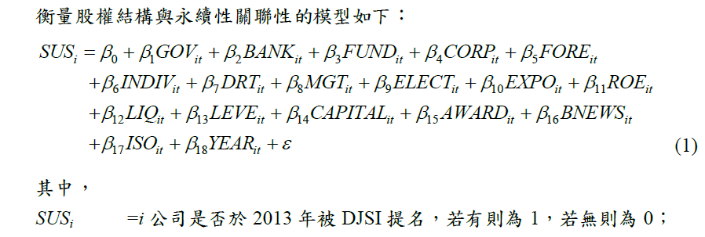

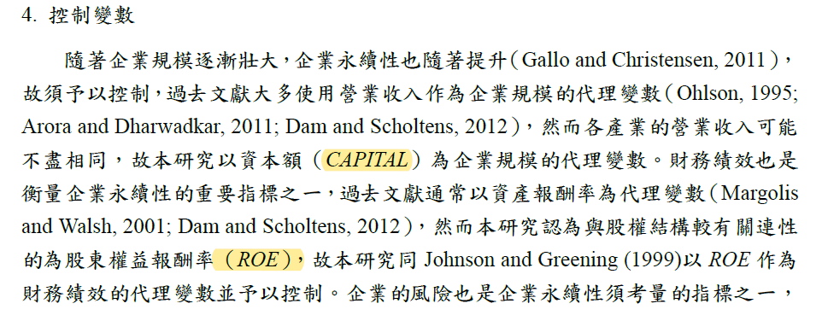

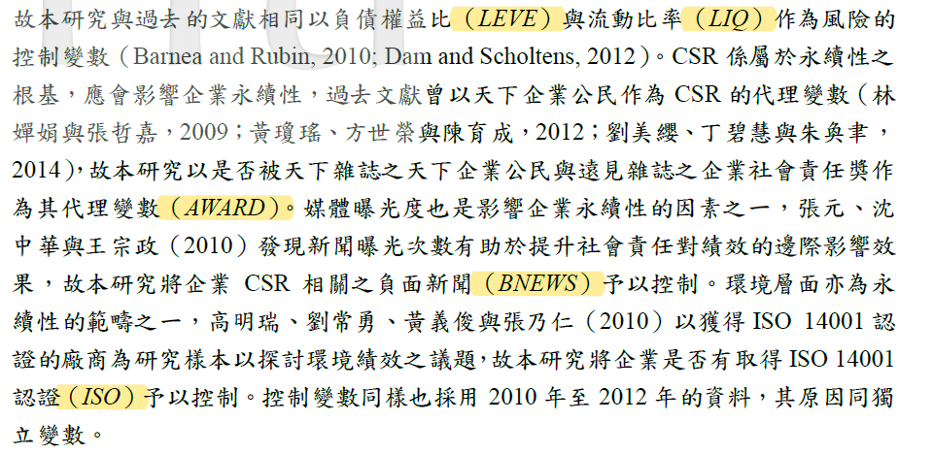

================================================

1. 4-2 Davidson, R. H., Dey, A., & Smith, A. J. (2019). CEO materialism and corporate social responsibility. *The Accounting Review*, *94*(1), 101-126.

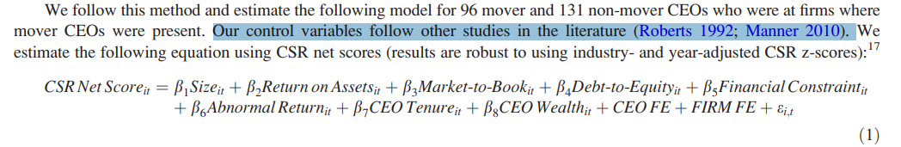

1. 4-3 (為主)Manner, M. H. (2010). The impact of CEO characteristics on corporate social performance. *Journal of business ethics*, *93*, 53-72.

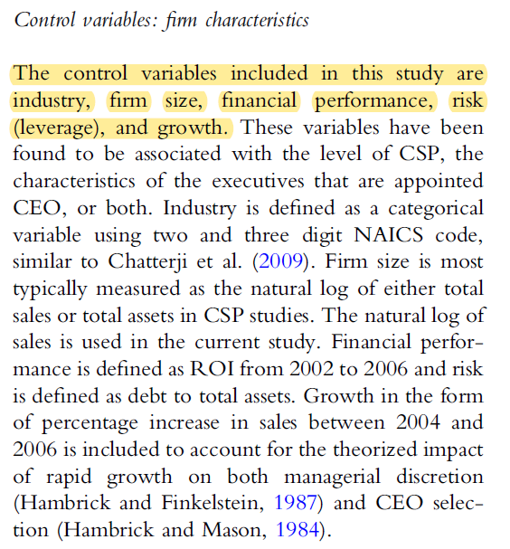

* Firm Size: log Sales(最多)、log TA、Capital(台灣)
* Financial Performance: ROI、ROA、ROE—找稅後？(台灣)
* Risk: debt/TA、debt/equity(台灣)、流動比率(台灣)
* Growth: Sales成長率
* 永續相關(台灣)：社會責任獎(作者自己標)、負面新聞(也有區分ESG)、ISO(資料庫只有E/S認證)

1. 4-4 Roberts, R. W. (1992). Determinants of corporate social responsibility disclosure: An application of stakeholder theory. *Accounting, organizations and society*, *17*(6), 595-612.

===============================================

1. 4-5 Naughton, J. P., Wang, C., & Yeung, I. (2019). Investor sentiment for corporate social performance. *The Accounting Review*, *94*(4), 401-420.

為了抓CSR_premium；CSR:表示環境和治理

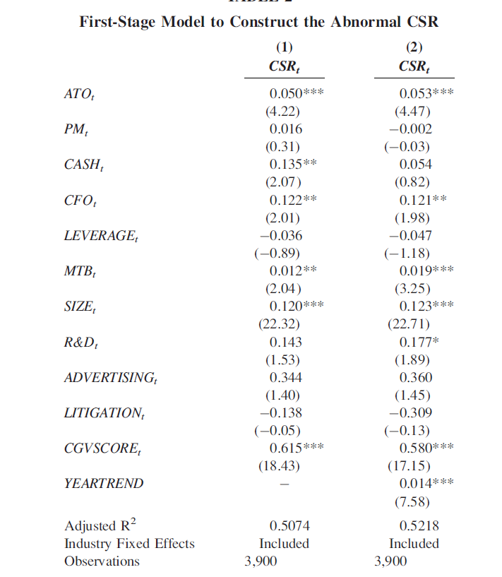

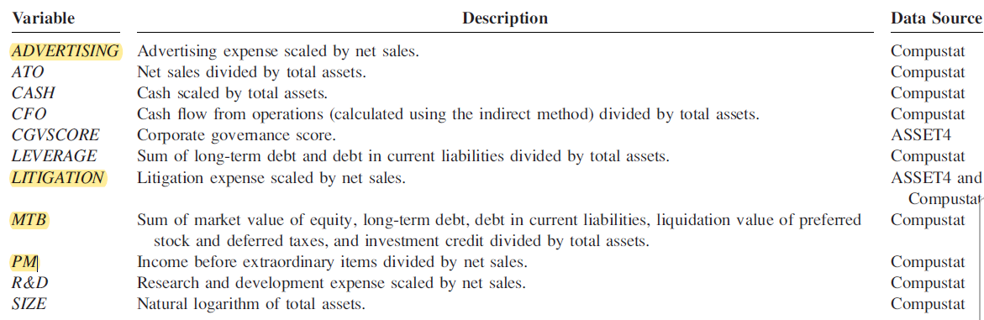

這模型幾乎和我們一模一樣

沒放過去CSR績效、FIN、LIQUID、RD

1-4 Du, S., & Yu, K. (2021). Do corporate social responsibility reports convey value relevant information? Evidence from report readability and tone. *Journal of business ethics*, *172*, 253-274.

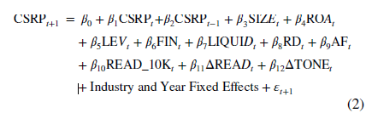

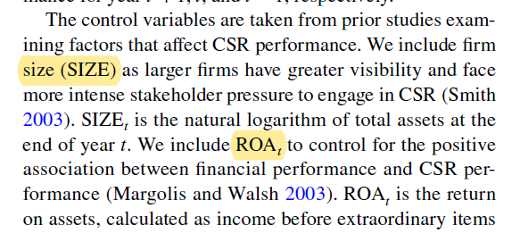

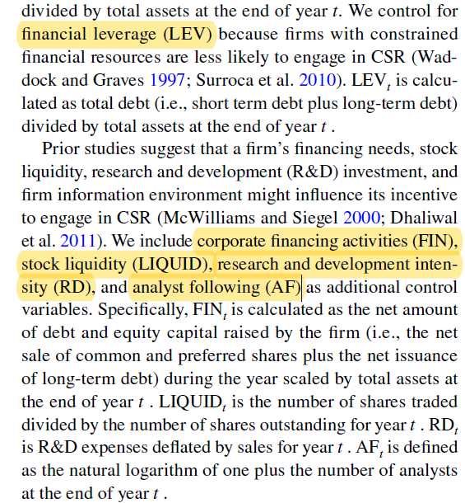

# **研究假說**

H1a: 根據資訊觀點，正向語調與未來ESG績效呈正向關係

H1b: 根據掩飾觀點，正向語調與未來ESG績效呈負向關係

* 機構投資人通常會要求公司提供攸關資訊
* 機構投資人會促使公司投資ESG (法人持股與ESG績效呈正向關係)
* 機構投資人通常扮演外部監理的角色，可減少經理人的投機行為

H2a: 根據資訊觀點，法人持股會強化正向語調與未來ESG績效之正向關係

H2b: 根據掩飾觀點，法人持股會弱化正向語調與未來ESG績效之負向關係

# **研究設計**

## 語調的衡量方式

* 介紹FinBERT的操作方式
* 實證變數參考Jain et al. (2023) JBFA文章中的TONE，計算整份報告書的TONE、TONE_E、TONE_S、TONE_G

附件一：程式碼

附件二：分類結果

## 實證模型

* H1a/H1b模型：

ESG_Perft+1=TONE + Controls + IndustryFE + YearFE

* H2a/H2b模型：

ESG_Perft+1=TONE + INST + INST*TONE/ (ABTONE) + Controls + IndustryFE + YearFE

## 樣本與資料來源

2018-2022年非金融業上市上櫃公司，有出具英文ESG報告書之公司

# **實證結果**

## 敘述統計

為了避免極端值對迴歸結果產生偏誤，連續變數皆經過上下1%的溫賽化 (winsorization)處理。

## 相關係數

## 迴歸結果

# **額外分析**

* 將法人分為國內法人與國外法人
* 還要加跑一條國內(新增變數INST_local)，比較與foreign的差別
* 研究Endnote

# **結論**

* 研究限制：只分析英文ESG報告書的樣本