The Raccoons are Back!

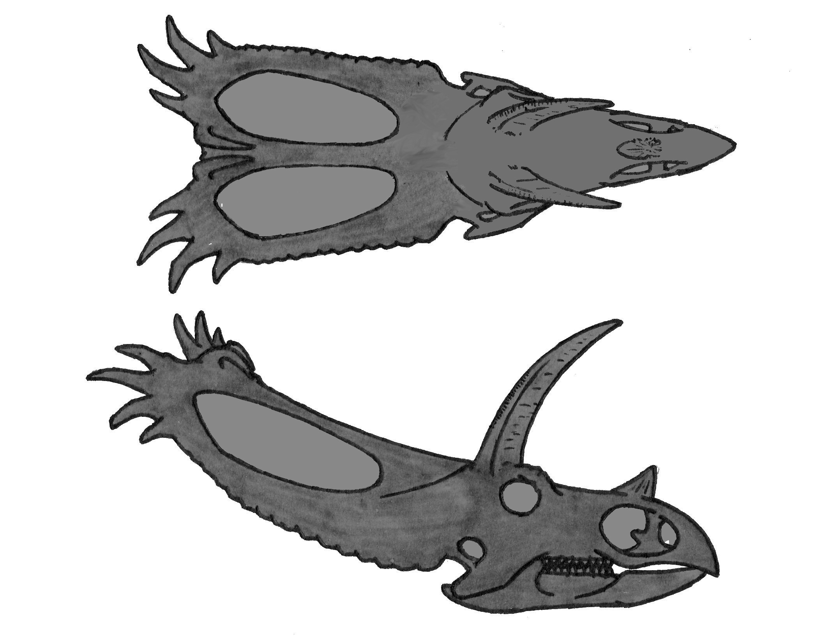Hurray!!