Cybersecurity Lab Setup Report
Isolated lab with Kali Linux, Metasploitable 2, OWASP BWA and Wazuh
Prepared by: Jama Ali Jama
Instructor: Abdihalin Adan Weli
Date: October 29, 2026

1. Objective
The goal of this lab was to build a small, isolated cybersecurity environment in Oracle VirtualBox with one attacker machine, two intentionally vulnerable targets, and one monitoring platform. The lab is used to practice scanning and enumeration, to see how vulnerable services appear to an attacker, and to observe monitored endpoints in a SIEM, which is the foundation for SOC analyst work.

2. Lab Environment
Machine | Role | Operating system / version | IP address
kali33 (linux01) | Attacker | Kali GNU/Linux 2026.3 | 192.168.56.108
Wazuh v4.14.9 OVA | SIEM / defender | Wazuh manager and dashboard | 192.168.56.105
metasploitable2 | Vulnerable target | Metasploitable 2 (Linux) | 192.168.56.106
Owasp | Web target | OWASP Broken Web Apps v1.2 | 192.168.56.107
Host PC (jama) | Host | Windows 11 Pro | 192.168.56.1
Note: addresses are assigned by DHCP on the Host-Only network and can change between sessions. The Kali address shown above is the one Wazuh reported at the time of the final check.

3. Network Configuration
All four VMs use a VirtualBox Host-Only adapter on the 192.168.56.0/24 network, so they can reach each other and the host. A second NAT adapter provides outbound internet access only. No VM uses a Bridged adapter, so none of the vulnerable machines is reachable from the home network or the internet.
VM | Adapter 1 | Adapter 2
kali33 | Host-Only | NAT
metasploitable2 | Host-Only | NAT
Owasp | Host-Only | NAT
Wazuh | NAT | Host-Only

4. Virtual Machines and Network Settings
The VirtualBox Manager screenshots below show all four VMs in the Running state and the network adapters of each one.
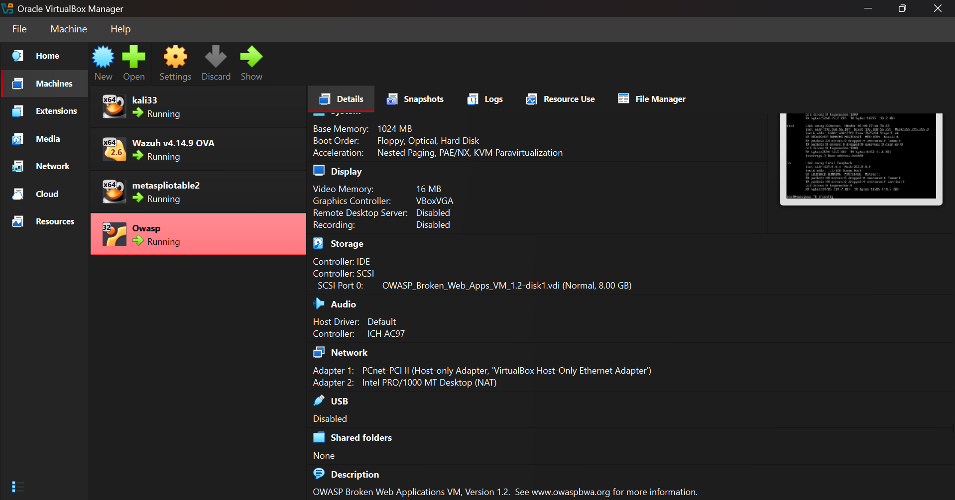
Figure 1. VirtualBox Manager: all four VMs running. metasploitable2 selected (Host-Only + NAT).
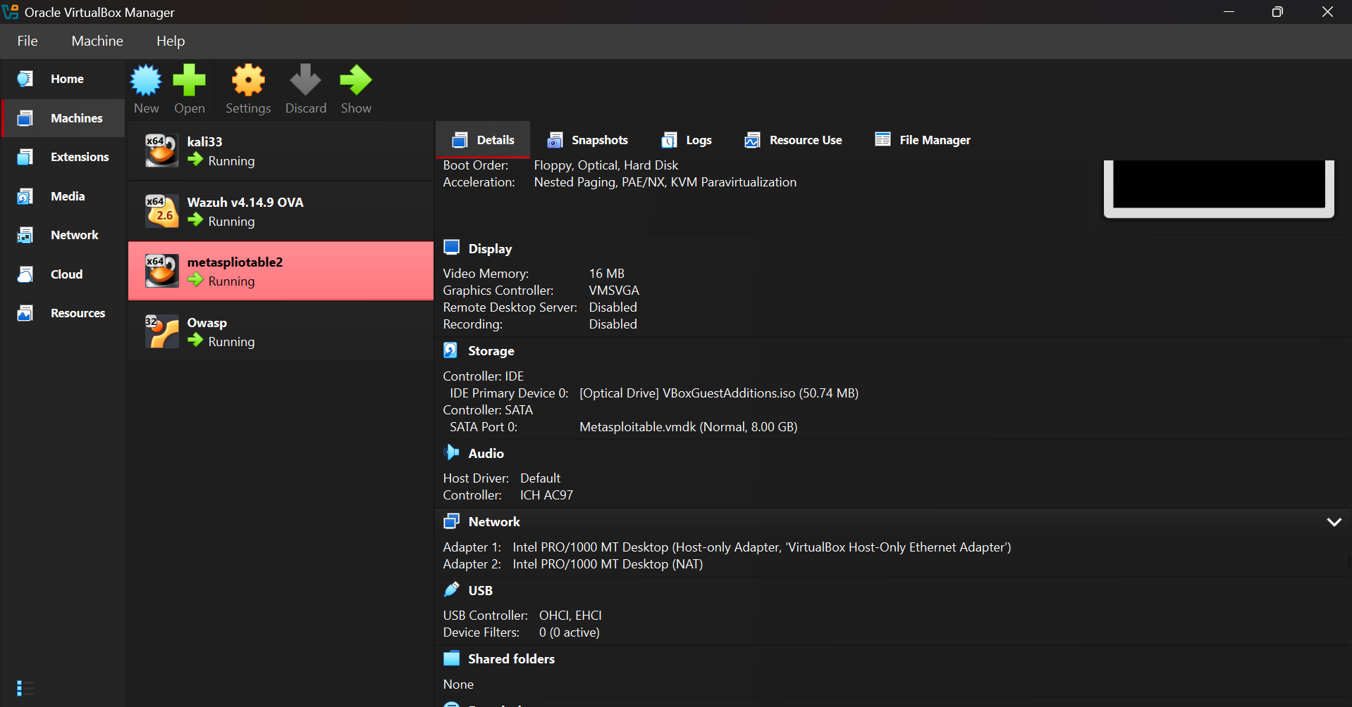
Figure 2. Owasp selected: Adapter 1 Host-Only, Adapter 2 NAT.
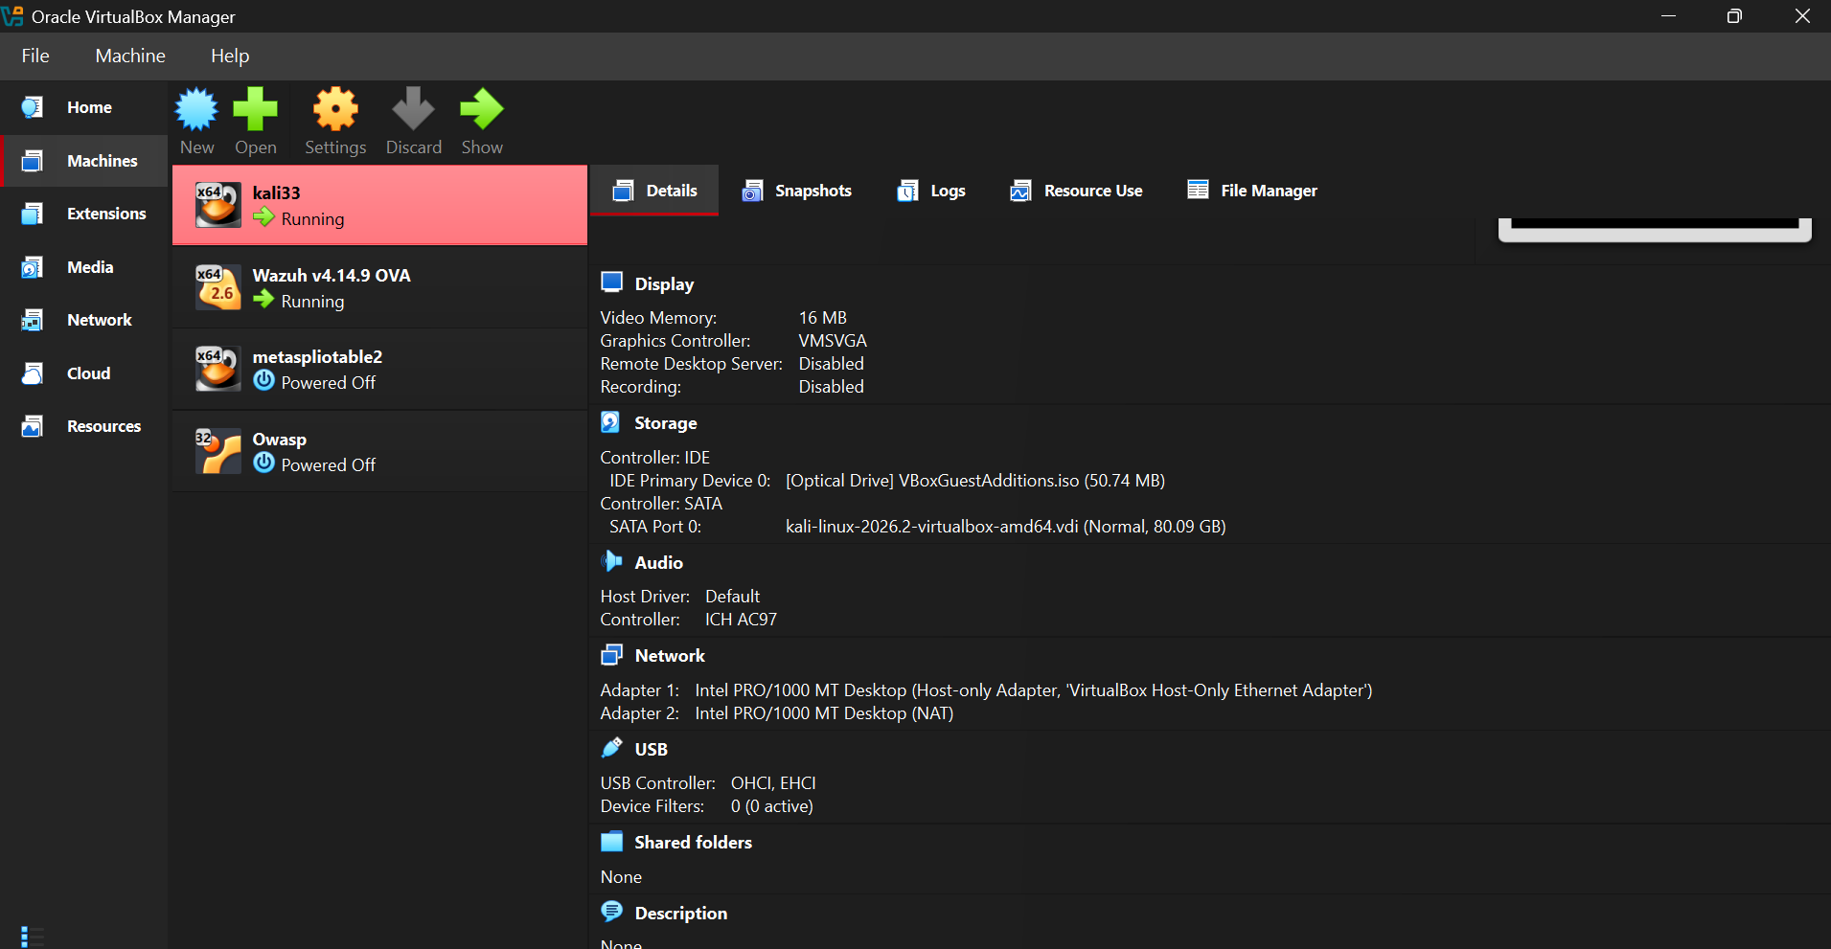
Figure 3. kali33 selected: Adapter 1 Host-Only, Adapter 2 NAT (taken in a later session; the two targets were powered off).
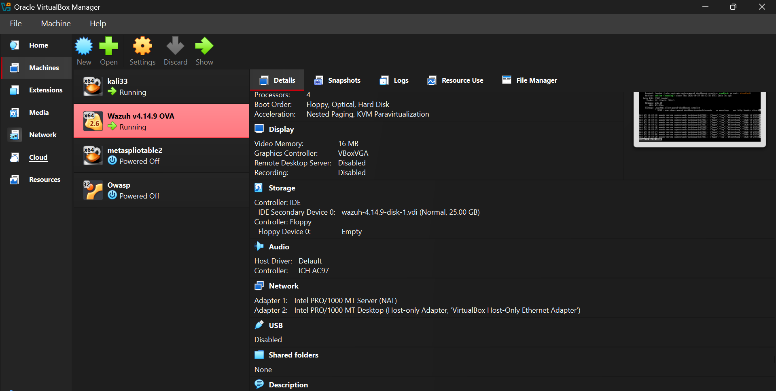
Figure 4. Wazuh selected: Adapter 1 NAT, Adapter 2 Host-Only (taken in a later session).

5. Connectivity Test
From the Kali terminal, ping tests were sent to the other machines on the Host-Only network. Every test returned 4 of 4 replies with 0% packet loss, which confirms the lab network is working.
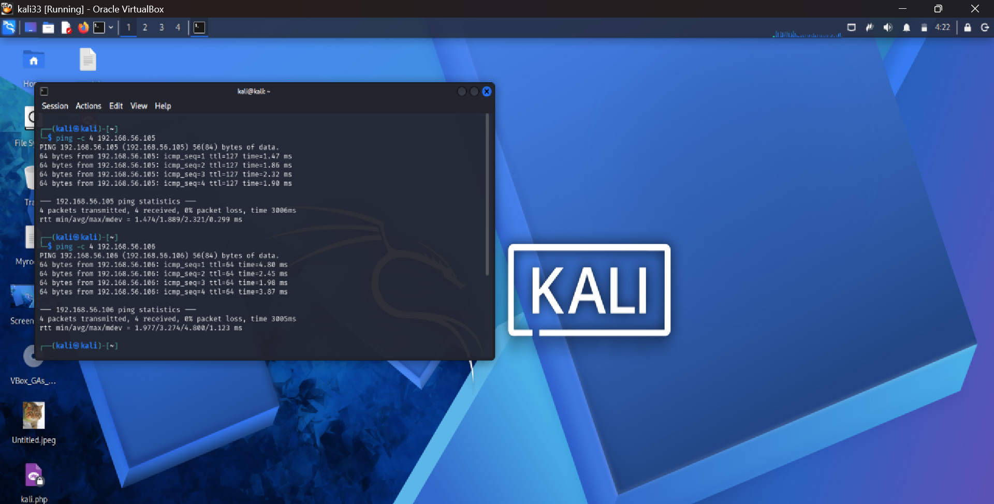
Figure 5. Kali pinging 192.168.56.105 (Wazuh) and 192.168.56.106 (Metasploitable 2).
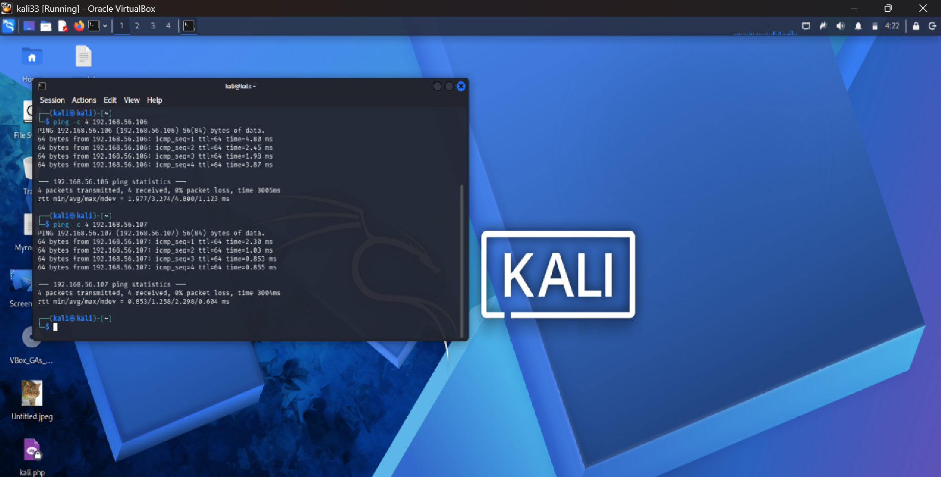
Figure 6. Kali pinging 192.168.56.106 and 192.168.56.107 (OWASP BWA).

6. Service Scan of Metasploitable 2
An Nmap service-version scan (nmap -sV 192.168.56.106) was run from Kali against the Metasploitable 2 target in the isolated lab. The scan finished in about 16 seconds and found 23 open TCP ports, with the host identified as metasploitable.localdomain.
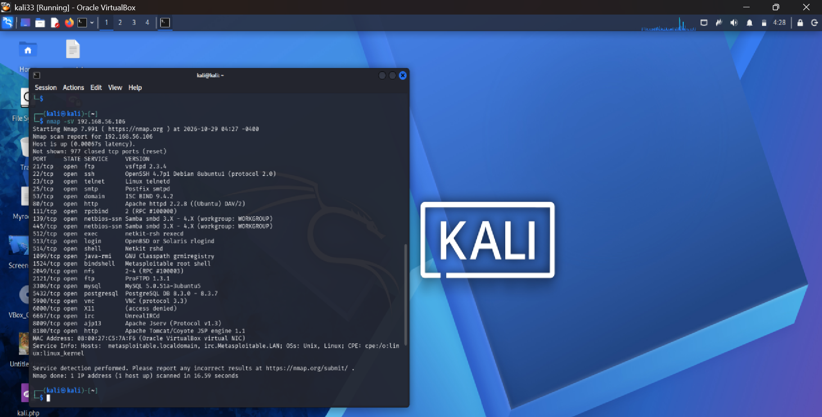
Figure 7. Nmap -sV scan results for 192.168.56.106.
Examples of services reported:
- 21/tcp FTP: vsftpd 2.3.4, and 2121/tcp ProFTPD 1.3.1
- 22/tcp SSH: OpenSSH 4.7p1; 23/tcp Telnet (unencrypted remote login)
- 80/tcp HTTP: Apache httpd 2.2.8; 8180/tcp Apache Tomcat/Coyote JSP engine 1.1
- 139 and 445/tcp: Samba smbd 3.X - 4.X
- 1524/tcp: bindshell (labelled "Metasploitable root shell"); 6667/tcp: UnrealIRCd
- 3306/tcp MySQL 5.0.51a and 5432/tcp PostgreSQL 8.3.x
These are old, outdated services. That is expected, since Metasploitable 2 is deliberately vulnerable for training. The scan was run only against my own lab machine.

7. Web Targets
Both web targets were opened in Firefox on Kali.
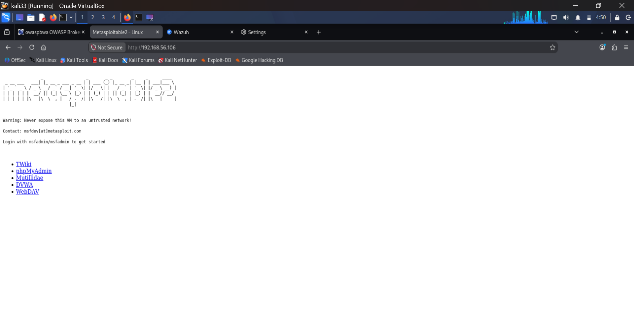
Figure 8. Metasploitable 2 web page at http://192.168.56.106 (TWiki, phpMyAdmin, Mutillidae, DVWA, WebDAV).
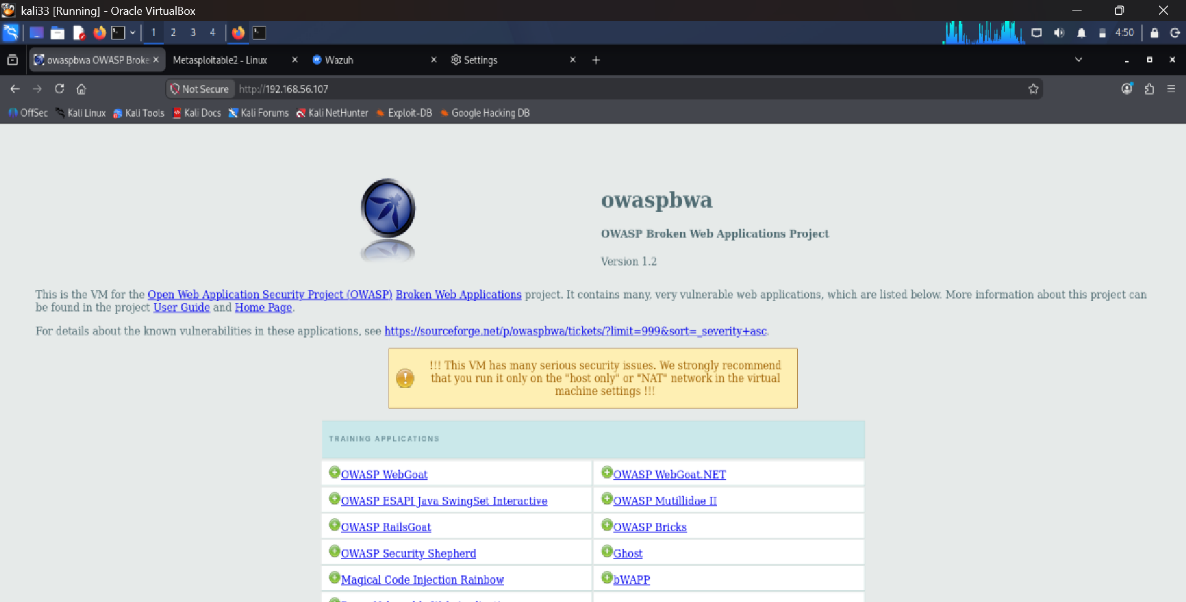
Figure 9. OWASP Broken Web Applications v1.2 at http://192.168.56.107.

8. Wazuh Monitoring
The Wazuh dashboard at http://192.168.56.105 lists two enrolled agents: the Windows 11 host (jama) and the Kali VM (linux01).
Troubleshooting note: both agents first showed as Disconnected. The Kali agent configuration (/var/ossec/etc/ossec.conf) still pointed to 192.168.56.104, an old address of the Wazuh manager, while the manager was now at 192.168.56.105. A connectivity test to port 1514 on the correct address succeeded. After correcting the manager address and restarting the agent, both agents became Active.
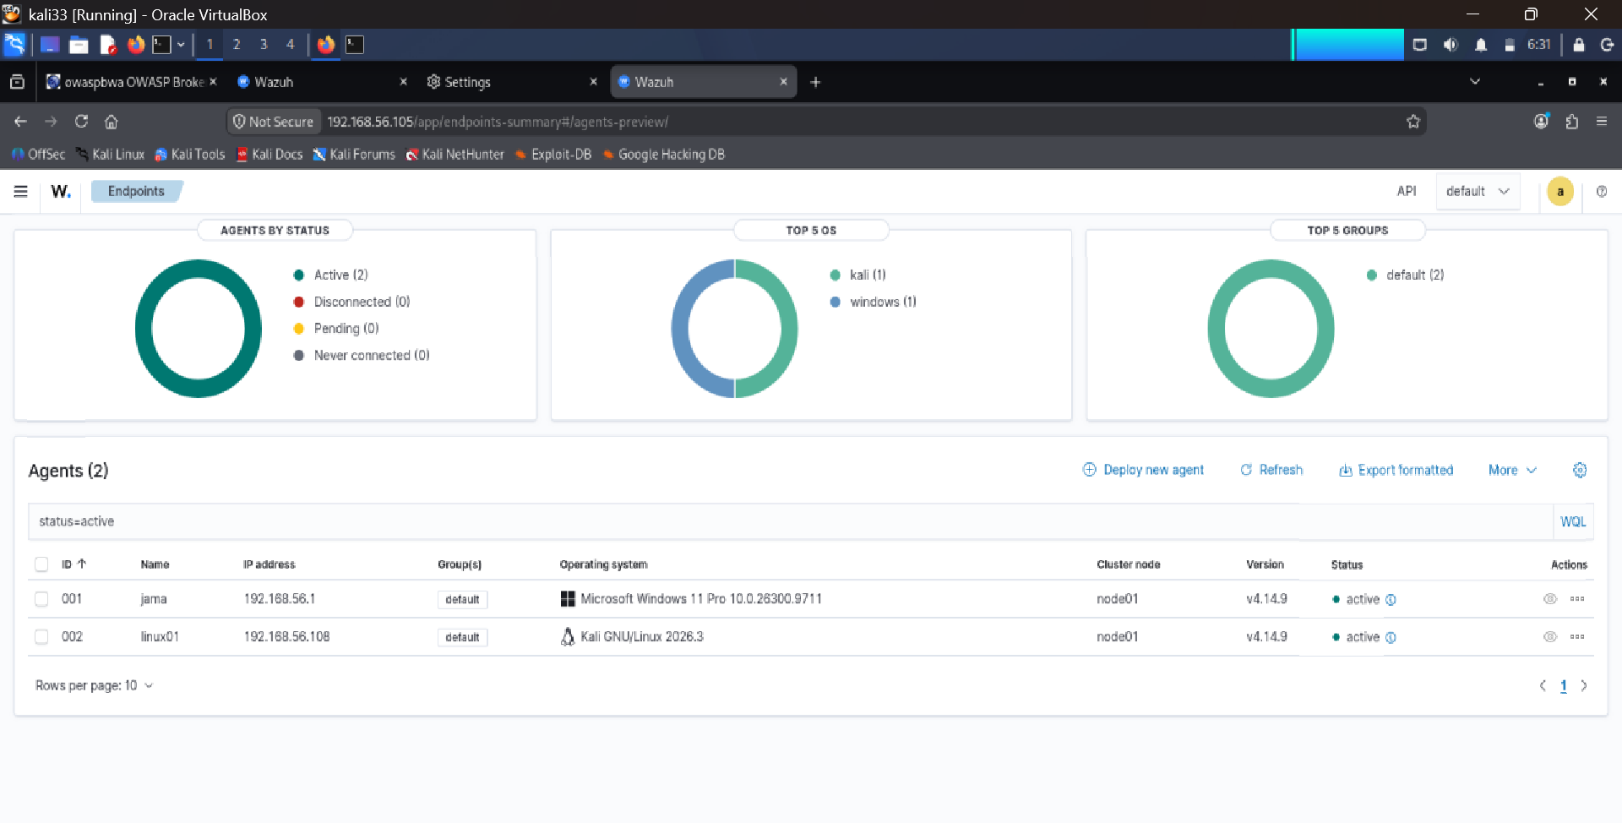
Figure 10. Wazuh Endpoints: Active (2), Disconnected (0).

9. Verification
The following terminal output shows the user, the system date and time, and the Wazuh dashboard with both agents active, taken in the same session.
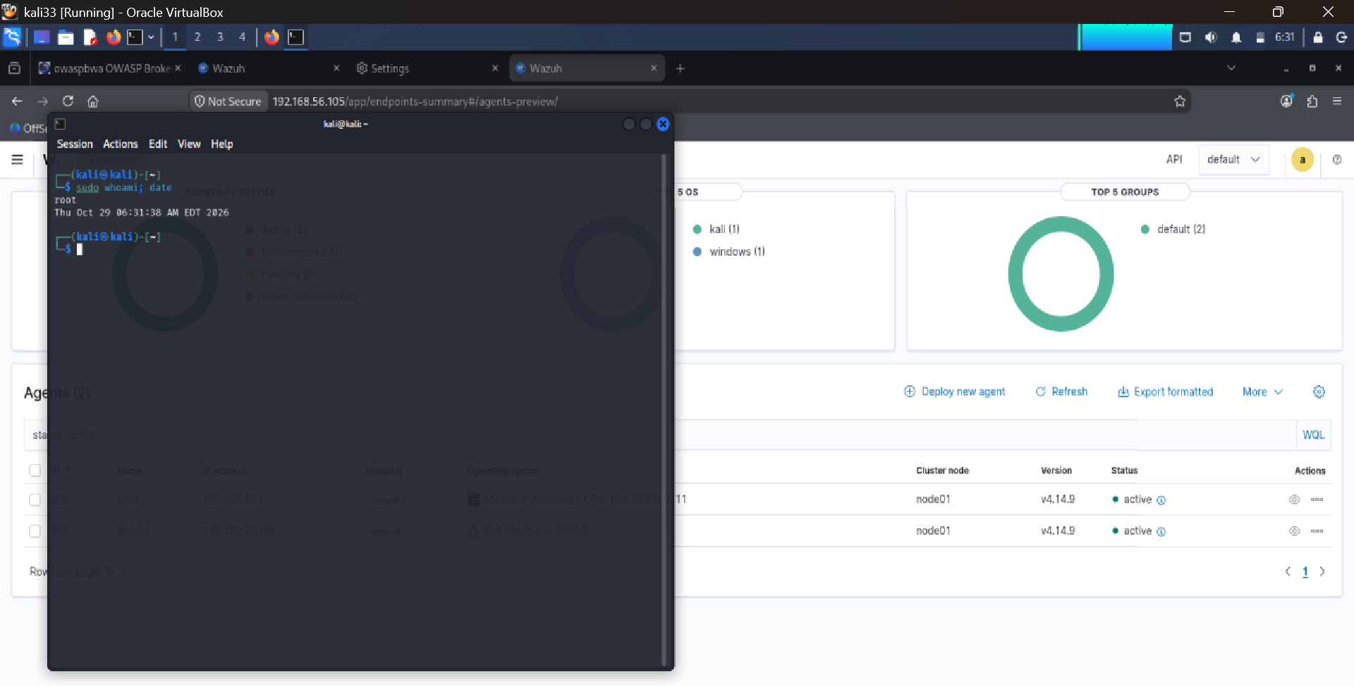
Figure 11. "sudo whoami; date" on Kali (root, Thu Oct 29 06:31:38 AM EDT 2026) over the Wazuh dashboard.

10. Conclusion and What I Learned
- Built a working four-machine lab on an isolated Host-Only network, with NAT used only for outbound internet access.
- Verified connectivity with ping and enumerated open services on a target with Nmap.
- Learned how Host-Only, NAT and Bridged networking differ, and why vulnerable machines must never be bridged.
- Diagnosed a real fault: Wazuh agents were disconnected because DHCP changed the manager IP. Checking the agent config, the connection to port 1514 and the manager address fixed it.
Next steps: run a controlled scan or login attempt from Kali against a monitored machine, find the resulting alerts in Wazuh, record the rule ID and severity, and map the activity to MITRE ATT&CK in an incident-style write-up.

