Test Case Generator – via LangFlow API

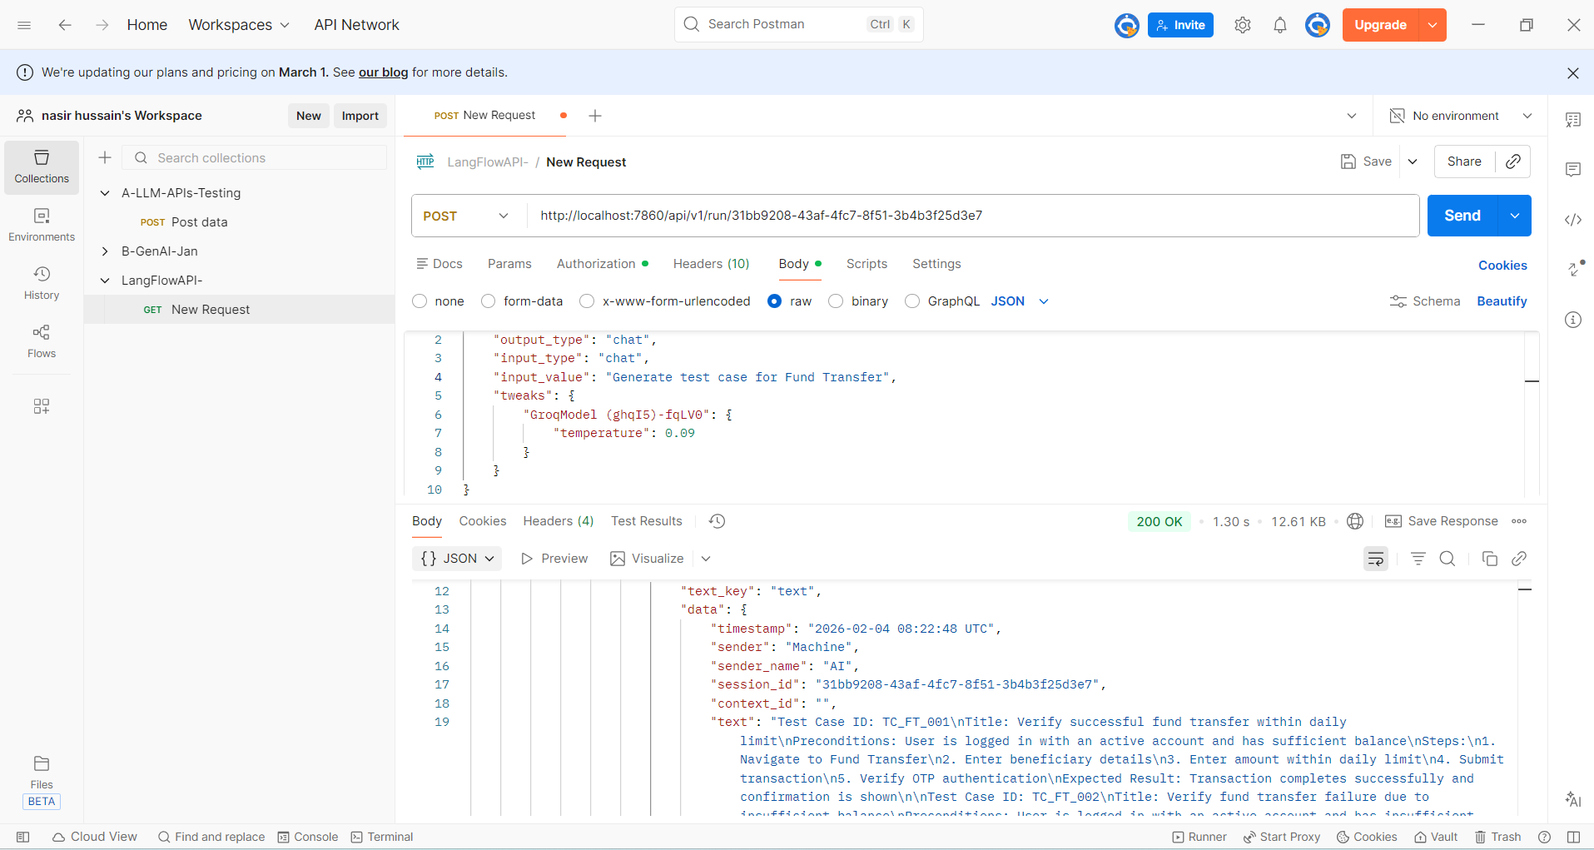

UserStoryReviewAgent - Customized
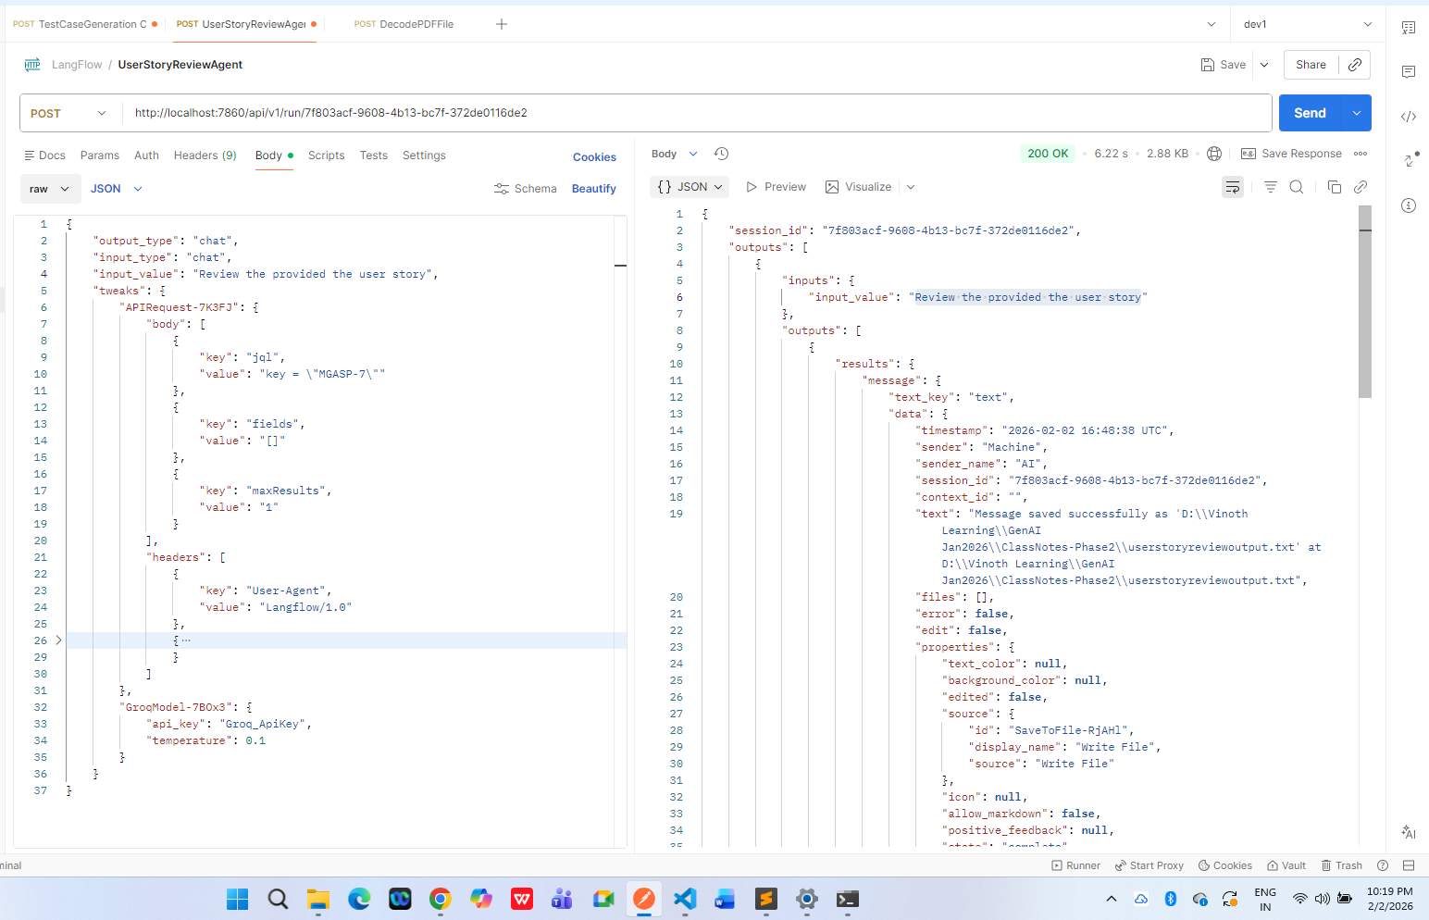

DecodePDFFile – Customized
