

An-Najah National University
Faculty of Engineering

Database Project

Trust Insurance International Company

Made by:
Zaid M Habiba
Jamal W Zaid
Steps and Procedure
1- find the idea of project so that, it supports the needs of a wide layer
of companies in the market, also provides many options shorten the time and effort.
2- Second step is writing the requirements of the project which contains a detailed description of the main components of the company and what information should be stored for each component and also define the relationships between them.
3- creating the schema of database then create tables and determining the
primary keys, foreign keys of each table as well as what attribute should not be null or should be unique, this all depends on the UML diagram we designed.
4- design the GUI of the application such that it’ll be guaranteed there will be no errors and exceptions.

Database Design
The database has been divide, so that the client was removed from the complexity of branched different cities. The internal division of the company had been approved, so that all the branches and each department are connected to the private manager, who can access too many of operations that are not allowed to the staff’s account, which it will be mentioned later.

SMS Messages
Many of other features had been added to our application, such that it will make the communication between the company and the customer more easier than usual. For example, the SMS messages, this feature had been added to facilitate the communication between the staff and the client. Moreover, this service works from the begging of the customer registration in the company.

Email Messages
Email messages had been also added to our application, such that it ill enhance the communication between the staff and the client.

Since the process of subscription to the company until the end will be easy, this will attract the customers to be registered in our company.

Layouts
Our application provide a lot of layouts, such that they’re designed in a very simple way, to make the staff so comfortable with the GUI and the ease of access to the layouts.

The interface is made up of two interfaces either the first one, which is for the customer information and the second interface is the insurance and the car information which are needed to register the car.

Main Application
1.Login Layout
Our login layout is made very attractive, comfortable and so simple, it is designed using material design such that it will be too attractive.
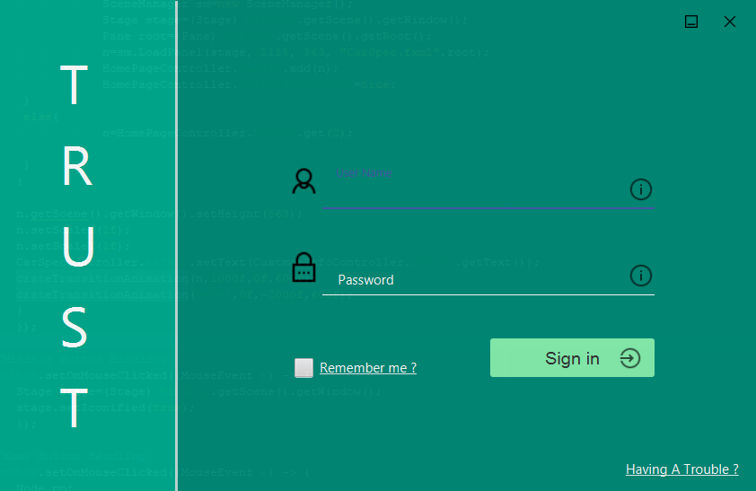
We can see that if the information entered are wrong a popup Dialog would appear which tells the user that the entered information are wrong.
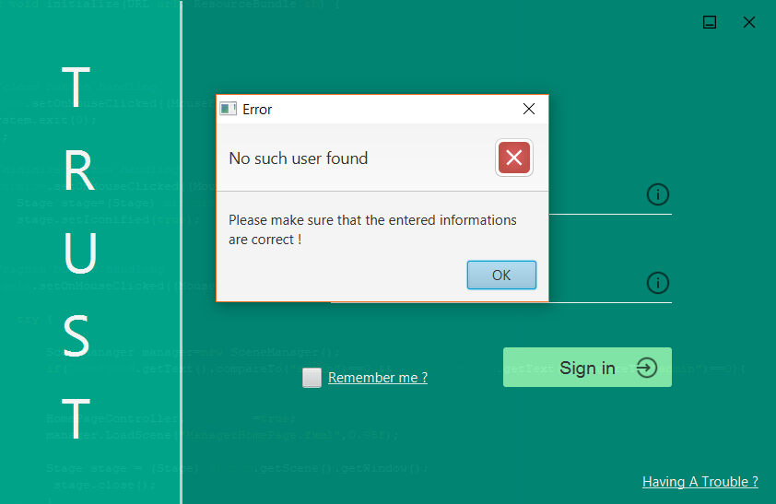
a)Staff & Admin Layouts
The staff has limited access to the application, such that he can’t add, delete or modify any of the data in the database, because all of these features are only prohibited to the Admin of the application the following pictures show the difference between the staff layout and the admin layout.

Staff Layout

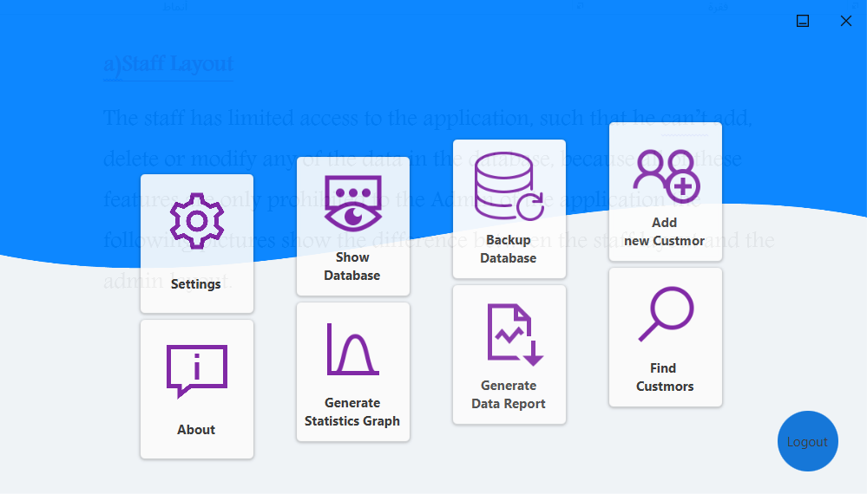

Admin Layout

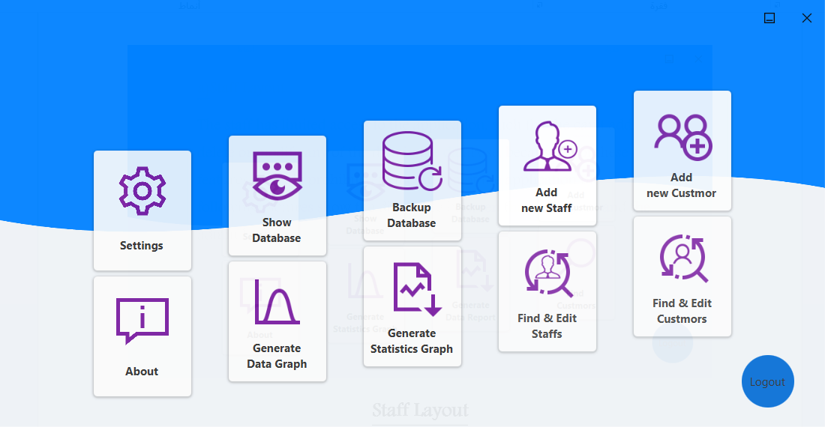

b)Home Page Layout
out home page layout is designed in a way it will have high access to the whole application and the beauty of the application.

c)Add Custmor Layout
the add customer layout is very simple and arranged in a way such that the staff can fill the required information easily, where every related information are grouped together and separated by lines.
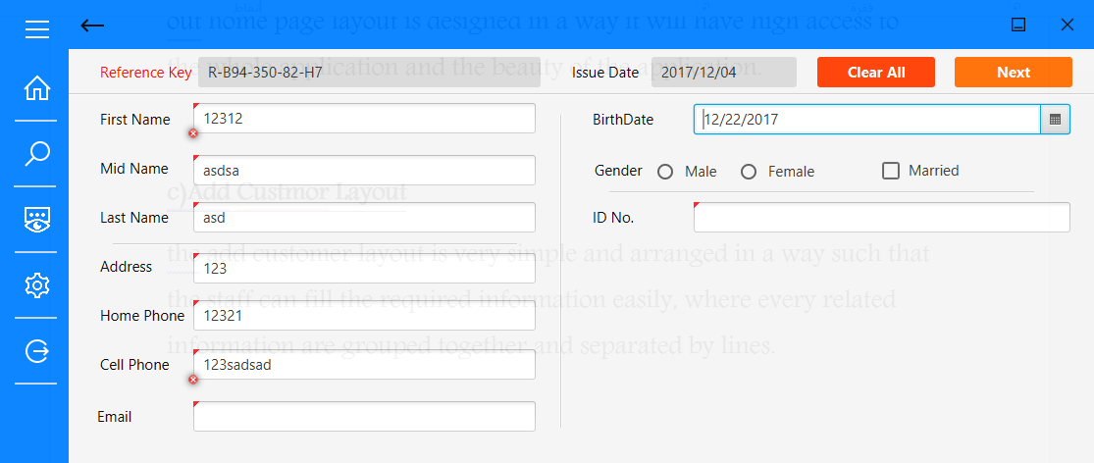
We can see the validation on the whole required filed where the entered text is invalid.

d)Insurance & Car Specifications
Our Insurance & Car Specifications is the same technique used in the customer information.
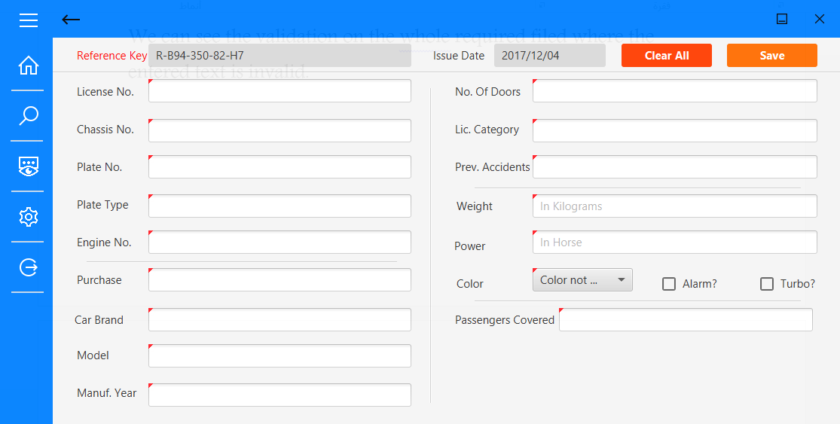
→we can see the unique reference key which is applied to the customer itself.

- We can note the quick access buttons on the leftmost, so that the staff will be able to access the hot things quickly

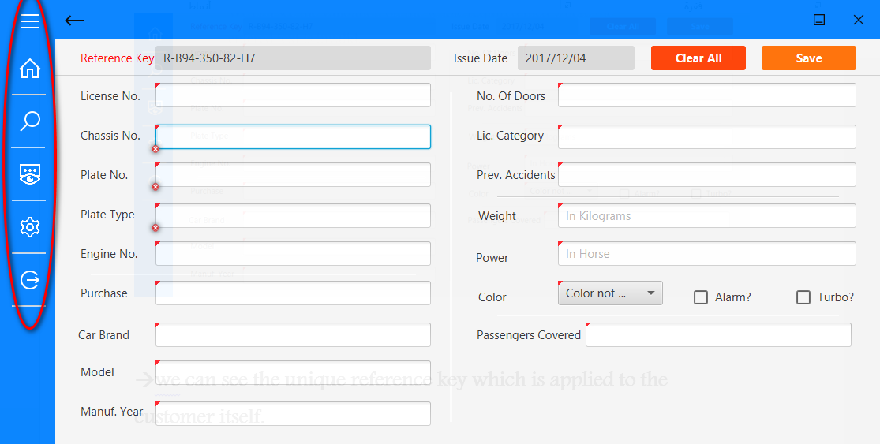

E)Add Staff Layout
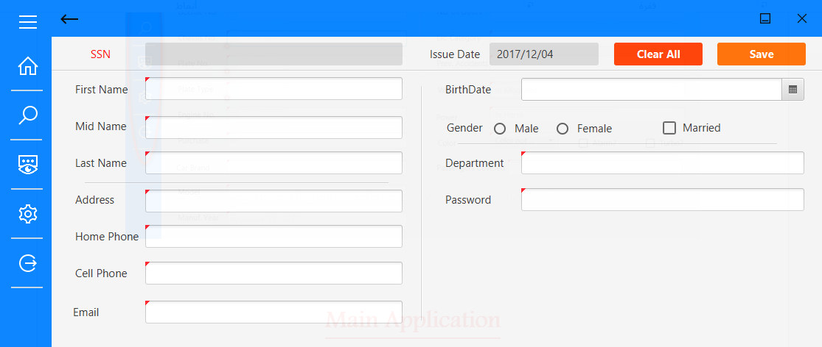

F)Database Backups and Restoration
Our program provides backups and restores to the database in order to keep secure from the attacks and for more security purposes.
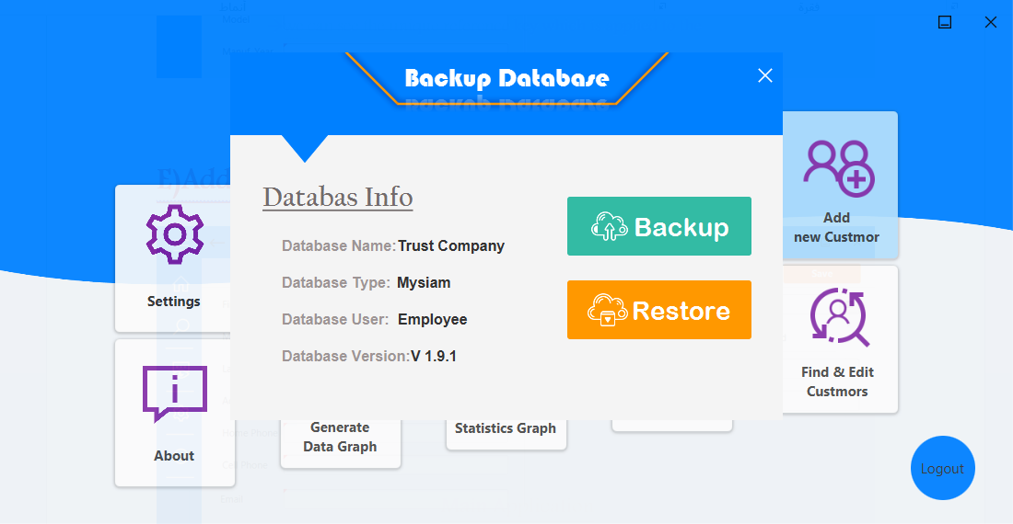
G)Graph Generation
Our application provide statics for the database in a convinect way and simple way as follows.
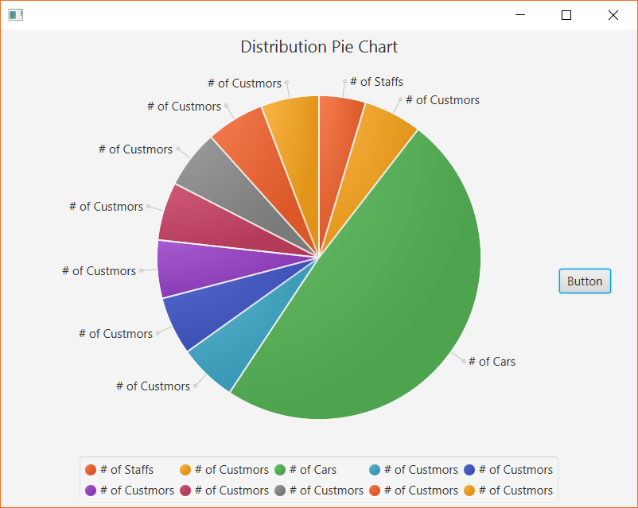

H)Reports
Our application provides up to two reports one for the customer (both the staff and the admin can produce it) and the staff report ( only the admin can produce it)
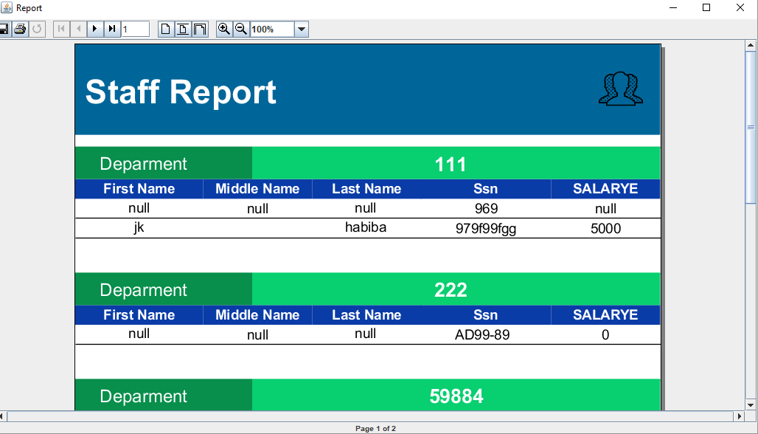
K)Tables
Our application provides three tables two for the customer and the insurance (prohibited for all employees) and the other is for the staffs (prohibited only for the admin)
Staff Table view
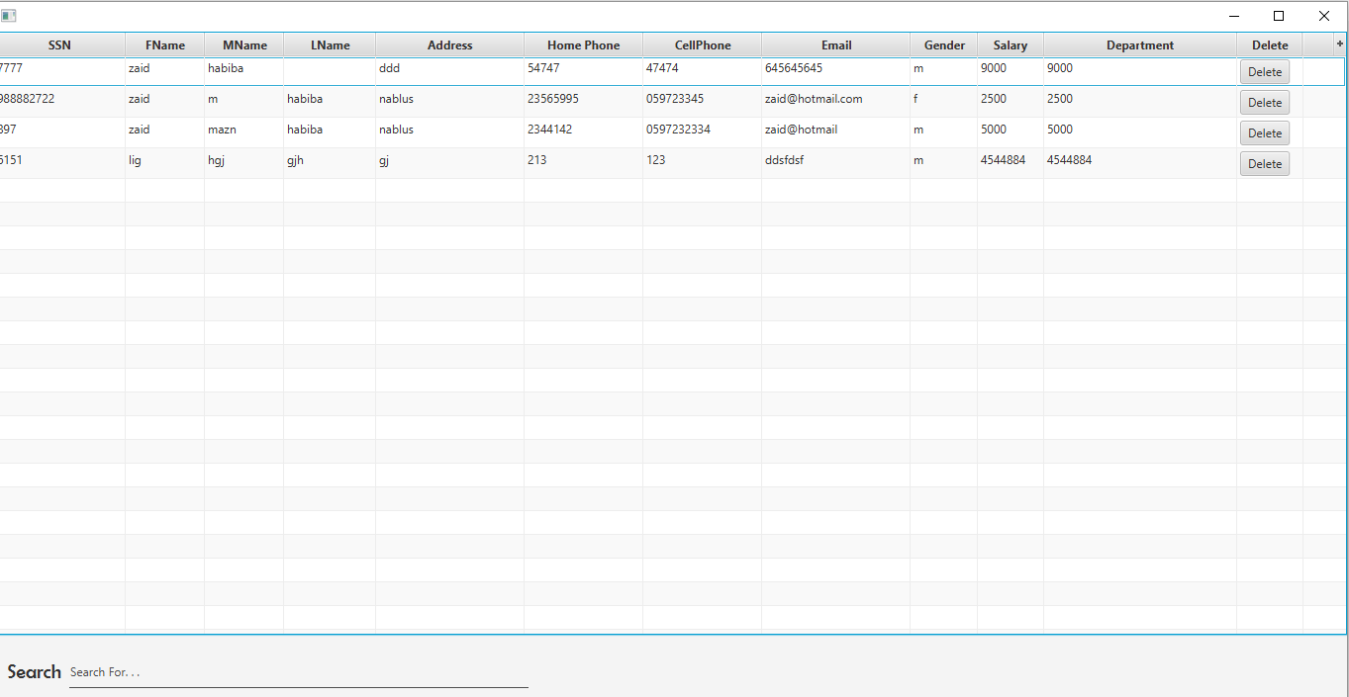
Customer Table view
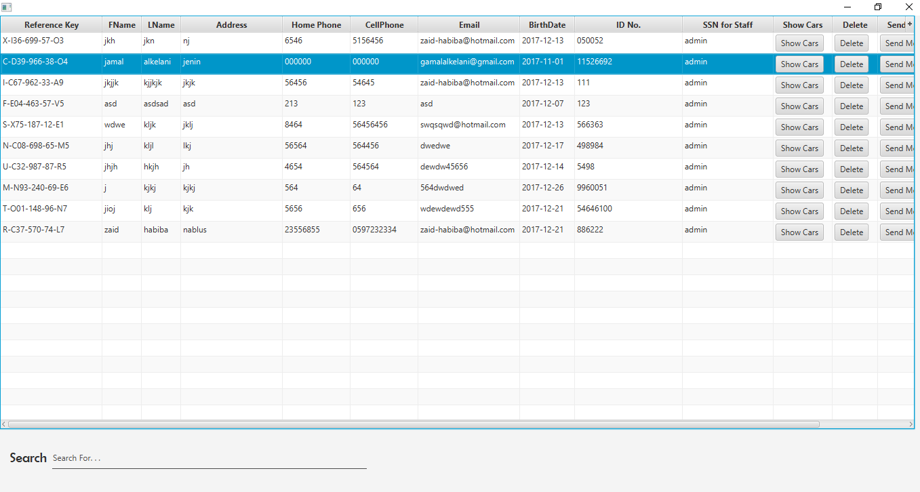
Car table view
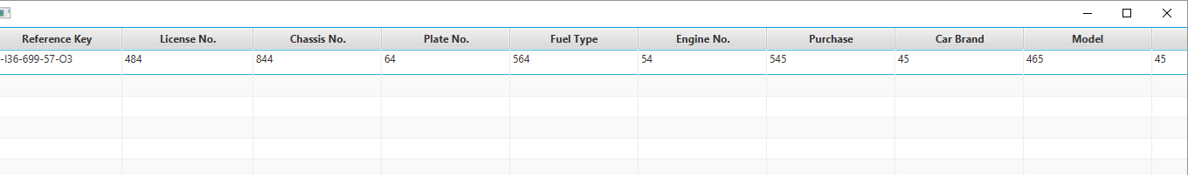

Deleting and Modification
Our application provide a very simple powerful way of editing as follows
1.double click on the cell you want to edit
2. press enter (tic tac) everything is up to date now !
It also a very simple way of deleting by pressing the button in front of the row you are going to delete.
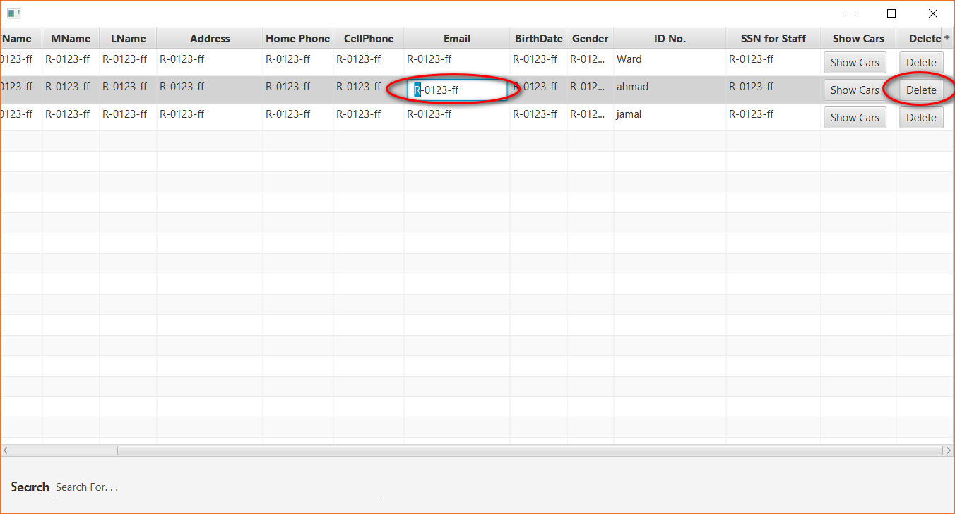
Search Engine
Our application provides a very powerful search engine based on everything, you can search for anything you want! It provides up to 40 different way of searching just enter the word, which you are looking for, and like magic, the whole table will be updated and shows the results. !!

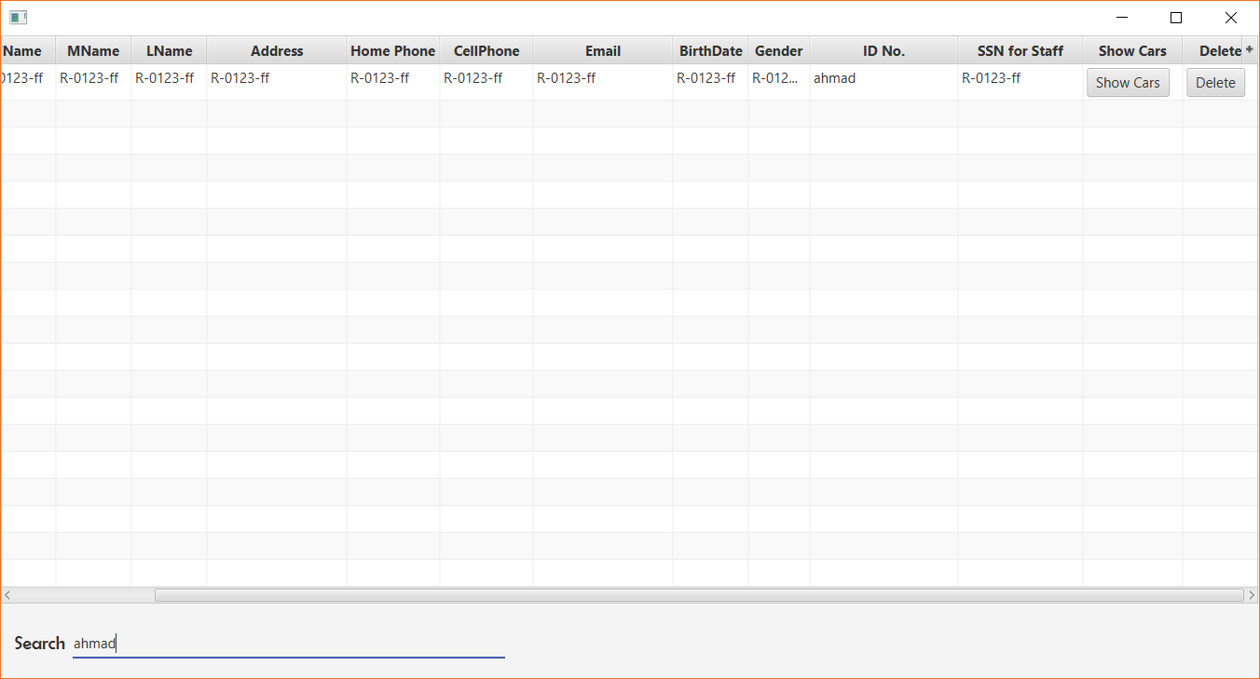
Search by name !
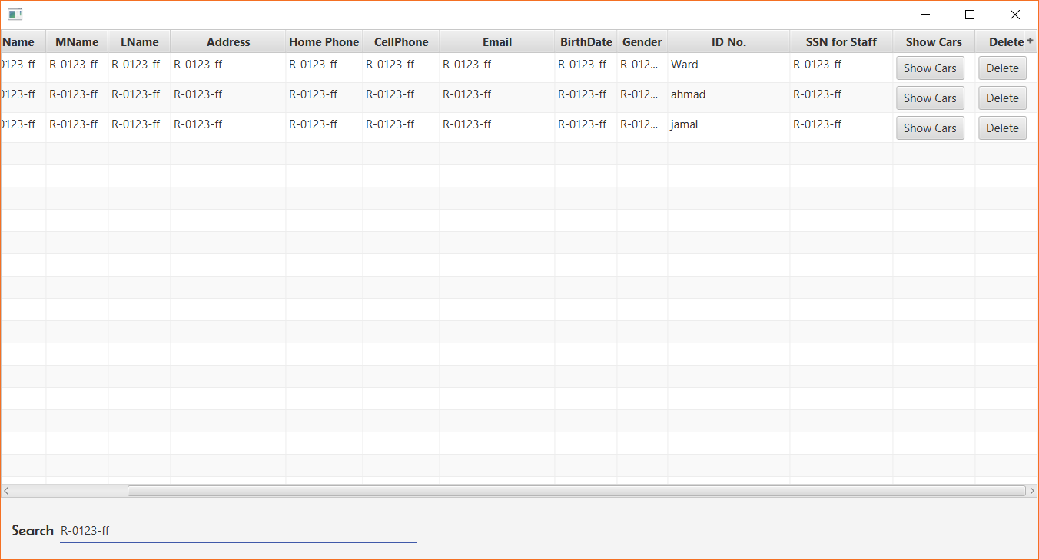
Search by Email

Validation
Our application is very very well validated, such that it’s Impossible to make an error or exception by mistake. We have relied our validation based on the powerful tool provided by Javafx (Component Validation).
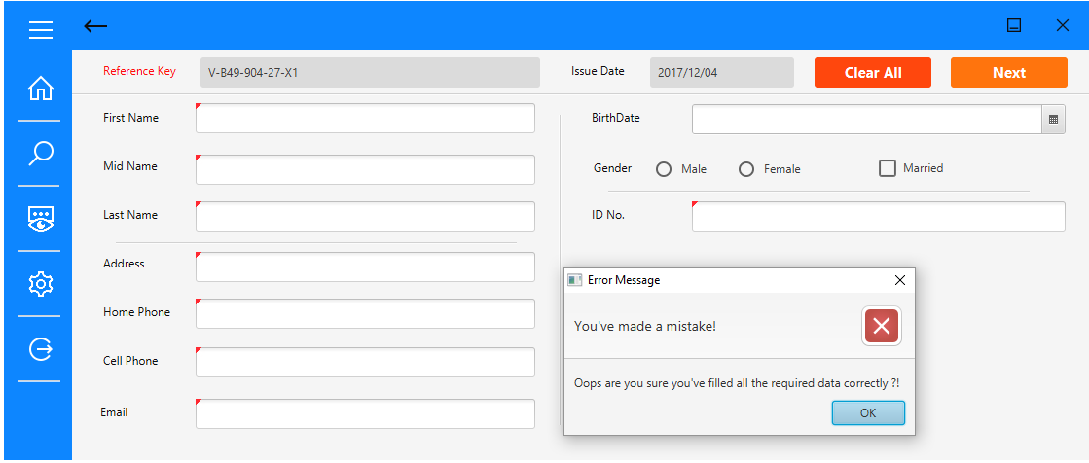
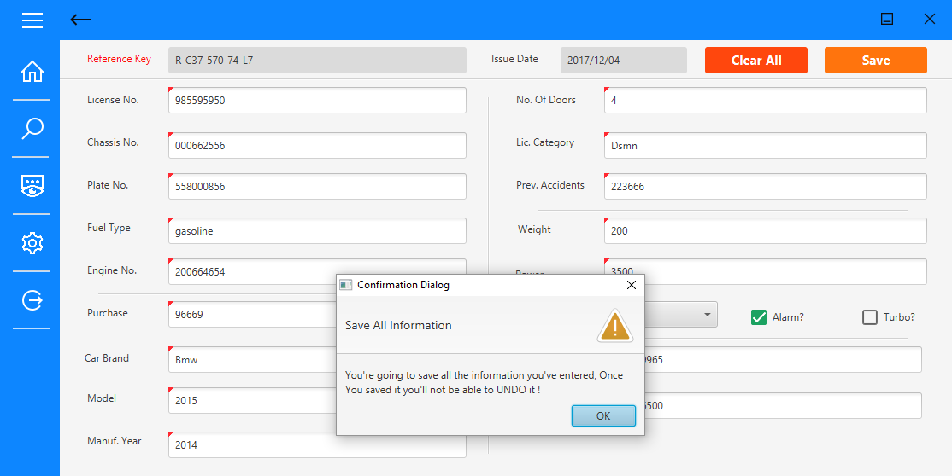

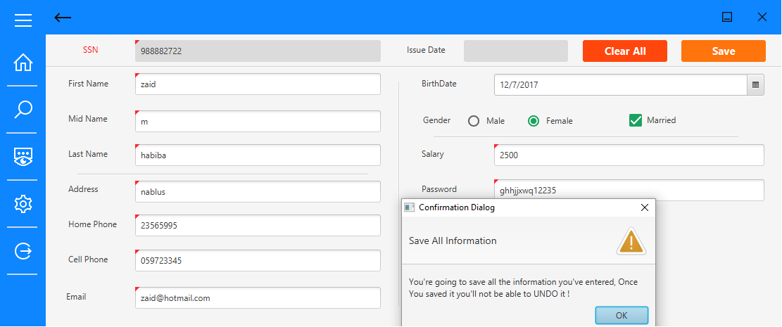

We can see the different scenarios of validation on the whole program.

About our Copmany
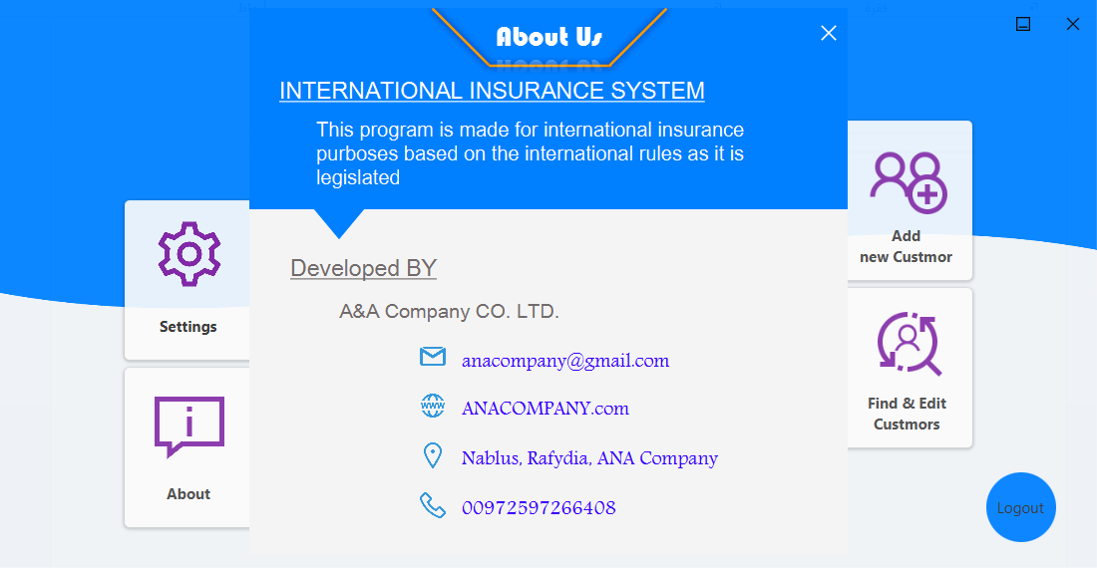
How we deal with deletions and modification to the database ?

After adding the insurance you can modify the insurance or employee in the event of any problem
Or renewal to secure through a special booth was done to show each customer
And through the name of the person or ID number or any information about a customer to access all his information in the databases
Whether the information of the person or customer can easily review the customer data and all his car is added to the company
If the customer withdraws from the company, the client file can be deleted easily in seconds
Client can be given full disclosure by click on the Good (Report)
Which shows all customer information and all its insurance
All previous things are enhanced in the provision of mobile messaging and e-mail services
Which the client looks for all operations that are carried out on his account

Or the features of the manager account, the management will be much easier with a set of features created
To facilitate the management of the director
So that the employee can add a client fully to the set of details reviewed in the Employee (Customer Server) by reviewing, modifying, adding, deleting and issuing a report
Sending messages to customers
Either other features are facilitated by the administrator
Either of these things, each customer is added to connect that customer with the employee number
In order to facilitate the administration if there was a problem with the client in terms of addition and also to know the active employee from others
The manager can also issue a report to show all employees at all branches
It shows the information of all employees in each branch
The manager has the option of adding an employee so that each manager is responsible for the branch that any employee is responsible for adding to the branch in which he is added
The manager can delete any employee or modify his information
If the employee is deleted, all the clients they are connected to are transferred to an existing fictitious employee who does not follow any branch to XXX-XX

