**CLASS DIAGRAM:**

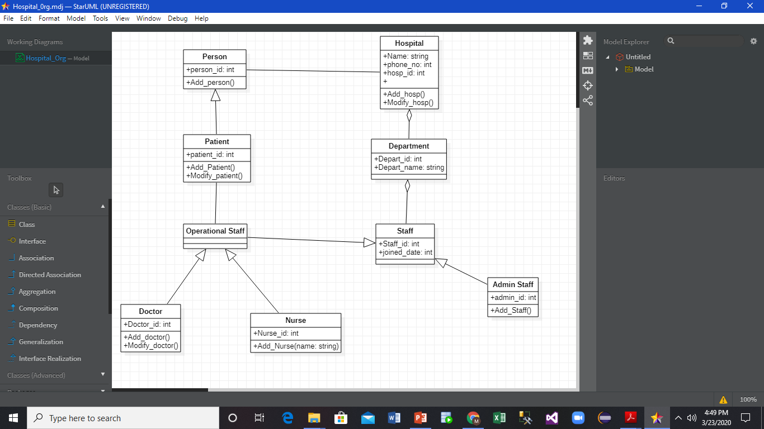

**CODE GENERATED USING STARUML IN JAVA:**

1. **Admin Staff:**

import java.util.*;

/**

*

*/

public class Admin Staff extends Staff {

/**

* Default constructor

*/

public Admin Staff() {

}

/**

*

*/

public int admin_id;

/**

*

*/

public void Add_Staff() {

// TODO implement here

}

}

1. **Department:**

import java.util.*;

/**

*

*/

public class Department {

/**

* Default constructor

*/

public Department() {

}

/**

*

*/

public int Depart_id;

/**

*

*/

public string Depart_name;

}

1. **Doctor:**

import java.util.*;

/**

*

*/

public class Doctor extends Operational Staff {

/**

* Default constructor

*/

public Doctor() {

}

/**

*

*/

public int Doctor_id;

/**

*

*/

public void Add_doctor() {

// TODO implement here

}

/**

*

*/

public void Modify_doctor() {

// TODO implement here

}

}

4

1. **Hospital:**

import java.util.*;

/**

*

*/

public class Hospital {

/**

* Default constructor

*/

public Hospital() {

}

/**

*

*/

public string Name;

/**

*

*/

public int phone_no;

/**

*

*/

public int hosp_id;

/**

*

*/

public void Add_hosp() {

// TODO implement here

}

/**

*

*/

public void Modify_hosp() {

// TODO implement here

}

}

1. **Nurse:**

import java.util.*;

/**

*

*/

public class Nurse extends Operational Staff {

/**

* Default constructor

*/

public Nurse() {

}

/**

*

*/

public int Nurse_id;

/**

* @param name

*/

public void Add_Nurse(string name) {

// TODO implement here

}

}

1. **Operational Staff:**

import java.util.*;

/**

*

*/

public class Operational Staff extends Staff {

/**

* Default constructor

*/

public Operational Staff() {

}

}

1. **Patient:**

import java.util.*;

/**

*

*/

public class Patient extends Person {

/**

* Default constructor

*/

public Patient() {

}

/**

*

*/

public int patient_id;

/**

*

*/

public void Attribute1;

/**

*

*/

public void Add_Patient() {

// TODO implement here

}

/**

*

*/

public void Modify_patient() {

// TODO implement here

}

}

1. **Person:**

import java.util.*;

/**

*

*/

public class Person {

/**

* Default constructor

*/

public Person() {

}

/**

*

*/

public int person_id;

/**

*

*/

public void Add_person() {

// TODO implement here

}

}

1. **Staff:**

import java.util.*;

/**

*

*/

public class Staff {

/**

* Default constructor

*/

public Staff() {

}

/**

*

*/

public int Staff_id;

/**

*

*/

public int joined_date;

}