I needed to make a FIFO function that can do following 3 different actions.

1. Writes data in array in FIFO order. When data is called (Read) then data is released in FIFO order. It works like a text book definition of a FIFO operation.

2. Writes data in array in FIFO order. When data is called (Read) then first element of the array is read & removed from array. Then whole array is shifted one slot to the left. This is similar to POP function in python programming.

3. Writes data in array in FIFO order. When data is called (Read) then first element of the array is read & removed from array. One additional action is done in the array. The program checks for similar elements in the array which has been just read(& removed from array) and deletes them. Finally program removes all the zero elements in between non-zero elements.

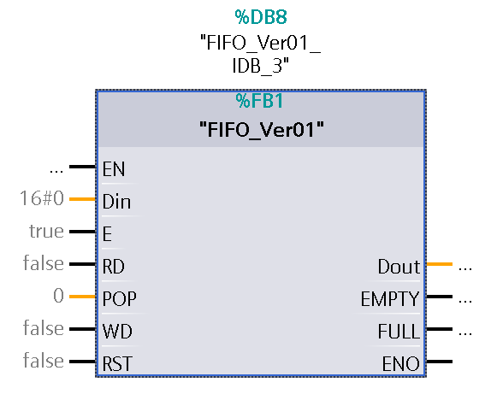

EN - not needed

Din - Data input. Here the data needs to be available which will be added to FIFO array.

E - Enable or disable FIFO function

RD - Trigger READ action (only R_TRIG should be connected here)

POP - There are 3 options here. 0,1 and 2.

0: no POP action

1: POP action type 1. When data is called (Read) then first element of the array is read & removed from array. Then whole array is shifted one slot to the left. This is similar to POP function in python programming.

2: POP action type 2. When data is called (Read) then first element of the array is read & removed from array. One additional action is done in the array. The program checks for similar elements in the array which has been just read (& removed from array) and deletes them. Finally, program removes all the zero elements in between numerical elements.

WD - Trigger WRITE action (only R_TRIG should be connected here).

RST - Reset.

Dout - Data output. Here the last triggered (by RD) data will be available.

EMPTY - When the FIFO array is empty this becomes TRUE.

FULL - When the FIFO array is full this becomes TRUE.

ENO - not needed

**Note:** The programmer first needs to decide which of the Read actions he wants and write the value in the POP input*. No-POP or POP? If POP then what kind of POP ? 1 or 2 ?* It is not possible to change the selection type dynamically while the program is running, if changed the FIFO function output Dout will give wrong values.