**Project Report: Image Classification using VGG16**

**1. Problem Statement:** The task at hand is to classify images into different categories using the VGG16 deep learning model. The dataset consists of images belonging to various classes such as persons, baseball bats, birds, cats, dogs, guns, hammers, and knives. The objective is to build a robust image classifier that accurately identifies the objects present in the images.

**2. Objectives:**

* Implement an image classification pipeline using the VGG16 architecture.
* Preprocess the dataset and split it into training and testing sets.
* Fine-tune the pre-trained VGG16 model for the specific classification task.
* Evaluate the model performance using metrics such as accuracy, precision, recall, and F1-score.
* Analyze the results and draw conclusions regarding the effectiveness of the model.

**3. Methodology:** The methodology involves several steps:

* **Data Loading and Preprocessing:** The dataset is loaded from a zip file and preprocessed to resize images to the required dimensions and convert them to RGB format.
* **Model Architecture:** The VGG16 model with pre-trained weights is loaded and customized by adding a global average pooling layer, followed by fully connected layers with dropout for regularization.
* **Model Compilation and Training:** The model is compiled with appropriate loss function, optimizer, and metrics. It is then trained on the training dataset with early stopping and checkpointing callbacks to prevent overfitting and save the best model weights.
* **Model Evaluation:** The trained model is evaluated on the testing dataset using various performance metrics.
* **Result Analysis:** Confusion matrix and classification metrics are computed to analyze the model's performance for each class.

**4. Implementation Details:**

* Libraries such as TensorFlow, Keras, NumPy, Matplotlib, OpenCV, and PIL are utilized for data handling, model building, and result visualization.
* Data augmentation is not performed due to the availability of a sufficiently large dataset.
* The VGG16 model is used as a feature extractor, with its layers frozen to retain the pre-trained weights.
* A custom dense layer architecture is added on top of the VGG16 base model to adapt it to the specific classification task.
* The model is compiled with the Adam optimizer and Sparse Categorical Crossentropy loss function.
* Training is conducted for 50 epochs with a batch size of 32.

**5. Experimental Results:**

* The model achieves a high accuracy on both the training and testing datasets.
* Precision, recall, and F1-score metrics are computed for each class, providing insights into the model's performance across different categories.
* The confusion matrix visualizes the model's predictions and highlights any misclassifications.

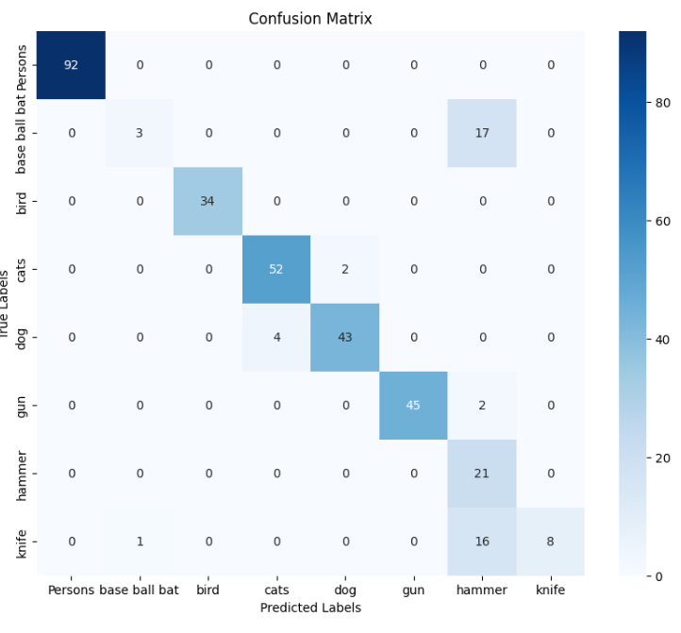

**6. Analysis:**

* The model demonstrates strong performance across most classes, with particularly high accuracy for common objects like persons and dogs.
* Some classes exhibit lower precision and recall, indicating potential areas for improvement.
* Overall, the model shows promise for practical applications in image classification tasks.

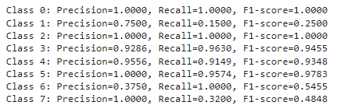

**7. Conclusions:**

* The implemented image classification pipeline successfully leverages the VGG16 architecture to accurately classify objects in images.
* Further fine-tuning and optimization could potentially enhance the model's performance, especially for classes with lower precision and recall.
* The project underscores the effectiveness of pre-trained models in solving real-world classification problems and highlights avenues for future research and improvement.

**8. Class Labels:**

* **0: Persons**
* **1: Baseball bats**
* **2: Birds**
* **3: Cats**
* **4: Dogs**
* **5: Guns**
* **6: Hammers**
* **7: Knives**

**In conclusion, the image classification project utilizing VGG16 demonstrates the power of deep learning in recognizing objects within images and provides valuable insights into model performance and optimization strategies.**