DBMS

Gamal Eldin Ahmed Khalaf

Ziad Taha Ali Mekawy

Mohamed Samy

Mostafa Mohamed Mahmoud Hussien Farrag

UML diagram:

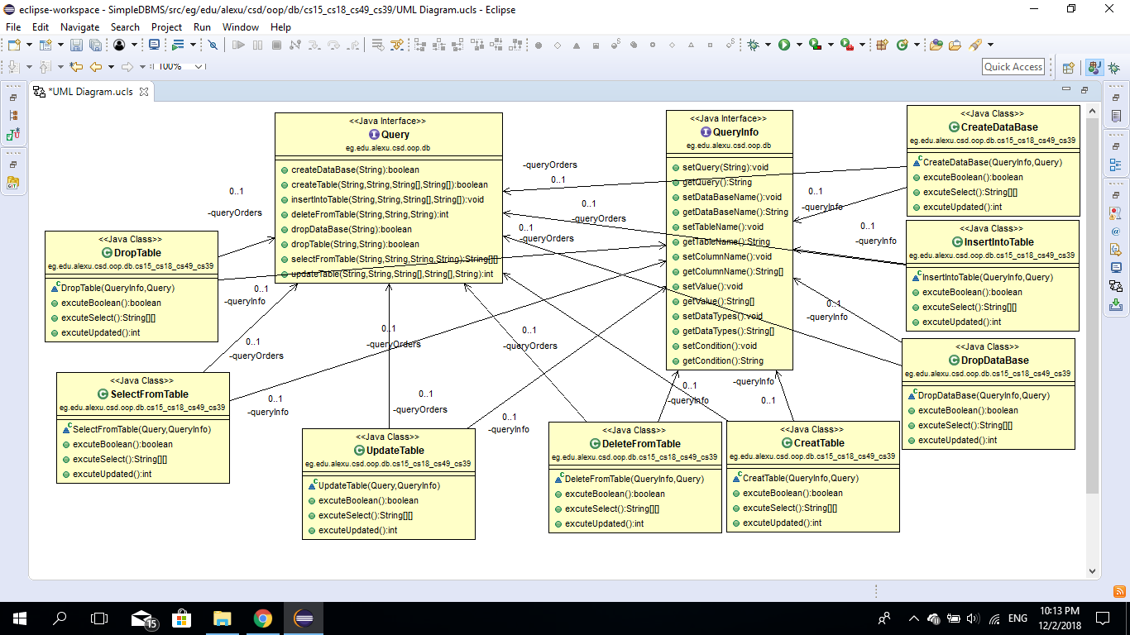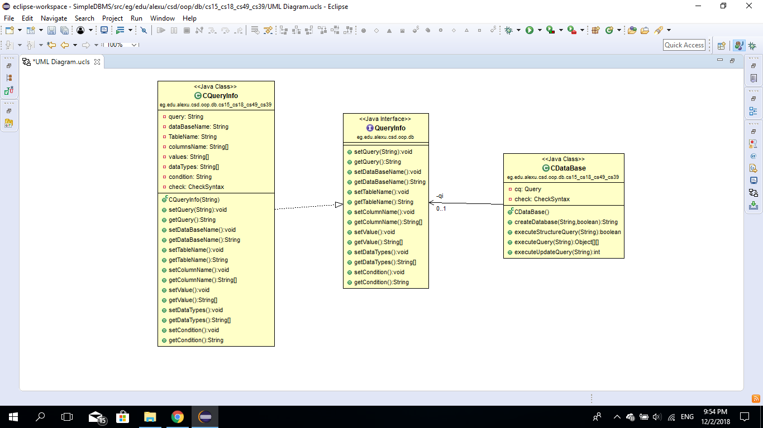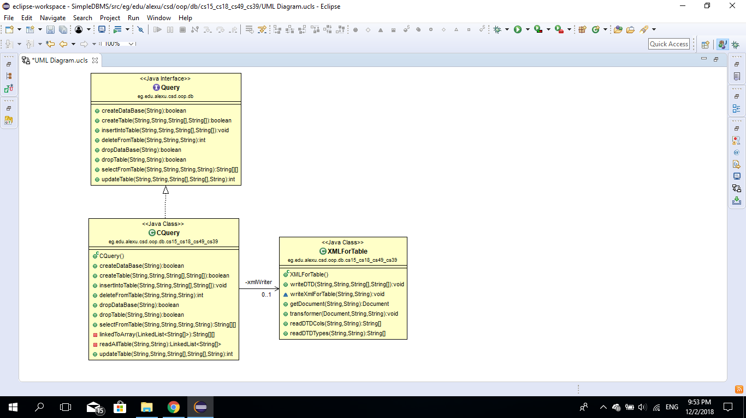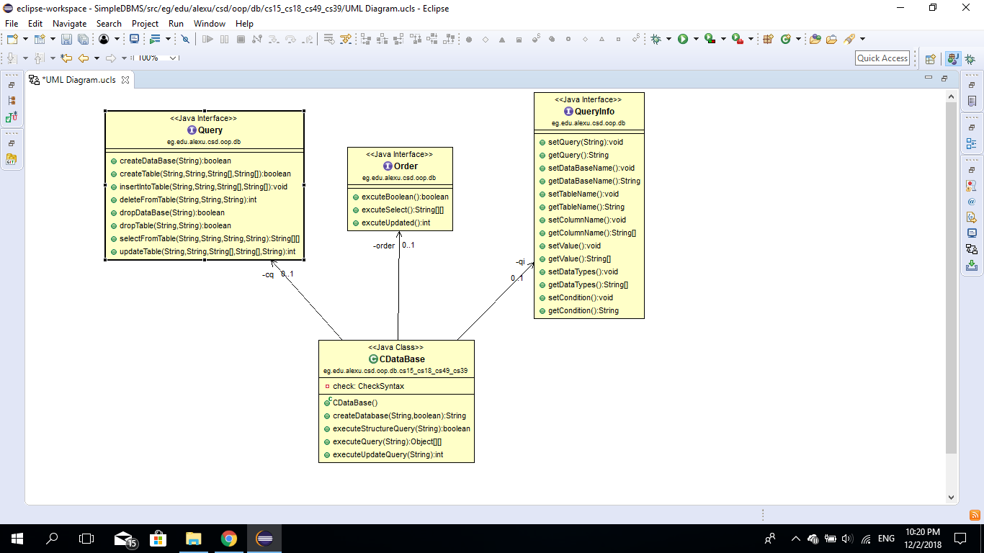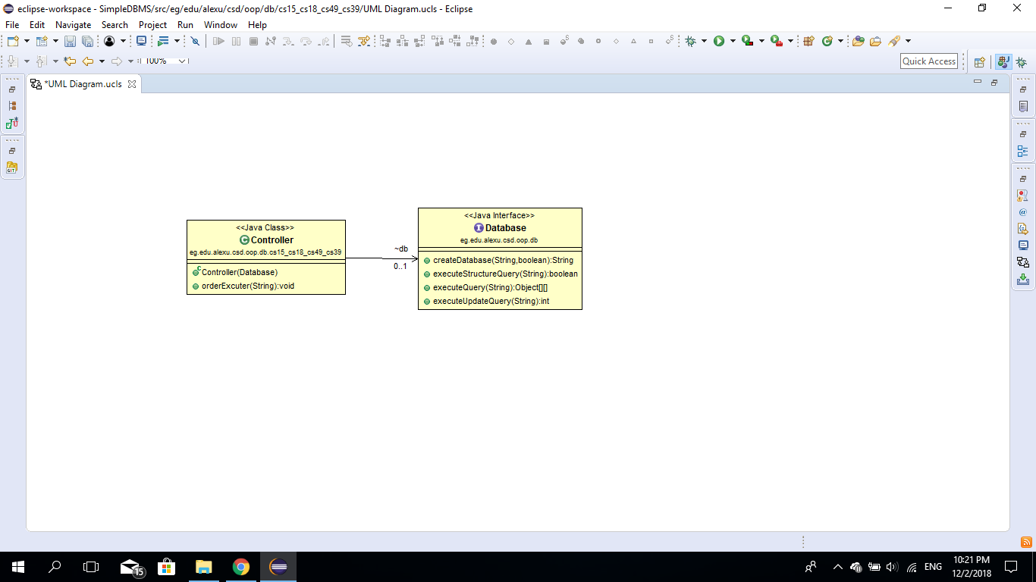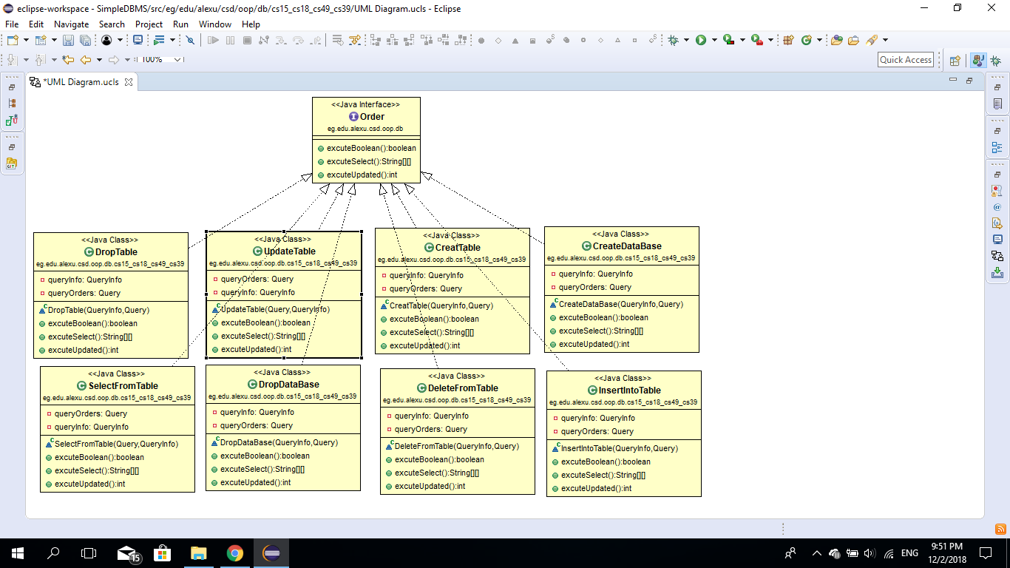

Screenshot:

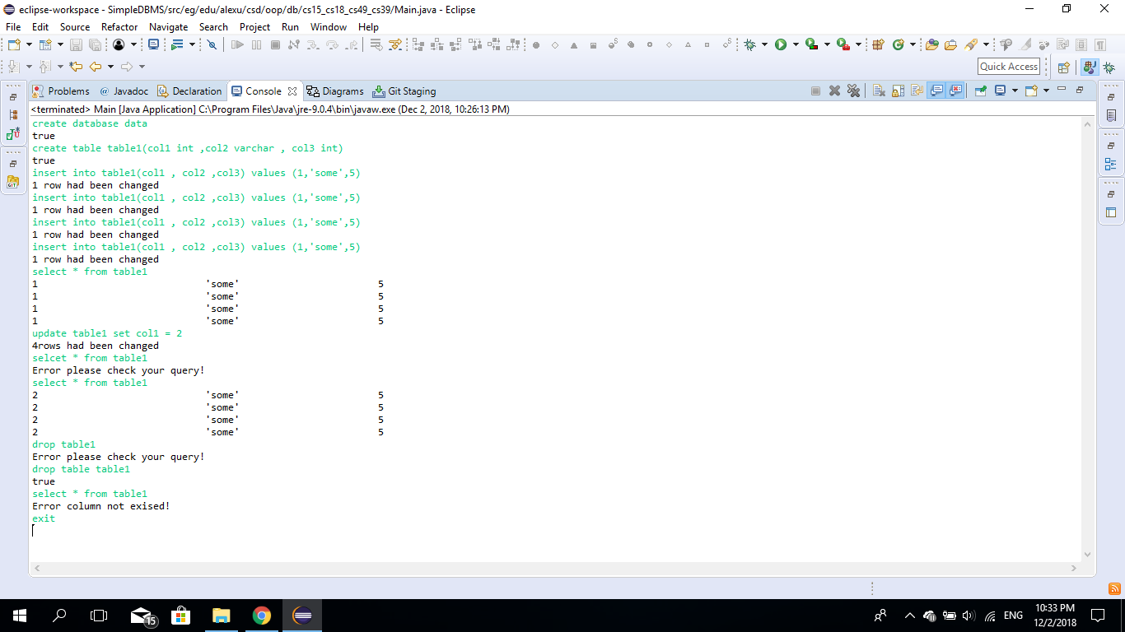

Design:

we used regex to validate SQL queries to match its syntax

,Dom parsers to store the tables in xml files and used DTD schemas to validate xml files ,each table was saved in separate folder and all tables was saved in DB folder.

We used command design pattern to handle all the database operations.

Design decisions:

We decided to make a class to execute every query according to command design pattern .

We decided to use factory to choose the query we need.

User guide:

User should follow the following syntax to be apple to use the application :

create database database_name  
create table table_name(column_name datatype)  
insert into table_name (columns_name_separated with ",") values (their_values separated with ",")  
delete from table_name **you can put a condition using 'where'**  
drop database database_name  
drop table table_name  
select("*" for all columns or write column_name) from table_name  
update table_name set column_name=value*you can put condition using where*