|  |
| --- |
| Hackhathon Day : 1 Step:1 & 2 |
|  |
|  |
|  |

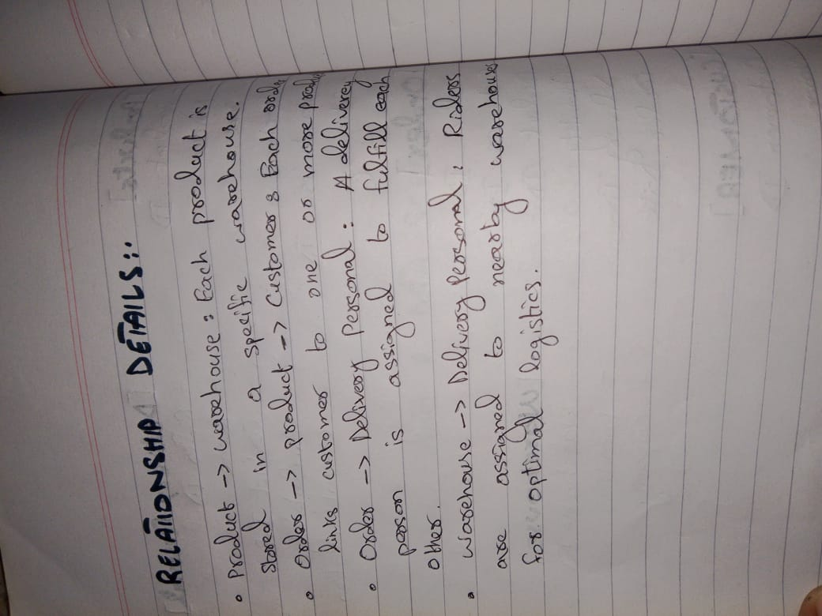

____________________________________________________________________________________

Hackhathon Day : 2

Planning the Techanical Foundation

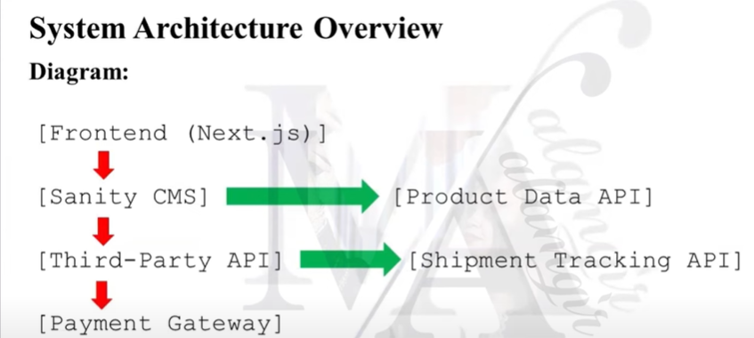

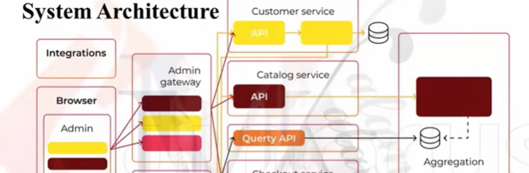

Hackhathon Day: 3 API Integeration & Data Migration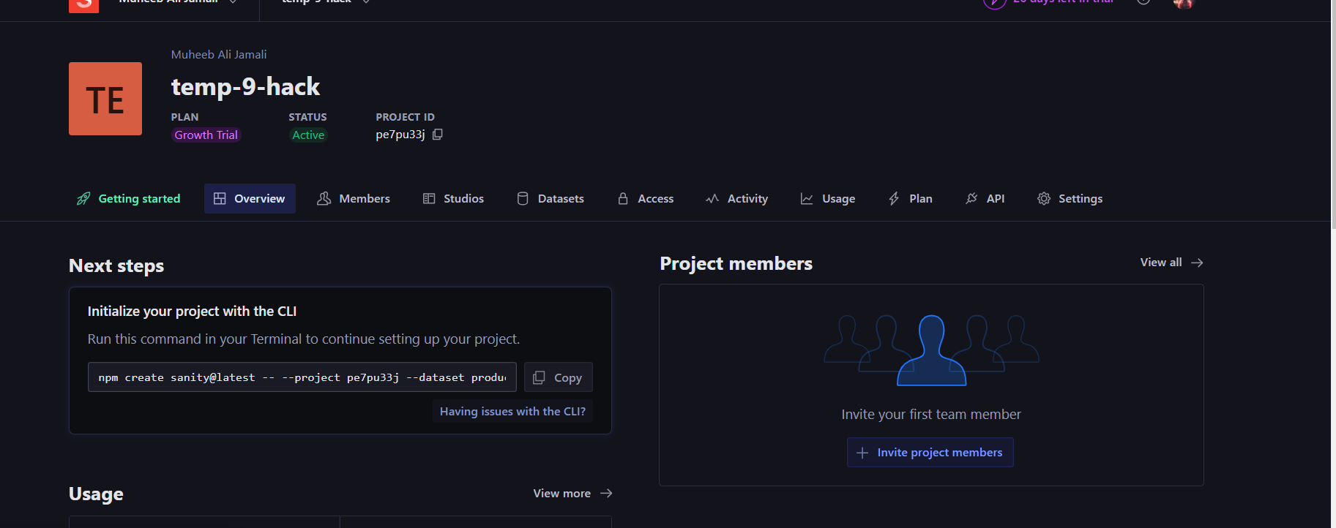

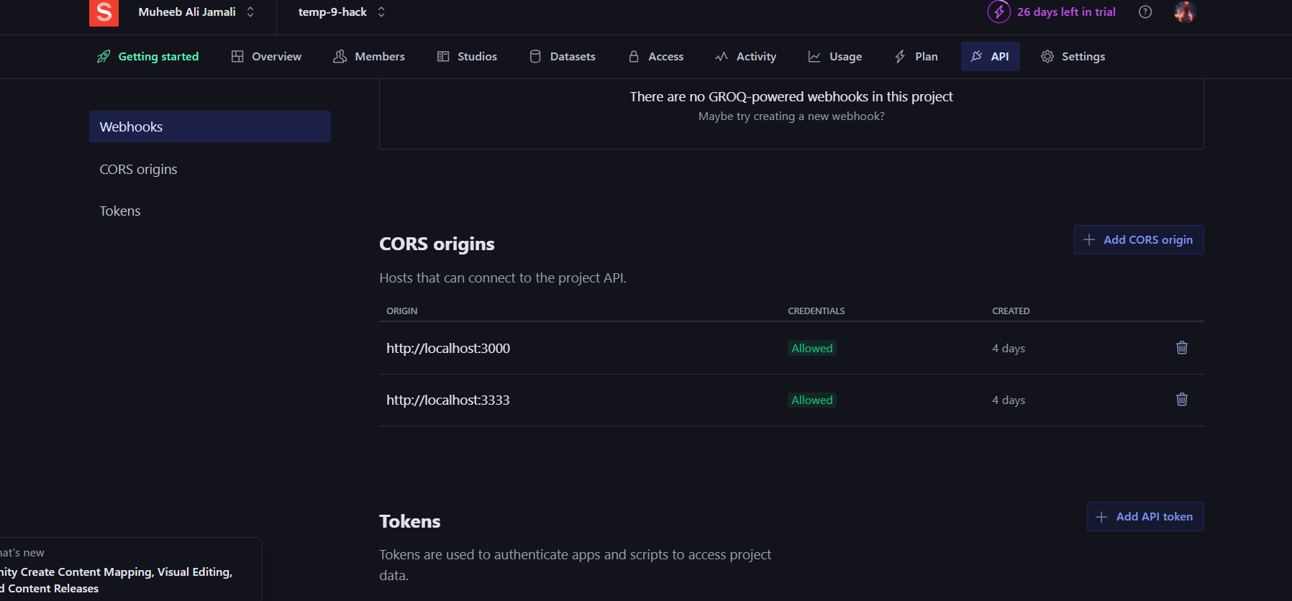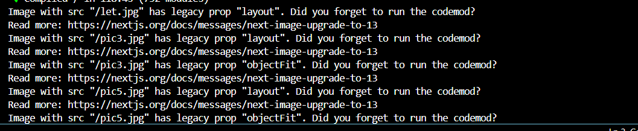Imported Data from api

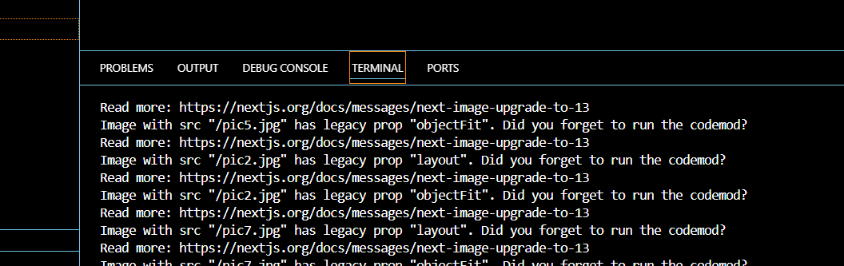

Import Schema through sanity

# Chef.ts

# Food.ts

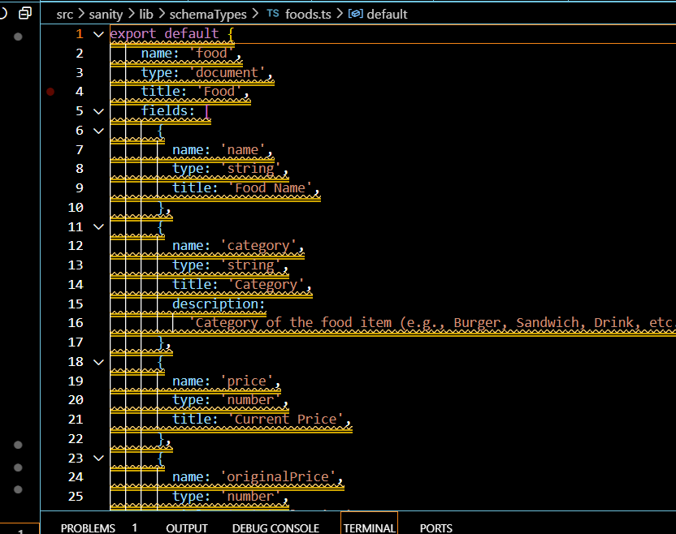

# Data imported in sanity of Food page

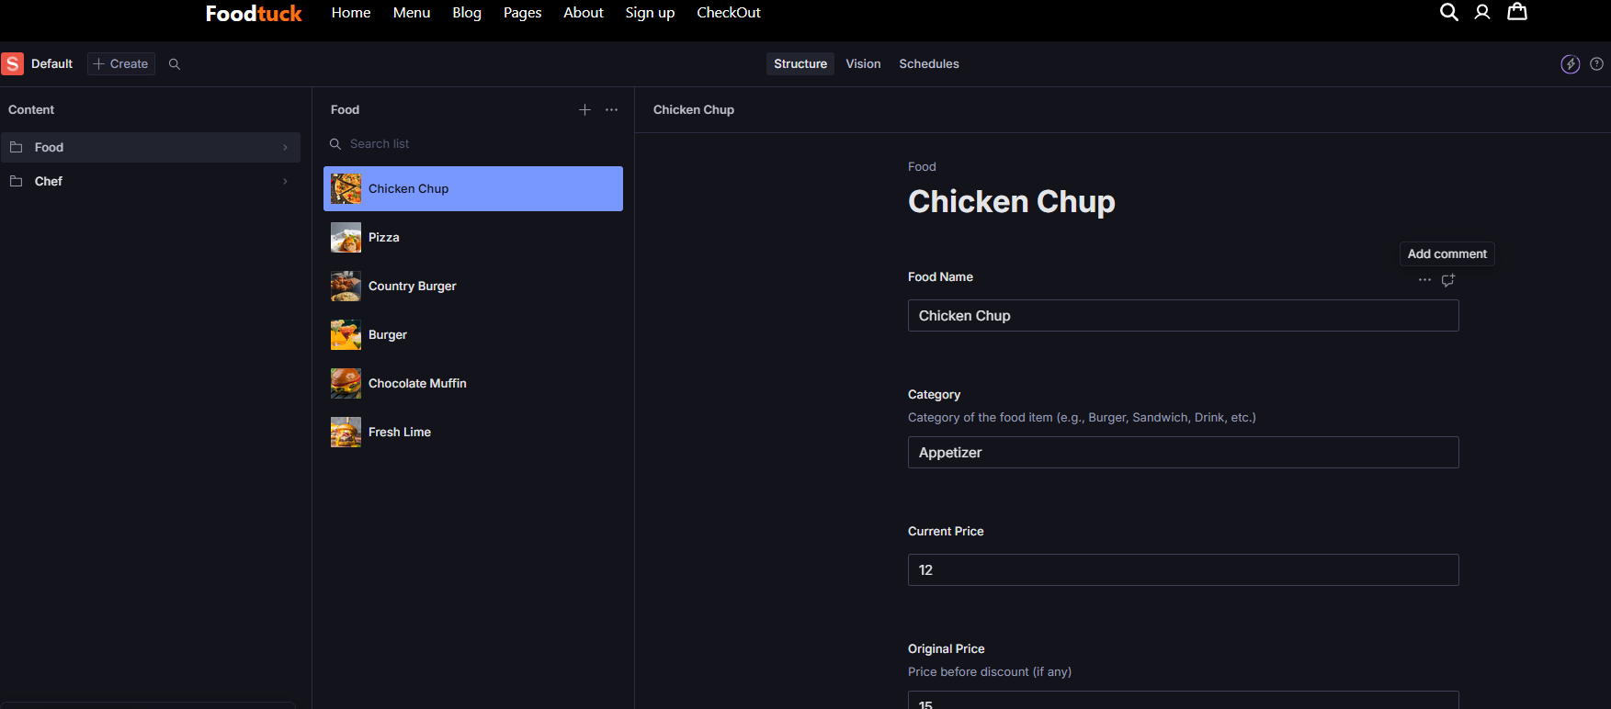

# Chef page

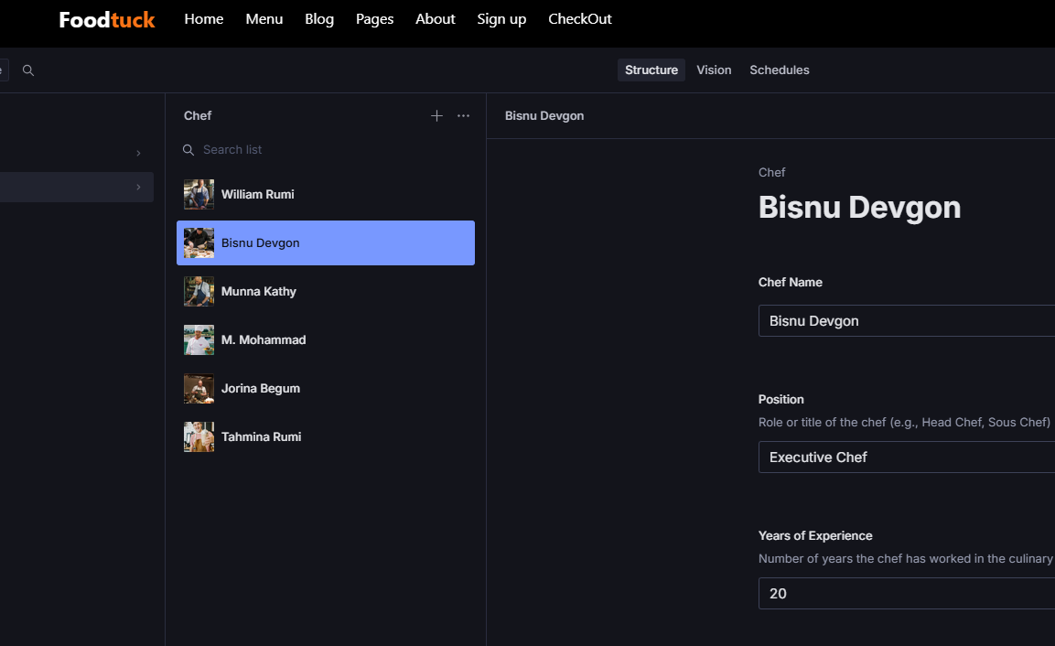

# Fetch chef through query in sanity

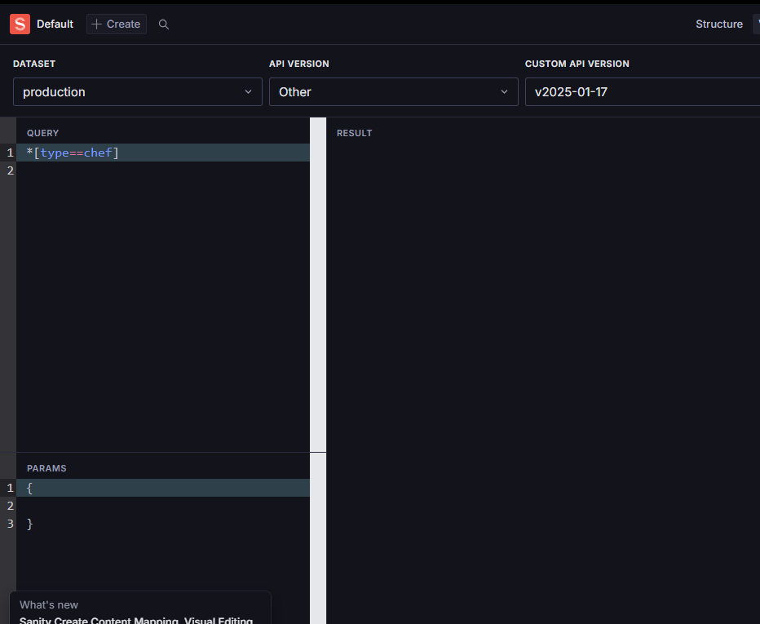

DAY 4 : Building dynamic Frontend

# Fetch Food page

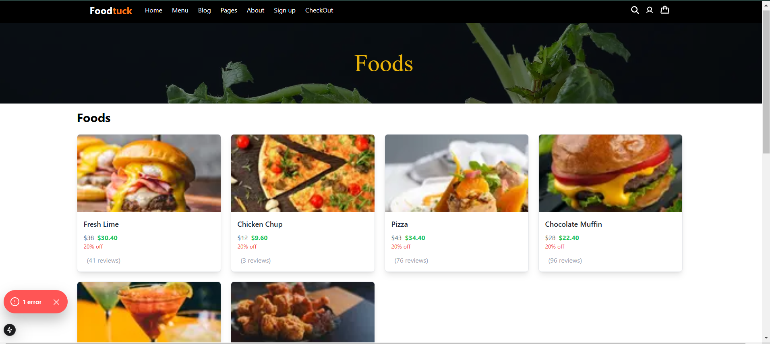

# Code of Food

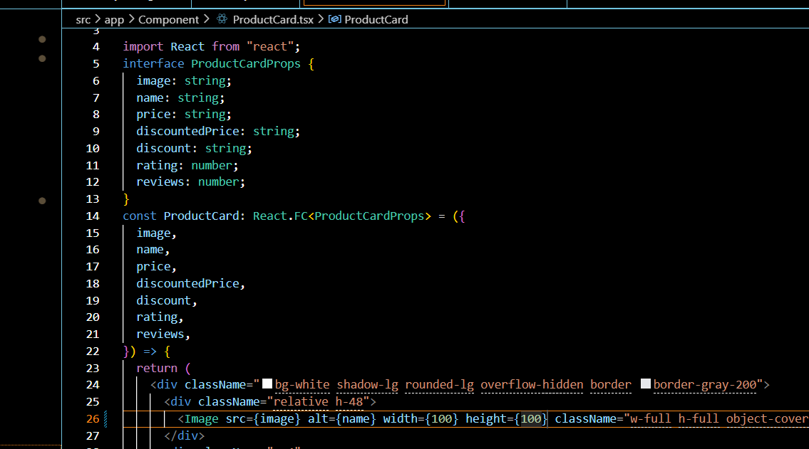

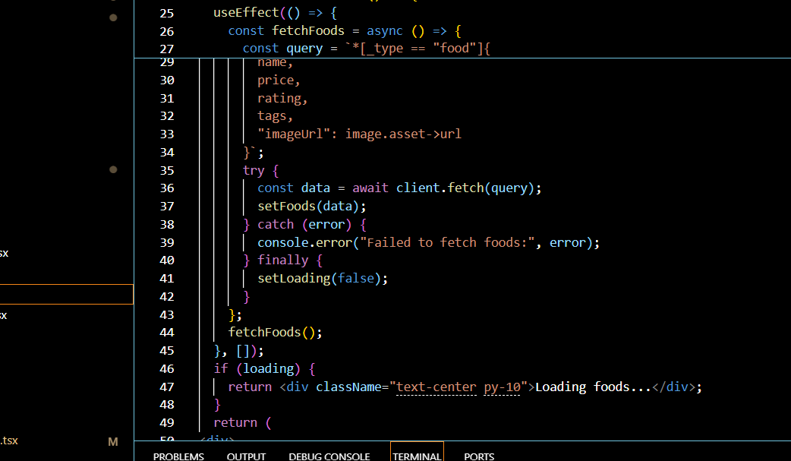

# Chef page fetch

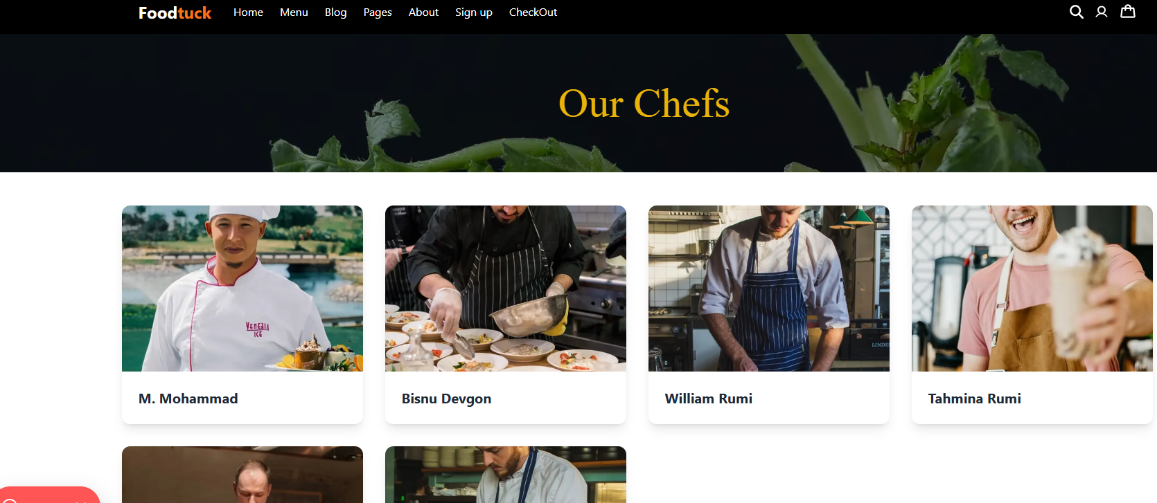

# Code of chef

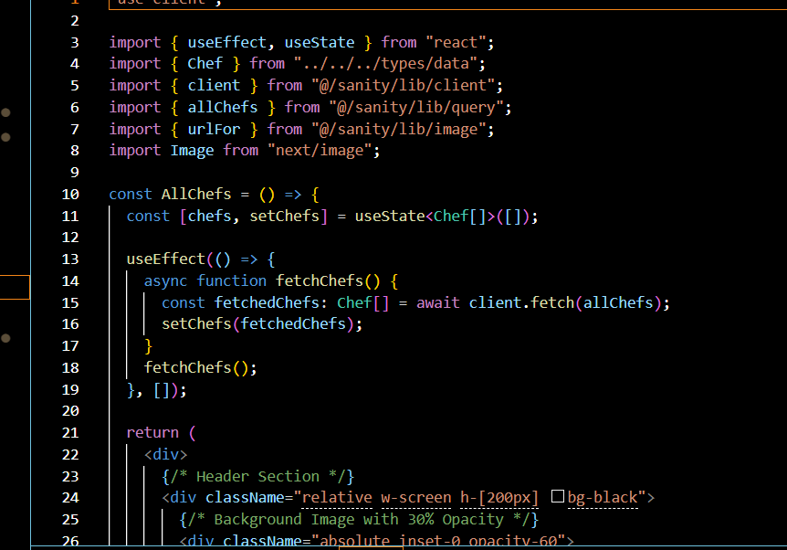

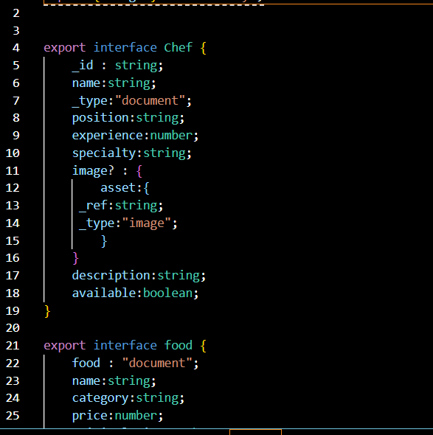

# Script file

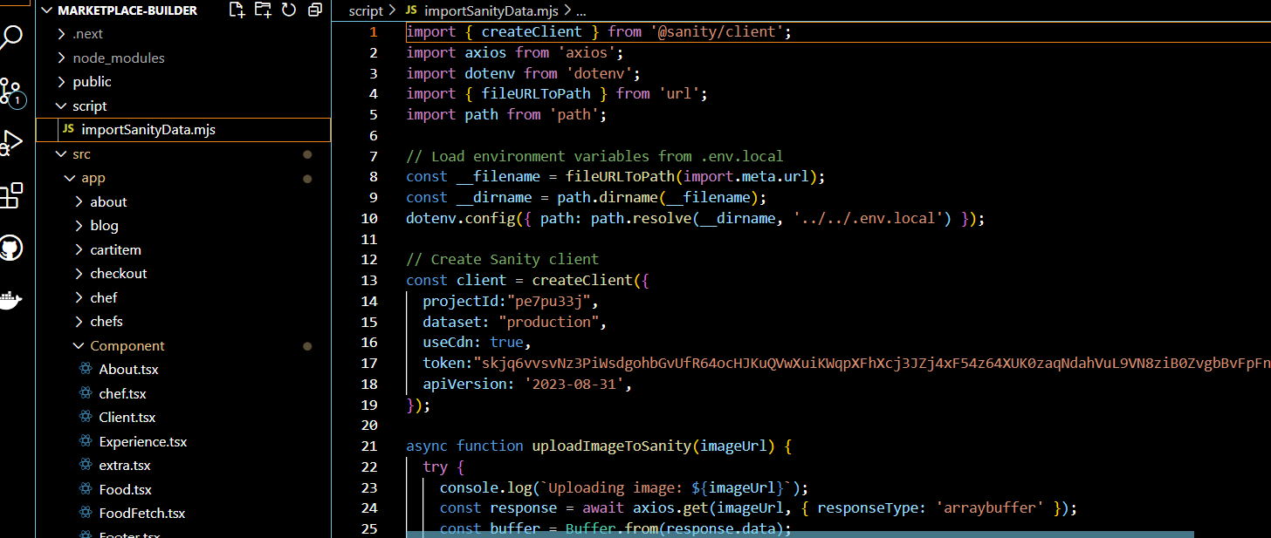

Hackhathon Day:5 Testing ,Error Handelling and Backend integeration

# Step 1: Error handeling

Api : ( http: template9/api)

* The api is working and fetching data in localhost 3000 but taking a while in vercel deployed web
* Api is taking too much time to load in frontend



# Test report Cvs

|  |  |  |  |  |  |  |  |  |  |
| --- | --- | --- | --- | --- | --- | --- | --- | --- | --- |
| TestcaseID | TestCaseDescription | TestSteps | ExpectedResults | Actual Results |  |  |  |  |  |
| TC005 | All pages Mobile Responsive | Inspect to check layout on each page | Mobile Responsive | All pages mobile responsive | Status | Remarks |  |  |  |
| TC001 | Data from Api to sanity | openlocalhost3000/studio/structure | Products in sanity displayed correctly | products in sanity displayed correctly | passsed | Worked |  |  |  |
| TC002 | Fetch data from sanity to allproduct page | open product page > verify products | chef and food page displayed on the page | Chef and food page displayed on web | Passed | No issue |  |  |  |
| TC003 | Dynamic Routing to display pages dynamically | click on product from all product page | Product detail page opens of specific product | Product detail page opens of specific product | passed | Handled gracefully |  |  |  |
| TC004 | Dynamic pages of all products have all description | Route to each page and check specific details | All details, images place accordingly | All details, images place accordingly | passed | Worked |  |  |  |
| TC006 | Search Functionality working | Search using the searchbar | search occurs, gives result | No search functionality | passsed | Successful |  |  |  |
| TC007 | Cart Functionality | Add to Cart working on each product | Cart working properly | Cart is working properly, add subtract "+" "-" sign not available | failed | Will add soon |  |  |  |
| TC008 | Other Functionality | Rating,User information stogare and recording | Should have worked | Not able to add any other thing | passed | Will work on it |  |  |  |
| TC009 | Checkout page and its functionality | products available on checkout page with price | Check out page displayed correctly |  | failed | practice practice and practice is required |  |  |  |
|  |  |  |  |  |  |  |  |  |  |
|  |  |  |  |  |  |  |  |  |  |
|  |  |  |  |  |  |  |  |  |  |
|  |  |  |  |  |  |  |  |  |  |

DAY 6: Deploying preparation and staging