**CSCI 4125/5125**

**Data Models and Database Systems**

**Fall 2021**

**Course Project**

**Phase 2: E-R Mapping (2/16)**

**Due: Tuesday, 3/8 @ 11:59pm**

**Reading:** SilberschatzChapters 6 and 2

**Submission Guidelines:**

1. This assignment is worth 100 points for all students.

2. All answers in the form of images or screenshots must be readable. Any additional files must be clearly referenced and labeled.

3. It is your responsibility to make sure all files are readable and submitted on time.

**Submission:**

- Part A requires you to submit a relational schema (containing primary keys and foreign keys) worth 40 points.

- Part B requires you to submit a single screenshot of a successfully ran change password command in SQL Developer worth 30 points.

- Part C requires you to submit a Java source file and an output file named “animal.sql” worth 30 points.

**Part A. E-R Mapping (40 pts)**

Your task is to generate a complete logical schema for your E-R diagram from Phase 1 of the project. You may submit a drawing using your favorite software (e.g., PowerPoint, Visio) or clearly handwritten. Remember that all primary keys are to be underlined with a solid line, all foreign keys use a dotted underline (or clearly stated), and foreign keys must point to the primary key they reference. While you may have generated a slightly different E-R diagram in Phase 1, use the E-R diagram below to generate you relational schema.



**Part B. SQL Developer Connection (30 points)**

In Phase 3 of the project, you will execute SQL DDL to build your tables and SQL DML to populate your tables and execute queries. This task has you setup your database connection to perform Phase 3. We will use a popular IDE supported by Oracle to connect to our database.

**Step 1. Download SQL Developer**

Download the relevant SQL Developer for your platform at this [link](https://www.oracle.com/tools/downloads/sqldev-downloads.html). To download SQL Developer, you may need to create a **FREE** Oracle account using whatever email and password you like (note: this account is not related to the account you will use to connect to the database). Also, notice that SQL Developer requires you to have JDK 8 or 11 installed.

**Step 2. Run SQL Developer**

Unzip your download and run the application, sqldeveloper.exe. Your application should look like the screenshot below:

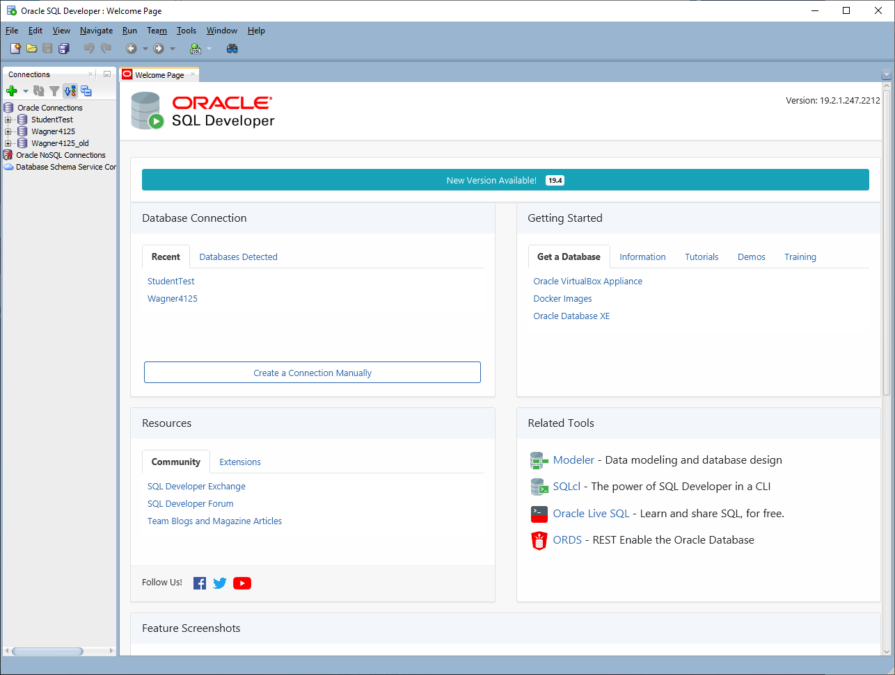

**Step 3. Create a connection.**

In the upper left-hand side of the application, there is a green plus symbol. Click this to create a new database connection. Fill in the following fields:

* + **Name:** Name your connection “[Your UNO username][4125/5125]”.
  + **Username:** Use your UNO username.
  + **Password:** Use “NewOrleans123” (you will change this later).
  + **Save Password:** You can check this if you want to, but you will need to update this when you change your password later.
  + **Hostname:** dbserver.cs.uno.edu
  + **Port:** 1521
  + **SID:** check the “ServiceName” field below this field. We won’t use the SID field.
  + **ServiceName:** ORCL
  + Click the “Test” box at the bottom. If everything is correct, the “Status” and the lower left-hand corner should say “Success”.
  + Click the “Save” box at the bottom to save your connection.
  + Click the “Connect” box.

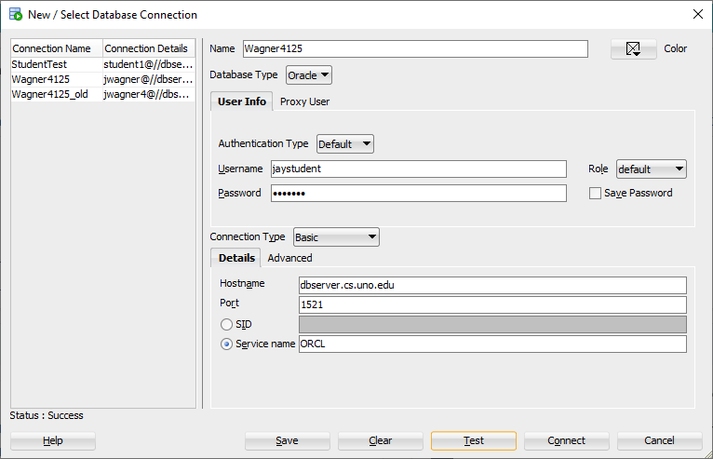

**Step 4. Change your password.**

Click on your connection on the left-hand side of SQL Developer. This should open up a blank script in the center of SQL Developer.

Type in the following command. Note the semicolon at the end and do not use the brackets:

ALTER USER [your username] IDENTIFIED BY [your new password];

Click the green arrow directly above the script window to run the command.

If your command properly runs, you should get a message in the script output: “User [your username] altered.”

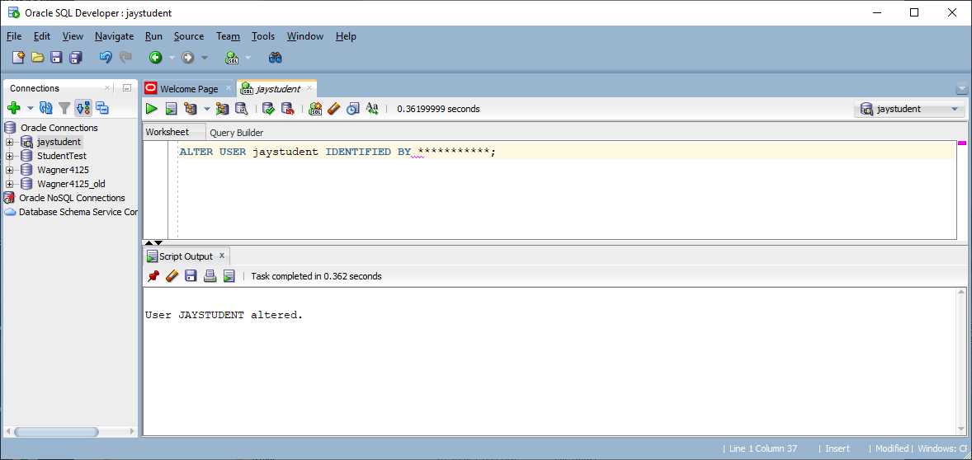

**Submit:** A screenshot (like mine) that shows that your change password command properly ran. Note: you can obfuscate or erase your new password in the script if you would like. Your screenshot must use the “Print Screen” command. DO NOT submit a picture of your computer using your phone.

**Part C. Generating SQL Insert Statements (30 points)**

Writing SQL insert statements is tedious if you have a few dozen records and unrealistic if you have thousands or millions of records to insert. Also, picture a user interface (e.g., a website) you may develop for a typical end user; you don’t want them writing SQL! You will now modify your Java code from Phase 1 to generate SQL INSERT statements.

Your Java program should include the following functionality:

1. It should accept a command line argument, which will be the table name that the record will be inserted into. **Note:** in this project, the table names will match the names of the csv files I will provide to you.
2. Datatypes should be correctly formatted in you insert statement. Do not hardcode the positions of values in files. In Phase 3, I will give you input csv files with varying schemas. Your Java program should work for any schema.
   1. Number don’t use single quotes.
   2. Strings use single quotes
   3. Also, consider NULL values now. NULL values do not use single quotes.

I included a Java source file which you may find to be a useful template. I also included the table schema in animal_schema.sql, which you can use to test the INSERT statements you generate.

**Submit:** Your Java source file and the output file, animal.sql file containing (your properly formatted) INSERT statements, when you run pass “animal” to your Java program.