**Geek Label Development**

**Contents**

1. Theme Development 1

2. Module Development 2

3. Web Development 3

4. Import & Export 5

# Theme Development

**Summary :**

The theme is used to design the overall appearance of the web.

**Implementation :**

* Create *GeekLabel.info* which define the following
  + Theme name & description
  + Drupal supported version
  + *CSS Bootstrap 4 minified version*
  + Additonal CSS file
  + Define Theme region
* Create file *html.tpl.php* in purpose to add

*<meta name="viewport" content="width=device-width, initial-scale=1">* and put title *Geek Label*.

* Create files *page.tpl.php, block.tpl.php, field.tpl.php* to override the default nested div and generate more cleaner element
* Create folder *css* in theme directoy which contains files below :
  + *style.css*

Define font and design html element for different screen

* + *bootstrap.min.css*

[Bootstrap v4.0.0](https://getbootstrap.com/docs/4.0/getting-started/download/) minified vesrion

* Create folder *fonts* in theme directory which contains font *MuseoSans_300.otf.*
* Create folder *js* in theme directoy which responsible to load google map. The map will centered on lat: 51.524451, lng: -0.073866 (around Bethnal Green Road)

# Module Development

**Summary :**

The module wll create block called *Geek Label – Container* described below :

* + - The block will display any nodes from given tags.
    - All displayed nodes will automaticly have button as a last child, which can be used to slide to the next node.
    - All displayed nodes have color based on their index. The first node will have red-pink color. The 4th node will have white color, and the other have gray color as default. This predefined color can be change by modifying the value of *NODE_COLOR* on *file (sitename)/sites/all/modules/ GeekLabel.module*
    - The numbers of generated block can be change by modifying the value of *BLOCK_CONTAINER_SIZE* on *(sitename)/sites/all/module/geeklabel/geeklabel.module.*
    - Any html elements with class name *Slider* will turn into a slider/carousel.
    - Hide node title if contain prefix ‘#’

**Implementations :**

* Create *GeekLabel.info* file
  + Module name and description
  + Drupal supported version
  + Stylesheet for slider/ carousel.
  + Javascript for the slider/carousel
  + Javascript to slide to next node
* Create folder js which contain javascript files below :
  + *main.js*

The script will turn html elements which have class name *Slider* into a slider. The script also contain recursive function to slide to the next nodes.

* + *Slider.js*

Slider class implementation

* Create folder css which contain the css file for the slider
* Create folder images which contain image of next button, prev button, and page button for the slider
* Create *GeekLabel*.module which implement some of drupal hook
  + [hook_block_info](https://api.drupal.org/api/drupal/modules%21block%21block.api.php/function/hook_block_info/7.x) || *GeekLabel_block_info*

Define blocks which displayed in block administration page

* + [hook_block_configure](https://api.drupal.org/api/drupal/modules!block!block.api.php/function/hook_block_configure/7.x) || *GeekLabel_block_configure*

Display form in block configuration

* + [hook_block_save](https://api.drupal.org/api/drupal/modules!block!block.api.php/function/hook_block_save/7.x) || *GeekLabel*_block_save

Save block configuration form value

* + [hook_block_view](https://api.drupal.org/api/drupal/modules%21block%21block.api.php/function/hook_block_view/7.x) || *GeekLabel*_block_view

Display block

# Web Development

Using the theme, module and Bootstrap 4, the web only have single block which display any node with tags *main.* ( Block *Main page content* is empty )

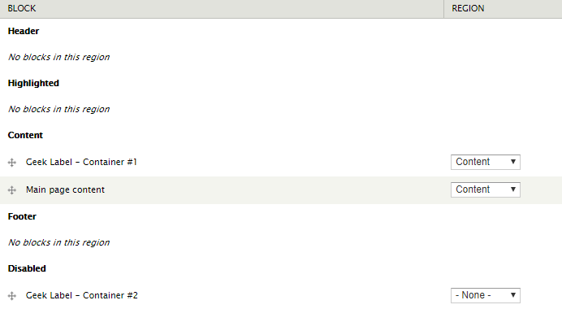

The node displayed in block *Geek Label – Container* will automaticly have button to slide to next node (except for the last one).



Any html element containing class *maps_google* will automaticly turn into google map.

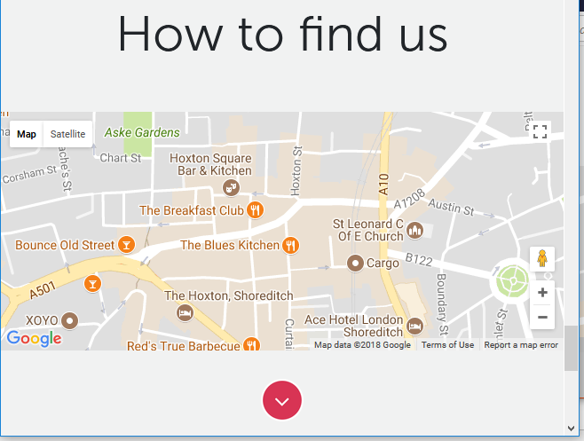

Any html element with class name *Slider* will automaticly turn into slider/ carousel.

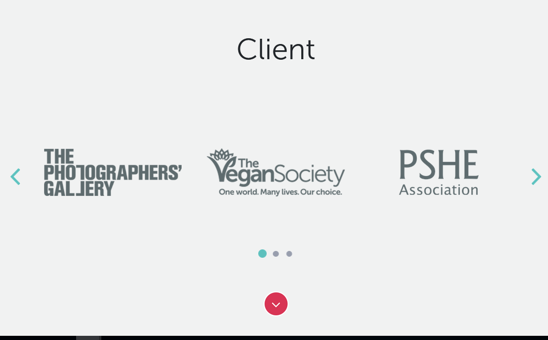

# Import & Export

To replicate the web to a new site, step below can be used :

* + - * + In the new site, add theme GeekLabel inside folder *(sitename)/sites/all/themes/*
        + In the new site add module GeekLabel inside folder *(sitename)/sites/all/modules/*
        + Copy folder *files* inside direcoty *(sitename)\sites\default* to same directory in the new site
        + Export the sql database from old site and import it to new site