Open Charity Development

Contents

1. Theme Development 1

2. Module Development 2

3. Web Development 4

4. Import & Export 7

# Theme Development

**Summary :**

The theme will control the overal appearance of the web.

**Implementation :**

* Create *OpenCharit.info* which define the following
  + Theme name & description
  + Drupal supported version
  + Stylesheet for device below 768 width
  + Stylesheet for device above 768 widt*h*
  + Stylesheet to locate additional CSS fonts
  + Theme screenshot
  + Theme supported region
  + Activate Drupal *logo* feature
* Create file *html.tpl.php* in purpose to add

*<meta name="viewport" content="width=device-width, initial-scale=1">* and add title *Open Charity*.

* Create *page.tpl.php* to override the default nested div and generate more cleaner element
* Create *field.tpl.php* to override the default nested div and generate more cleaner element
* Create folder *css* in theme directoy which contain files below :
  + *styleBEM.css*

CSS file following [BEM](http://getbem.com/) rules for device above 768 width

* + *styleBEM-small.css*

CSS file following [BEM](http://getbem.com/) rules for device below 768 width

* + *fonts.css*

Define additional fonts location.

* Create folder *fonts* in theme directoy which contains fonts *MuseoSans_300.otf, MuseoSans_500.otf, OpenSans-Regular.ttf*
* Create folder *image* in theme directoy which contains all images files.

# Module Development

**Summary :**

The module wll create 2 type of block called *Open Charity – Container* and *Open Charity - Menu*.

*Open Charity – Container* :

* Display any node (articles, pages, content types) from given tags.
* Allow user to display bunch of nodes inside a slideshow horizontally or vertically
* The horizontal slideshow will forced to vertical on device below 768 width.
* Allow user to limit the number of visible content inside the slideshow.
* Allow user to control background image & color of the slideshow.
* Hide title if contain prefix ‘#’.
* The numbers of generated block can be change by modifying the value of *BLOCK_CONTAINER_SIZE* on *(sitename)/sites/all/module/opencharity/opencharity.module.*

*Open Charity – Menu :*

* Display menus from user selection.
* Display site logo
* The numbers of generated block can be change by modifying the value of *BLOCK_MENU_SIZE* on (sitename)/sites/all/module/opencharity/opencharity.module.

**Implementation :**

* Create *OpenCharity.info* which define the following
  + Module name and description
  + Drupal supported version
  + Stylesheet for the slideshow.
  + Stylesheet for menu.
  + Javascript for the slider/carousel
* Create folder js which contain javascript files as show below :
  + *main.js*

The script will turn any html element with class *slider* into a slideshow

* + *Slider.js*

Contain slideshow/carousel class implementation

* + *SliderConfig.js*

The script will added to web only in page *Open Charity - Container* block configuration only. It used to show/hide form color if checkbox is being selected

* Create folder css which contain the css file below :
  + *Slider.css*

Contains the style of the slideshow/carousel.

* + - *styleHardcode.css*

Contains the style of menu for device above 768px.

* *styleHardcode-small.css*

Contains the style of the menu for device below 768px.

* Create folder images which contain image of next button, prev button, and page button for the slideshow /carousel.
* Create *OpenCharity.module* which implement some of drupal hook
  + [hook_block_info](https://api.drupal.org/api/drupal/modules%21block%21block.api.php/function/hook_block_info/7.x) || *OpenCharity_block_info*

Used to define blocks which displayed in block administration page

* + [hook_block_configure](https://api.drupal.org/api/drupal/modules!block!block.api.php/function/hook_block_configure/7.x) || *OpenCharity_block_configure*

Used to display form in block configuration

* + [hook_block_save](https://api.drupal.org/api/drupal/modules!block!block.api.php/function/hook_block_save/7.x) || *OpenCharity_block_save*

Save block configuration form value

* + [hook_block_view](https://api.drupal.org/api/drupal/modules%21block%21block.api.php/function/hook_block_view/7.x) || *OpenCharity_block_view*

Display block

* + [template_preprocess_block](https://api.drupal.org/api/drupal/modules!block!block.module/function/template_preprocess_block/7.x) || *OpenCharity_preprocess_block*

I use to set html attribute for the block

# Web Development

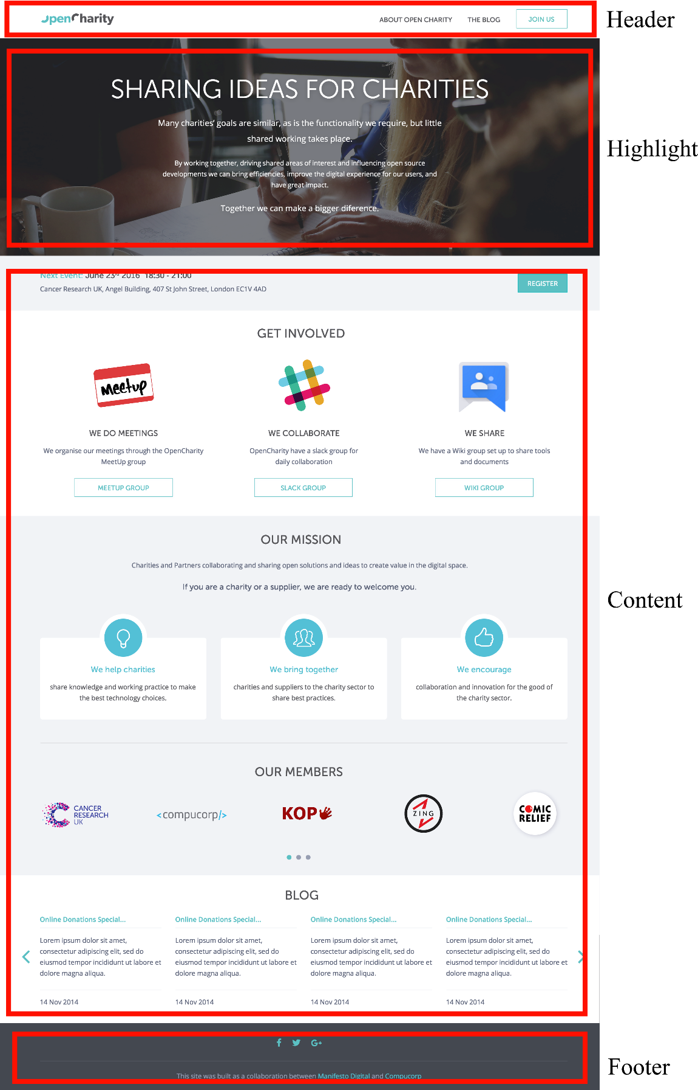The web is divide into 4 region as shown below :

The region contain blocks which display nodes as shown below :

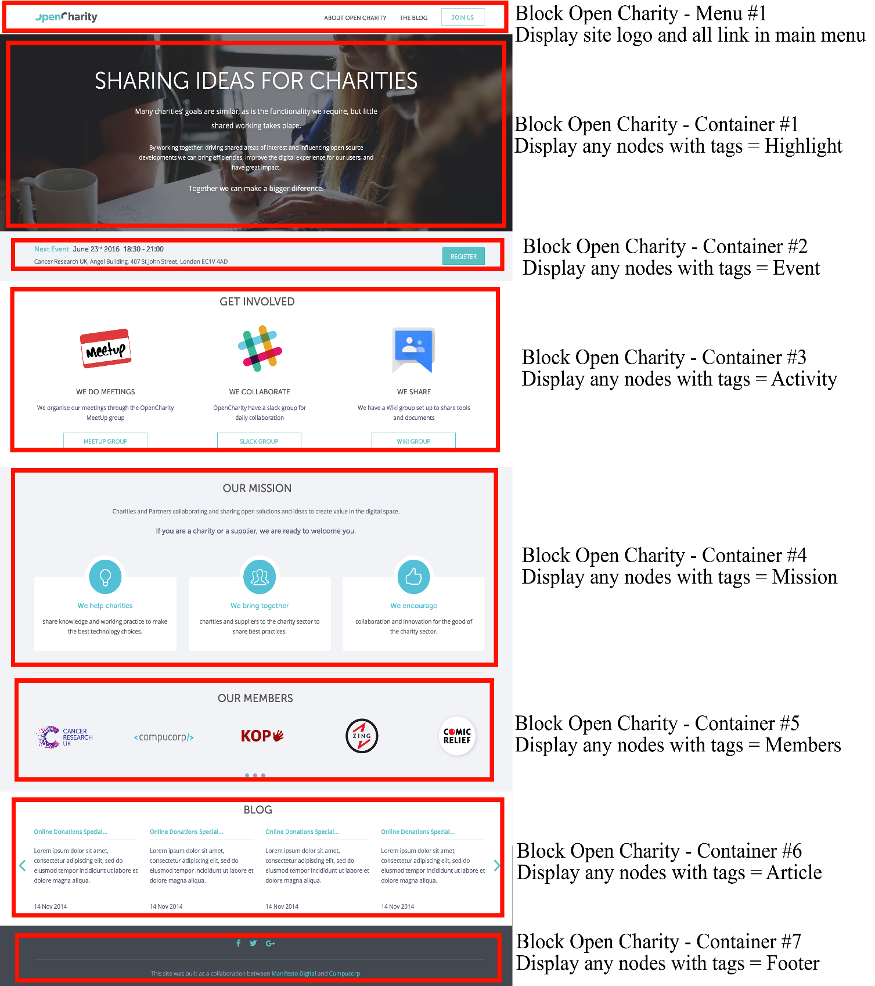

In adminstration page, the blocks structure looks as below :

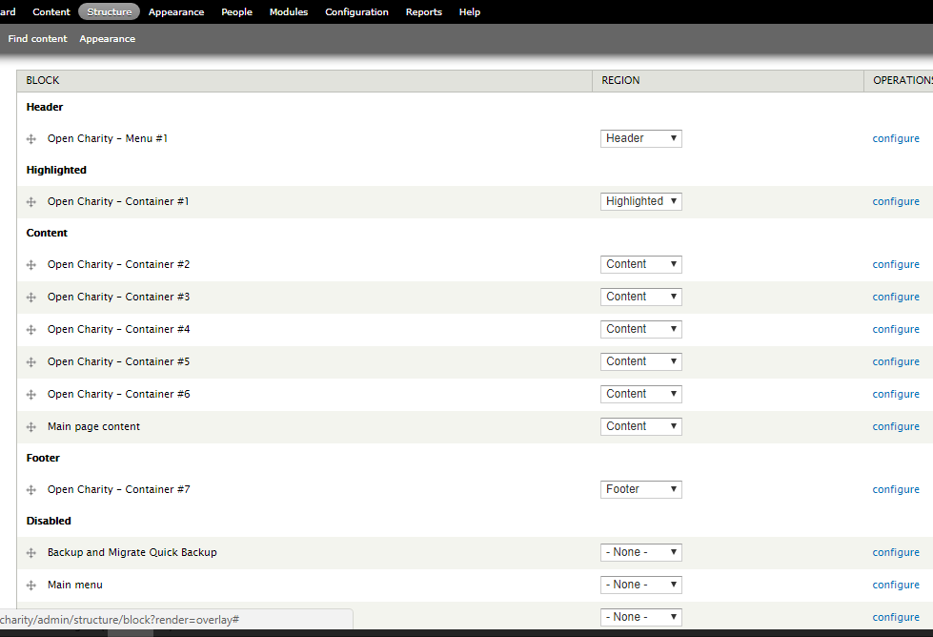

User may also choose the color and background image for the block as shown below :

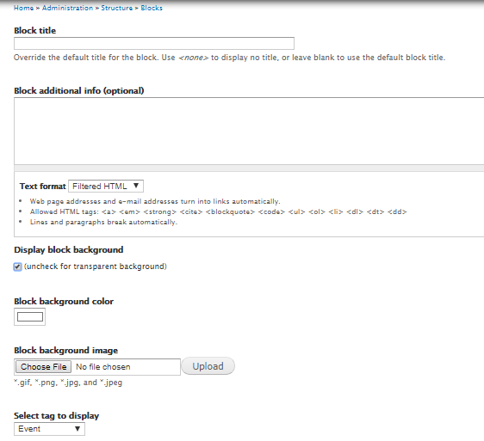

To manage content more easily, new content type is created for convinient. The content type will have their own default field tags. User may choose other tags outside the default, but it will displayed in different block.

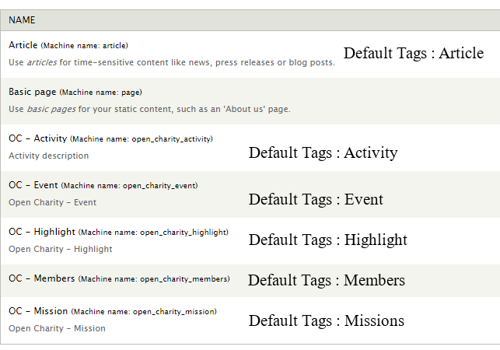

# Import & Export

To replicate the web to a new site, step below can be used :

* + - * + In the new site, add theme OpenCharity inside folder *(sitename)/sites/all/themes/*
        + In the new site add module OpenCharity inside folder *(sitename)/sites/all/modules/*
        + Copy folder *files* inside directory *(sitename)\sites\default* from the old site to same directory in the new site
        + Export the sql database from old site and import it to new site