D205 TMG1 Task 1: Data Acquisition

Julia Amanda Terzin

009968680

Mentor: Linda Howell

December 16, 2021

**A. Research Question:**

What categories of service did customers, who canceled their account, rate the lowest, and how many outages, equipment failures and service contacts did they have? The purpose of the question is to identify where improvement can be made to retain customers.

**A.1.** From the original data set in the customer table, I used customer_id to join the two tables and match the results with the appropriate customer. Churn was used to filter for inactive accounts. Outage_sec_week, contacts, and yearly_equip_faiure were used to compare the customer’s experience to the survey responses of the customer in the add-on file. All columns of the add-on file, survey_responses, were used.

**B.** Create a logical data model for the add-on CSV file by evaluating the data contained in the file and emphasizing the relational constraints.

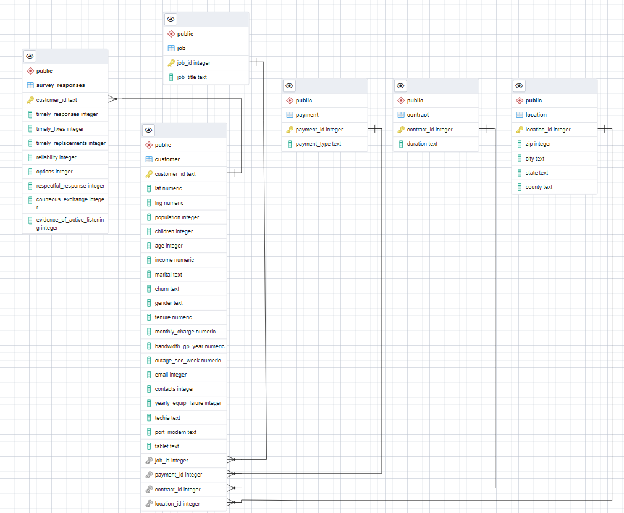

**B.1.** Write SQL code that creates a table that accommodates the extension of the logical data model to a physical data model by specifying the field types and relevant keys.

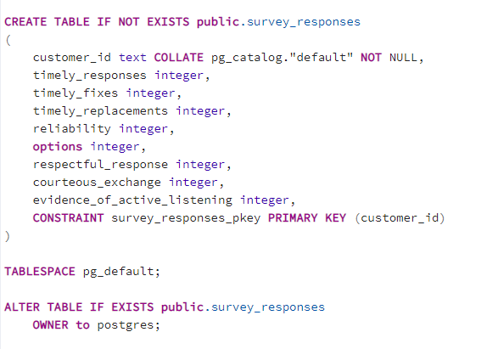

**B.2.**   Write SQL code that loads the data from the add-on CSV file into the table created in part B1.

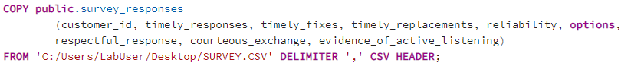

(https://www.postgresqltutorial.com/import-csv-file-into-posgresql-table/)**C**.  Write SQL statement(s) for a query or queries that inform the research question summarized in part A.

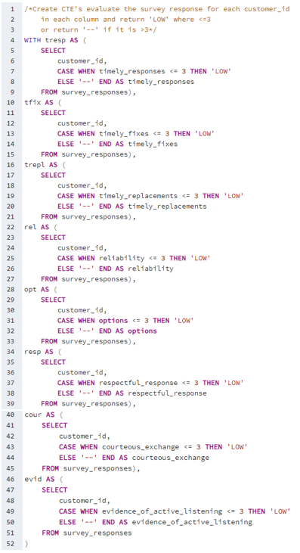

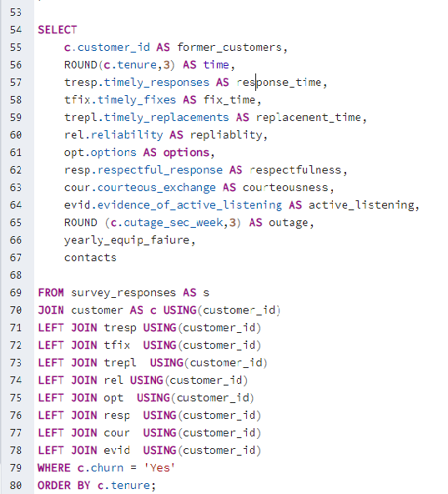

**C.1.** Provide a CSV file or files that capture the results from the query or queries.

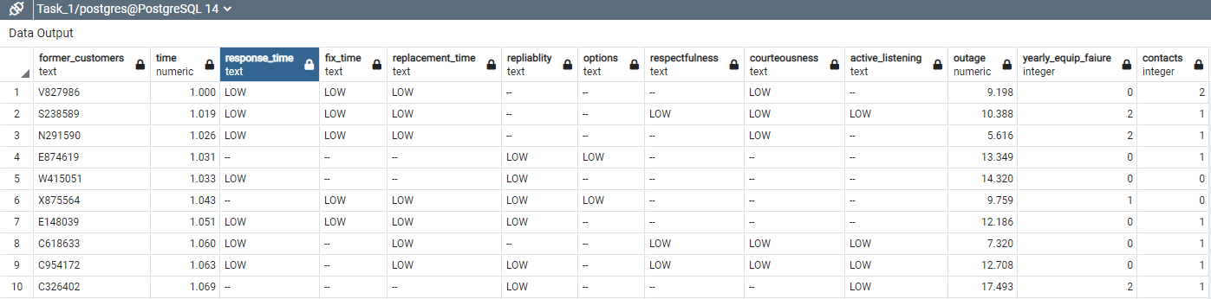

**D.**  Determine how often the add-on file should be acquired and refreshed in the database for the data to remain relevant to the business and the research question.

The add-on file should be acquired and refreshed monthly.

**E.**  Create an SQL script that performs the process of loading the add-on data.

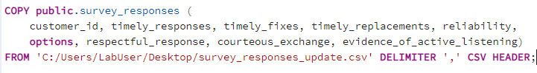  
(https://www.postgresqltutorial.com/import-csv-file-into-posgresql-table/)

**F.**  Provide a Panopto video recording that includes a demonstration of the functionality of the code used for the analysis and a summary of the programming environment.

https://wgu.hosted.panopto.com/Panopto/Pages/Viewer.aspx?id=969d1d0b-118c-4efe-84e6-ae00016ccba5

**G.**  Record the web sources used to acquire data or segments of third-party code to support the application. Be sure the web sources are reliable.

No third-party data was used. <https://www.postgresqltutorial.com/import-csv-file-into-posgresql-table/> was used as a reference on how to import a csv file.

**H.**  Acknowledge sources, using in-text citations and references, for content that is quoted, paraphrased, or summarized.

None.