**Usability Test – Building Your First Computer!**

***Purpose*** *–* A Cordial Welcome!

* *Testing the usability of a set of instructions intended to help you build a PC!*

This is ONLY intended to test the usability of the instructions, not your skills

* *You can stop this task at any time*

If the instructions are too overwhelming or make you uncomfortable, please stop

* The data will be collected mainly using a questionnaire that you will be asked to complete after reading through the instructions.
* The instructions begin on the next page, please be sure to give feedback and review the instructions at the end v.i.a the questionnaire.
  + Your notes/observations will be recorded and then the instructions document will be updated according to your feedback.

***Instructions*** *–* How to Build Your PC!

These instructions will walk you through a step-by-step guide to build your own computer.

**IMPORTANT –** Remember to check using PC Part picker before ordering all parts to ensure that your computer parts are ***compatible***

***Prepare!***

1. A circuit board

   Description automatically generatedPrepare all of your components. You should have a –

* Case

*PC Parts Diagram -- https://international.download.nvidia.com/geforce-com/international/images/DIY-Diagram.png*

* Power supply
* Storage device
* Memory
* Video card
* CPU
* Motherboard

A diagram of every part that will be used

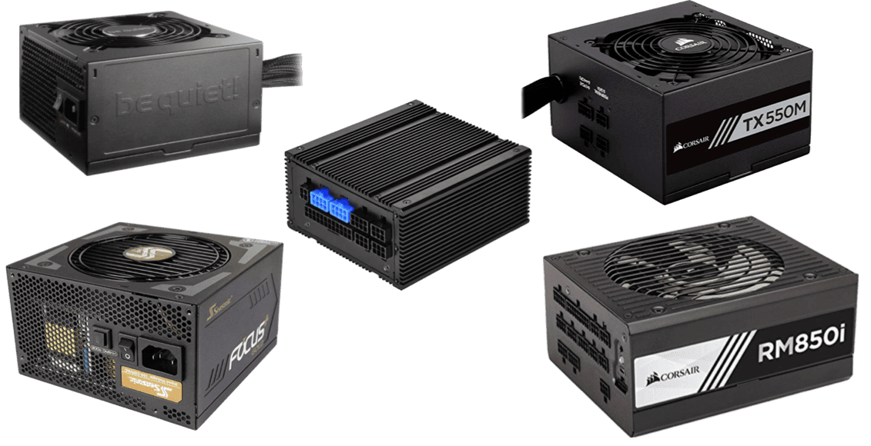

This is a Power Supply

***Power First!* *–*** *Installing the Power*

1. Install the power supply into your case. This is a super important first step!

***Processor! –*** *Installing your Processor*

This is a CPU

1. Open the locking mechanism
2. Place your CPU into the locking mechanism
3. Relock it into place

NOTE -- Try and do this on your motherboard without having it in the case yet.

***Brrrr! –*** *Installing a CPU Cooler*

1. Install the cooler into your case
2. Apply thermal paste to the cooler’s plate
3. Attach the cooler to the CPU, paste against the unit

This is a CPU Cooler

***** – *Installing your RAM*

This is RAM

1. Insert your RAM into the motherboard’s RAM bays



This is an I/O Board

***Devices! –*** *Installing your I/O Plate*

1. Attach your I/O plate to the case!

This is a Motherboard

***Motherboard!*** – *Install your Motherboard*

1. Install the completed motherboard into your case
2. Screw it into your case and be sure not to overtighten the screws

This is a GPU

***Video! –*** *Installing your GPU*

1. Plug your GPU into the longest PCIe slot on the motherboard

***Drives! –*** *Installing your (optional) Drives*

1. If you plan on using any drives, it’s time to install them into the front of your case

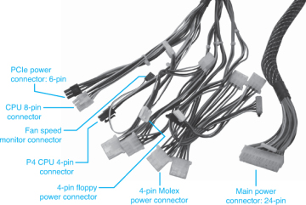

These are Connectors

***Connections! –*** *Installing the final Connections*

1. Connect all your cables to the power supply

NOTE -- This is how your PC will be powered

***Wiring!*** – *Installing the final Wiring*

1. Connect all the wiring on your PC parts to the motherboard’s respective slots

This is a diagram that shows spots where wires need to be connected.

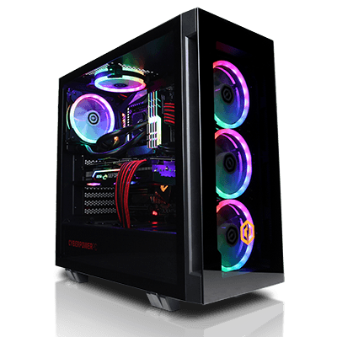

***Have fun! You’re done!***

NOTE – Clearly the most important part! You’ve just built your own PC! Have fun with your newfound superpower!

***Questionnaire*** *–*

On a scale of 1-5, how would you rate the instruction’s –

*Were these instructions informative?*

**Helpfulness --** 1 2 3 4 5

*Were these instructions written easy to understand?*

**Readability --**  1 2 3 4 5

*Were these instructions effective in teaching you a new skill?*

**Usability** -- 1 2 3 4 5

Finally, please answer the following short-answer questions –

*Was everything that was necessary included? Please explain if not –*

*What were the best features of the instruction set that helped you? –*

*What were some features of the instruction set that were ineffective? –*

*Do you have additional questions/concerns? --*